Restaurant ChatBot Web App

# 1. Introduction

This project is a restaurant-themed chatbot that can interact with users in a conversational way. It provides restaurant-related information such as menu, timings, location, delivery options, and special offers. It also performs sentiment analysis on user input using the VADER sentiment analyzer from NLTK.

# 2. Technologies Used

- Python 3  
- NLTK (Natural Language Toolkit)  
- Gradio  
- VADER Sentiment Analyzer

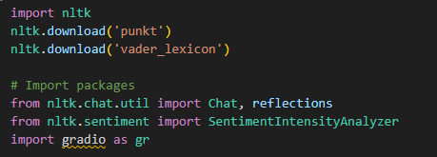

# 3. Features

- Chat-based interaction using predefined patterns  
- Sentiment analysis of user messages  
- Simple web-based interface via Gradio

# 4. Code Architecture

The chatbot uses NLTK's pattern matching to identify user intent. Predefined patterns are stored in the `pairs` list. A SentimentIntensityAnalyzer is initialized to analyze the emotional tone of user input. The Gradio interface presents a web app UI with options to chat or perform sentiment analysis.

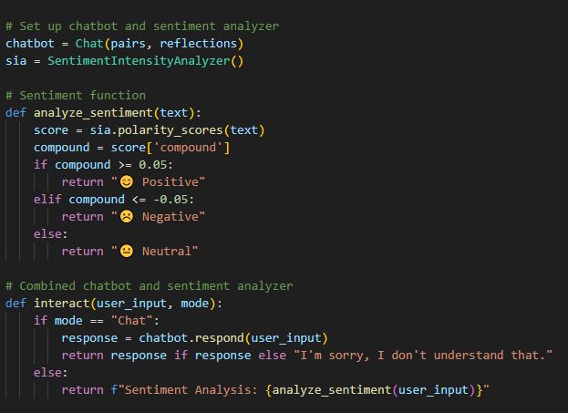

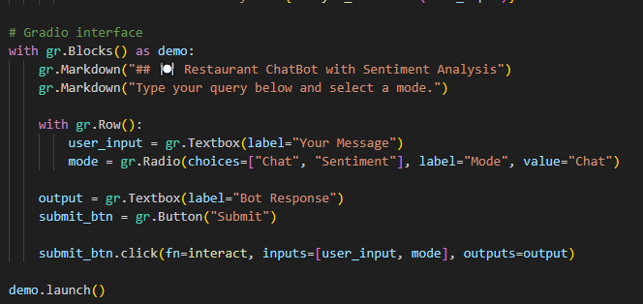

# 5. How it Works

## 5.1 Chatbot Mode

When the user types a message in Chat mode, the input is matched against regex patterns and an appropriate response is returned.

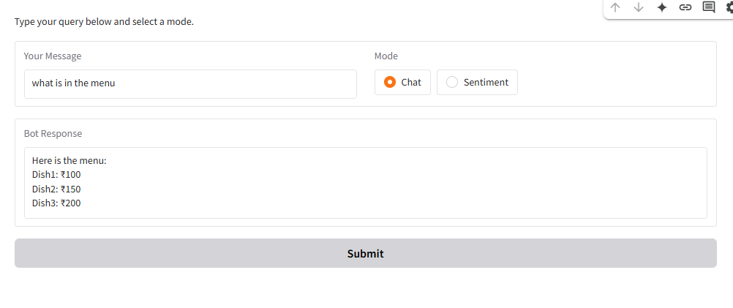

## 5.2 Sentiment Analysis Mode

In Sentiment mode, the user's input is analyzed using VADER to determine if it's positive, negative, or neutral.

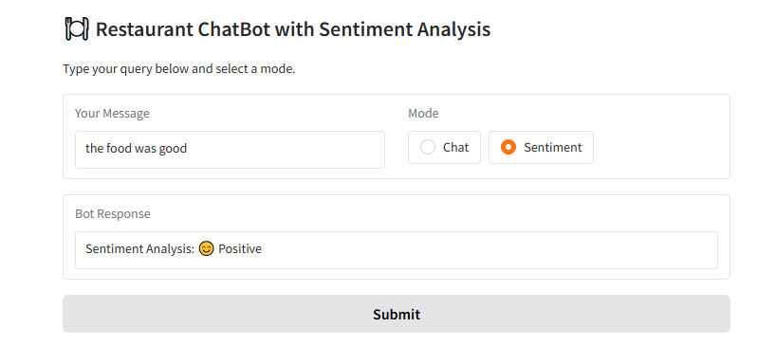

## 5.3 User Interface

The UI is built with Gradio. It contains a textbox for user input, a mode selector (Chat or Sentiment), and a Submit button.

# 7. Conclusion

This chatbot application demonstrates the use of natural language processing and sentiment analysis in a restaurant setting. It is simple, interactive, and fully deployable in a Google Colab environment using open-source tools.