Water Jug Problem

# Objective

The objective of this task is to solve the classic Water Jug Problem using Python. Given two jugs with specific capacities, the goal is to measure an exact target amount of water using the allowed operations.

# Algorithm Overview

The Breadth-First Search (BFS) algorithm is used to explore all possible states of the two jugs. Each state is a tuple of the current water volumes in Jug1 and Jug2. A queue is used to traverse states layer by layer, ensuring the shortest sequence of actions leading to the goal is found.

# Python Code

Here is the code for water jug solution in this code deque is implimented and all the rules are applied to solve it

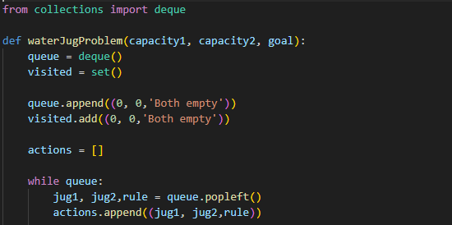

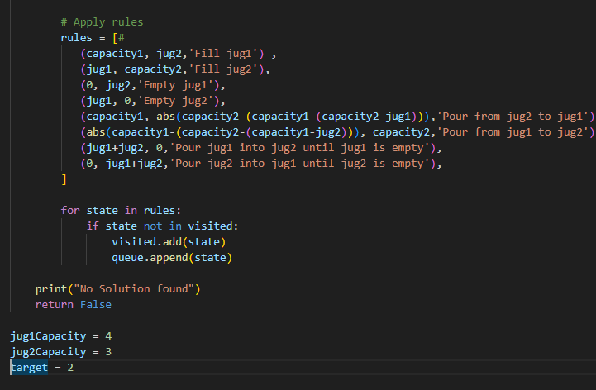

# Step-by-Step Explanation

The BFS algorithm explores all possible operations: filling a jug, emptying a jug, or transferring water between jugs. A visited set is used to avoid revisiting the same states. Once a state with the target value is found in either jug, the algorithm prints the sequence of steps taken to reach that state.

# Sample Output

For the input with Jug1 = 4L, Jug2 = 3L, and goal = 2L, the algorithm finds a valid sequence such as:  
  
At this point, Jug1 has exactly 2 liters.

# Conclusion

The Water Jug Problem is an example of a classic state-space search problem. Using BFS ensures that the solution found is the shortest possible sequence of operations. This Python implementation successfully solves the problem for given jug capacities and a target value.