Animal Herd Detection

# Objective

The objective of this task is to detect animals in a herd using computer vision techniques. This implementation uses a pre-trained Faster R-CNN model with ResNet-50 backbone to identify animals in images, which is helpful in monitoring wildlife or livestock in farms.

# Algorithm Overview

The model used in this project is Faster R-CNN with a ResNet-50 backbone and Feature Pyramid Network (FPN). It is pre-trained on the COCO dataset and is capable of detecting multiple object categories including animals. We apply a confidence threshold to filter low-confidence detections and then visualize the results by drawing bounding boxes.

# Python Code

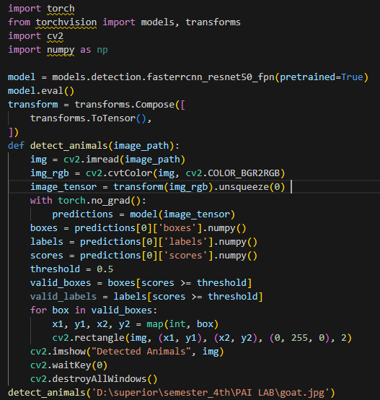  
Here the full code:

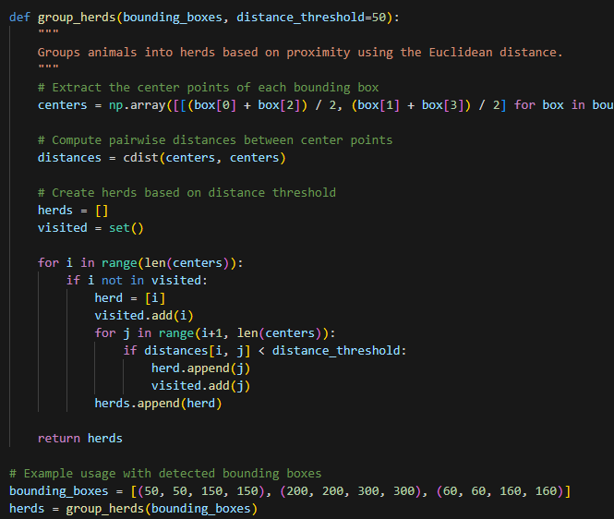

# Step-by-Step Explanation

1. A Faster R-CNN model is loaded from torchvision models.  
 2. The input image is read using OpenCV and converted to RGB.  
 3. The image is transformed and passed to the model for inference.  
 4. Bounding boxes are drawn on the animals detected with a confidence above 50%.

# Animal detection in given Area

This part of code can also detect animal herd in provided area of longitude and latitude

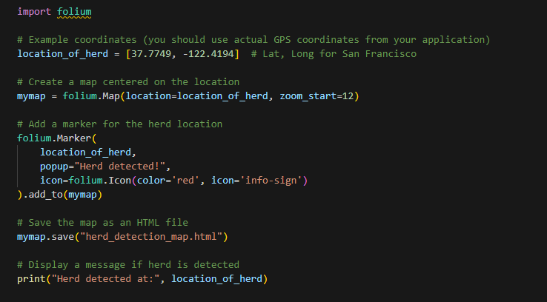

# Sample Output

The program displays the input image with bounding boxes drawn around each detected animal. The program also detect animal population in the area.

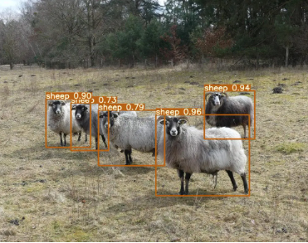

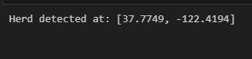

# Conclusion

Using Faster R-CNN, animal detection in images becomes accurate and automated. Such detection techniques are essential for tasks involving herd tracking in agriculture, wildlife preservation, and surveillance systems.