Useless Fun Fact App

# Objective

The objective of this project is to develop a light-hearted and engaging web application that provides users with random fun facts and humorous advice, as well as the ability to submit their own fun facts.

# Project Overview

This web application is built using the Flask framework for the backend. It displays a "Fact of the Day", a random fun fact, and a piece of advice. Users can also submit new fun facts, which are added to the existing collection dynamically.

# Technology Stack

• import random  
• import datetime

# Backend Python Code (app.py)

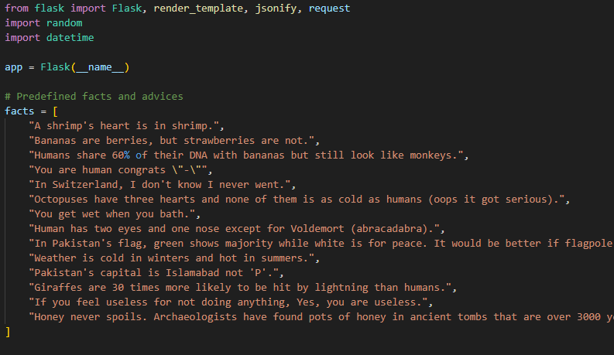  
app.py highlight  
1. Randomly select and return a fun fact and advice.  
2. Provide 'fact of the day' based on calendar day.

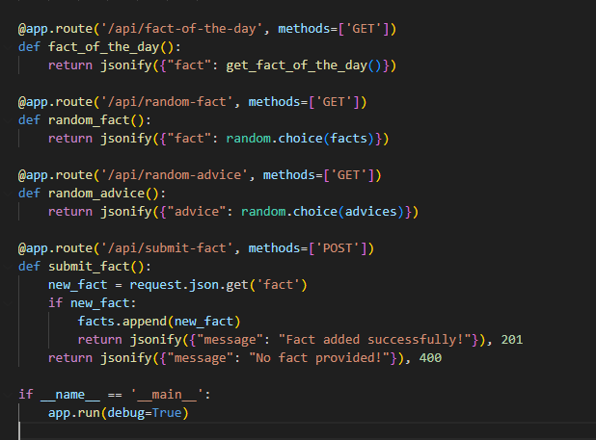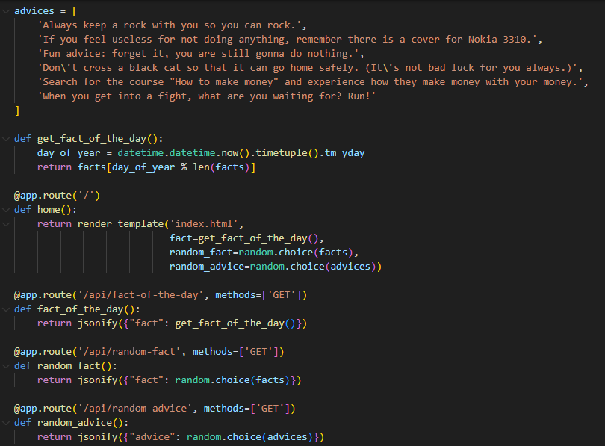

# Features and Functionality

• Show daily and random fun facts and advice  
• Accept and store user-submitted fun facts  
• Clean and responsive user interface

# Sample Output

Here is the output of the code.

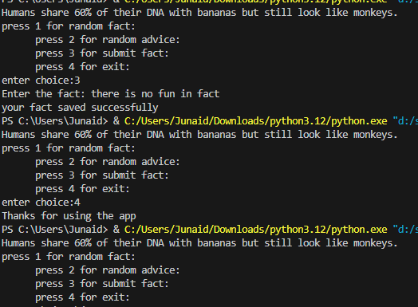

# Conclusion

This Useless Fun Fact App demonstrates how simple code can entertain users with random content. It also showcases how random functions works