Email Extractor Web App

# 1. Project Overview

This Python Flask web application allows users to input a company name and website URL. It scrapes the given URL for email addresses using BeautifulSoup and regular expressions. The extracted emails are displayed on the page and stored in a local CSV file for record-keeping.

# 2. Technologies Used

• Python 3

• Flask (web framework)

• BeautifulSoup4 (HTML parsing)

• requests (HTTP client)

• re (regex for email extraction)

• python-docx (for this report)

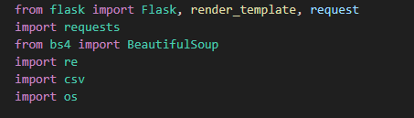

# 3. How It Works

1. User enters a company name and website URL.

2. Flask routes the request to the backend.

3. The backend uses requests + BeautifulSoup to get the page text.

4. Emails are extracted using a regex pattern.

5. Results are shown on the page and saved to `db2.csv`.

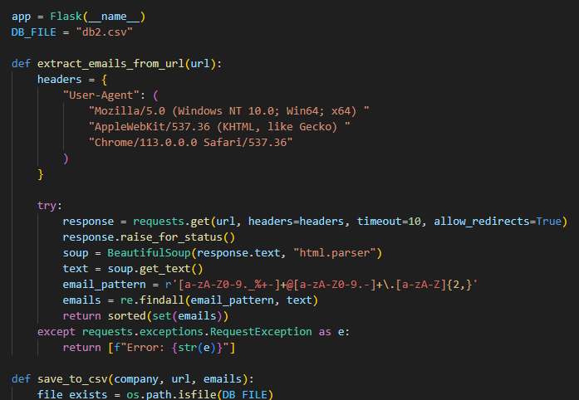

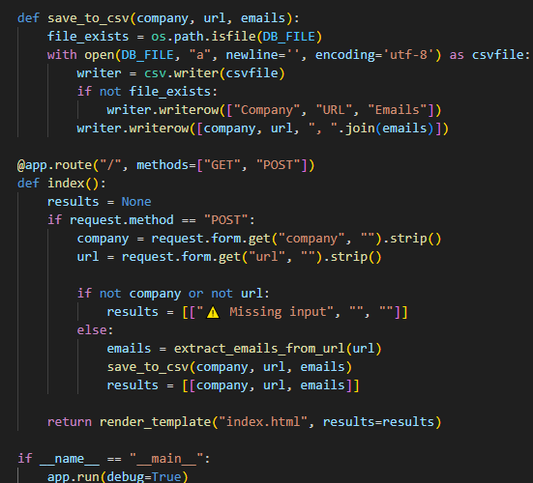

# 5. Email Extraction Logic

A regular expression is used to match email patterns in the HTML:

[a-zA-Z0-9._%+-]+@[a-zA-Z0-9.-]+\.[a-zA-Z]{2,}