

WAD

FALL 2025

Project Document

Real-Time Bus Tracking & Management System

Course Instructor: Sir Zahid Hussain

  - Section: SEE1 (Fall ‘25)

Aiman – 0237

Hira-0254

Postman Screenshot
1.Register a User:
- Method: POST
- URL: http://localhost:5000/api/auth/register
{
"name": "Admin User",
"email": "admin@test.com",
"password": "password123",
"role": "admin"
}
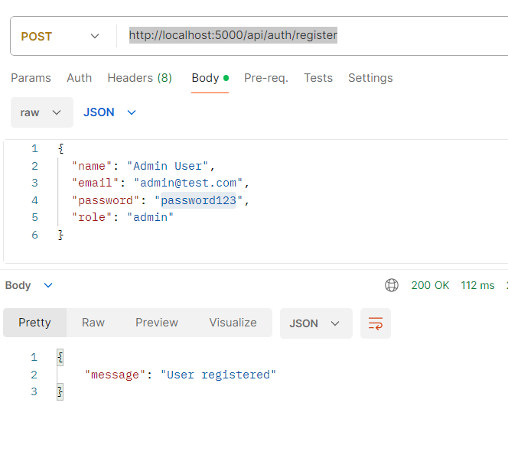
2.Login to get Token:
- Method: POST
- URL: http://localhost:5000/api/auth/login
{
"email": "admin@test.com",
"password": "password123"
}
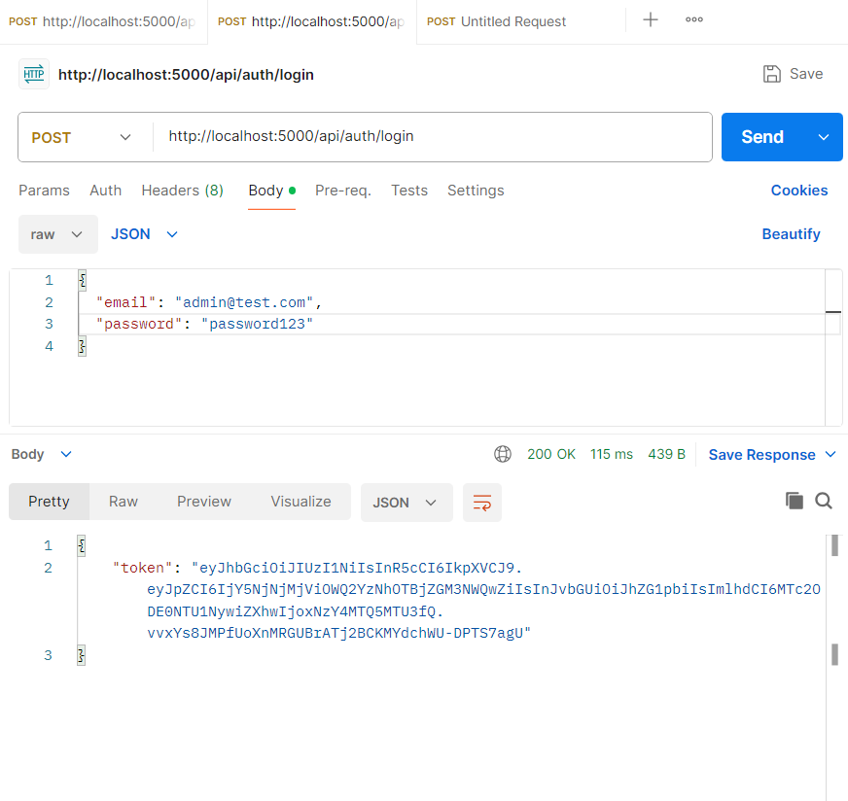
3.Authenticated Requests
Method: Post
http://localhost:5000/api/buses
{
"busNumber": "LHR-786",
"capacity": 40
}

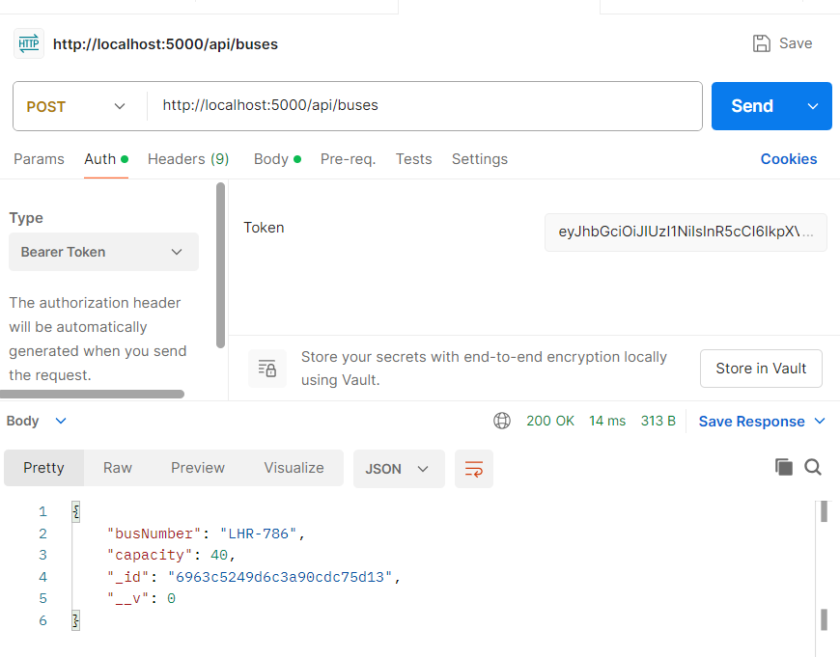
4.Get Your Profile
Method: GET
http://localhost:5000/api/auth/profile
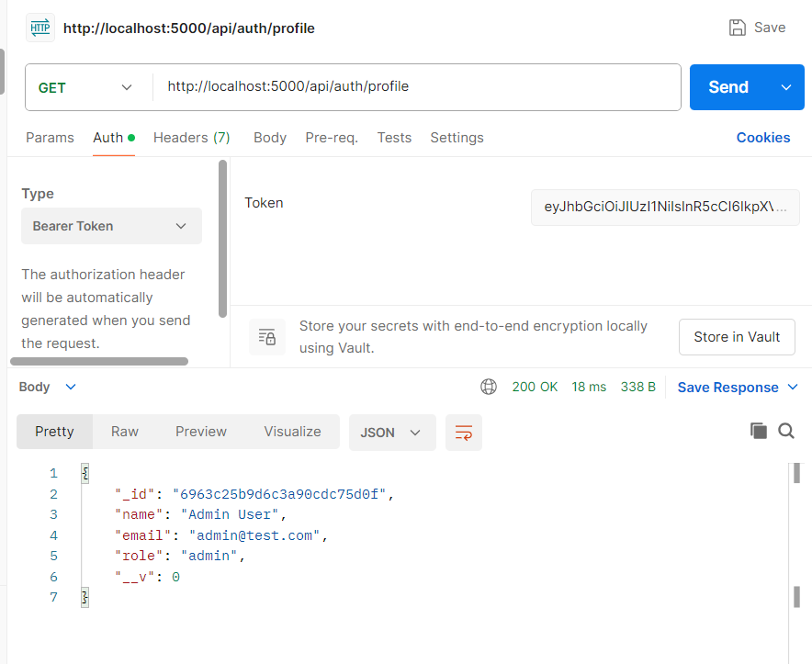
5.Create a Bus (Admin Required)
Method: POST
URL: http://localhost:5000/api/buses

{
"busNumber": "UCP-001",
"capacity": 55
}
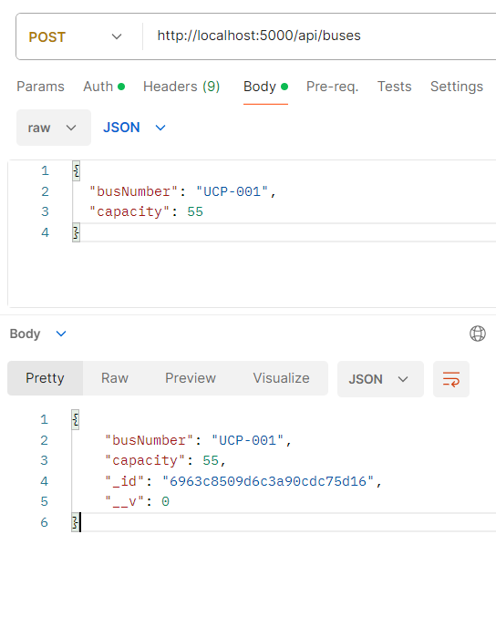
6.Get All Buses
Method: GET
http://localhost:5000/api/buses
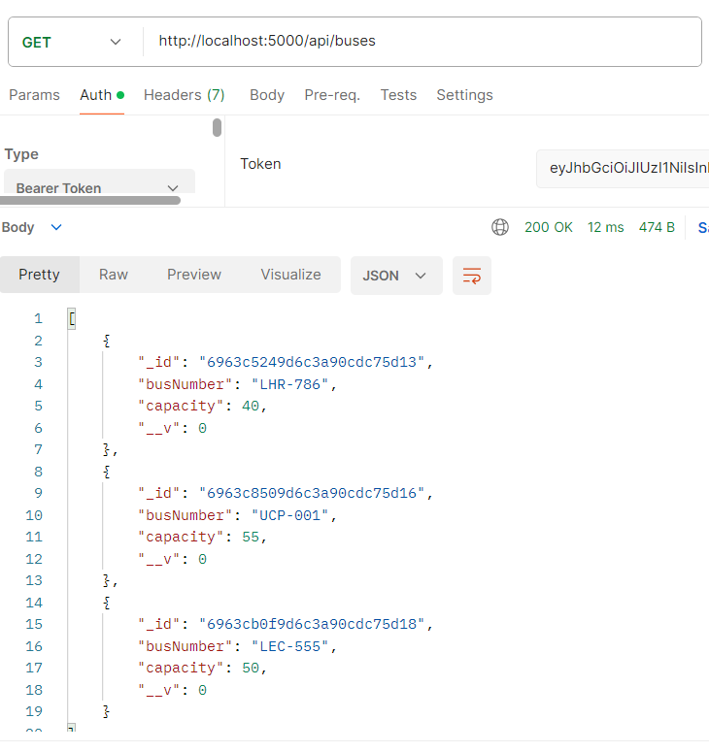
7.Get Bus Details
Method: GET
URL: http://localhost:5000/api/buses/BUS_ID

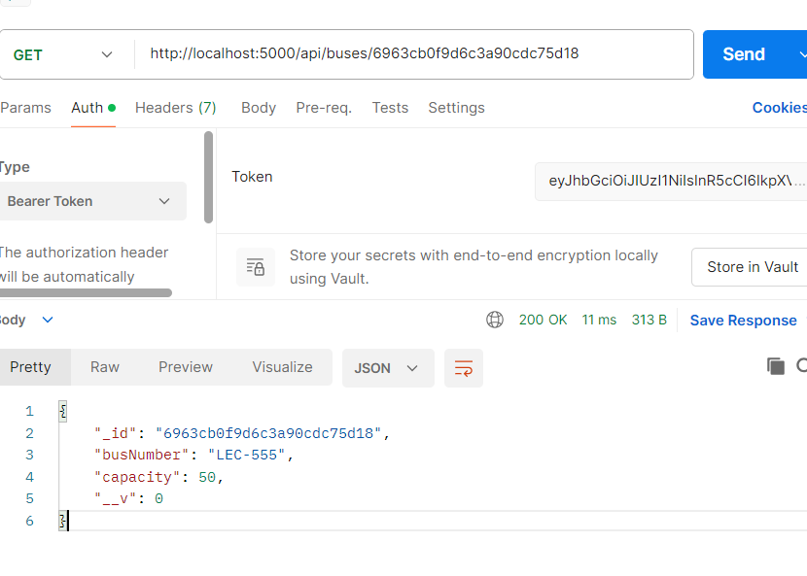
8.Update Bus (Admin)
Method: PUT
URL: http://localhost:5000/api/buses/BUS_ID
Body (JSON):
{"capacity": 60}
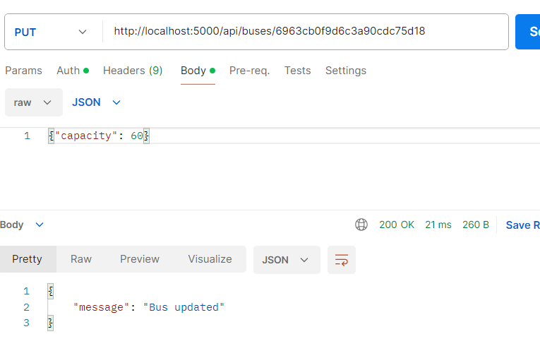
9.Delete Bus (Admin)
Method: DELETE
URL: http://localhost:5000/api/buses/BUS_ID
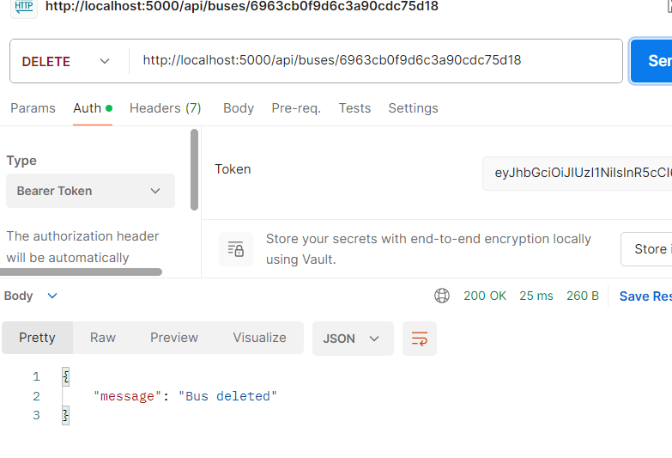
10.Get All Users
Method: GET
URL: http://localhost:5000/api/users
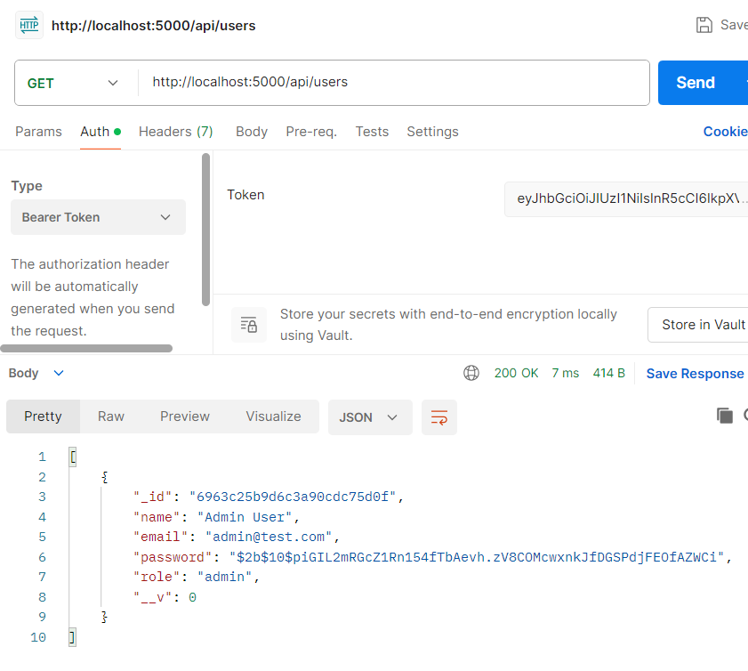
11.Get Single User
- Method: GET
- URL: http://localhost:5000/api/users/USER-id

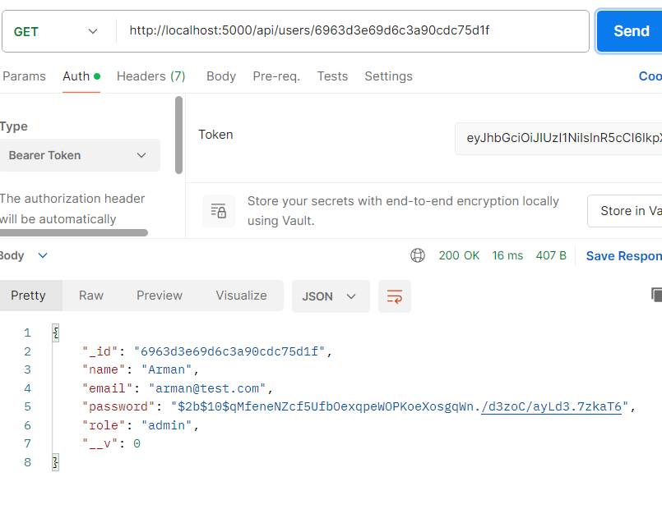
12.Update User
Method: PUT
URL: http://localhost:5000/api/users/USER_ID
Body (JSON):
{"name": "Sabeen"}
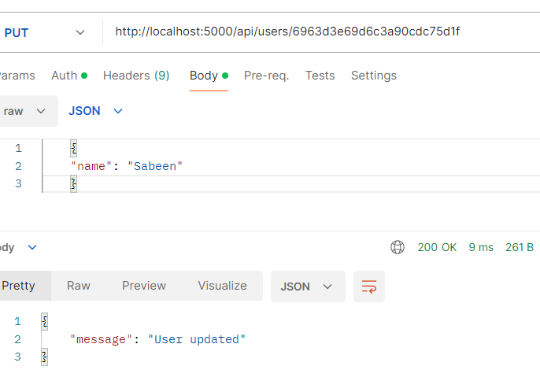

13.Delete User
Method: DELETE
URL: http://localhost:5000/api/users/USER_ID
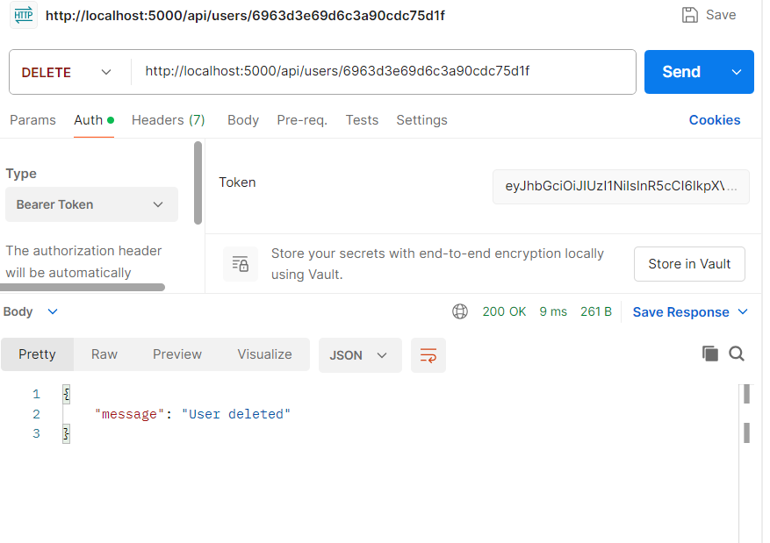
14. Create Route (Admin)
Method: POST
URL: http://localhost:5000/api/routes
Body (JSON):
{
"startPoint": "UCP",
"endPoint": "dhaPhase8",
"stops": ["Gulberg", "Dha"]
}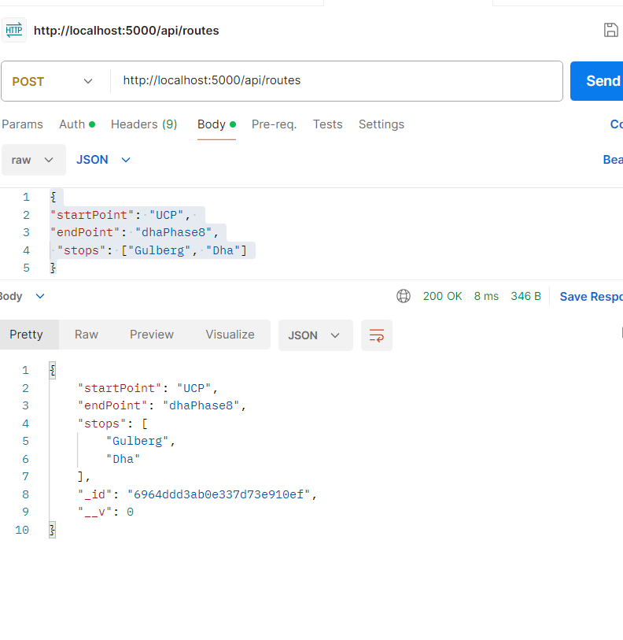

15. Get All Routes
Method: GET | URL: http://localhost:5000/api/routes
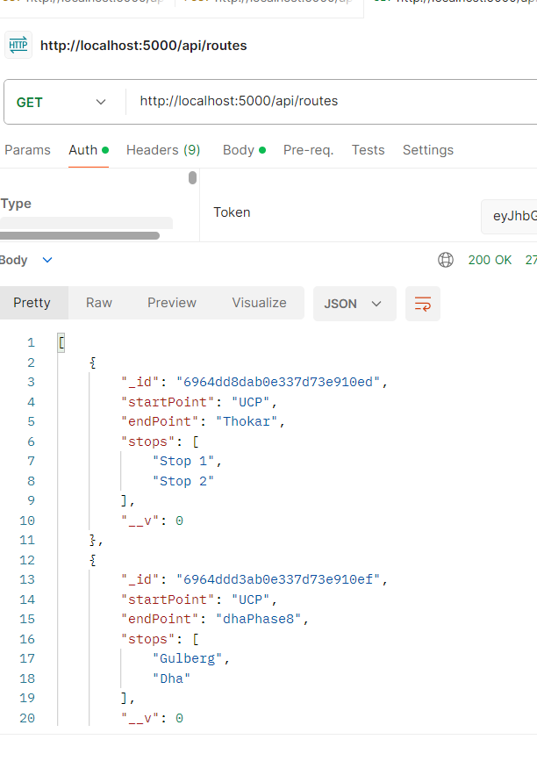
16. Get Route Details
Method: GET | URL: http://localhost:5000/api/routes/ROUTE_ID
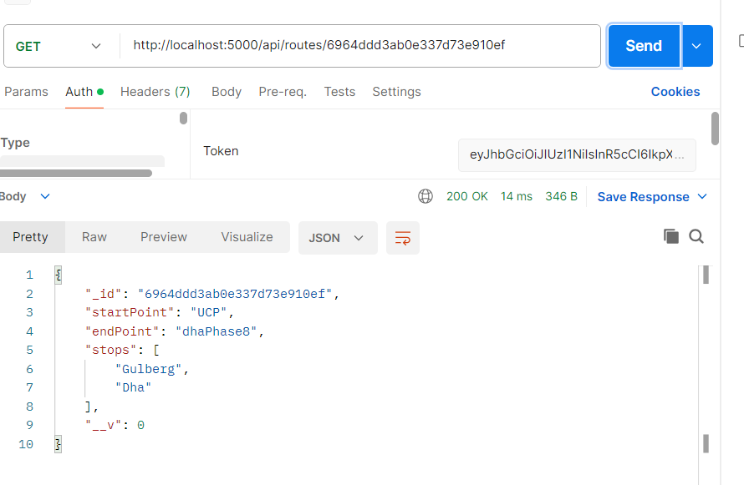
17. Update Route (Admin)
Method: PUT | URL: http://localhost:5000/api/routes/ROUTE_ID
Body (JSON): {"endPoint": "Jauhar Town"}
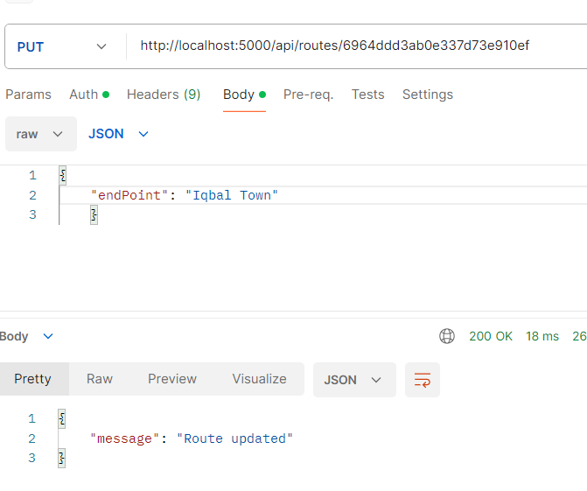

Live Tracking (Driver/User)
18.Driver Register
Method: POST
URL: http://localhost:5000/api/auth/register
{
"name": "Ali Driver ",
"email": "alidriver1@test.com",
"password": "password123",
"role": "driver"
}

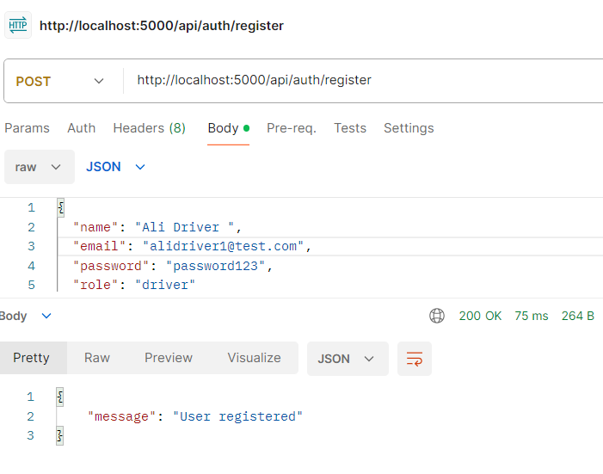
19.Driver Login
- Method: POST
- URL: http://localhost:5000/api/auth/login
- Body (JSON):
{
"email": "alidriver1@test.com",
"password": "password123"
}
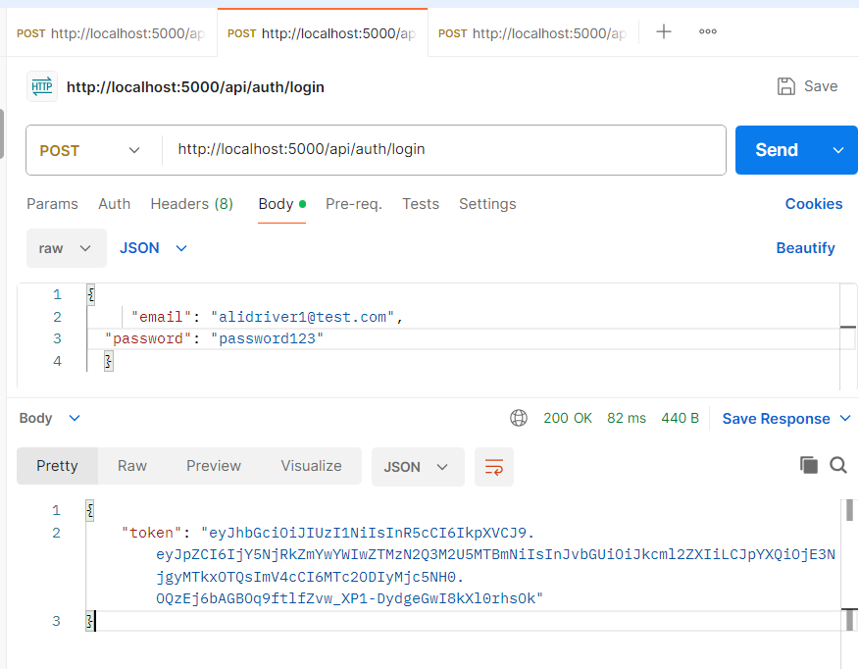

20. Update Location (Driver)
Method: POST
URL: http://localhost:5000/api/location/update
Body (JSON): {
"busId": "BUS_ID",
"latitude": 31.44,
"longitude": 74.26
}
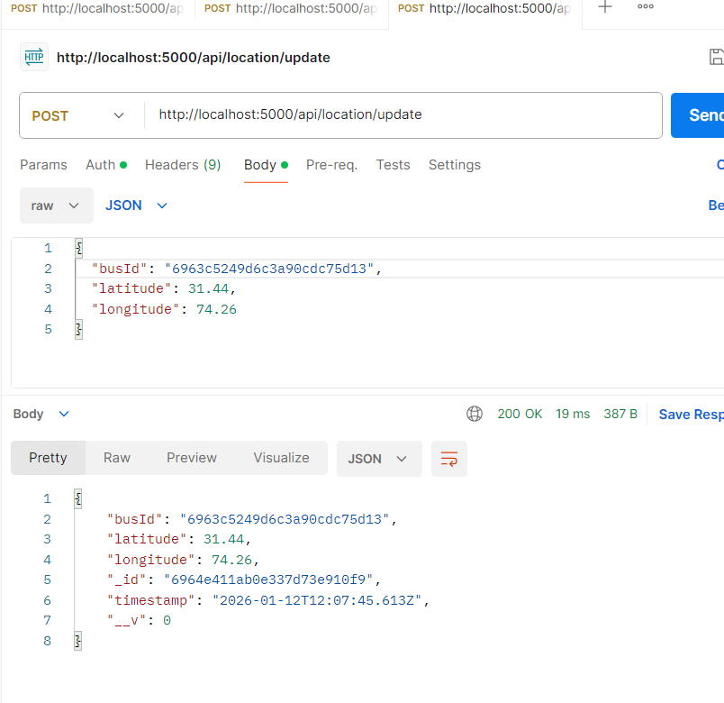
21. Current Location
Method: GET
URL: http://localhost:5000/api/location/BUS_ID
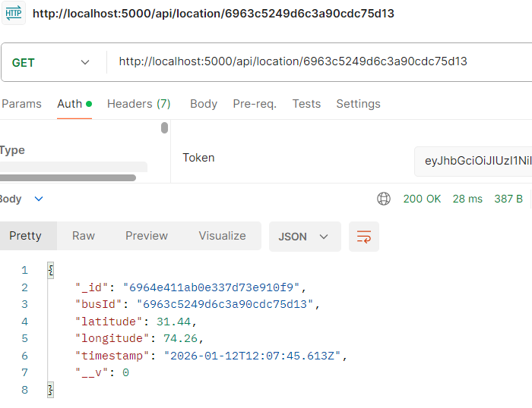
22. Location History
Method: GET | URL: http://localhost:5000/api/location/history/BUS_ID
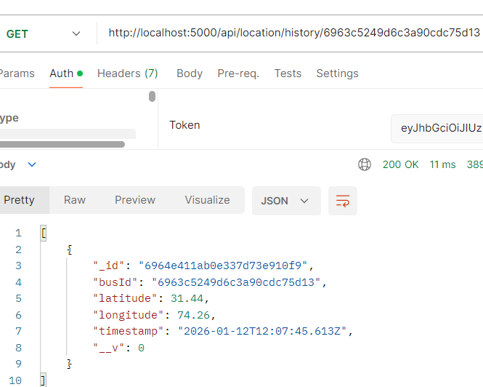

23. Create Status (Driver)
Method: POST | URL: http://localhost:5000/api/status/update
Body (JSON): {"busId": "BUS_ID", "status": "On Route"}
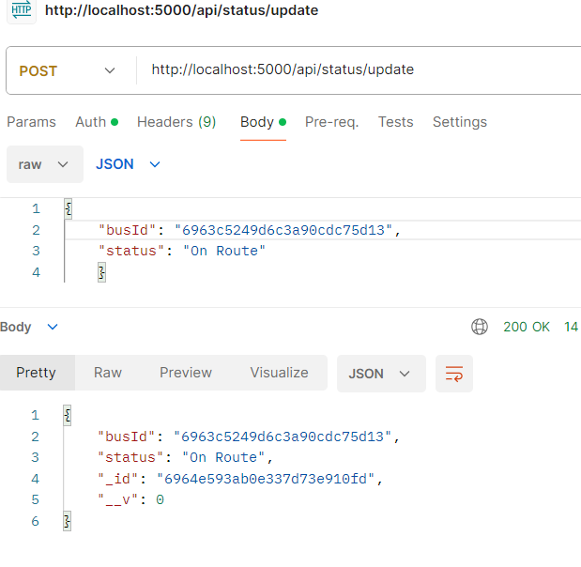
24. Update/Upsert Status (Driver)
Method: PUT | URL: http://localhost:5000/api/status/BUS_ID
Body (JSON): {"status": "Delayed"}
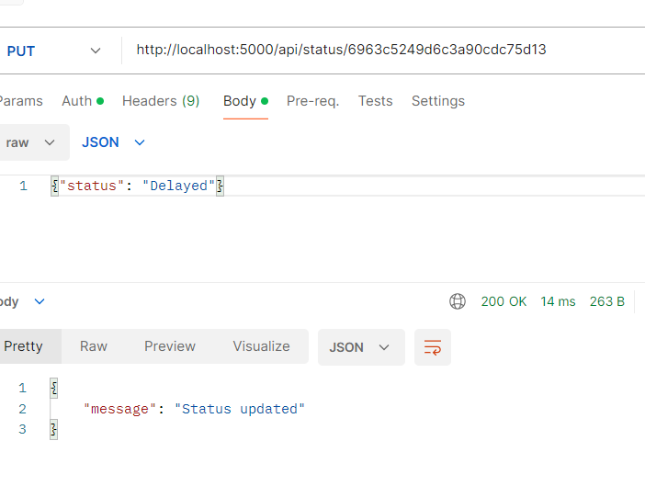
25. Create Schedule (AdminToken)
Method: POST | URL: http://localhost:5000/api/schedule
Body (JSON): {"busId": "BUS_ID", "timings": ["08:30 AM", "03:45 PM"]}
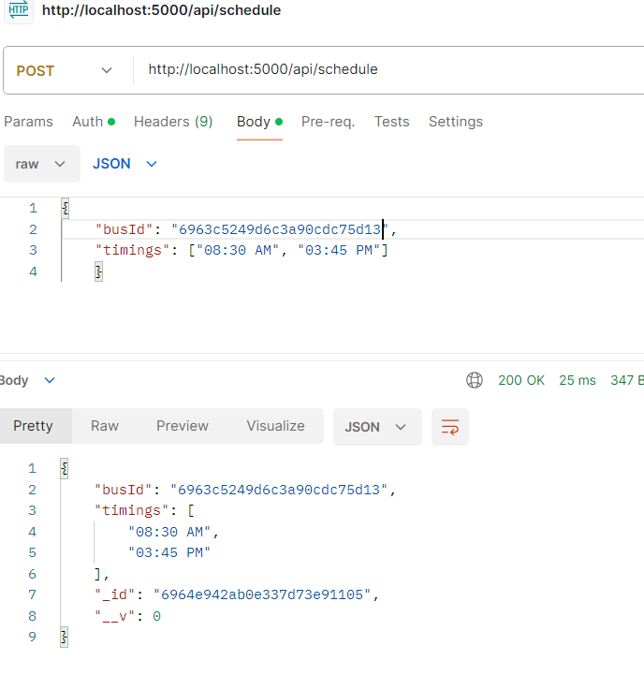
26. Get Schedule
Method: GET | URL: http://localhost:5000/api/schedule/BUS_ID
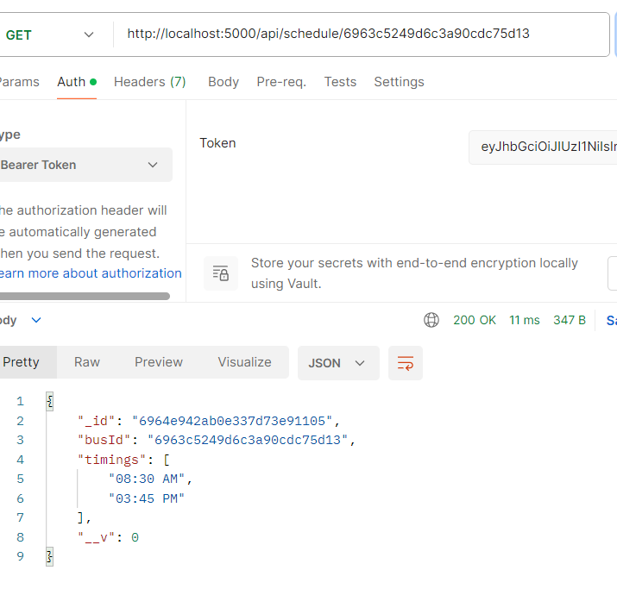
27. Update Schedule (Admin)
Method: PUT | URL: http://localhost:5000/api/schedule/BUS_ID
Body (JSON): {"timings": ["09:00 AM"]}
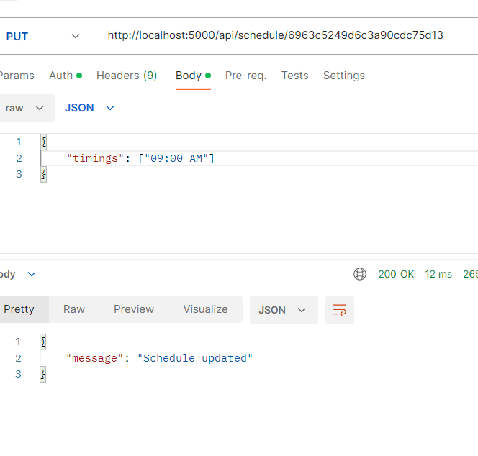
28. Logout
Method: POST
URL: http://localhost:5000/api/auth/logout


