Project Requirements Document: Recipes Hub

1. Introduction

1.1 Purpose
This document specifies the requirements for the "Recipes Hub" web application. The core objective is to create a user-friendly platform where individuals can easily discover and explore various recipes, presented in an organized and visually appealing manner.

1.2 Scope
The current scope of this project focuses on the front-end development of the Recipes Hub website. This includes the implementation of user interface (UI) and user experience (UX) elements such as recipe display, navigation, search and filter interfaces, and dedicated pages for user authentication (login and sign-up). Functionalities requiring server-side processing or database interaction (e.g., dynamic search, persistent likes, actual user authentication) are currently outside this scope, as indicated by the provided static HTML and CSS files.

1.3 Target Audience
The primary users of the Recipes Hub are home cooks, culinary enthusiasts, and anyone seeking recipe inspiration. The application aims to cater to users who appreciate a straightforward and visually engaging Browse experience.

2. Overall Description

2.1 Product Perspective
The Recipes Hub is designed as a standalone web application, accessible directly through a web browser. It's built using standard web technologies (HTML and CSS), emphasizing a clean and responsive client-side presentation.

2.2 Product Features

2.2.1 Global Navigation
A consistent navigation bar is present across all pages, offering:
- "Recipes Hub" Logo: Serves as a branding element and a direct link to the homepage.
- Home Link: Navigates to the main `index.html` page.
- Categories Link: Provides quick access by scrolling to the category filter section on the homepage.
- Login Link: Directs users to the `login.html` page.
- Sign Up Link: Directs users to the `signup.html` page.

2.2.2 Homepage (`index.html`)
The homepage is the central hub for recipe discovery, featuring:
- Hero Section: A prominent introductory area with a catchy title ("Discover Delicious Recipes") and a brief description.
- Search and Filter Controls:
- Search Bar: An input field for users to type in recipe keywords.
- Category Filters: A set of checkboxes enabling users to filter recipes by categories such as Breakfast, Vegetarian, Dessert, Dinner, and Vegan.
- Recipe Grid: The core display area, showcasing 15 distinct recipe cards in a responsive grid layout. Each card includes:
- A compelling recipe image.
- The recipe title.
- A concise description.
- A "View Recipe" button that links to the detailed recipe page.
- A "Like" button (heart icon) for user interaction, designed with a visual feedback mechanism upon selection.

2.2.3 Recipe Detail Pages (`recipeX.html`)
Each recipe (e.g., `recipe1.html` for Pancakes, `recipe2.html` for Veggie Stir Fry, etc.) has its own dedicated page, providing comprehensive information:
- A large, high-quality image of the prepared dish.
- The recipe's title.
- Metadata: Key information like Prep Time, Cook Time, and Servings.
- Ingredients List: A clear, itemized list of all necessary ingredients.
- Instructions: A step-by-step guide to prepare the dish.
- "Back to Home" Button: For easy return to the main recipe grid.

2.2.4 User Authentication Pages
The project includes static interfaces for user authentication:
- Login Page (`login.html`): Features fields for email and password, a login button, and links to the sign-up page and the homepage.
- Sign Up Page (`signup.html`): Includes fields for name, email, and password, a sign-up button, and links to the login page and the homepage.
Both pages utilize a distinct background and a centralized container for their forms.

2.3 User Characteristics
The application assumes users have basic internet navigation skills. The interface is designed to be intuitive, requiring no specialized technical knowledge.

2.4 Constraints
- Front-End Implementation Only: The current project scope is limited to the client-side presentation. Backend logic for search functionality, category filtering, "liking" recipes, and actual user authentication is not implemented.
- Static Content: All recipe data and page content are hardcoded directly into individual HTML files. There is no dynamic content generation from a database or API.
- External Assets: The project relies on an `images/` directory for all recipe visuals.
- Styling Dependency: The entire visual design and responsiveness are controlled by the `styles.css` file.

3. Specific Requirements

3.1 Functional Requirements (F-R)
- F-R 1: Recipe Display: The system must display recipe cards on the homepage, each showing an image, title, description, and action buttons.
- F-R 2: Recipe Detail View: Users must be able to navigate from a recipe card to a dedicated page that displays the full ingredients list and cooking instructions for that recipe.
- F-R 3: Navigation: The system must provide clear navigation links (Home, Categories, Login, Sign Up) in a persistent header across all pages.
- F-R 4: Homepage Access: Users must be able to return to the `index.html` from any recipe detail page or authentication page via designated links.
- F-R 5: Search Interface: The homepage must present a text input field for recipe searching.
- F-R 6: Category Filter Interface: The homepage must offer checkbox options for filtering recipes by predefined categories.
- F-R 7: User Login Interface: The system must present a form for users to enter their email and password for login.
- F-R 8: User Sign Up Interface: The system must present a form for new users to enter their name, email, and password for registration.
- F-R 9: Like Button Interaction: Each recipe card must feature a "like" button that visually changes state when clicked.

3.2 Non-Functional Requirements (N-F-R)

3.2.1 Usability
- N-F-R 1.1: Intuitive UI: The user interface should be intuitive, allowing users to easily understand and operate the website's features.
- N-F-R 1.2: Readability: All textual content, especially recipe instructions and ingredients, must be clearly legible.
- N-F-R 1.3: Consistency: The design, layout, and interactive elements must maintain a consistent appearance and behavior throughout the application.

3.2.2 Performance
- N-F-R 2.1: Page Load Time: All pages should load quickly, providing a smooth user experience.
- N-F-R 2.2: Responsiveness: The website must be fully responsive, adapting seamlessly to various screen sizes, including desktops, tablets, and mobile devices, without loss of functionality or visual integrity.

3.2.3 Look and Feel (Derived from `styles.css`)
- N-F-R 3.1: Color Scheme: The design shall adhere to the defined color palette, utilizing warm tones (`--primary: #ff7043`, `--primary-light: #ffab91`) for emphasis and soft neutrals for backgrounds and text.
- N-F-R 3.2: Typography: The application shall consistently use the specified font stack ('Segoe UI', 'Roboto', Arial, sans-serif) for all text elements.
- N-F-R 3.3: Visual Effects: Elements like recipe cards, input fields, and buttons should incorporate subtle visual effects (e.g., rounded corners, shadows, smooth transitions) to enhance user engagement.
- N-F-R 3.4: Interactive Feedback: Interactive elements, particularly recipe cards and like buttons, must provide clear visual feedback on hover and interaction (e.g., card scaling, like icon color change).

4. Future Enhancements (Beyond Current Scope)
For future iterations of the "Recipes Hub" project, consider adding the following functionalities to enhance its robustness and user value:
- Dynamic Content Loading: Implement JavaScript to fetch recipe data from a JSON file or a database, allowing for easier updates and scalability than static HTML.
- Working Search and Filters: Develop JavaScript logic to enable real-time searching and filtering of recipes based on user input and selected categories.
- User Authentication System: Integrate a backend for user registration, login, session management, and profile creation.
- Persistent User Preferences: Store user-specific data, such as liked recipes, in a database.
- Recipe Submission: Allow authenticated users to submit their own recipes.
- Error Handling: Implement user-friendly error messages for forms and other interactions.

5. Screenshots:

5.1. Login:
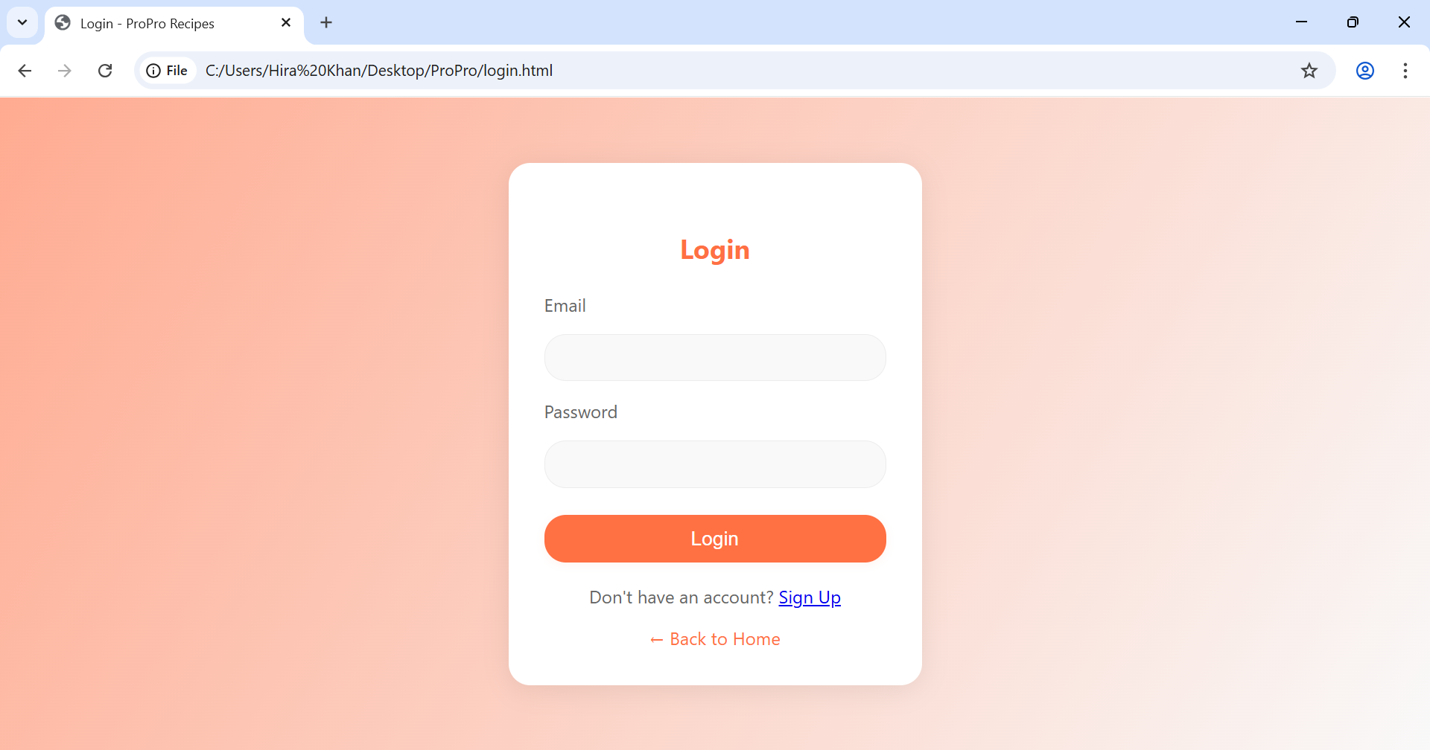

5.2. Sign Up:
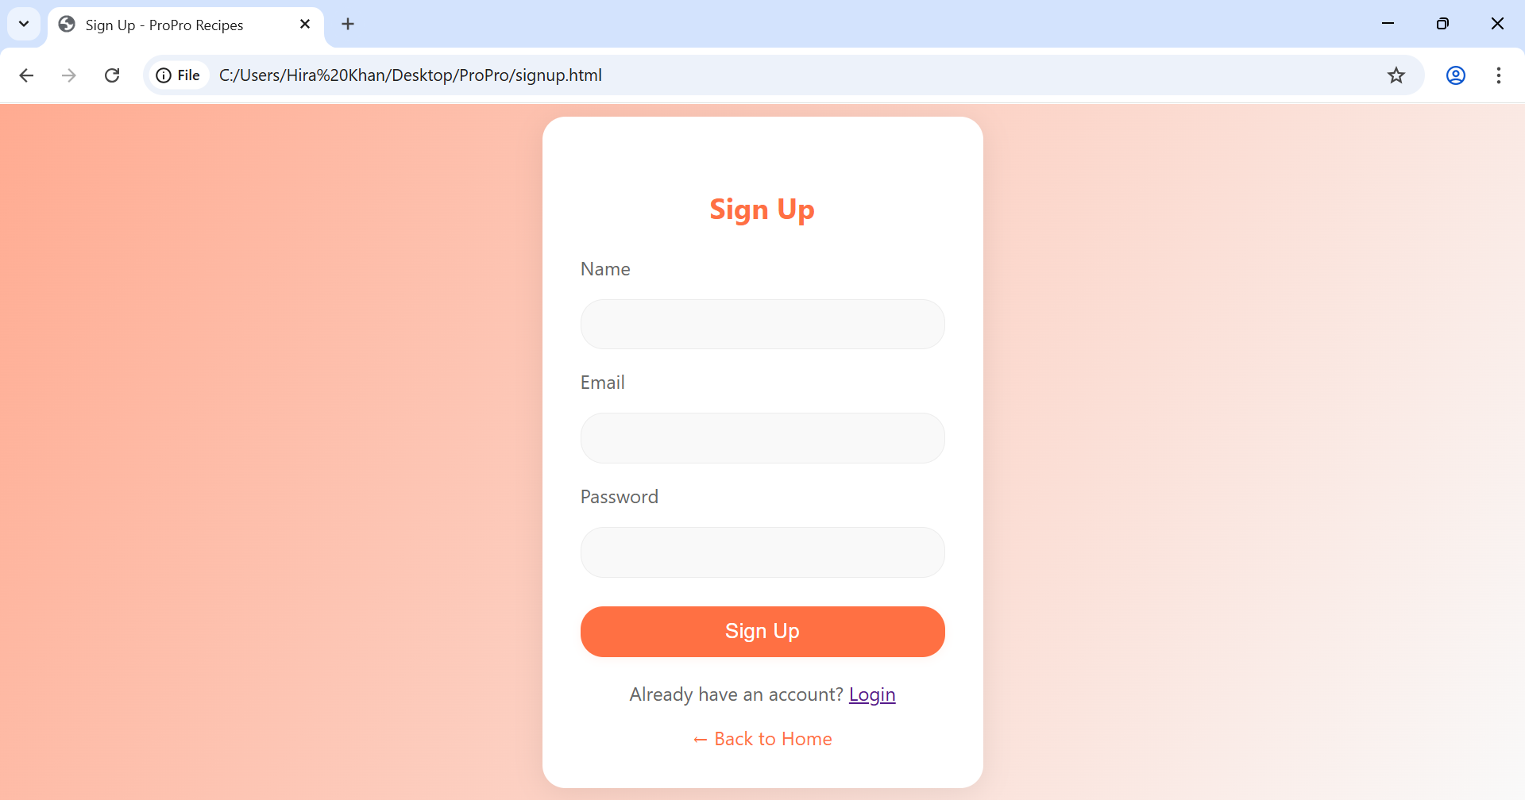

5.3. Home:
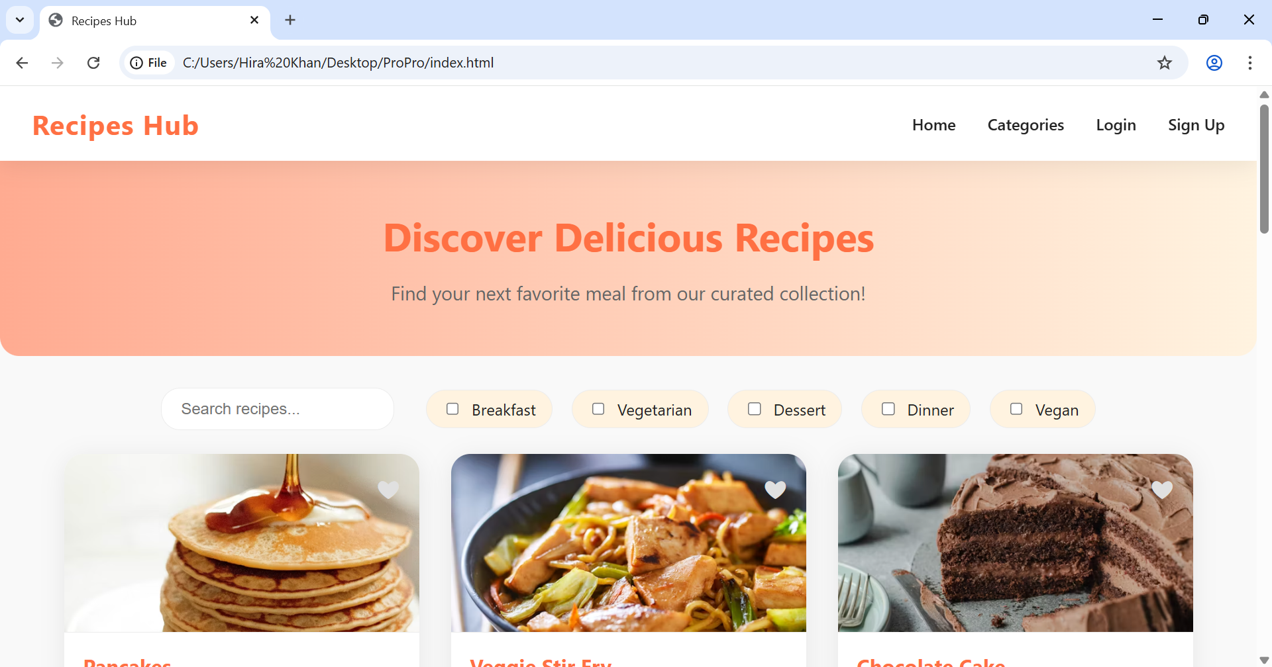

5.4. Like a recipe:
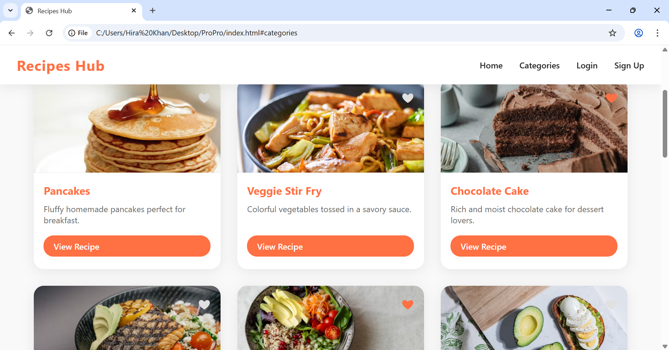

5.5. Opening a Recipe:


