Name: Hirain Singadia

Email: hirainsingadia2000@gmail.com

Q.1 Find out the mail servers for the following domain :

a) ibm.com

b) wipro.com

* Steps :

1. Open command prompt
2. Type nslookup
3. Type set type=mx
4. Type the name of the domain [www.ibm.com](http://www.ibm.com)

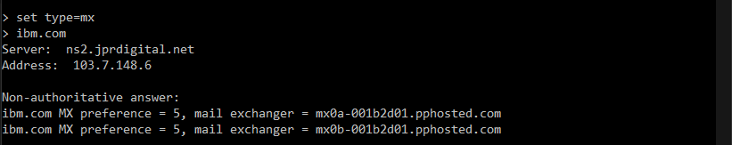

1. For wipro.com follow the same steps from 1 to 3
2. Change the domain name to [www.wipro.com](http://www.wipro.com)

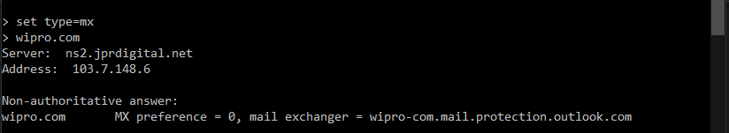

Q.2 Find the location where the servers are hosted

* Steps :

1. Open terminal in kali linux
2. Type traceroute [www.ibm.com](http://www.ibm.com) for Ibm.com
3. Type traceroute [www.wipro.com](http://www.wipro.com) for Wipro.com

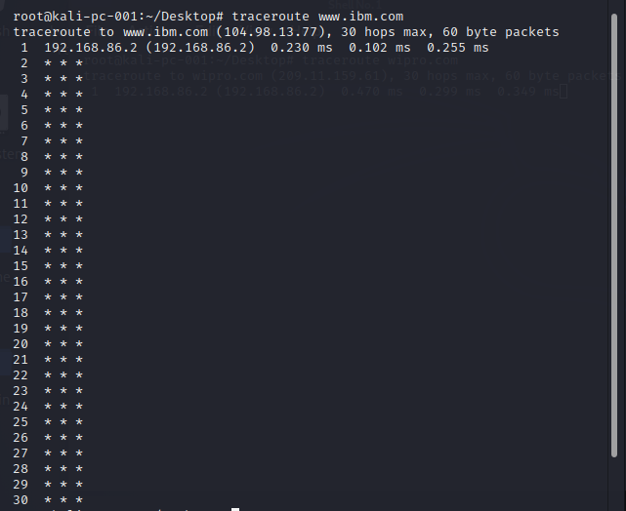

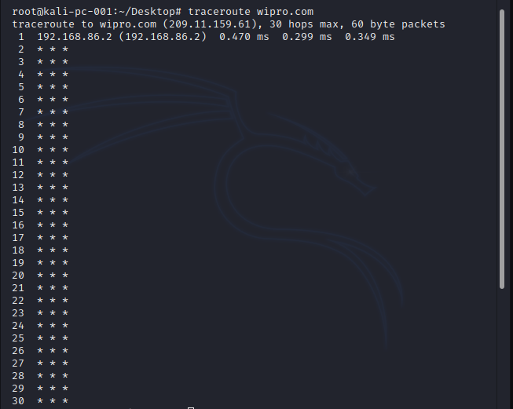

Q.3 Scan and find out open port number 203,163,246,23

* Steps :

1. Open terminal in kali linux
2. Type sudo nmap -p- 203.163.246.23

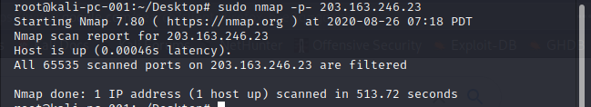

Q.4 install Nessus in a VM and scan your laptop for CVE

