Computer network

A computer network is a telecommunication network that enables sharing of resources and information. Nodes or PCs in network are interconnected with each other using cables or wireless media.

All the Nodes inside the network should use digital rules (also known as protocol) for the data transmission. The devices inside your network are LAN (local area network).

Data is transferred among the nodes in the form of packets (A formatted unit of data) .

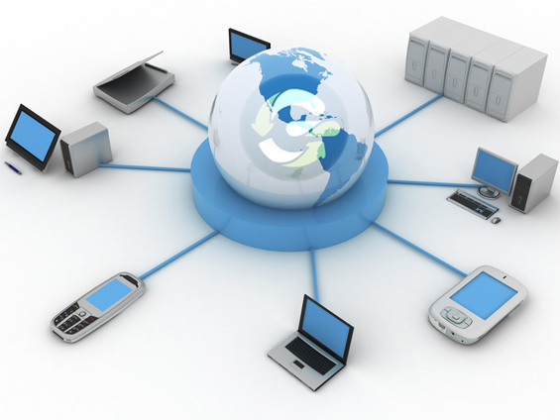

For Example when you are browsing the internet your computer is the part of biggest network (internet) and you can exchange data using internet protocols such as HTTP (Hypertext transfer protocol) and DNS(Domain name system).

HTTP is a standard for web browsers and server to communicate. HTTP defines how messages are formatted and transmitted and what actions Web server and browsers should take in response to various commands.



DNS (Domain name System)

Domain name system is an internet service that translates domain names in to IP(internet protocol) addresses . Because domain names are Alphabetic they are easier to remember , the internet however is really based on IP address . Every time you use a domain name It must be translated in to IP address in order to access that particular website . For example when you type [www.Googl.com](http://www.Googl.com) first of all it will be translated in to IP address by domain name system then will be able to access the particular website .

To check the DNS of any website

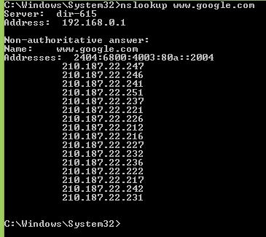

So instead of typing domain name ([www.Google.com](http://www.Google.com)) you can just type 210.187.22.231 to access the Google.



In order to connect Two computers together we should use a device known as Switch.

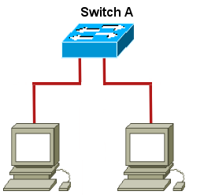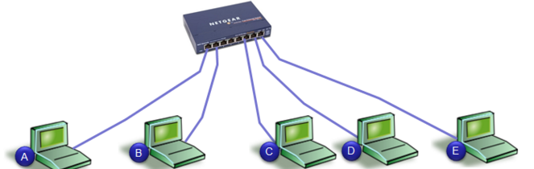

**OSI (open system interconnection interconnection) Model**

**The Open System interconnection model was created by the international organization for Standardization(ISO) . OSI model has been divided into 7 layers named as**

1. **Physical Layer**
2. **Data link layer**
3. **Network layer**
4. **Transport layer**
5. **Session Layer**
6. **Presentation**
7. **Application layer**

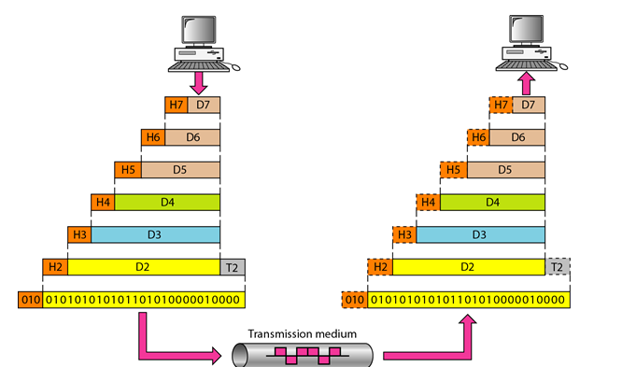

**Physical Layer**

**Physical layer is responsible for movements of individual bits from one hop to next n hop. It deals with the physical characteristics of transmission media, describing the connectors, pins, cables, and network interface cards.**

**Examples of services and devices used at physical layer includes**

* **Telnet ( A way to remotely access the Device)**
* **FTP (file transfer protocol)**
* 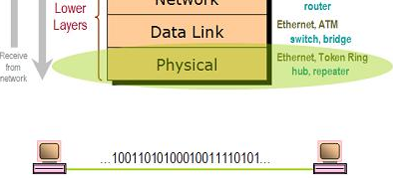**Repeaters , Hubs**

**Data Link layer**

Data link layer is responsible for moving of frames from one hop (node) to another. It combines packets into byte and then byte into frames. Each frame has header and trailer. A Header contains source and destination MAC address. Because MAC (media access control) Addresses work at Data link layer so they are also known as Layer 2 address. A trailer contains the frame check sequence for error detection.

FCS(frame check sequence ) is extra error detecting code added to frame during the communication .These FCS(frame check sequence) values are checked at the destination if the value of FCS(frame check sequence ) calculated by source is equal to FSC(frame check sequence ) value at receiving end then transmission is considered as error free. An example of Layer two devices includes Switches.

To check the layer 2 address of devices you may use the “arp –a” command. ARP (Address resolution protocol) which is used to map IP (internet protocol) address with MAC (Media access control) address.

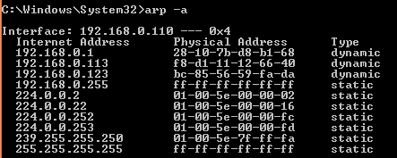

In the switches frames are delivered based on the mac address table every switch has a mac- address table. In CISCO switches it can be checked by using “show mac-address-table” command without quote.

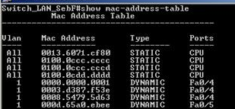

Examples of protocols that runs on Data link layer can also include PPP(point to point protocol) HDLC( High Level data link control) , Ethernet

**Network Layer**

This is third layer of OSI (open system interconnection system) model logical address of devices works on this layer**. This is the reason IP (internet protocol) addresses are also known as layer 3 addresses.**

It provides logical addressing that can be used by router for path determination. Without proper configuration of layer 3 addresses we cannot access the outside network because it is used by router for path determination. To check how data is travelling from your network to another network the basic command that can be used on cmd is “tracert” without quote.

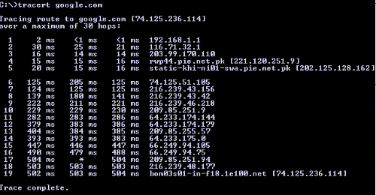

To check the network address of your PC just enters “ipconfig” the IP address of your device will be network address of your device. Devices that work at layer 3 can include Router, Firewall, Layer 3 switch and ICMP (internet control message protocol).

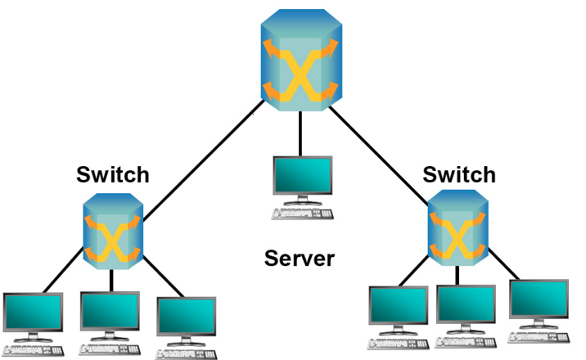

**Transport layer**

**This layer is responsible for end-to –end integrity and control of session. Data is accepted from session layer and passed through network layer most commonly used protocols at transport layer are TCP(transmission control protocol) for reliable transmission and UDP(user data gram protocol ) for un reliable transmission.**

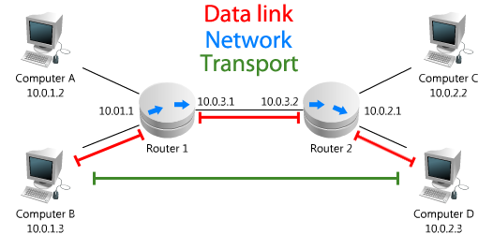

**Session layer**

**It determines how to establish, control and terminate session between two systems. Examples of protocols can include SSL (secure socket layer) and NetBIOS.**

**Presentation Layer**

**This Layer defines the data formats processes such as compression, encryption are handled at this Layer . Encryption is the process of converting plain text in to something that appears random and meaningless while decryption is the process of converting that random information in to plain text again. This is done in order to avoid security threats in the network**

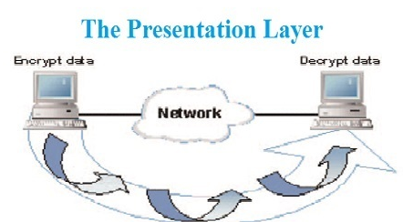

**Application**

**It provides user interface and enables network applications to communicate with other network applications. Examples of Application layer include HTTP, Telnet, FTP (file transfer protocol).**

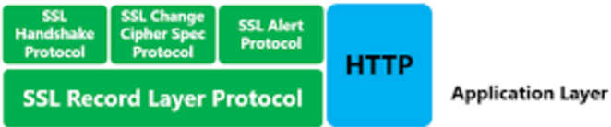

**The seven layer OSI model can be summarized as below**

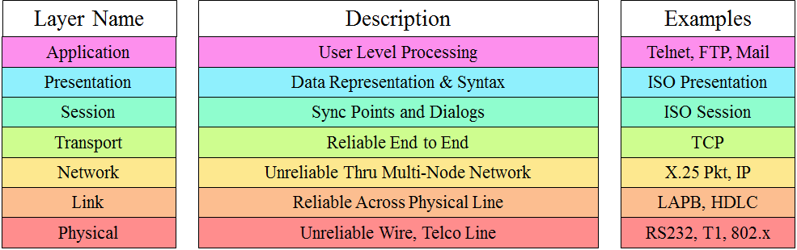

**Layer 2 Versus Layer 3 switching**

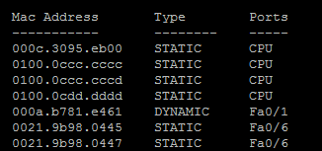**Traditional switching works at layer 2(data Link) of OSI (open system interconnection) where packets are sent to specific port based on MAC address table while routing works at layer 3(Network) where packets are sent to specific next hop IP address based on destination IP address .Devices in same layer2 segment do not need routing to reach the local peers . What is needed is Destination mac address.**

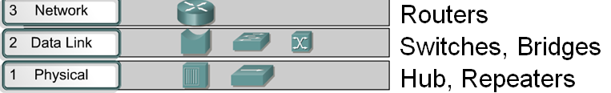

The switches created virtual circuit between two connected devices, establishing a dedicated communication path between two devices. It allows the maximum utilization of the available bandwidth.

Routers are layer 3 devices they are used to route traffic between two or more networks . For example if you want to check how many routers (networks) you packet have passed before reaching the final destination .

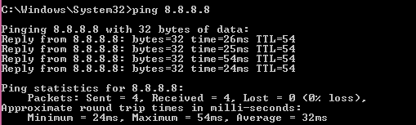

This is very helpful troubleshooting command that helps network administrator to check actually where the problem is occurring. Although ping can also be used to check the layer 3 connectivity but by using this command we can only see either connection is successful or not.

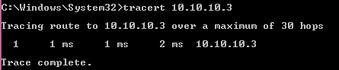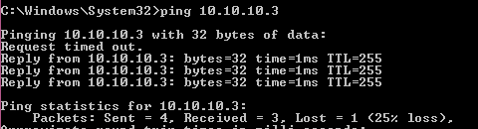

Bridges also works at Layer 2 of OSI model (Data link layer) the purpose is to filter traffic on LAN . Filtering is done based on MAC(media access control) address like Switches if the destination MAC address is already in the MAC(media access control) address it will be only forwarded to that particular host . Bridges maintain the MAC address table for the segments they are connected to .

Quick Quiz

(1) : Which networking device will be used if both hosts are at Different networks?

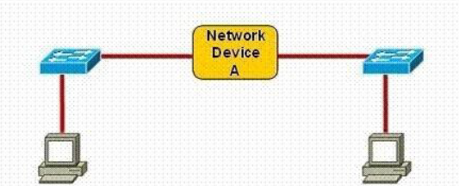

Explanation: it is router which is used to redirect traffic among the different networks so the device being used over here will Be router …

But in case if these PCS are at the same network then we can use either HUB or switch in order for them to communicate.

(2) At which layer of OSI model does routers works?

1. Physical
2. Data link
3. Network
4. Transport

**Network Layer**

**(3)** Which command is used to list down ARP (address resolution protocol) on PC ?

1. Arp –a
2. Show arp
3. Show ip arp interface
4. None of the above

**Answer: ARP –A**