

Please join us for a symposium on

Metabolic and Cardiovascular Disorders

At Foster City, CA on April 24, 2017, 2:30 pm - 5:00 pm PST

Dr. Srinivasan Vedantham
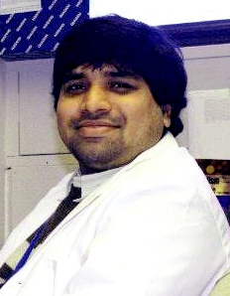
Talk Title: Introduction to Diabetome: A novel clinical database/analytic platform based on 300,000 individuals with diabetes(15 minutes)
Disease Program Lead – Diabetes, MedGenome Inc.

Dr. Srinivasan has a PhD in Biochemistry and Molecular biology and was last associated with Sastra University as Senior Assistant Professor.
Dr. Ravichandran Ramasamy
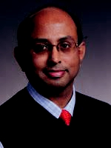
Talk Title: Therapeutic interventions for diabetic complications: challenges and opportunities (30 minutes)
Associate Professor, Department of Medicine, NYU School of Medicine
Dr. Ravichandran Ramasamy’s main focus of research is to understand the metabolic and inflammatory mechanisms underlying diabetic cardiovascular complications. Driven by the complexities of mechanisms that underlie myocardial ischemic injury and heart failure, the goal of his laboratory is to elucidate the importance of AR and AGE-RAGE pathways in mediating ischemic injury, metabolic imbalances, heart failure and diabetic atherosclerosis.
Dr. Chad L. Myers
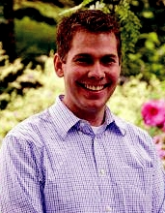
Talk Title: Translating insights from yeast to discover genetic interactions underlying human disease (30 minutes)
Faculty, Computer Science and Engineering, University of Minnesota

Dr. Myers’s research focuses on machine learning approaches for integrating diverse genomic data to make inferences about biological networks. The main purpose of his lab’s work is to further enhance the understanding of gene function and how genes or proteins interact to carry out cellular processes.
Dr. Dharambir K. Sanghera
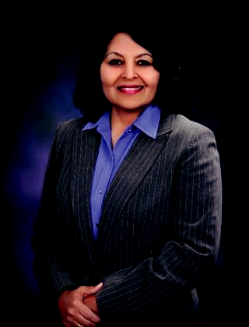
Talk Title: Genome, metabolome and Type 2 diabetes: challenges and opportunities for translational research (30 minutes)
Professor of Pediatrics Genetics, The University of Oklahoma College of Medicine

Dr. Sanghera's research is focused on efforts to understand the interplay between environmental and genetic factors involved in type 2 diabetes, obesity, and cardiovascular disease pathogenesis.
Dr. Noel Burtt
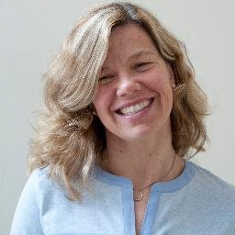
Talk Title: To be confirmed soon (30 minutes)
Associate Director of Operations for Diabetes Research at the Broad Institute

Dr. Noel Burtt is a key player in diabetes work at Broad for over a decade, she manages diverse aspects of major national and international consortia that support Broad's research on Type 2 Diabetes.
Please RSVP by email to: hiranjith.gh@medgenome.com to confirm your participation

 |  |  |  | MedGenome Inc.
 |  | Monday, | 2:30 pm – 5:00 pm PST | 348 Hatch Drive
 |  | April 24, 2017 | 2:30 pm – 5:00 pm PST | Foster City, CA - 94404


Cocktails & Food will be provided

