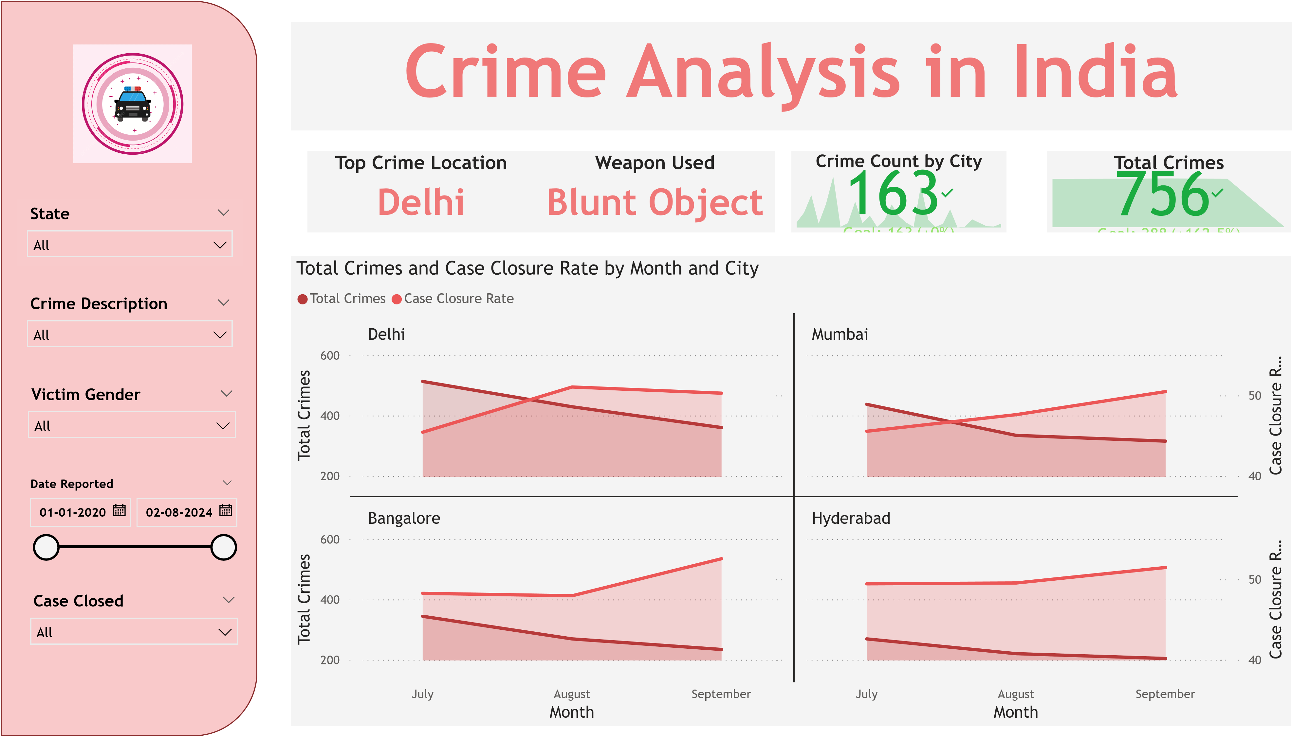

Power BI Desktop

**Crimes by City**

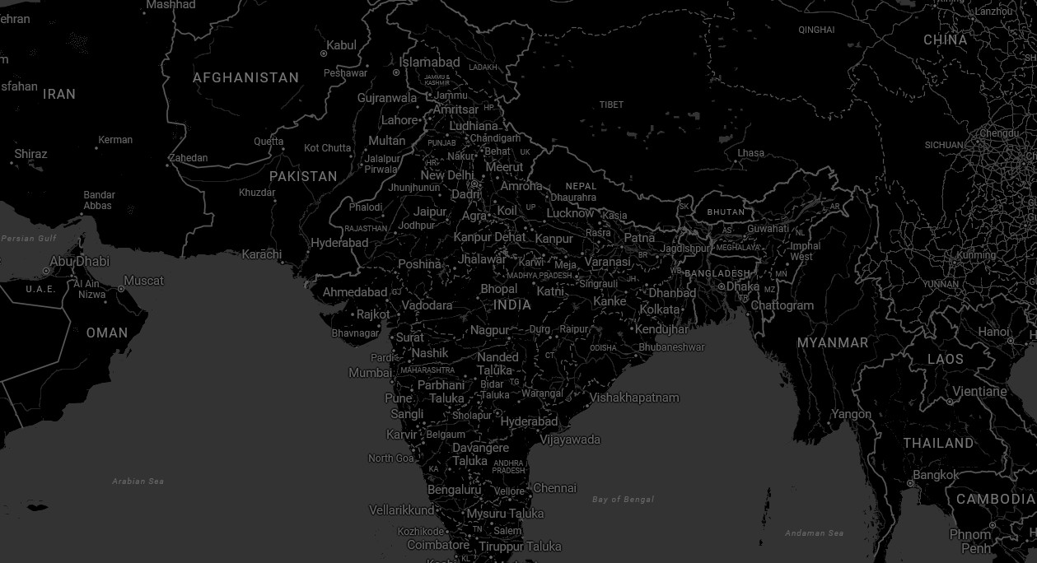

© 2025 Microsoft Corporation

© 2025 Microsoft Corporation