Home Assignment- Thread

1.
child sees i=0/nparent sees i=0?nparent sees i=1?nparent sees i=2?nparent sees i=0?nchild sees i=1/nparent sees i=0?nparent sees i=1?nchild sees i=2/nhiral@hira
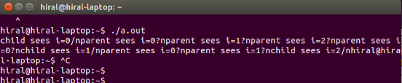

2.
parent saysa:1

id:1 a:2 b:1

id:2 a:3 b:1

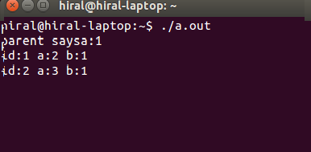

3.1
In some multi-threaded applications, m user-level threads are mapped to n kernel-level threads. This means m number of application threads onto some n number of kernel entities and m can be much higher than n. It means the abstraction of threads presented to user space is implemented using threads in kernel space, with each user thread being represented by a kernel implemented thread. The advantage of using one thread for each task is that we can consume less resource and we also get less context switches, which increases performance. The advantage of user only threading is that we can take advantage of multiple CPUs or multiple CPU cores.

3.2
m>>n relative values of m and n is the mapping a possibility.
m>>n this values or possibility for the relative values of m and n.

