**Mini Project, Python Laboratory – I**

Project By:

Hiral Patel – 16010421071

Adwait Patankar – 16010421070

Problem Statement and Objective:

Create a **Graphical User Interface (GUI)** using **Tkinter** **- Standard Python Interface**, to make the algorithm of **Disease Prediction** much easier and more accessible for the users.

The system should be functional as to **accept the user input** as their **Name** and the **Symptoms (any 3)** the user has been facing.

The system then runs the program which uses **Pandas** and **NumPy** libraries from python and accesses a database/dataset in the form of an excel sheet containing **Prototype** - the symptoms and their possible consequences (diseases). The **symptoms given by the user are trained and as per the accuracy score**, a **disease is predicted**.

Working of the System:

* When we access and run the code, an output window pops up, which is a graphical user interface made with the help of a python library – Tkinter. The page asks the user to input its Name and the user gets to choose any 3 symptoms out of the given drop-down menu.
* Once user has selected the symptoms, the user presses on the “CHECK” button, also made with the help of Tkinter.
* The program stores the prototype file of excel and reads it with the help of Data-Frames, which helps us access the data in the form of tables. We have allotted every disease with a serial number which makes it easier when used for prediction.
* The user input then goes through the random forest classifier where it goes through multiple decision trees and gives an output as the disease-prognosis after data validation.

Importing Libraries:

We use **NumPy** to **ravel** through the sheet, **Pandas** – we use **Data-Frames** to **read and replace** values and **Tkinter** to build a **basic GUI**.

**NumPy:** NumPy is a Python library used for working with arrays. It also has functions for working in domain of linear algebra, Fourier transform, and matrices. NumPy stands for Numerical Python.

**Pandas:** Pandas is an open-source Python package that is most widely used for data science/data analysis and machine learning tasks.

**Tkinter:** Tkinter is the de facto way in Python to create Graphical User Interface and is included in all standard Python Distributions. In fact, it is the only framework built into the Python standard library.

Results:

The interface which pops up as the **Output Window.** Where user can enter their **Name** and **Symptoms.**

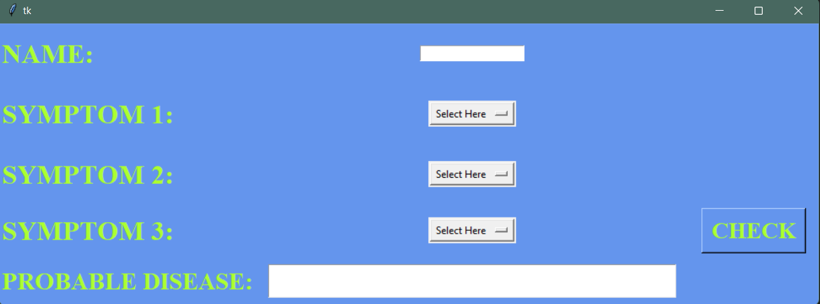

The **Symptoms** can be selected from the **Drop-Down Menu.**

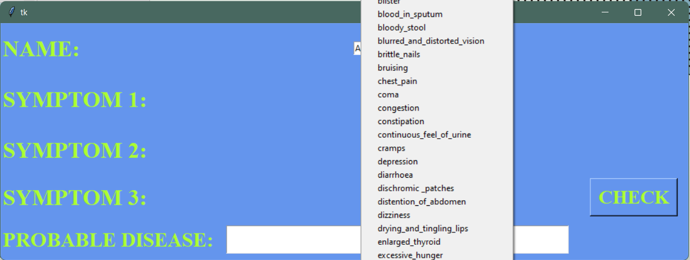

Once the information is **entered**, we can see the **“PROBABLE DISEASE”**

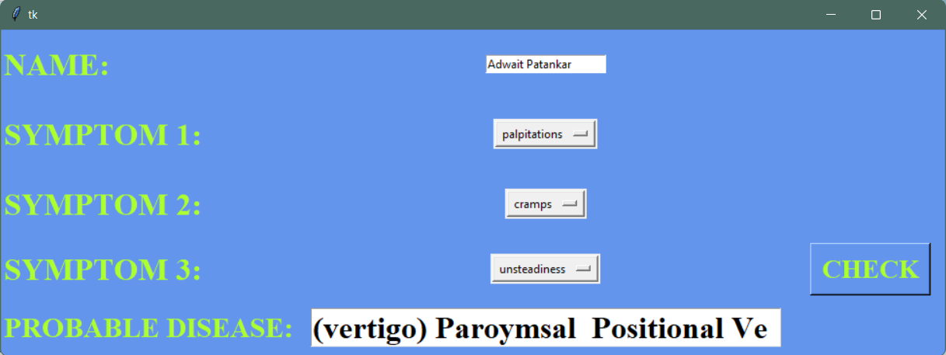

The **Drop-Down Menu.**

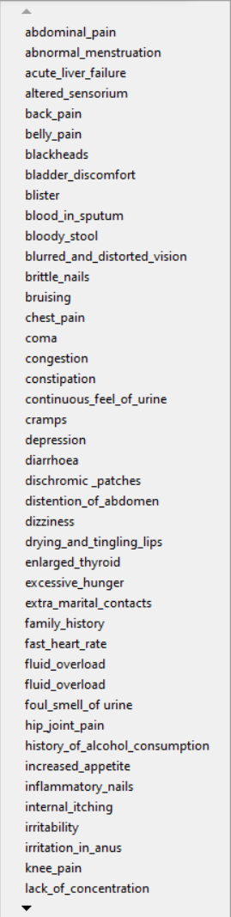

Conclusion:

We learned how to use **Tkinter – Standard Python Interface** as a GUI for the front-end of the mini-project and how to apply our **in class developed knowledge** about python as a language in a real-life **helping mechanism** that is our project of **Disease Prediction.**

The project also helped uslearn and explore **basics of Machine Learning,** using **Random Forest Classification.** We strengthened our grasps on **Pandas** and **NumPy.**

The algorithm and **our logic application** work **optimally** and in favor of the user for **predicting the disease** one might have.

References:

* <https://www.youtube.com/watch?v=v6VJ2RO66Ag&ab_channel=NormalizedNerd>
* <https://scholar.google.co.in/scholar?q=disease+prediction+using+machine+learning&hl=en&as_sdt=0&as_vis=1&oi=scholart>
* <https://www.geeksforgeeks.org/disease-prediction-using-machine-learning/>
* <https://www.kaggle.com/datasets/kaushil268/disease-prediction-using-machine-learning>

**Thank-you!**

PS: Feel free to try out the Disease-Prediction for your own self, hopefully you will find it helpful in self-prognosis at time of need.

GitHub - https://github.com/Hiral25p/Disease-Prediction:))