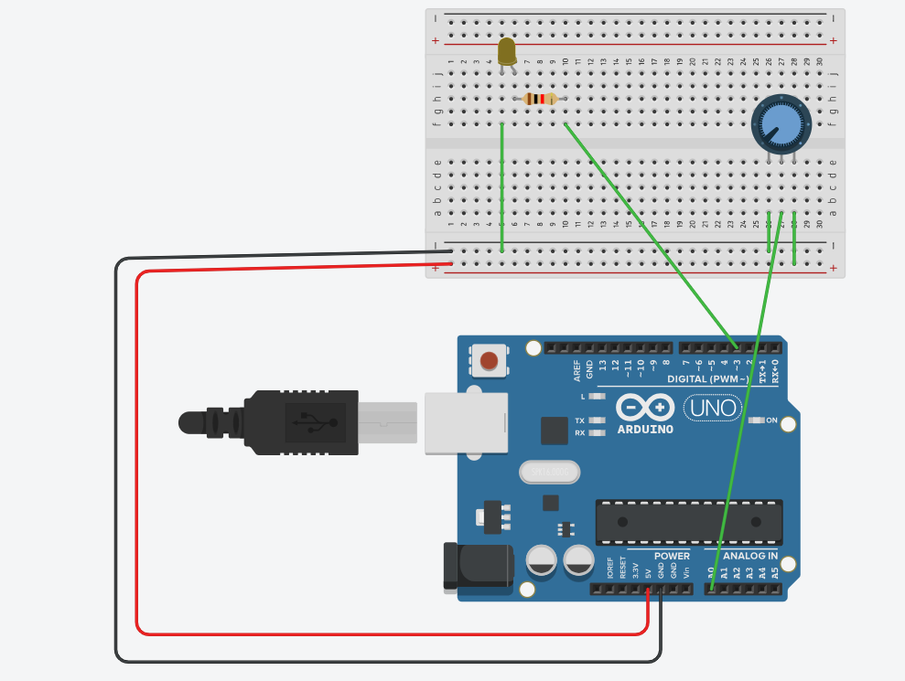

#include <SoftwareSerial.h>
#define LED 3
#define KNOB 0
void setup() {
pinMode(LED, OUTPUT);
Serial.begin(9600);
}
void loop() {
int val = analogRead(KNOB);
int ledPower = map(val, 1, 1024, 1, 255);
String stringOne = "Sensor value: ";
Serial.println(stringOne + ledPower);
analogWrite(LED, ledPower);
}

