FeaGPT: figure-by-figure study and catwalk content mapping
Reference-led preparation for the catwalk manuscript | English working document | 6 October 2026

Reference and reading order
Qi, Y., Xu, R., and Chu, X. FeaGPT: an End-to-End agentic-AI for Finite Element Analysis. arXiv:2510.21993v1 (2025). https://arxiv.org/abs/2510.21993v1
Downloaded reference: reference/FeaGPT.pdf, 21 pages. Read the paper in its original order: Introduction; Methods A–G; Experiments and Results A–G; Conclusions. The mapping below preserves the purpose, arrangement and evidence sequence of each figure while specifying catwalk content.
Reference page previews reproduce the unchanged source pages. Source: Qi, Xu and Chu (2025), FeaGPT, arXiv:2510.21993v1, licensed CC BY 4.0 (https://creativecommons.org/licenses/by/4.0/). The catwalk figure plans and quantitative Figure 4 are new adaptations.

Figure 1 — Workflow architecture (source page 4)
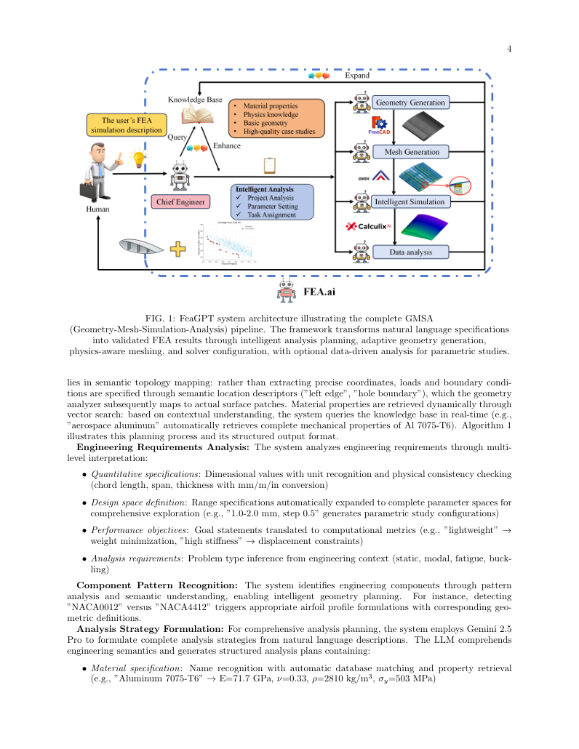
Source page 4: Qi, Xu and Chu, FeaGPT (2025), CC BY 4.0; unchanged page preview.

What the source figure does
A user request feeds the chief engineer/planner; a knowledge base supplies geometry, materials and prior cases; four connected modules perform geometry, meshing, simulation and data analysis. Arrows show both task flow and returned results.

Catwalk panel-by-panel replacement
Keep the left-to-right request-to-result composition and the knowledge block above the workflow. Replace the aircraft request with the catwalk INP set and reference report. Use four module boxes: input/model audit; Gmsh topology reconstruction; nonlinear CalculiX execution; field recovery and report generation. Add the manifest, Skill and benchmark assets above, and the Word/PDF/CSV/VTU outputs at the return arrow.

Data to use
SKILL.md; scripts/run.py; assets/reference/manifest.json; examples/run.json

Draft catwalk caption
Figure 1. Skill-guided workflow for nonlinear static verification of the catwalk cable system, connecting versioned inputs, mesh verification, finite element solution, field recovery and engineering-report generation.

Figure 2 — Geometry and structural detail (source page 12)
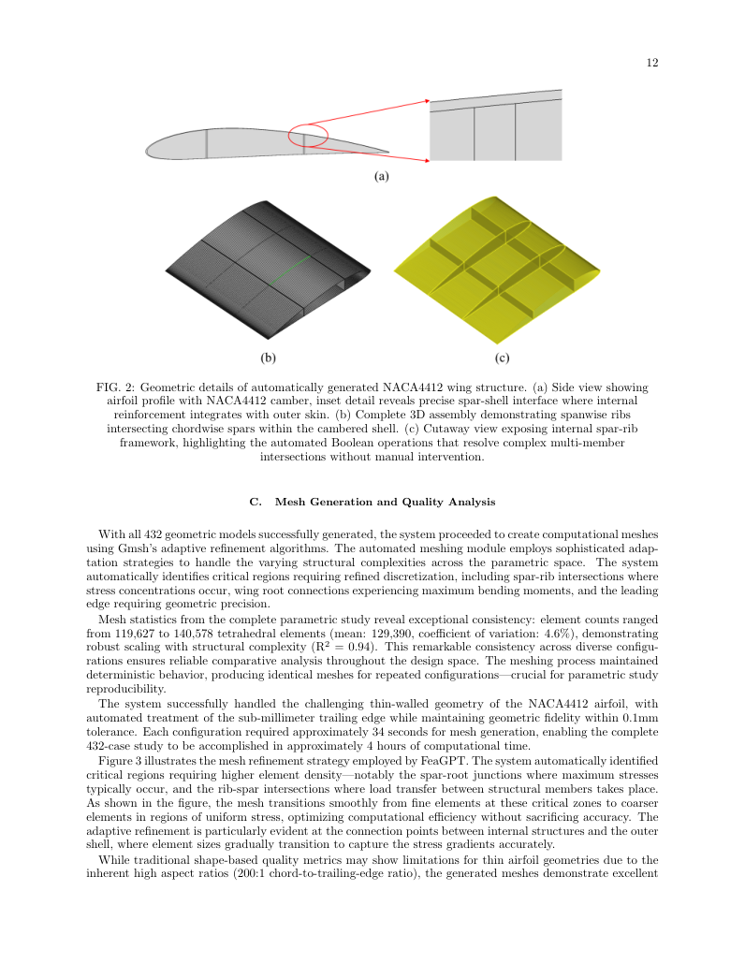
Source page 12: Qi, Xu and Chu, FeaGPT (2025), CC BY 4.0; unchanged page preview.

What the source figure does
Three panels progress from an external wing view with a highlighted detail to a complete assembly and an internal structural view. The red ellipse and arrow connect global geometry to a local feature.

Catwalk panel-by-panel replacement
Retain three panels and the global-to-local zoom. Panel (a): full X–Z catwalk profile and control points. Panel (b): bottom cables, portal cables and equivalent members in three colors. Panel (c): enlarged portal/cable connection with original node and element IDs, material assignments and supports. Draw geometry directly from the INP coordinates.

Data to use
assets/inputs/migrate_P1.inp; scripts/model.py; assets/reference/P1_input_audit.json

Draft catwalk caption
Figure 2. Catwalk finite element model: (a) longitudinal profile and control points; (b) cable families and equivalent members; (c) a portal connection with element assignments and boundary conditions.

Figure 3 — Mesh-to-field correspondence (source page 13)
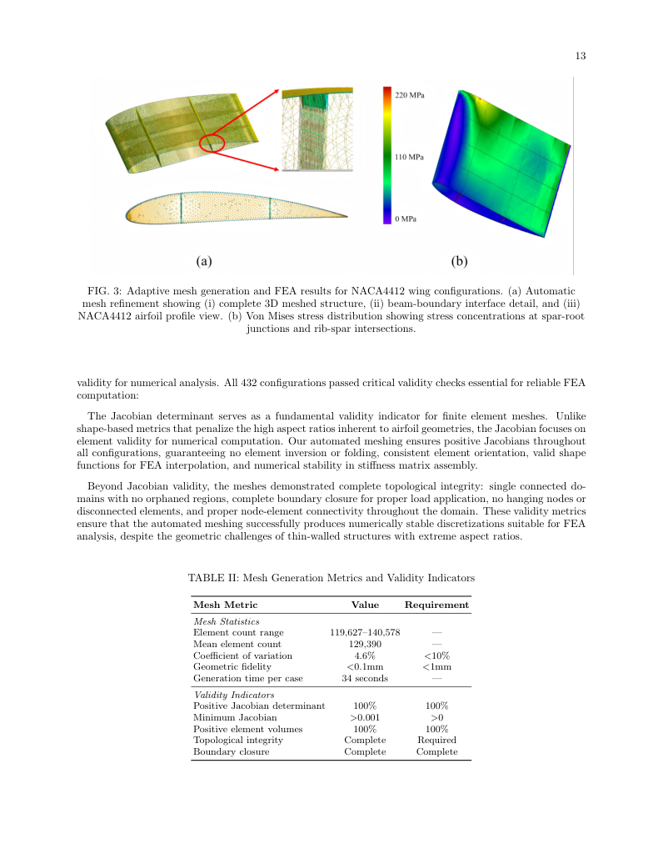
Source page 13: Qi, Xu and Chu, FeaGPT (2025), CC BY 4.0; unchanged page preview.

What the source figure does
A mesh overview and local mesh enlargement occupy the left side; a stress contour occupies the right. The arrangement connects discrete geometry to the solved response.

Catwalk panel-by-panel replacement
Retain the two main panels and inset. Panel (a): original/Gmsh line mesh overlay with an enlarged tag-mapping detail. Annotate 1,125 nodes, 1,194 elements and zero coordinate discrepancy. Panel (b): P5 axial-force line contour using the same geometry; show kN, span group and governing element. Draw only line elements.

Data to use
examples/validated-run.zip: mesh/mesh_map.json and P5 field files; scripts/mesh_gmsh.py; scripts/postprocess.py

Draft catwalk caption
Figure 3. Mesh reconstruction and field transfer: (a) Gmsh mesh and original-input tag correspondence; (b) P5 bottom-cable axial-force distribution on the verified line mesh.

Figure 4 — Four-panel quantitative evidence (source page 15)
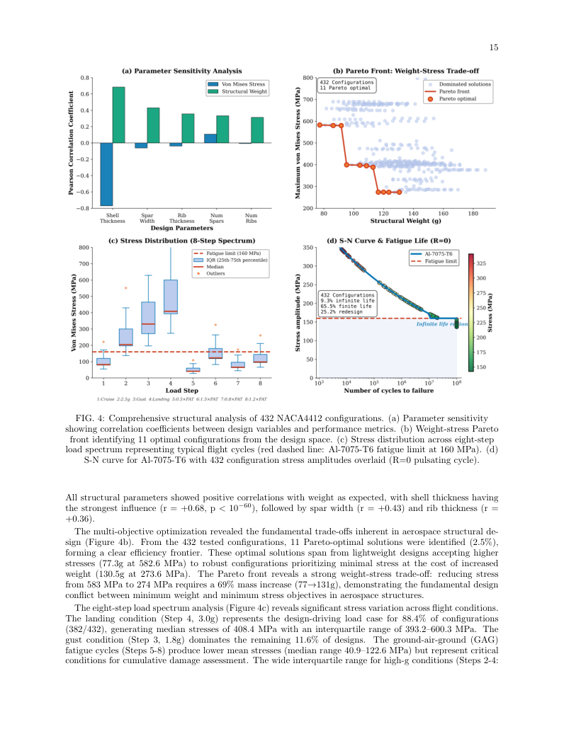
Source page 15: Qi, Xu and Chu, FeaGPT (2025), CC BY 4.0; unchanged page preview.

What the source figure does
The original 2×2 panel layout moves through parameter correlations, a stress–weight Pareto scatter, load-step stress distributions and fatigue-life results. Each panel answers a different quantitative question.

Catwalk panel-by-panel replacement
Keep the 2×2 evidence layout. Panel (a): six-case CalculiX/MAPDL peak-displacement bars. Panel (b): parity scatter for 48 report/calculated span-force pairs, distinguished by cable family. Panel (c): minimum four-span safety factor by family and case with required values. Panel (d): signed relative-error heatmap for six cases × eight span groups. Use the actual summary JSON for every point.

Data to use
examples/summary.json; examples/comparison.csv; figures/figure_4_data.csv

Draft catwalk caption
Figure 4. Six-case verification: (a) maximum displacement compared with MAPDL; (b) 48 span-force comparisons with the engineering report; (c) minimum span safety factors and required values; (d) signed force differences by case and span.

Figure 5 — Grouped field visualization (source page 18)
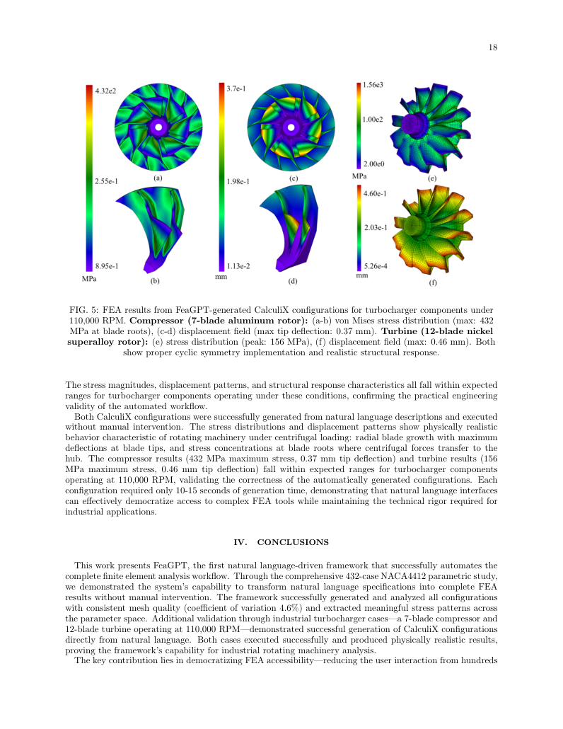
Source page 18: Qi, Xu and Chu, FeaGPT (2025), CC BY 4.0; unchanged page preview.

What the source figure does
Six panels are arranged in three columns and two rows. Compressor and turbine results combine full-component/sector views and stress/displacement fields with independent color bars.

Catwalk panel-by-panel replacement
Keep six panels, arranged as three columns × two rows. Columns: P1 dead load, P5 maximum gust and P6 cooling. Upper row: signed UZ. Lower row: bottom-cable axial force. Use common limits within each field row, label mm/kN, and annotate the relevant extreme node/element. Place all six load cases in supplementary field plates using the same settings.

Data to use
examples/validated-run.zip: P1/P5/P6 nodes.csv, element results and VTU; scripts/postprocess.py

Draft catwalk caption
Figure 5. Representative field responses under dead load, maximum gust and cooling: upper row, vertical displacement; lower row, bottom-cable axial force. Columns correspond to P1, P5 and P6.

Table-by-table and algorithm mapping
Source item | Source function | Catwalk replacement
Table I, p. 11 | Parameter values and configuration count | Six load combinations, step count, temperature and required K; six cases total.
Table II, p. 13 | Mesh statistics and validity checks | Node/element counts, element families, coordinate discrepancy, ordered-connectivity checks and initial-stress record count.
Table III, p. 14 | Solver performance and response summary | Six-case Umax, peak node, signed MAPDL difference, minimum cable factors and measured solver wall time.
Algorithm 1, p. 5 | Structured JSON analysis plan | Manifest-driven task schema and ordered validate/mesh/solve/recover/compare/report stages.

Reading-to-writing sequence
I. Introduction, pp. 1–2 → I. Introduction. Paragraph 1 — Introduce agentic engineering workflows through the sequence used in FeaGPT: language-based task specification, tool execution and computational engineering results. Cite FeaGPT at the transition to finite element analysis.
II.A. System Overview, p. 3; Fig. 1 → II.A. System overview. Describe the four workflow modules and their file interfaces using Figure 1. The assistant reads the English Skill and invokes the packaged tools; each tool produces named, machine-readable evidence.
II.B. Engineering Analysis Planning and Task Orchestration, pp. 3–6; Algorithm 1 → II.B. Skill-guided planning and task orchestration. Replace the reference geometry-design JSON with the catwalk task schema: input manifest, cases P1–P6, solver identity, units, execution stages, comparison criteria and report outputs.
II.C. Intelligent Geometry Generation with Knowledge Augmentation, pp. 6–7; Fig. 2 → II.C. Versioned model reconstruction and engineering knowledge. Describe reconstruction from the original coordinates and connectivity, followed by material/section/support audit. Use Figure 2 to connect global geometry, structural families and a local connection.
II.D. Adaptive Mesh Generation, pp. 7–8; Fig. 3; Table II → II.D. Gmsh mesh generation and identity mapping. Explain point/line creation from INP IDs, section physical groups, setTransfiniteCurve(eid, 2), first-order generate(1), and MSH 4.1 export.
II.E. Automated FEA Simulation and Analysis, pp. 8–9 → II.E. Nonlinear static analysis and load-history execution. Write equilibrium as R(u, λ) = fint(u, σ0, T) − fext(λ) = 0. Describe geometric nonlinearity, initial prestress, gravity and prescribed supports within the planar X–Z system.
II.F. Intelligent Data Analysis and Batch Processing, p. 9 → II.F. Field recovery and automated verification. Define Umax = max sqrt(UX²+UY²+UZ²) over original nodes. Define the deformed chord n and recover N = A0 nᵀ σbar n / 1000 in kN, averaging the eight integration-point tensors.
II.G. Scalable Batch Processing Architecture, pp. 9–10 → II.G. Reproducible batch execution and report generation. Describe independent case directories, common geometry audit, recorded solver commands, failure preservation and per-stage status.
III.A. Natural Language Input and System Understanding, p. 11; Table I → III.A. Task specification and six-case execution. Present the task request and its mapped case/output specification. Table I enumerates the six combinations and required safety factors.
III.B. Geometry Generation Results, pp. 11–12; Fig. 2 → III.B. Model reconstruction results. Report 1,125 original nodes, 1,123 T3D2 cable elements and 71 B31 equivalent members. Show the complete geometry and member assignments in Figure 2.
III.C. Mesh Generation and Quality Analysis, pp. 12–13; Table II; Fig. 3 → III.C. Mesh identity and mapping results. Report identical node/element counts, zero coordinate discrepancy and matching ordered connectivity between the input and the Gmsh mesh. Use the local inset to display the mapping.
III.D. FEA Simulation and Results Analysis, p. 14; Table III → III.D. Nonlinear response and benchmark comparison. Report completion of all six cases and matching peak-displacement node IDs. Present the six numerical rows in Table III.
III.E. Intelligent Result Analysis and Autonomous Design Evaluation, pp. 14–16; Fig. 4 → III.E. Cable response interpretation and safety assessment. Follow the four panels in order: global displacement agreement, span-force agreement, cable safety factors and the spatial/case distribution of signed differences.
III.F. Computational Performance and Scalability, pp. 16–17 → III.F. Execution performance and automation accounting. Report the recorded solver wall times by case and their sum, with Python/platform/solver identity. Label timing boundaries explicitly.
III.G. Industrial Validation: CalculiX Configuration Generation, pp. 17–18; Fig. 5 → III.G. Engineering case presentation and report delivery. Present Figure 5 as the engineering field plate: three representative cases and two response quantities. Compare shared field scales within each row.
IV. Conclusions, pp. 18–19 → IV. Conclusions. Conclusion 1 — Summarize the Skill-guided sequence connecting versioned bridge inputs to mesh verification, nonlinear solution and engineering-report generation.

