Skill-guided agentic finite element analysis for nonlinear static verification of bridge catwalks

Abstract
An executable Skill is developed for nonlinear static verification of the Zhangjinggao Bridge catwalk. The workflow connects versioned finite element inputs, Gmsh mesh reconstruction, CalculiX analysis, cable-force recovery and engineering-report generation. The model contains 1,125 nodes and 1,194 elements and is evaluated under six combinations of dead, construction, wind and temperature loads. Gmsh reproduces the original coordinates and connectivity exactly. Maximum absolute differences from the displacement and cable-force benchmarks are 0.859887%, 0.853551% and 1.125518% for peak displacement, bottom-cable span force and portal-cable span force, respectively. Peak-displacement node identifiers agree in all six cases, and the calculated cable safety factors satisfy the specified requirements. The workflow generates 42 field plots and a Word/PDF calculation report from the shared numerical results.
Keywords: agentic finite element analysis; executable skills; bridge catwalk; nonlinear static analysis; Gmsh; CalculiX; reproducibility.

I. Introduction
Agentic finite element analysis connects engineering task specifications with geometry processing, mesh generation, numerical solution and result interpretation. FeaGPT organizes these operations into an end-to-end workflow supported by engineering knowledge and computational tools [1]. For bridge catwalk verification, the workflow must carry prestress, support definitions and load history consistently from the input model to the calculation report.
The Zhangjinggao Bridge catwalk provides a six-case application involving permanent loads, construction loads, wind and temperature changes. Its verification requires a common treatment of model identity, nonlinear loading and span-based cable-force assessment.
This study organizes the analysis through an executable Skill containing the input manifest, material and load definitions, tool sequence, result checks and report specification. The workflow connects Gmsh mesh reconstruction with CalculiX nonlinear analysis and generates displacement fields, cable-force comparisons and an engineering report from a shared result set.

II.A. System overview
The workflow consists of four modules: input and model audit, Gmsh mesh reconstruction, nonlinear CalculiX analysis, and field recovery with report generation. The Skill specifies each module’s inputs, operations and completion criteria. A versioned asset set supplies the six INP files, engineering-report benchmarks and report-format definitions.
Each case produces a solver log and numerical fields. These fields feed the comparison tables, visualization files and Word/PDF report, preserving the connection between calculated values and their source outputs.

II.B. Skill-guided planning and task orchestration
The task specification identifies cases P1–P6, the input manifest, solver executable, unit system and required outputs. Execution follows the ordered stages in Algorithm 1. Input hashes and model audits are checked before meshing; mesh identity is checked before solution; final-step field completeness is checked before result recovery.
Each case runs in an independent directory. The execution record stores the solver command, return code, elapsed time and warnings, together with the common model audit and final comparison status.

II.C. Versioned model reconstruction and engineering knowledge
The finite element geometry is reconstructed from the original node coordinates and element connectivity. The model contains bottom catwalk cables, portal support cables and equivalent portal members in the X–Z plane. Original entity identifiers link geometry with sections, supports, loads and reporting groups.
The bottom and portal cable materials have an elastic modulus of 120 GPa and equivalent areas of 22298.692 and 8402.9797 mm², respectively. Their assigned densities are 1.26484805e-8 and 8.59881705e-9 tonne/mm³. The equivalent B31 members use an elastic modulus of 206 GPa, a 98.954535 × 98.954535 mm rectangular section and an assigned density of 1.01978381e-17 tonne/mm³.
The initial state combines the supplied geometry with 8,984 global initial-stress records at eight integration points of each of the 1,123 cable elements. These records remain associated with their original elements throughout execution.

II.D. Gmsh mesh generation and identity mapping
Gmsh constructs points and lines from the input coordinates and connectivity. Each original line receives two mesh nodes through setTransfiniteCurve(eid, 2), followed by first-order one-dimensional mesh generation and MSH 4.1 export. Section sets define the physical groups.
Explicit mappings connect Gmsh mesh tags to the original node and element identifiers. Verification checks node and element counts, coordinate differences and the ordered endpoints of every line element.

II.E. Nonlinear static analysis and load-history execution
The static solution satisfies R(u, λ) = fint(u, σ0, T) − fext(λ) = 0, accounting for geometric nonlinearity, initial stress and thermal strain. P1 applies dead load in one step. Each of P2–P6 first establishes its own dead-load state, then applies the target total combination in a second step.
Gravity is 9806 mm/s². The second-step nodal loads include the permanent-load contribution. P5 has a final vertical CLOAD resultant of −6377029.291 N, compared with −4725567.874 N in its first step. P3 and P6 apply temperature changes of −15 and −34°C with a thermal expansion coefficient of 1.2e-5 /°C.
All 1,125 original nodes have UY constrained. The remaining supports follow the input UX and UZ sets. CalculiX 2.23-UCOR6-UCAB3-FT14 solves the six cases using the recorded nonlinear-static controls.

II.F. Field recovery and automated verification
Maximum displacement is evaluated as Umax = max sqrt(UX² + UY² + UZ²) over the original nodes. Cable axial stress is obtained by projecting the mean of the eight integration-point stress tensors onto the deformed element chord. Cable force is recovered as N = A0 nᵀ σbar n / 1000, in kN.
Four bottom-cable groups and four portal-cable groups define the span maxima. The cable safety factor is K = Nbreak/Nmax, using breaking forces of 38080 and 14280 kN, respectively. Required factors are 3.2 for P1, 2.7 for P2/P3/P4/P6 and 2.5 for P5.
Signed relative difference is calculated as 100(qcalc/qref − 1). Displacement comparisons use the independent MAPDL results; span-force comparisons use Tables 1-11 and 1-14 of the engineering report.

II.G. Reproducible batch execution and report generation
The six cases share a common geometry audit and retain separate input copies, solver outputs and result files. Final displacement and cable-stress fields are exported to CSV and VTU. Seven field plots are generated per case.
A common result object supplies the comparison tables and the Word/PDF calculation report. The report uses the prescribed SimSun, SimHei and Times New Roman fonts, four-span calculation tables and field-plot captions. The resulting package contains 42 plots, both report formats and input/output hashes.

III.A. Task specification and six-case execution
Table I lists the six combinations. The case set covers dead load, construction loading, construction wind, maximum gust and two cooling levels. All cases use the same audited geometry, sections, prestress and support definitions.

III.B. Model reconstruction results
The reconstructed model contains 1,125 nodes and 1,194 elements: 1,123 T3D2 cable elements and 71 B31 equivalent members. The original node identifiers, section assignments and 8,984 initial-stress records are retained across the six cases.

III.C. Mesh identity and mapping results
Gmsh reproduces all 1,125 nodes and 1,194 line elements with zero coordinate discrepancy. The mapped, ordered connectivity agrees for every element. Table II summarizes the identity checks linking the original analysis model with its mesh representation.

III.D. Nonlinear response and benchmark comparison
All six nonlinear static analyses reach their final states. The peak-displacement node agrees with the MAPDL benchmark in every case. The maximum absolute displacement difference is 0.859887%; maximum absolute span-force differences are 0.853551% for bottom cables and 1.125518% for portal cables.
P4 produces the largest displacement, 2846.280 mm at node 1176. P5 reaches 1325.314 mm at node 306. The P3 and P6 cooling combinations produce peak displacements of 1897.223 and 927.260 mm. Table III presents the complete six-case response.

III.E. Cable response interpretation and safety assessment
Figure 4 compares the six peak displacements, 48 span-force pairs, minimum cable safety factors and signed span-force differences. Calculated safety factors exceed the required value in every reported case and span.
P6 governs the minimum safety factor in both cable families: 2.9464 for the bottom cables and 3.4677 for the portal cables, against a requirement of 2.7. P5 gives minimum factors of 3.1873 and 3.8802, against a requirement of 2.5.
The P5 load sequence retains the permanent nodal-load contribution in the second-step total. Its resulting vertical displacement at the peak node is −1325.275 mm. The input audit records the load resultants and their application points alongside this response.

III.F. Execution performance and automation accounting
The six solver subprocesses complete in a combined wall time of 9.633834 s. Individual times range from 0.768065 s for P1 to 1.870485 s for P4. Table III reports these timings alongside the case responses.
The execution record identifies the Python environment, operating system, solver hash and case-specific commands. Input audits, mesh mappings and result summaries accompany the timing data.

III.G. Engineering case presentation and report delivery
The field presentation groups P1, P5 and P6 as representative dead-load, maximum-gust and cooling cases. Vertical displacement and bottom-cable axial force provide the two response fields, with consistent units and scales within each field group.
The engineering report presents the calculated four-span forces, reference values, signed differences and safety factors. Its tables and contours derive from the same six-case result set as the machine-readable files.

IV. Conclusions
The executable Skill integrates versioned input verification, Gmsh mesh reconstruction, nonlinear CalculiX solution, field recovery and engineering-report generation for the bridge catwalk.
The reconstructed mesh retains all original coordinates and connectivity. Across six cases, maximum absolute differences are 0.859887% for peak displacement, 0.853551% for bottom-cable span force and 1.125518% for portal-cable span force. All peak-displacement node identifiers match the benchmarks.
The calculated cable safety factors satisfy the requirements for all reported cases and spans. The workflow produces the six-case numerical evidence, 42 field plots and an automatically formatted Word/PDF calculation report.

Table I. Case specification
Case | Combination | Steps | ΔT / °C | Required K
P1 | Dead load | 1 | 0 | 3.2
P2 | Dead + construction | 2 | 0 | 2.7
P3 | Dead + construction + cooling | 2 | -15 | 2.7
P4 | Dead + construction + wind | 2 | 0 | 2.7
P5 | Dead + maximum gust | 2 | 0 | 2.5
P6 | Dead + construction + cooling | 2 | -34 | 2.7

Table II. Mesh and model identity
Metric | Recorded value
Original / Gmsh nodes | 1125 / 1125
Original / Gmsh line elements | 1194 / 1194
Structural element families | 1123 T3D2 + 71 B31
Coordinate discrepancy | 0 mm
Ordered connectivity | All 1194 elements match
Initial-stress records | 8984
Reporting span groups | 4 bottom + 4 portal
Reported-span cable elements | 1113
Original-node planar constraints | 1125 UY constraints

Table III. Six-case response and solver timing
Case | Umax/mm | Node | δU/% | K bottom | K portal | Solver/s
P1 | 42.259 | 304 | -0.7494 | 3.3165 | 4.0135 | 0.768
P2 | 2662.041 | 1176 | -0.8491 | 3.0165 | 3.5671 | 1.777
P3 | 1897.223 | 1176 | -0.6696 | 3.0056 | 3.5574 | 1.822
P4 | 2846.280 | 1176 | -0.8599 | 2.9895 | 3.5268 | 1.870
P5 | 1325.314 | 306 | -0.7830 | 3.1873 | 3.8802 | 1.724
P6 | 927.260 | 1166 | -0.0166 | 2.9464 | 3.4677 | 1.672
Recorded solver wall time summed across six sequential cases: 9.633834 s. Timing source: examples/run.json, executions[].elapsed_s; timing covers the solver subprocess. Run ID: 20261006T174516Z.

Algorithm 1. Skill-guided execution
1. Read task and resolve the versioned six-case manifest.
2. Verify asset hashes and audit material, section, prestress, load and support cards.
3. Regenerate the Gmsh line mesh and verify original-to-mesh identity.
4. For each case P1–P6: copy its complete INP into a new case directory and execute the recorded solver command.
5. Validate final step/time and complete finite U/S fields.
6. Recover deformed-chord cable forces; evaluate span maxima, safety factors and benchmark differences.
7. Write CSV, VTU and seven field plots per case.
8. Generate the Chinese engineering report from the common result object and prescribed style assets.
9. Write execution status and output hashes; return the report and evidence links.

Figure list and captions

Figure 1
Figure 1. Skill-guided workflow for nonlinear static verification of the catwalk cable system, connecting versioned inputs, mesh verification, finite element solution, field recovery and engineering-report generation.

Figure 2
Figure 2. Catwalk finite element model: (a) longitudinal profile and control points; (b) cable families and equivalent members; (c) a portal connection with element assignments and boundary conditions.

Figure 3
Figure 3. Mesh reconstruction and field transfer: (a) Gmsh mesh and original-input tag correspondence; (b) P5 bottom-cable axial-force distribution on the verified line mesh.

Figure 4
Figure 4. Six-case verification: (a) maximum displacement compared with MAPDL; (b) 48 span-force comparisons with the engineering report; (c) minimum span safety factors and required values; (d) signed force differences by case and span.
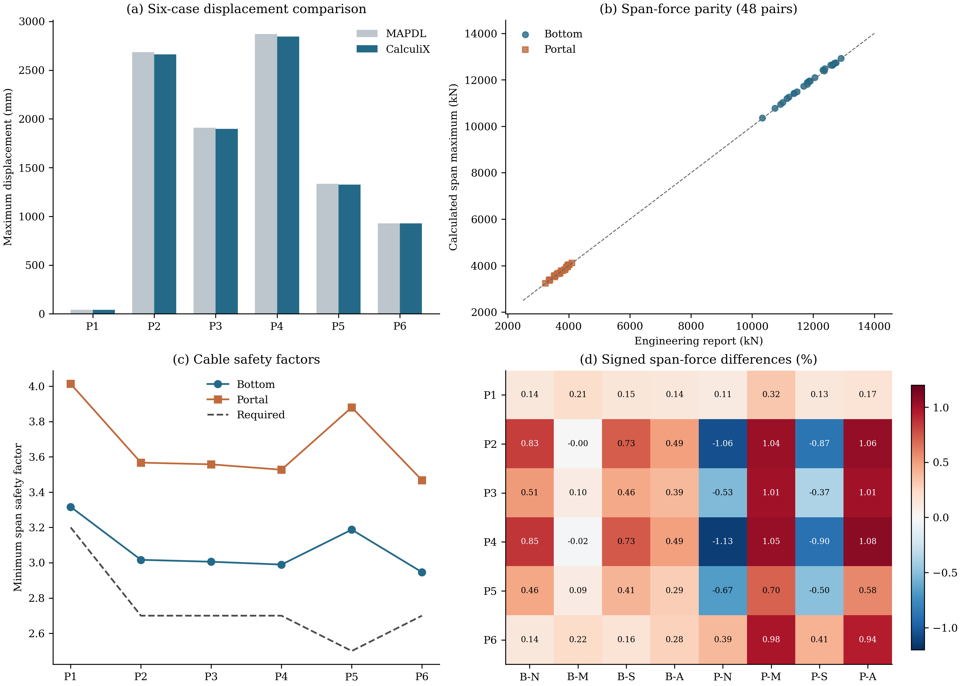
B/P = bottom/portal cables; N/M/S/A = north side/main/south side/south auxiliary span.

Figure 5
Figure 5. Representative field responses under dead load, maximum gust and cooling: upper row, vertical displacement; lower row, bottom-cable axial force. Columns correspond to P1, P5 and P6.

Supplementary material
S1: English Skill, seven execution references, source scripts and environment requirements.
S2: Input manifest, asset hashes, material/load audits and Gmsh mapping.
S3: Complete 48-row span-force comparison and six-case displacement table.
S4: Six-case solver logs, DAT/FRD/STA, CSV/VTU and 42 field plots.
S5: Generated Word/PDF engineering report and typography specification.

References and data provenance
Qi, Y., Xu, R., and Chu, X. FeaGPT: an End-to-End agentic-AI for Finite Element Analysis. arXiv:2510.21993v1 (2025). https://arxiv.org/abs/2510.21993v1
Zhangjinggao Yangtze River Bridge, South Navigation Channel Bridge: Catwalk Structural Review Calculation Report, version 0324, 118 pages. Project-supplied PDF; force benchmarks from Tables 1-11 and 1-14, safety-factor criteria from Table 1-7.
Catwalk static review Skill v1.2.0. Numerical evidence: examples/summary.json, examples/comparison.csv and examples/run.json. Input, solver and PDF identities are recorded in the package manifests.

