Project 1 for MOBI simple PDF.

Isaac Lohnes

Nov 19 / 2018

I chose to work with Google Maps for this project. The requirements were to place three pins on the map and place a circle. For the circle, I did a radius of how far the band “The Proclaimers” would walk, if they would walk 500 miles. I also did a second circle for how far they would walk if they would walk 500 more. Radius assumes the band is starting from Leith and is converted from meters to miles.

As well, I also dropped pins at the estimated location of some interesting areas. I am unwilling to take responsibility for the accuracy of these locations, but this is simply the best guess I had from reading online. If you would like yourself to find Atlantis or the City of Gold, I wholeheartedly welcome you to travel to those co-ordinates and have a quick peek about for your entertainment.

Java snippet from mapActivity:

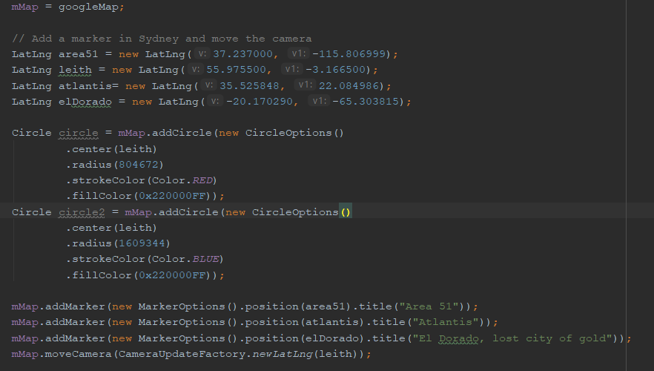

Confirmation that gMaps API Key is properly implemented (Don’t steal it 😉 )



Sample from emulator:

