Project 2, MOBI3002, Isaac Lohnes

**Java:**

Below is onCreate(), which sets up everything needed. I also have a whole bunch of task strings to execute, because I wanted to have a smooth progressbar, instead of skipping. I’m sure there’s a better way to do this, but I struggled implementing a for loop into the execution.

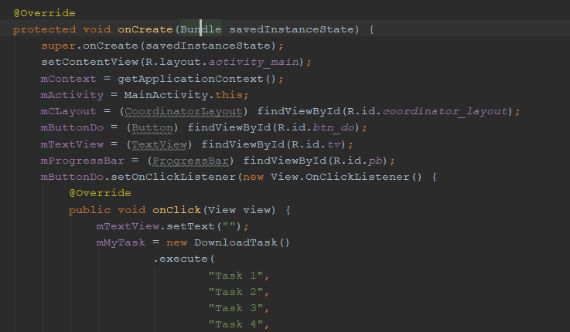

Below is all my methods, which sets up the thread sleep in the background, sets up progress bar/updates it, and processes everything for doInBackground.

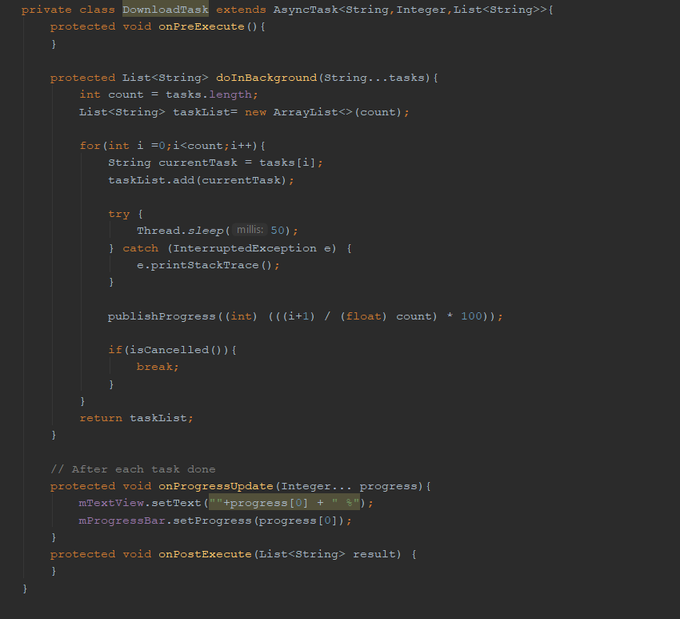

Below is sample output:

