M01

Isaac Lohnes

Prog2500

Mainline:

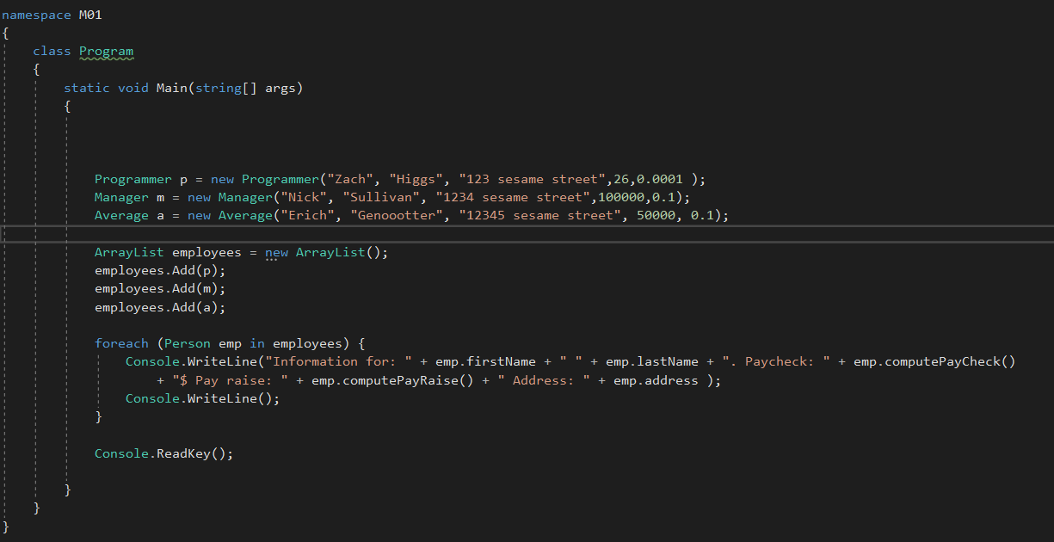

Person:

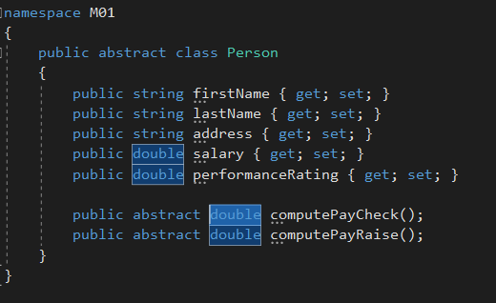

Example subclass of Person:

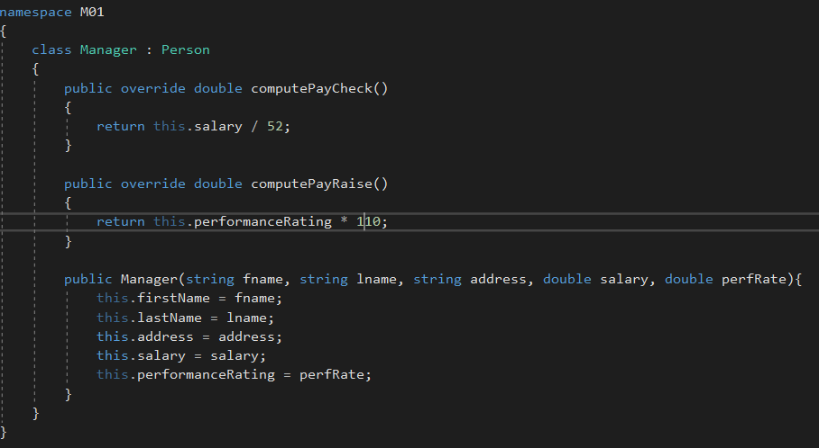

Output:

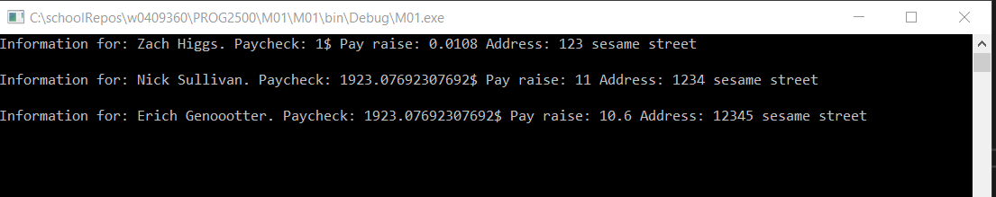

Syntax differences between C# and Java:

-C# uses “using” vs javas “import”

-C# uses “:” vs javas “extends”

-C# uses “Console.WriteLine();” vs javas “System.out.println”

-C# uses “,” vs javas “implements:

C# uses “namespace” to essentially the same effect as Java uses “package”, although there are slight differences