M03 Simple doc

Prog 2500

Isaac Lohnes

Sample output:

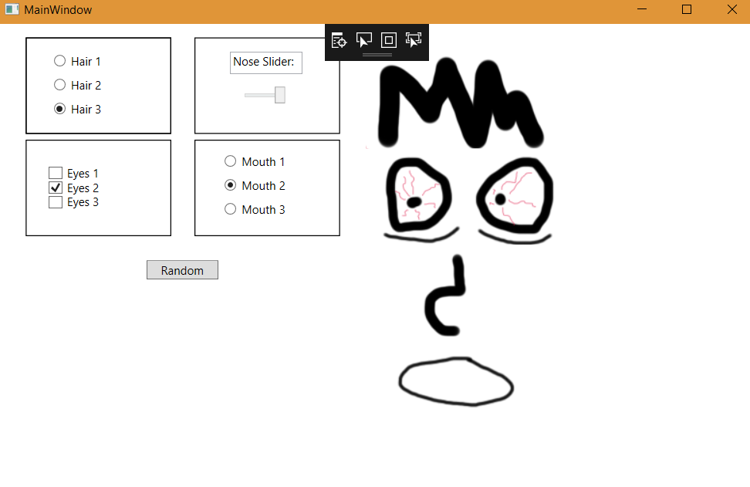

Sample switch case for radio buttons:

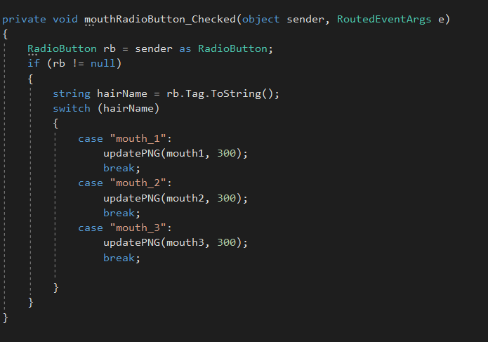

Sample code for slider: 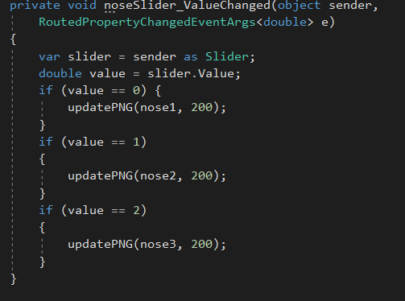

Sample xaml:

