Isaac Lohnes

M02

Prog2500 Simple doc

Below is output:

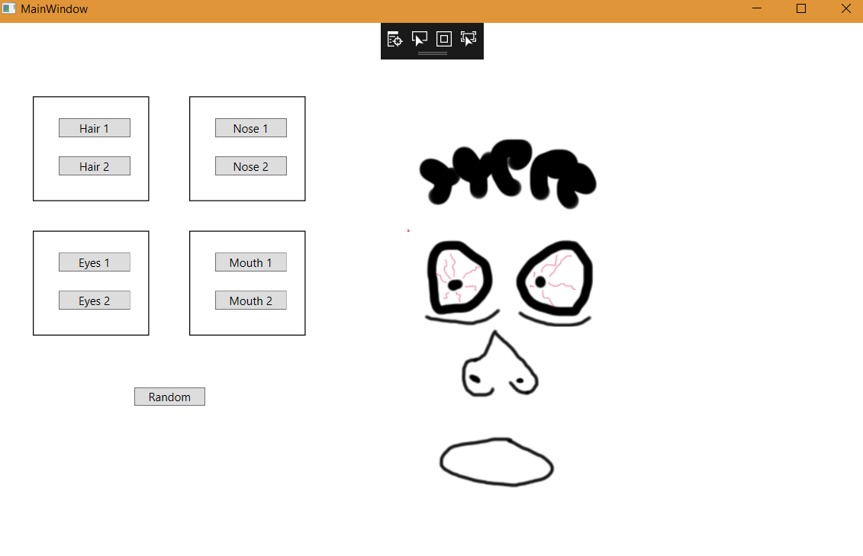

Below is setting up my arrays and bitmap images:

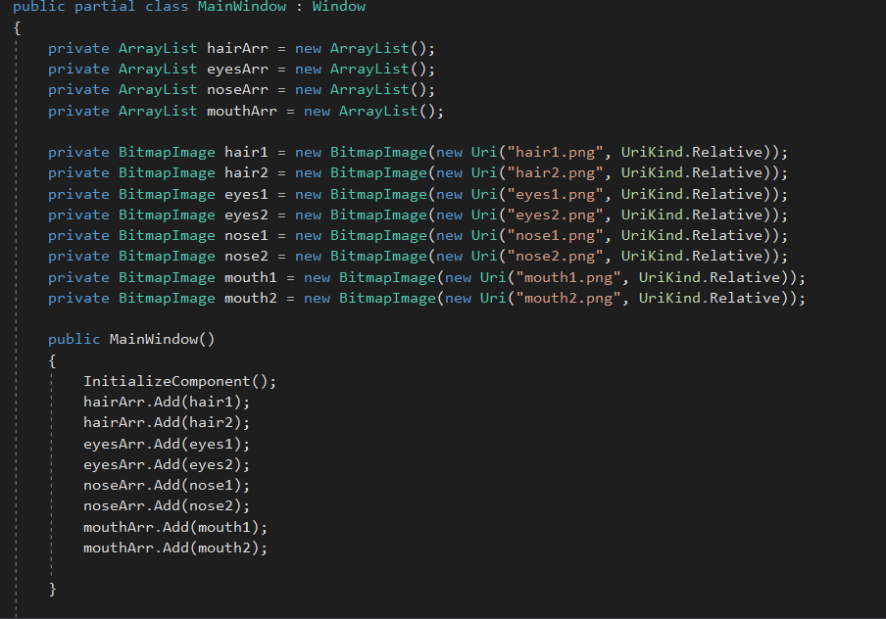

Below is my update function, random function, and a sample click function, all the rest of the click functions are the same, they just take a different image to a different y position. Update function only looks at y position, as all x positions will be at 0.

