M04 Simple Doc

Isaac Lohnes

Prog 2500

Below is what my xaml for menu looks like:

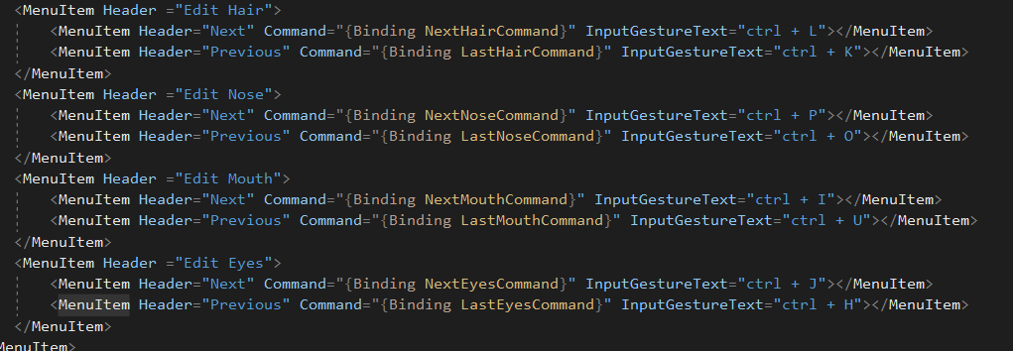

I’ve separated my logic for radio button clicks:

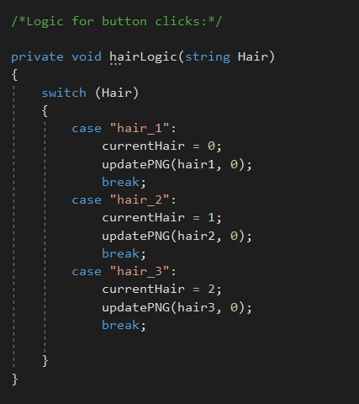

Button checked method now calls <bodypart>Logic() function, snipped below:

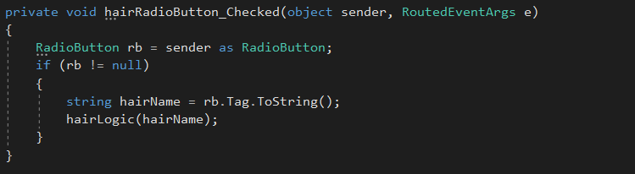

Commands are set to call actions using your supplied CommandHandler class:

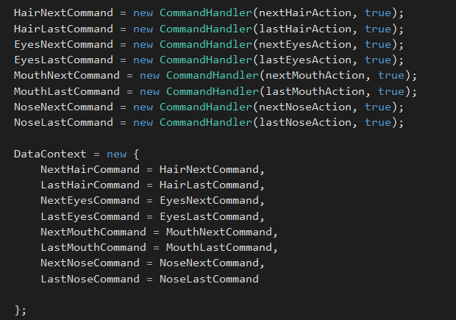

Each action calls nextLoad or lastLoad:

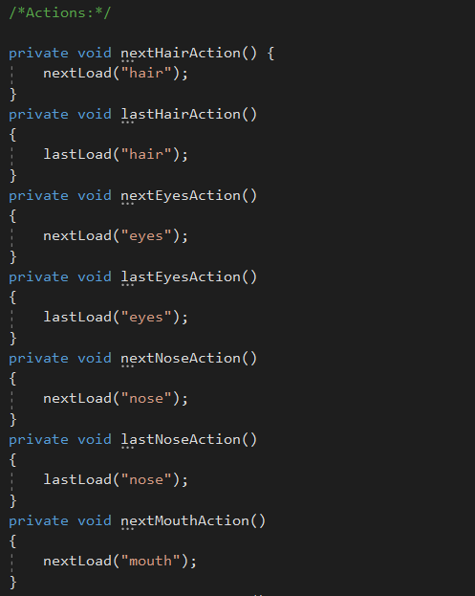

Sample from lastload:

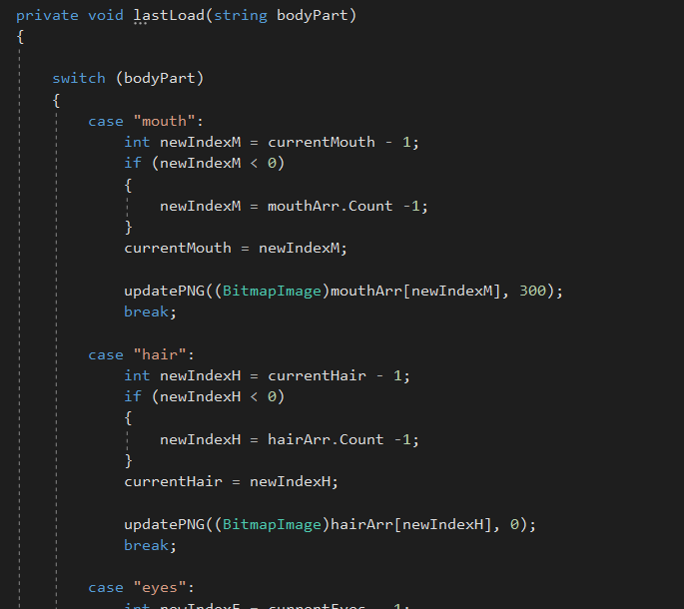

Sample output:

