M05 simple doc

Isaac Lohnes

Prog2500

Code is functionally pretty much the same. I added a new function for working with help:

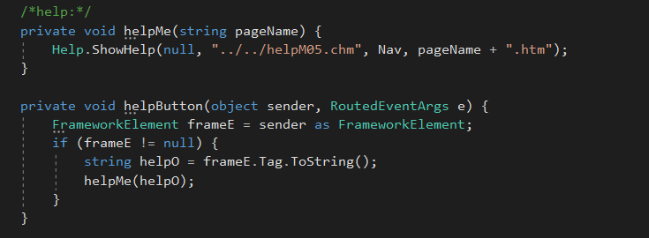

Here is new output:

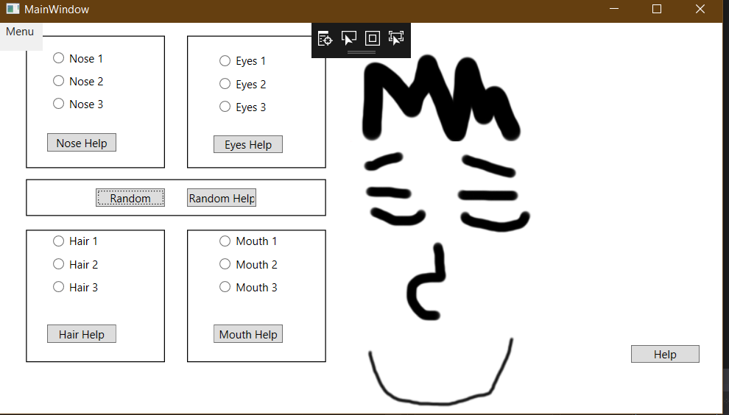

Here is new generated help:

