Android
Project
Documentation
For
M07_Sensors

Author: Isaac Lohnes
Date: Oct 29/2018

Table of Contents
1. Project Overview 1
2. Project Requirements 1
2.1. Derived Requirements 1
3. Android Design Plans 2
3.1. Java Design 2
4. Testing Paragraphs 4

Project Overview

Create bouncing ball with traced trail, that changes with color and has position based off device orientation.

Project Requirements

Create an Android App that uses gravity and touch to draw:

-A "cursor" (a small circle) starts on the screen at a location when the screen is touched.
-The cursor "falls" per gravity, leaving a trail behind it
-If the screen is touched again, the cursor is moved to that new location.
-Add some way to change colours, so the cursor colour can be changed (and the colour of the trail).
.

Show your testing with both screen snippets of the Android change, and emulator result (and catlog output if applicable). How you demonstrate what you did, shows what you understand about what you did.

Derived Requirements

Student has a deeper understanding of how android reads from device sensors, and how to work with classes in android studio.

Android Design Plans
Design plans were already complete by Russ, no modifications to Android XML. Changes were entirely in java classes.

Java Design
A new Cursor class was required. Cursor class included all elements from Russ’s “ball” class, as well as some new methods, captured below:
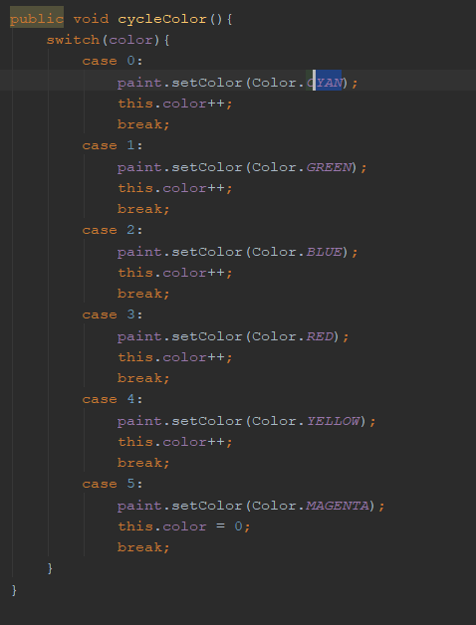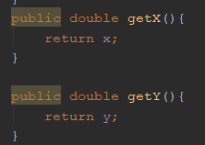

cycleColor used a counter “color” to run a switch, that would cycle through various colors to set the Cursors too. Each cursor had their own individual “color” counter, and cycleColor was called at ontouch, so that each time the position of the moving cursor was changed, a new set of colored cursor trails followed it, and each old trail incremented and changed color.

The two getters seen above were used to create the trail effect. Essentially, while the cursor array was under the limit of cursors on screen, a new cursor with no speedX or speedY was added where the cursor that was moving just was.

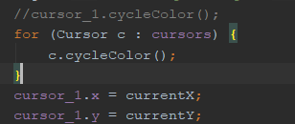

Pictured above is inside of ontouch. Essentially, the only real modification I made was to make cursor_1 move to where the screen was touched, and make all the trail cursors change color.

Testing Paragraphs
Below is screenshots from testing on my personal Pixel 2. As you can see, there is a trail following the first cursor. In the right snip you can also even see where the purple and cyan trails started, which shows that the ontouch is working correctly.

It looks pretty nifty I’d say.

