Android
Project
Documentation
For
M08 Intents

Author: Isaac
Date: Nov 5 / 2018

Table of Contents
1. Project Overview 1
2. Project Requirements 1
2.1. Derived Requirements 1
3. Android Design Plans 2
3.1. Sequence diagram 2
3.2. Java Design 3
4. Testing Paragraphs 4

Project Overview

Create drawable view in android, and set background to image selected by user.

Project Requirements

Your application takes a picture from the Android photo gallery and uses that picture as a bases for drawing.

-A blank screen can be drawn on at first (simple draw, just a line from a touch-drag, maybe a series of dots?).

-A picture can be imported via intents, from the photo gallery (you'll need to get some kind of picture in the gallery.

-The picture is the background, and you can draw on top.

-The image need not be saved.

-Create a suitable sequence diagram.

Derived Requirements

Student has a deeper understanding of intents and working with Android studio

Android Design Plans
UML must be edited to show button to launch intent.

Sequence diagram
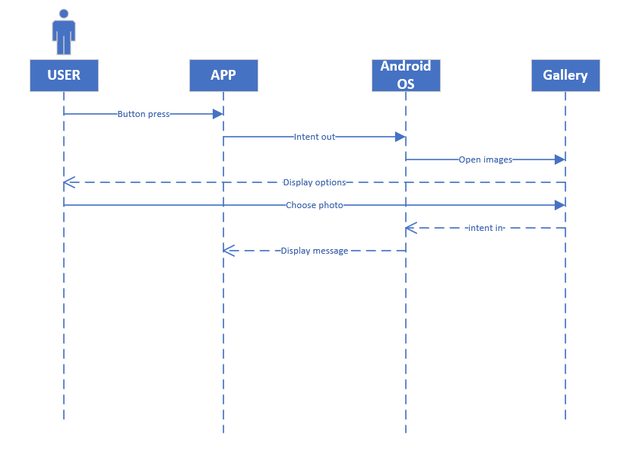.

Java Design

Below is new onCreate, showing new button, which has an onclick to launch the intent to get photo. Other then that, I mostly just modified my code from sensor.

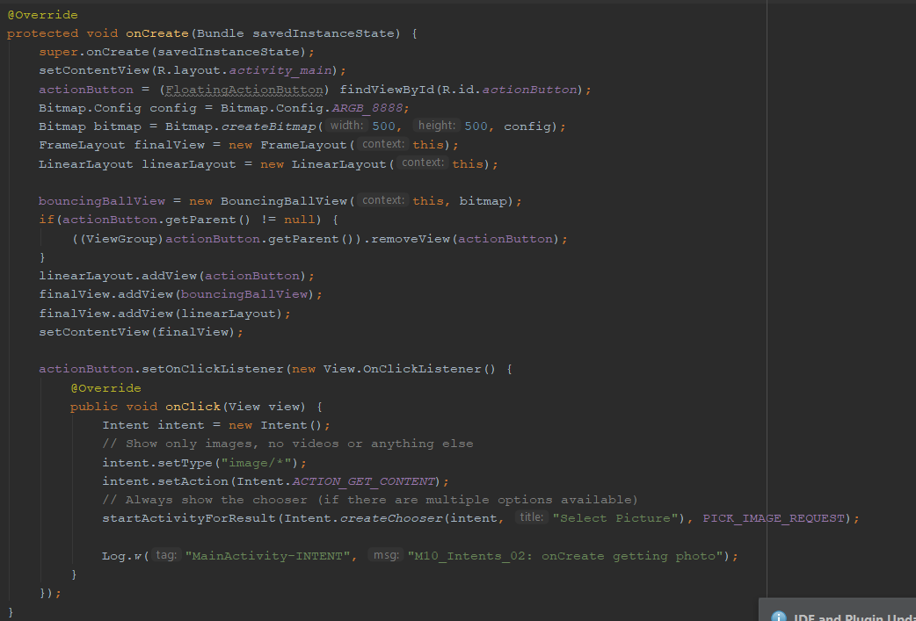

Testing Paragraphs
Below you can see on the left is the image I’ve chosen on my phone, and on the right is when the application launches, no image is present and there is a button to launch the intent.

