Project
Documentation
For
M05_Collisions

Author: Isaac Lohnes
Date: Oct 30 / 2018

Table of Contents
1. Project Overview 1
2. Project Requirements 1
2.1. Derived Requirements 1
3. Design Plans 2
3.1. UML 2
4. Implementation 2
4.1. Implementation in vehicle 2
4.2. Implementation in drawHere 4
5. Testing Paragraphs 6

Project Overview

Create collisions for vehicles assignment, and create junit tests for collision tests.

Project Requirements

Support Land and Air Vehicle collisions:

-Land vs Land ... on collision, rebound
-Air vs Air ... on collision, both crash down to the ground, and now can be collided with a land Vehicle.
-Land vs Fallen Air ... (Air Vehicles that have collided and hit the ground). Land vehicle either rebounds or crashes....your choice.

Perform a Unit Test on your Collision method(s).

-Set up JUnit for your collision code (refactor is necessary, so that you have a method that returns a Boolean)
-Run enough tests to perform full path testing

Derived Requirements

Student has further understanding of junit and constructing hitboxes for java objects.

Design Plans
I plan to implement a collision method, which checks vehicle types to decide what to do if two objects have the same hitbox.

UML
UML diagram shows modified class structure for vehicles assignment:
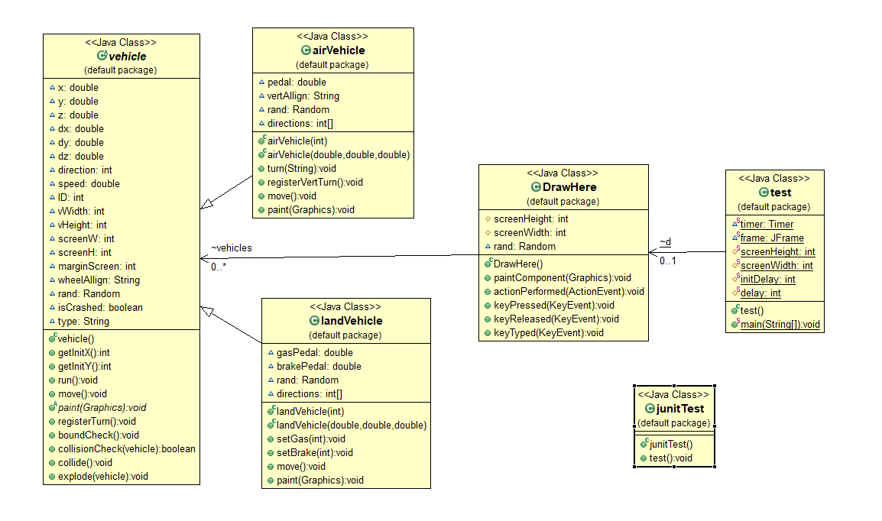

Implementation

Implementation in vehicle
Seen below is first method in vehicle, which checks if two vehicle objects have the same position. Also checks if vehicle == vehicle, as since this is called on every vehicle, we don’t want them to constantly switch directions if it checks against itself.
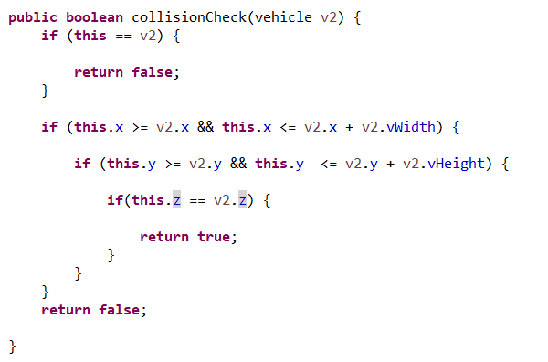

As well, we also have two different methods to call if collision returns true. One simply inverts both vehicles directions, causing a bounce, and the other causes both vehicles to stop, but still stay on map, which can cause fun little pile ups.

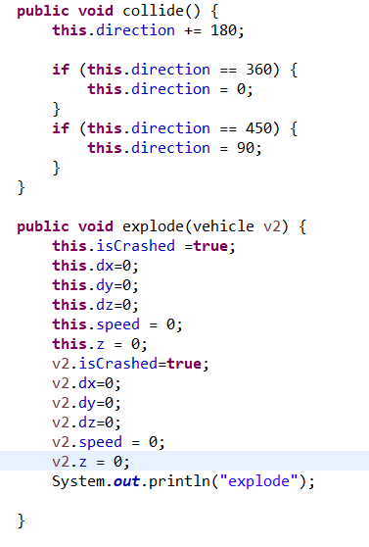

Implementation in drawHere
As you can see below, all vehicles in the vehicles array are compared against all other vehicles in vehicles array.
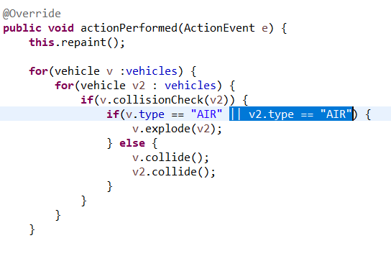

Testing Paragraphs
Below is junit testing, showing a variety of checks, with comments explaining what each check is testing.
