Project
Documentation
For
M09

Author: Isaac Lohnes
Date: Nov 4 / 2018

Table of Contents
1. Project Overview 1
2. Project Requirements 1
2.1. Derived Requirements 1
3. Theory response 1
4. Implementation 2

Project Overview

Add support for second input device to java project.

Project Requirements

Vehicles with 2nd input device

...continue from your Vehicles assignment.......

Add a button (or another approach, keystroke, mouse-wheel,...) that adds Vehicles .

Add a button (or another approach, keystroke, mouse-wheel,...) that removes Vehicles (either random, or the Vehicles under the mouse, or some other method)

Derived Requirements

Student is more comfortable working with a variety of input devices, and has a better understanding of theory.

Theory response
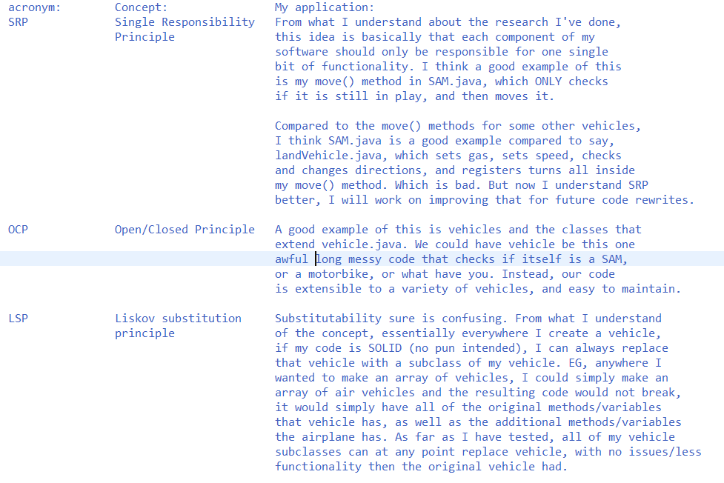
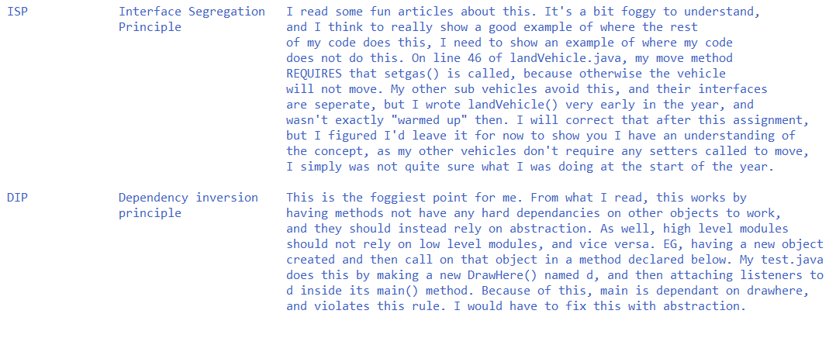

Implementation
