Sales Data Analysis Report
Analyzes sales performance using Python and Pandas

Dataset Infromation
Total Rows:12

Business KPIs
Total Sales :120700
Total Profit :135500
Total Revenue :256200

Revenue Chart
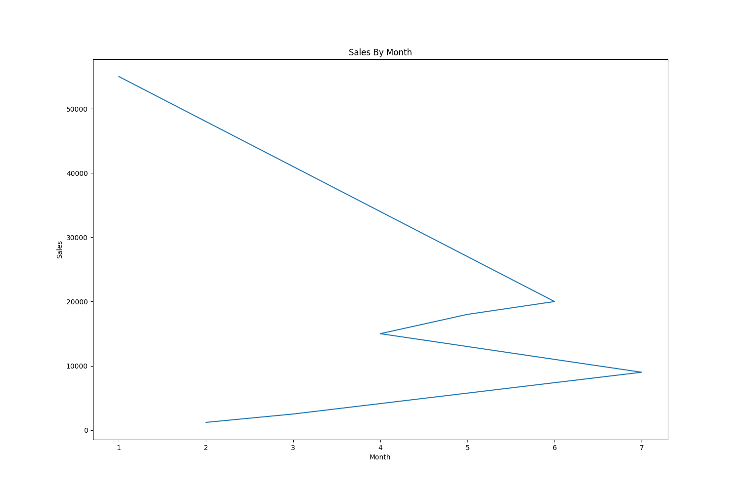
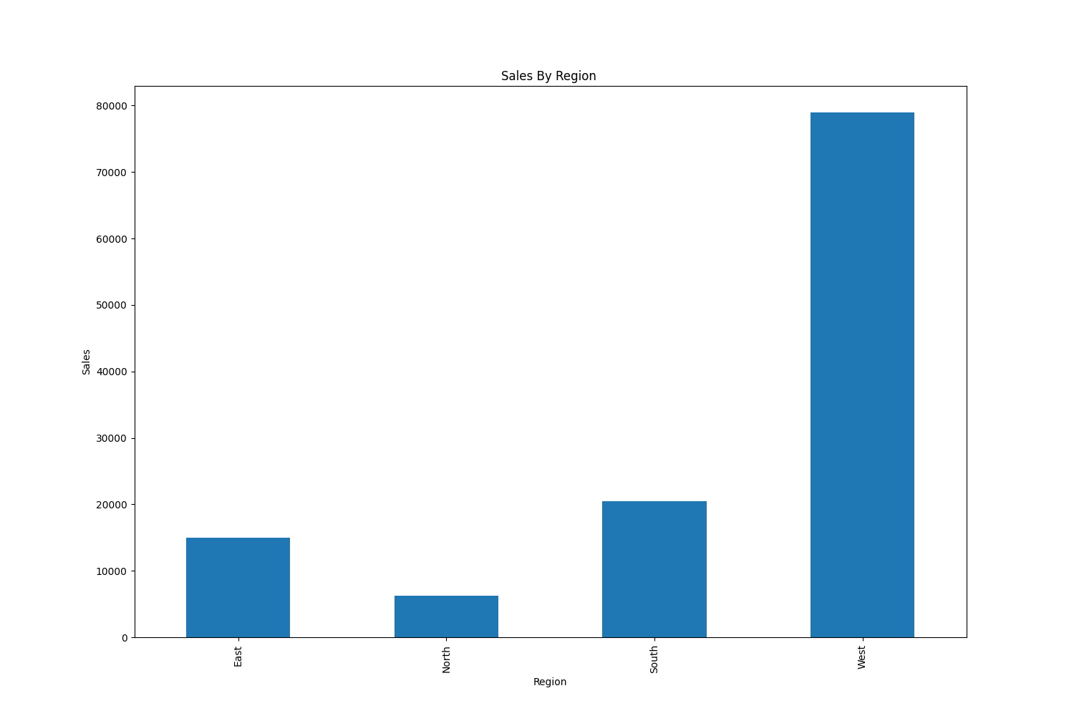
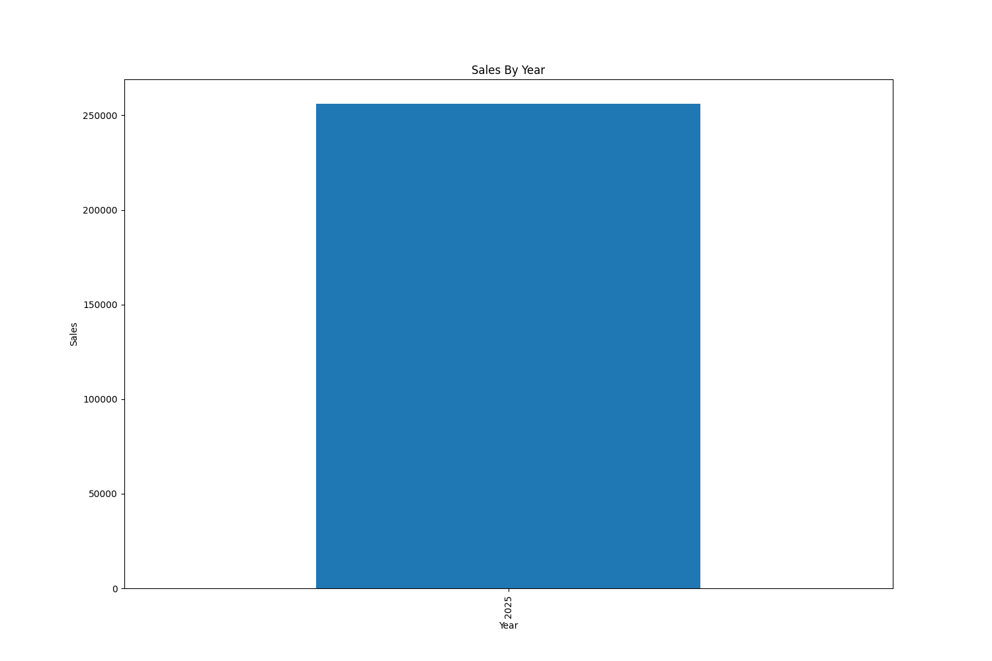

Conclusion
Business sales performance was analyzed successfully

