**TATVASOFT (SQL)**

**Assignment:-3**

**DEPARTMENT TABLE**

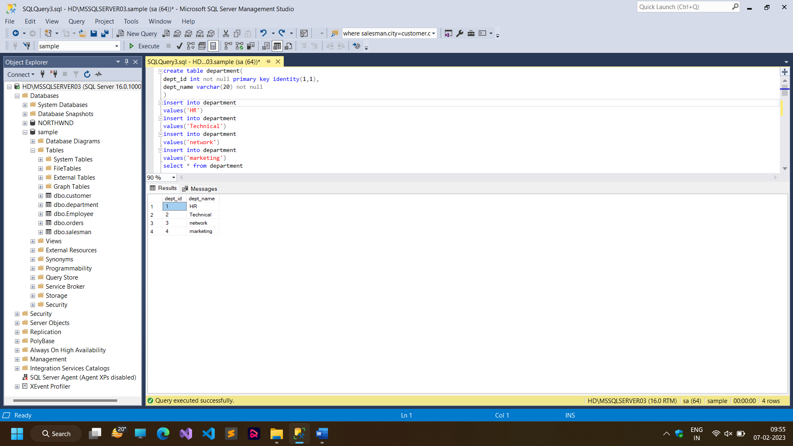

**EMPLOYEE TABLE**

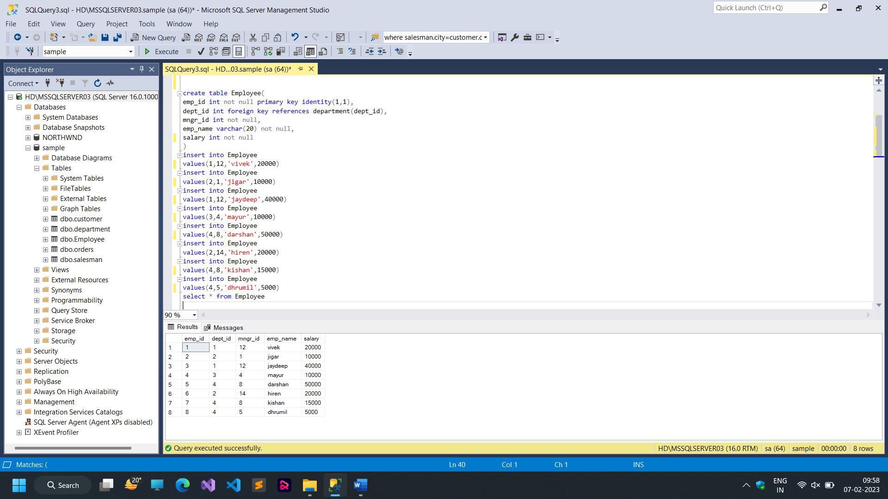

**Q:- 1**

**write a SQL query to find Employees who have the biggest salary in their Department**

**SCREENSHOT:-**

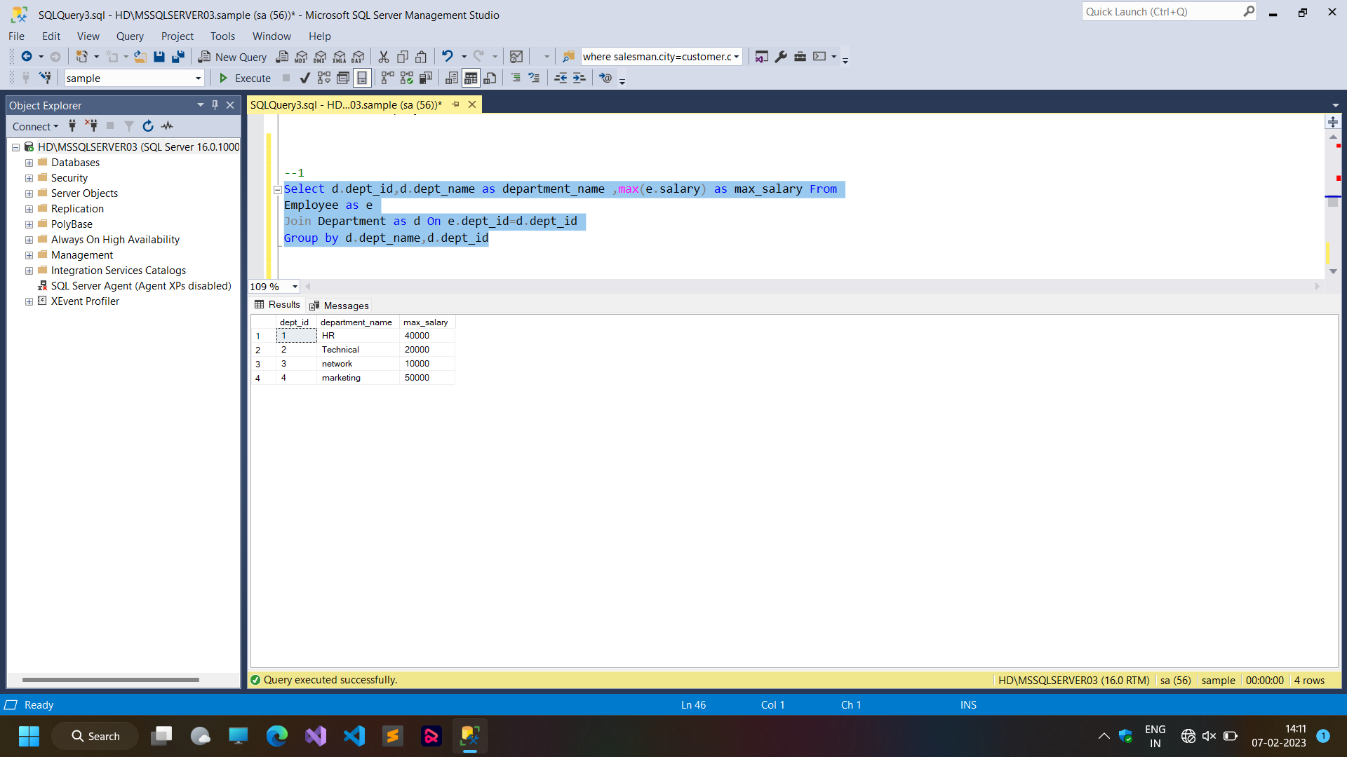

**Q:- 2**

**write a SQL query to find Departments that have less than 3 people in it**

**SCREENSHOT:-**

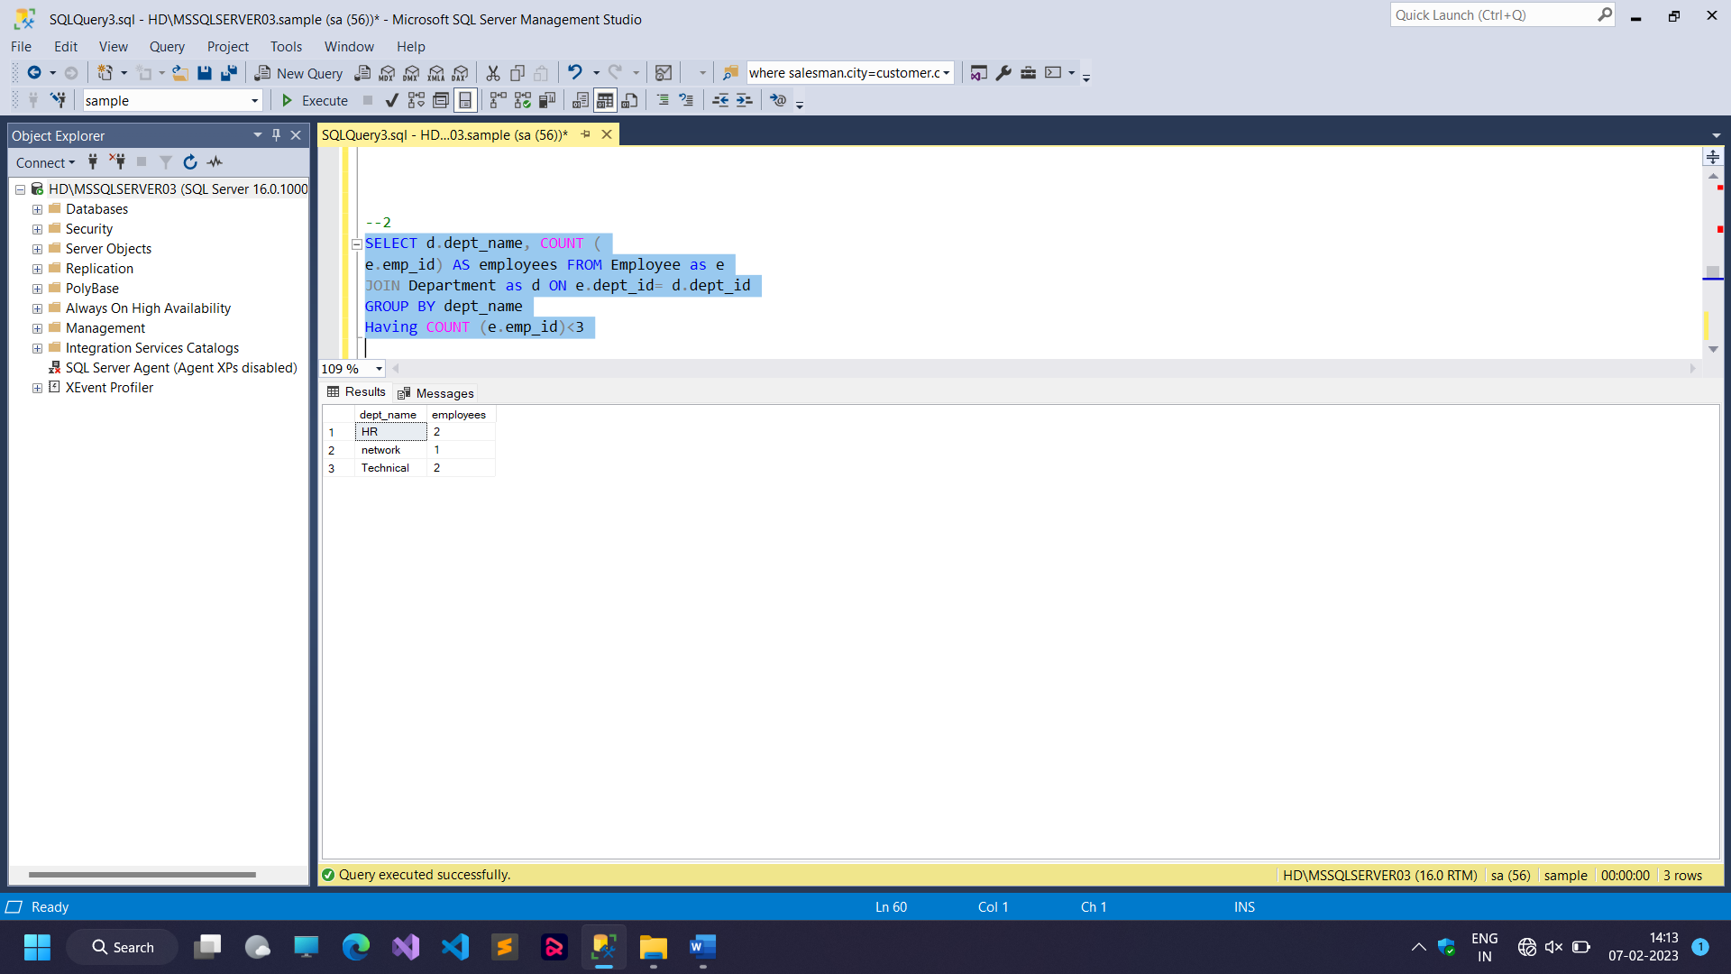

**Q :- 3**

**Write a SQL query to find All Department along with the number of people there**

**SCREENSHOT :-**

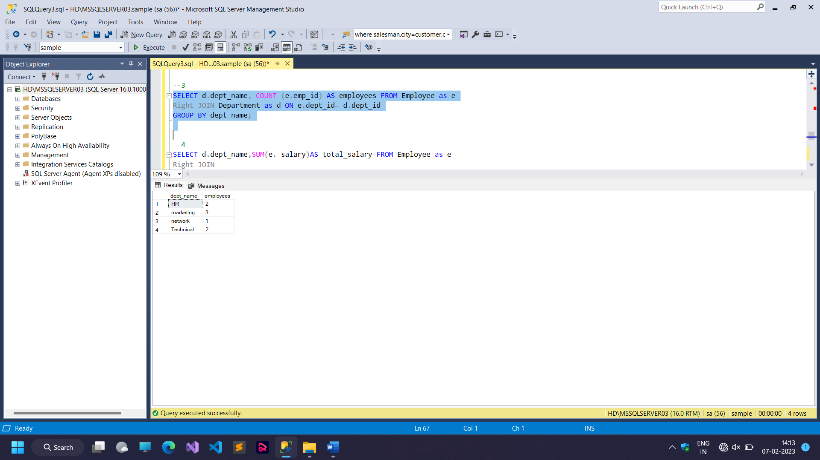

**Q :- 4**

**write a SQL query to find All Department along with the total salary there**

**SCREENSHOT :-**

