**TATVASOFT (SQL)**

**Assignment:-1**

**FULL DATABASE**

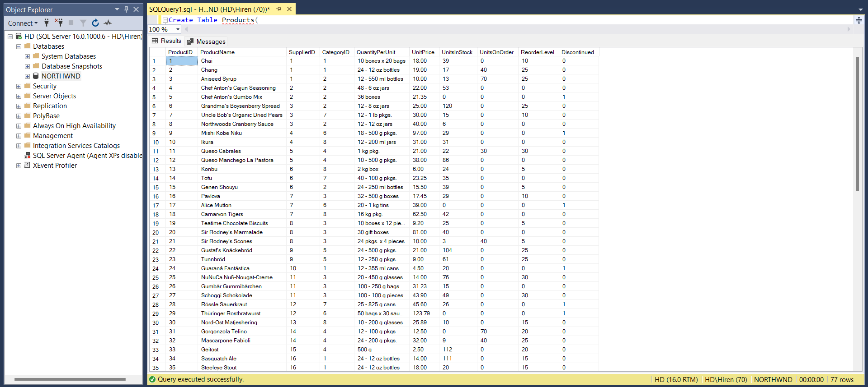**ScreenShot :-**

**Q:- 1**

**Write a query to get a Product list (id, name, unit price) where current products cost less than $20.**

**Query:-**

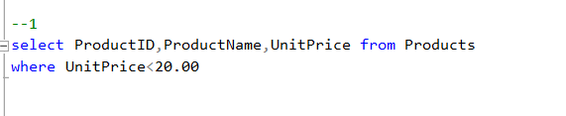

**OUTPUT:-**

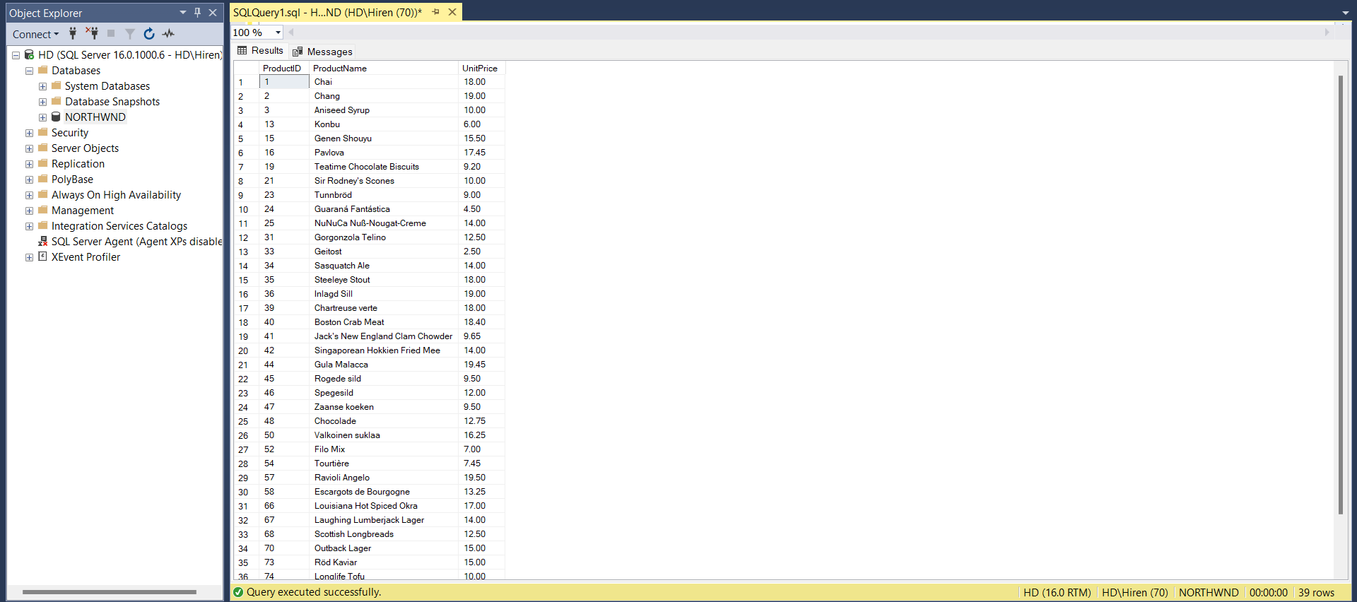

**Q:- 2**

**Write a query to get Product list (id, name, unit price) where products cost between $15 and $25**

**Query :-**

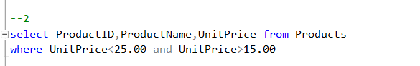

**Output :-**

**Q :- 3**

**Write a query to get Product list (name, unit price) of above average price.**

**Query:-**

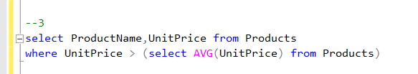

**Output:-**

**Q :- 4**

**Write a query to get Product list (name, unit price) of ten most expensive products.**

**Query :-**

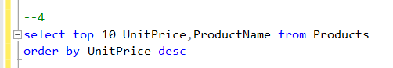

**Output :-**

**Q :- 5**

**Write a query to count current and discontinued products.**

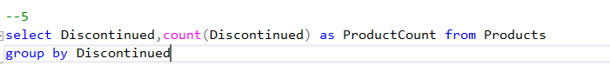**Query :-**

**Output :-**

**Q :- 6**

**Write a query to get Product list (name, units on order , units in stock) of stock is less than the quantity on order.**

**Query :-**

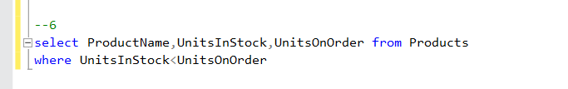

**Output :-**