Date : 04-08-2021

Session : basic introduction regarding HTML and GIT

Task given : Create github account and upload code.

My Task : Today , I have learn basic git and github and learn about HTML languages and upload all file in GITHUB.

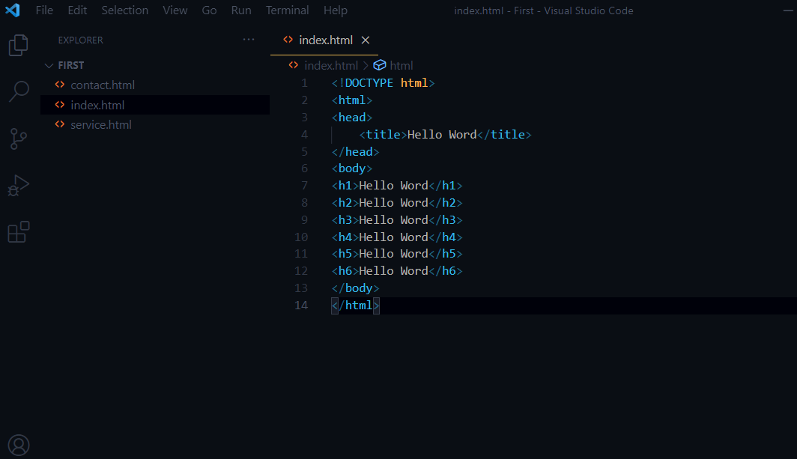

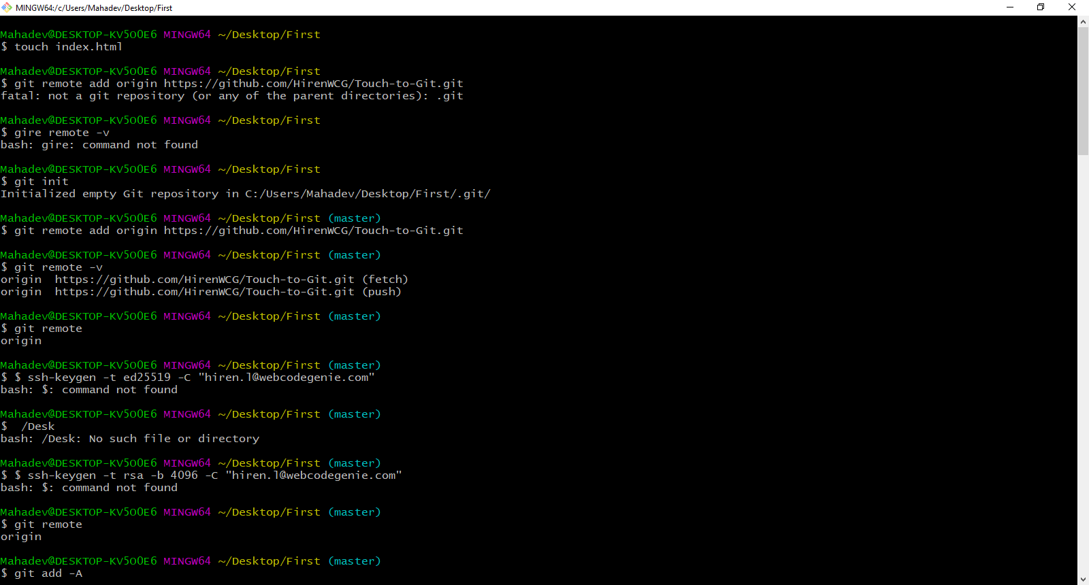

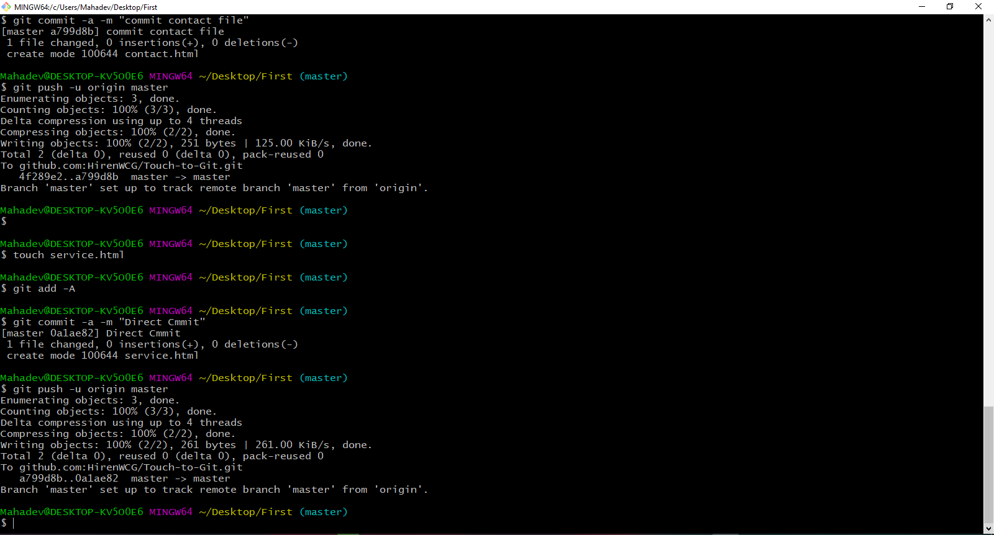

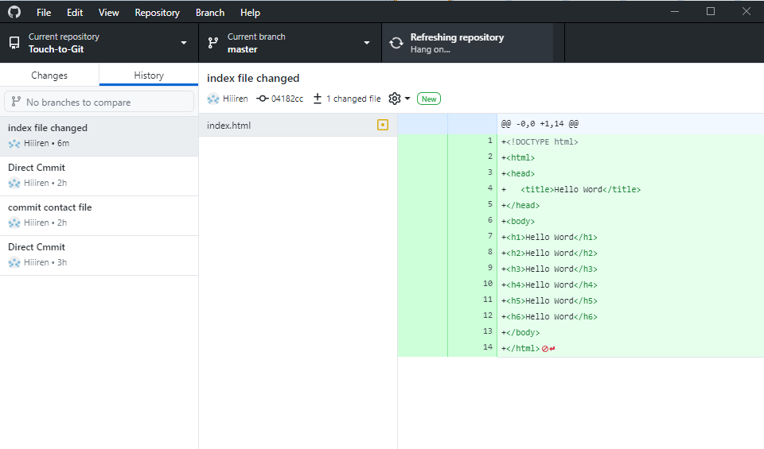

**☺ HAVE A GOOD DAY ☺**