**Module 8) Bootstrap Basic & Advanced**

**Q.1) What are the advantages of Bootstrap?**

**Ans:-**

* **Advantages:-**

1. 1)Bootstrap provides a responsive grid system, making easy to create layouts adapt to different screen sizes.
2. 2)Bootstrap includes a buttons, forms, navigation bars, etc. that you can easily integrate into your project.
3. 3)Bootstrap takes care of handling browser ensuring a consistent look and feel across different browsers.
4. Bootstrap has a large and active community.
5. 5)Bootstrap 4 is built with Flexbox, providing a more efficient way to design layouts.

**Q.2) What is a Bootstrap Container, and how does it work?**

**Ans:-**

* The container manage the layout and responsiveness of the content by providing a fixed-width container.
* The container class is part of Bootstrap's grid system, and it helps to organize and align the content within the page.
* **Example:-**

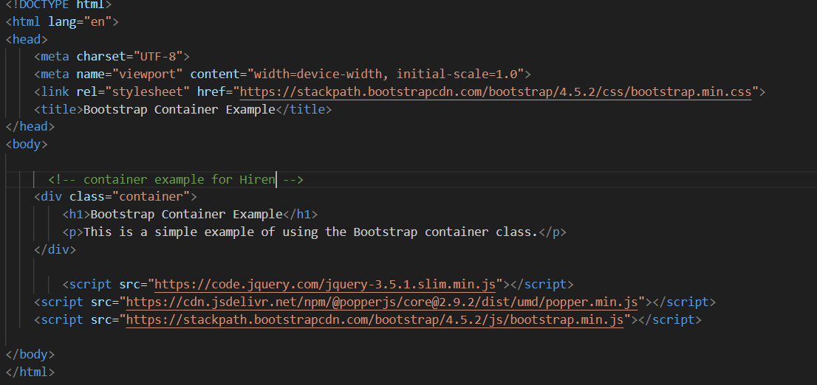

**Q.3) What are the default Bootstrap text settings?**

**Ans:-**

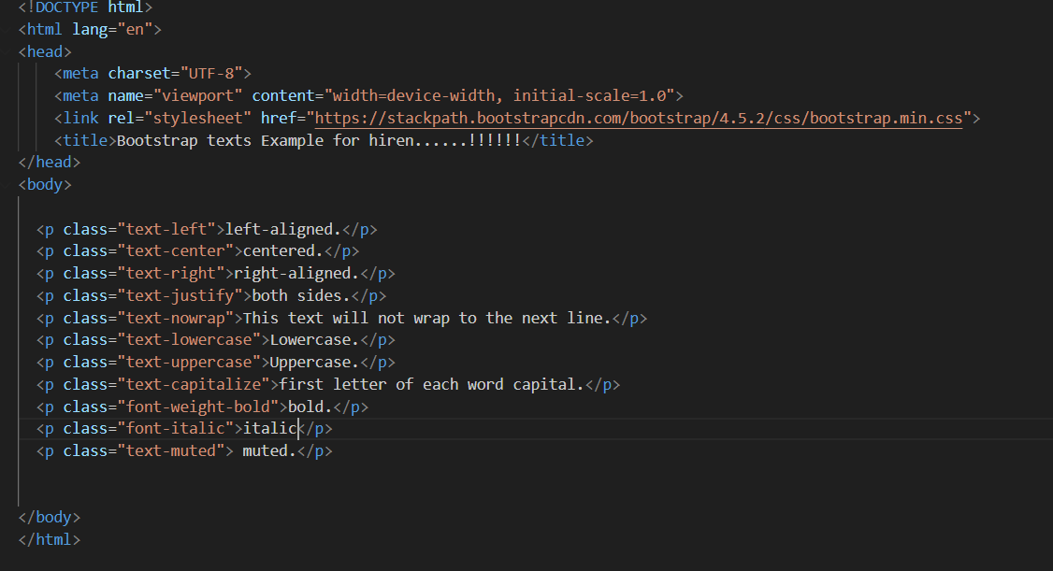

**Q.4) What do you know about the Bootstrap Grid System?**

**Ans:-**

* The Bootstrap Grid System is a responsive, mobile-first grid system that allows you to create flexible and responsive layouts for your web pages.
* It is based on a 12-column grid layout, providing a structure to organize content on different screen sizes.
* **Example:-**

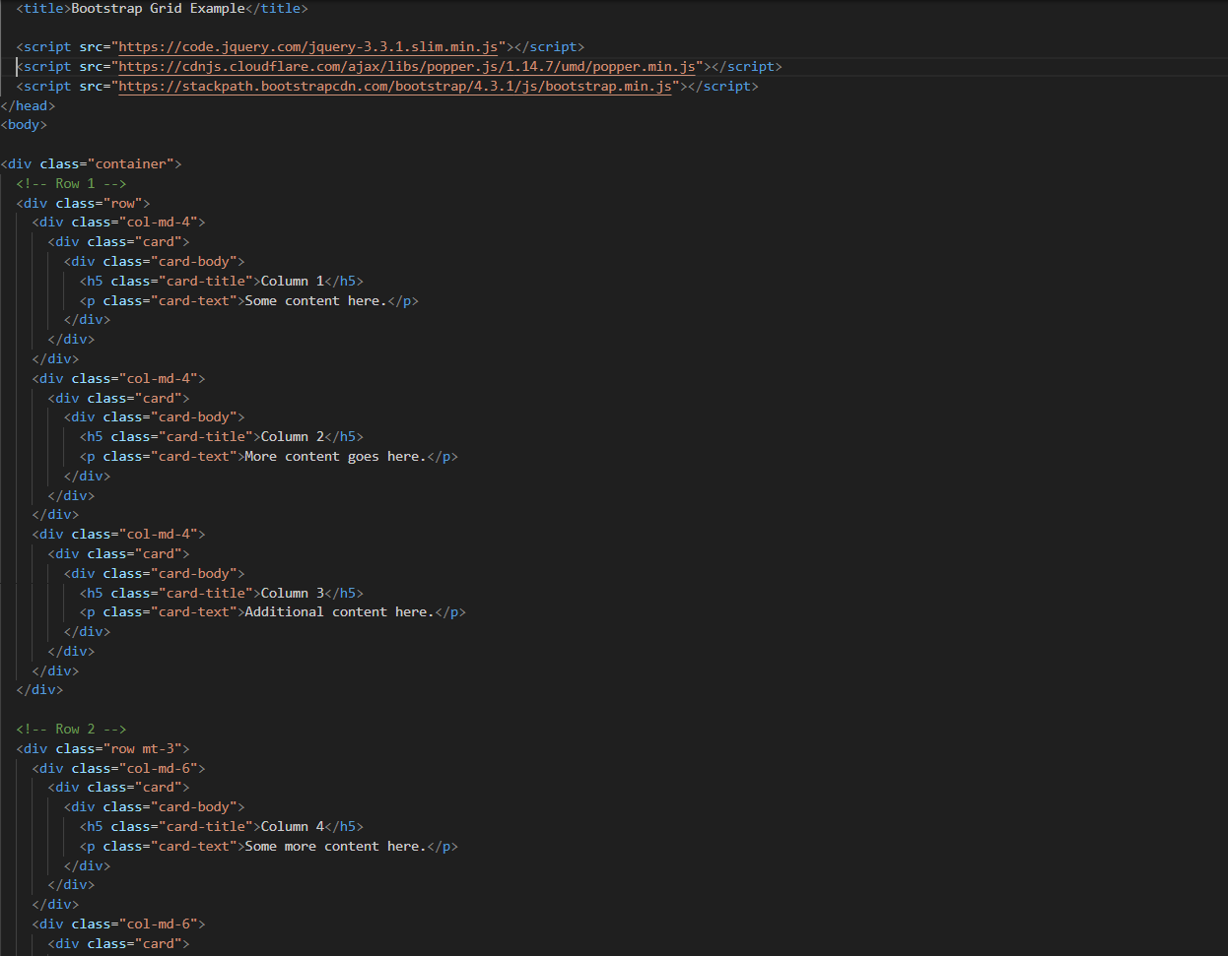

**Q.5) What is the difference between Bootstrap 4 and Bootstrap 5.**

**Ans:-**

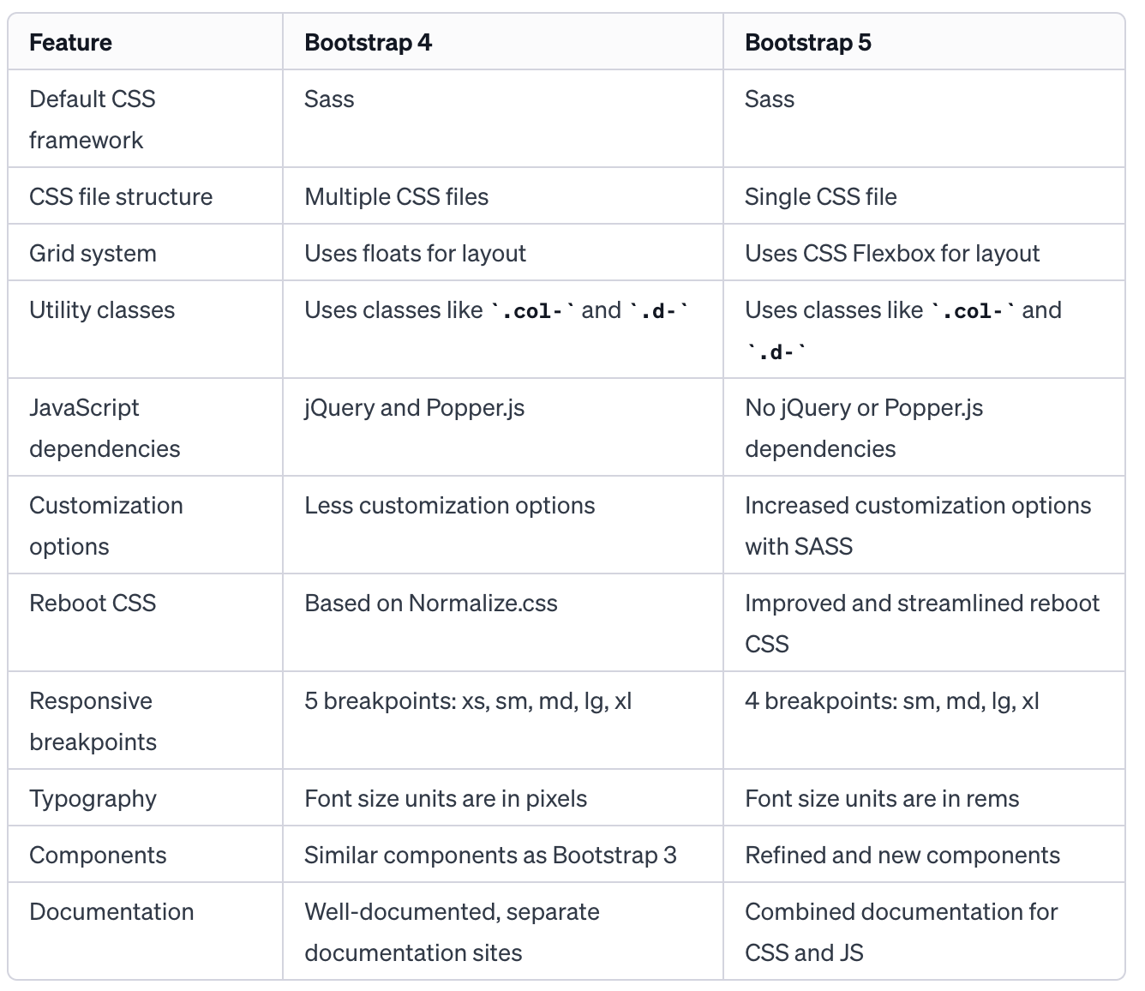

**Q.6) What is a Button Group, and what is the class for a basic Button Group?**

**Ans:-**

* A button group in Bootstrap is a group of buttons that are visually grouped together, typically to perform a related set of actions.
* Button groups can enhance the appearance and user experience by presenting related buttons as a cohesive unit.
* **Example:-**

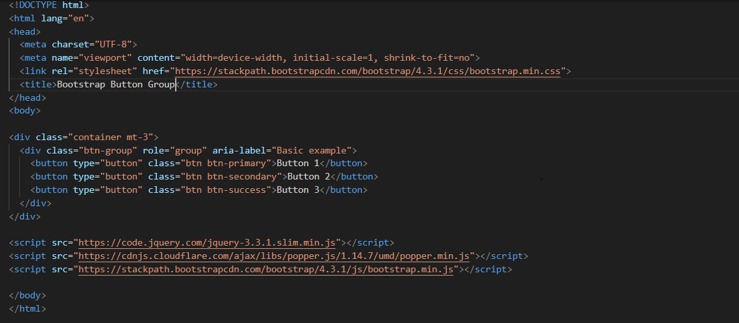

**Q.7) How can you use Bootstrap to make thumbnails?**

**Ans:-**

* In Bootstrap use the img-thumbnail class to create thumbnail-style images.
* This class adds some padding and a rounded border to the image, making it visually distinct.
* **Example:-**

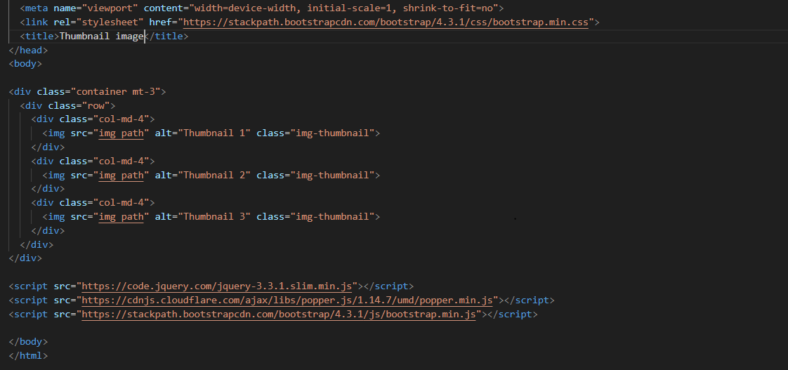

**Q.8) In Bootstrap 4, what is flexbox?**

**Ans:-**

* the Flexbox model is used as the default layout system for its grid system and many components.
* Flexbox is a one-dimensional layout method for laying out items in rows or columns.
* It provides a more efficient and predictable way to distribute space and align items in a container, especially when dealing with dynamic or unknown sizes of the items and the container.
* **Example:-**

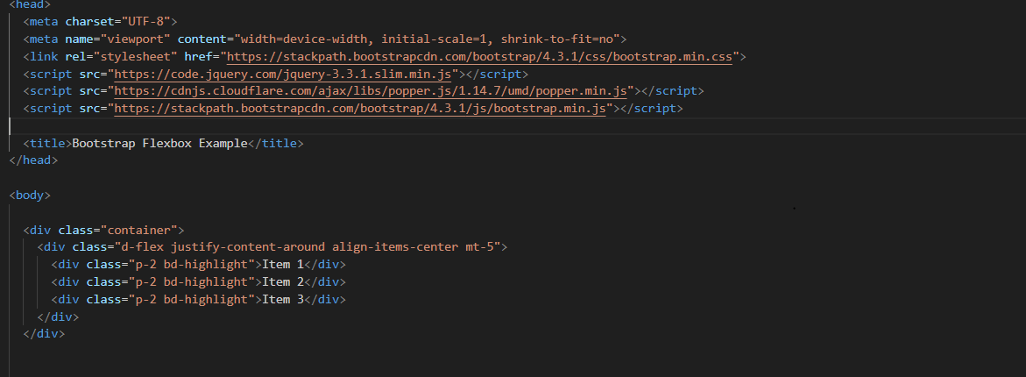

**Q.9) How can one create an alert in Bootstrap?**

**Ans:-**

* In Bootstrap create alerts to notify users of various messages, warnings, or information.
* Bootstrap provides a set of classes that you can use to style and customize alerts.

**Example:-**

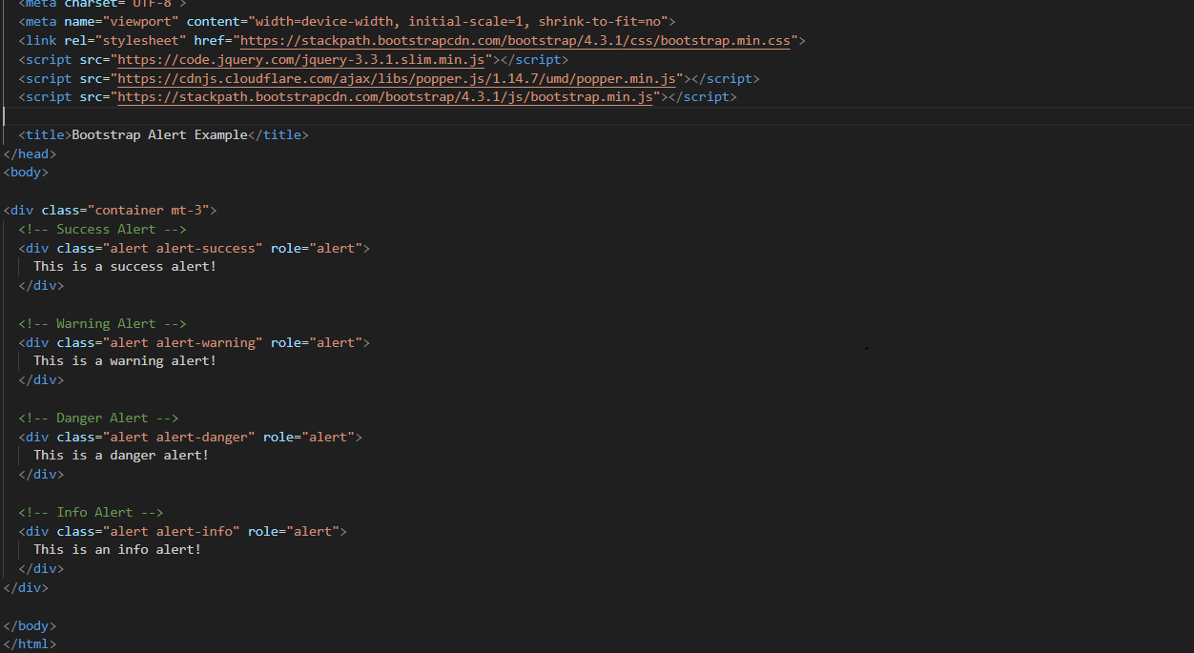

**Q.10) What is a bootstrap card and how would you create one?**

**Ans:-**

* In Bootstrap, a card is a flexible and extensible content container. It allows you to display various types of content, including images, text, links, and more, in a structured way.
* Cards are a versatile component and can be used to create a wide range of UI elements, such as blog posts, product listings, or user profiles.
* **Example:-**

