Module 7) JQuery Basic, Effects & Advanced

Q.1)What is JQuery?

Ans:-

* jQuery is a JavaScript library.
* HTML document traversal and manipulation, as well as event handling, animation, and Ajax interactions.
* It makes it easier to work with HTML documents, handle events, create animations, and make asynchronous HTTP requests.
* Example:-

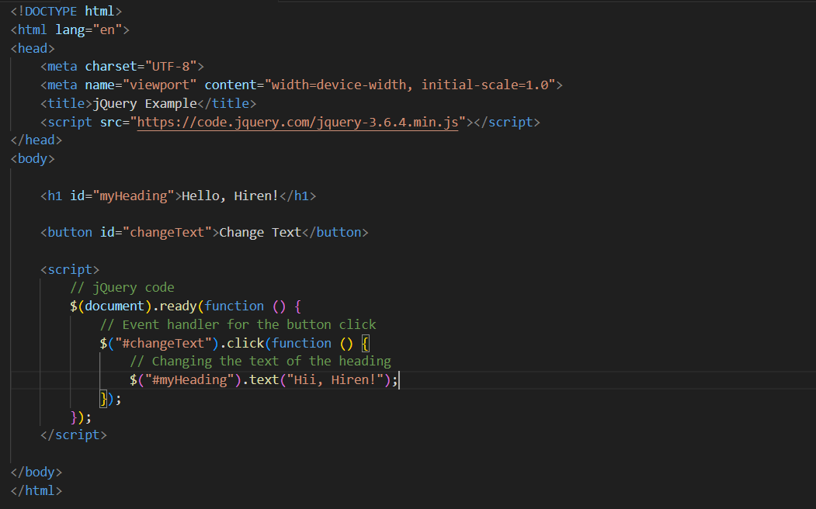

Q.2) How to Apply CSS Using JQuery, How to Add Class and Remove Class in Jquery, JQuery Animation?

Ans:-

1)Applying CSS Using JQuery:-

Example:-

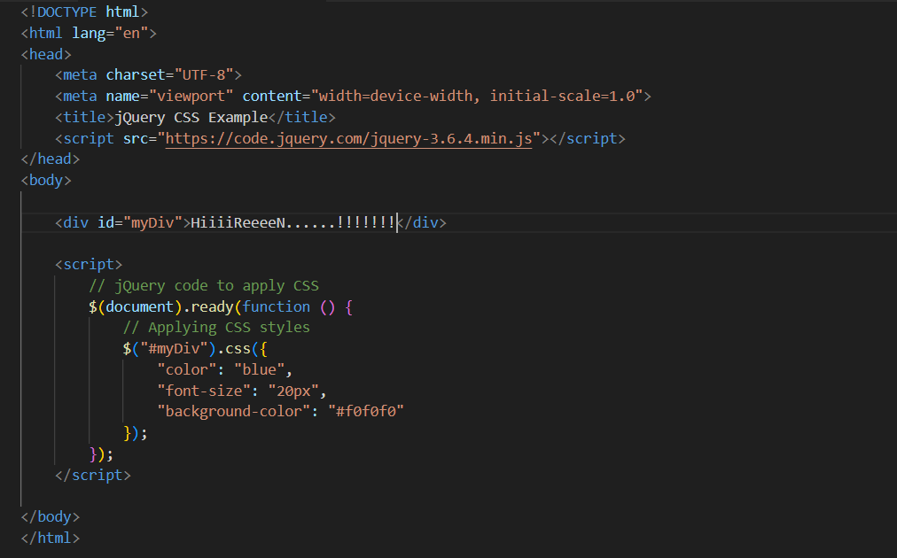

2)Adding and Removing Classes:-

Example:-

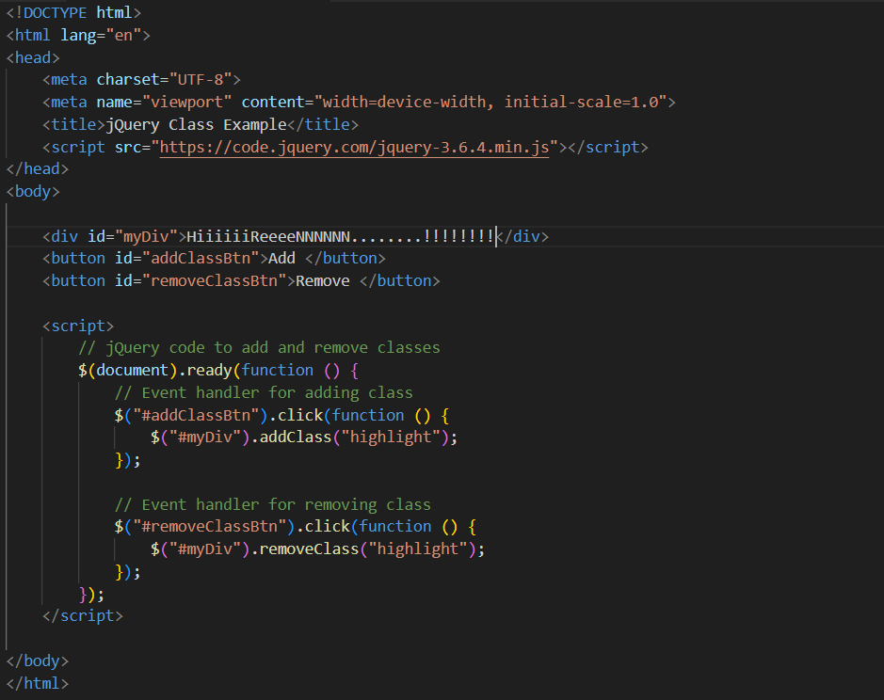

3)JQuery Animation:-

Example:-

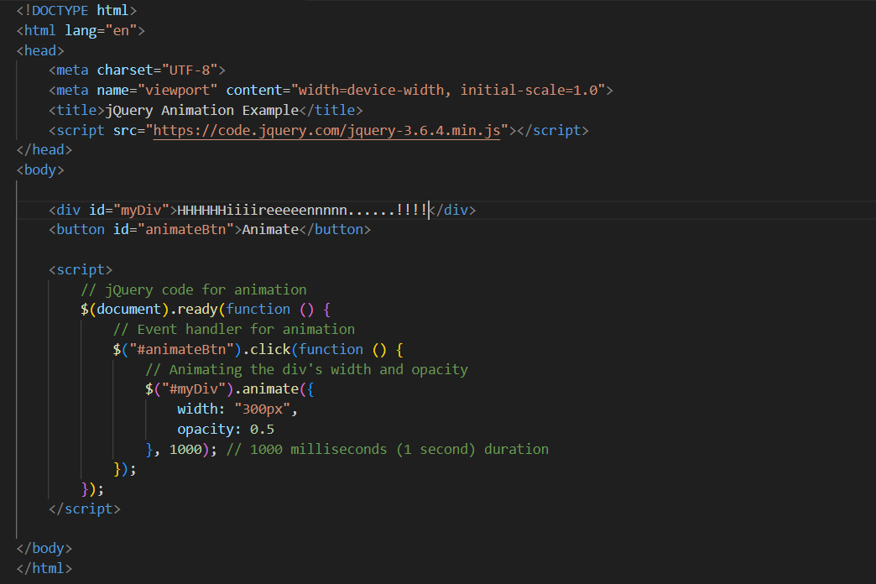

Q.3) • How to create slider with animation?

Ans:-

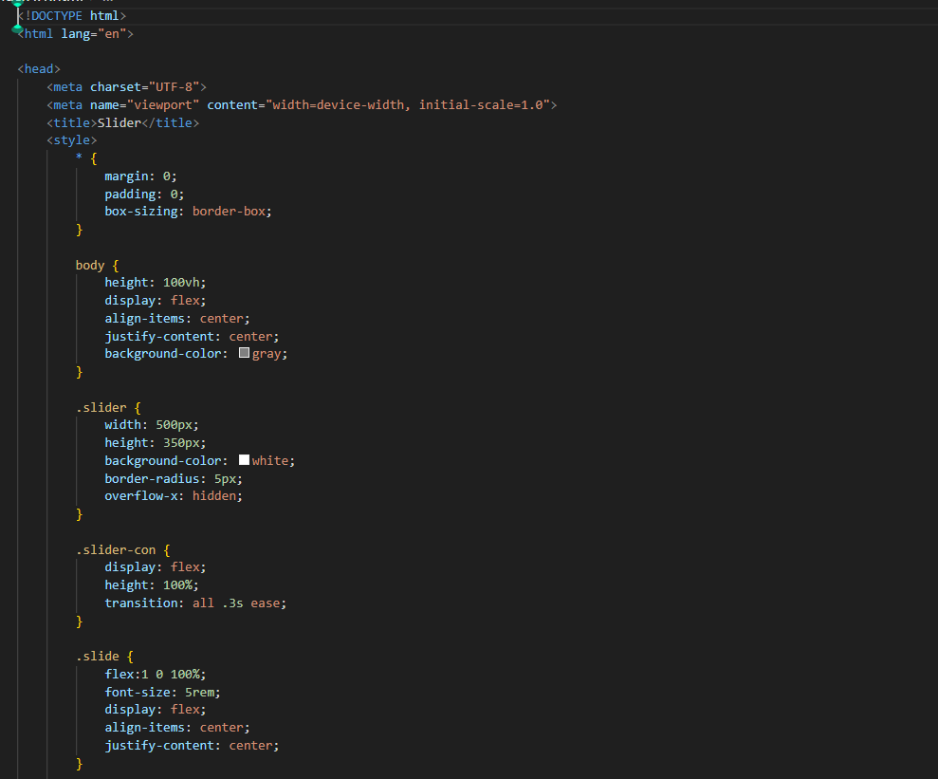

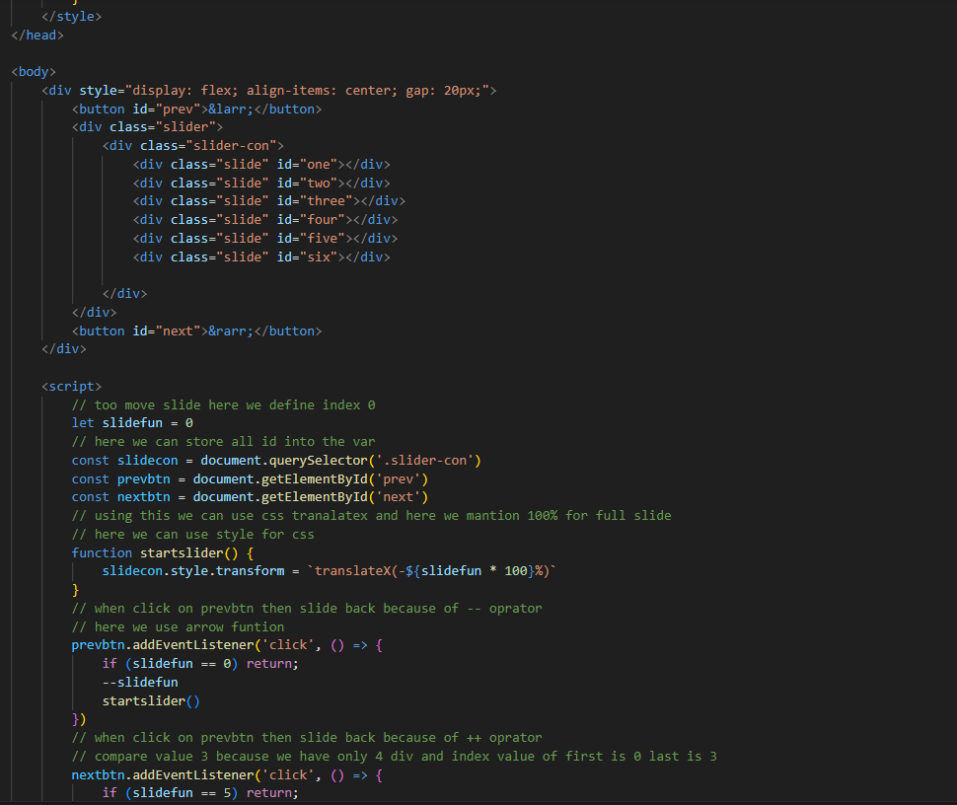

Q.4) Event bubbling tickling example…

Ans:-

