* ***Name:- Hiren Dhandhukiya***
* ***Assignment:-1***
* ***Module:-1)Foundation***

**Q.1) Do search for web-site, http, URL etc given topics in lecture.**

**Ans:-**

* **Web-Site:-**A website is a collection of web pages that are accessible through the internet. These pages are typically related to each other and are identified by a common domain name. Websites are designed to be viewed in web browsers, such as Google Chrome, Mozilla Firefox, or Safari.
* **HTTP:-** HTTP full form is Hyper Text Transfer Protocol. It is an application protocol used for transmitting and receiving information on the internet. HTTP is the foundation of any data exchange on the Web, and it is a protocol that allows the fetching of resources, such as HTML documents.
* [**URL:-**](URL:-) A URL full form is Uniform Resource Locator, is a reference or address used to access resources on the internet. It serves as a way to identify and locate a particular resource, such as a web page, document, image, or other file. URLs are used in web browsers to navigate to specific locations on the web.
* ***Module:-2)Fundamentals Of IT***

**Q.1) Do search for domain, hosting, SEO etc.**

Ans:-

* **Domain:-** A domain, in the context of the internet, refers to a human-readable label assigned to a specific set of numerical Internet Protocol addresses.
  + There are three type of Domain:

1. Top Level Domain(ex; .com,.in,etc)
2. Second Level Domain(ex; Exaple)
3. Subdoamin(ex; www)

* **Hosting:-** Web hosting refers to the service that enables individuals or organizations to make their websites accessible on the internet.
* **SEO :-** SEO full form is Search Engine Optimization. SEO is a set of practices aimed at improving a website's visibility in search engine results.
* ***Module:3)HTML***

**Q.1) Are th HTML tags and elements the same thing?**

**Ans:-**

No, HTML Tags and Element are not the same.

**Q.2) What are tags and attributes in HTML?**

**Ans:-**

* There are Six types of Tags…..

1. Paragraph Tag <p></p>

Example: <p>This is a paragraph.</p>

1. Heading Tag <h1></h1> To <h6></h6>

Example: <h1>This is a heading level 1</h1>

1. Anchor Tag <a>

Example:<a href="https://www.example.com">VisitExample.com</a>

1. Image Tag <img>

Example: <img src="hiren.jpg" alt="Hiren image">

1. List Tag <ol><ul><li>

* Oreder List <ol></ol>

Example:

<ol>

<li>Item 1</li>

<li>Item 2</ol>

</ol>

* Unorder List <ul></ul>

Example:

<ul>

<li>Item 1</li>

<li>Item 2</ol>

</ul>

1. Div Tag <div> </div>

Example:

<div>

<p>This is a paragraph inside a div.</p>

<p>Another paragraph in the same div.</p>

</div>

**Q.3) What are void elements in HTML? With Example.**

**Ans:-**

Image Tag (<img>):

Example: <img src="hiren.jpg" alt="Hiren's image">

Line Break Tag (<br>):

Example: <br>

Input Tag (<input>):

Example: <input type="text" name="username">

Meta Tag (<meta>):

Example: <meta charset="UTF-8">

Link Tag (<link> - often used for including external stylesheets):

Example: <link rel="icon" href="image Adddress">

HR Tag (<hr> - horizontal rule):

Example: <hr>

**Q.4) What are HTML Entities? With Example.**

**Ans:-**

Less Than (<) Sign:

Entity: &lt;

Example: <p>5 &lt; 10</p>

Greater Than (>) Sign:

Entity: &gt;

Example: <p>10 &gt; 5</p>

Ampersand (&) Sign:

Entity: &amp;

Example: <p>AT&amp;T</p>

Quotation Mark (") and Apostrophe ('):

&quot; for double quotation mark

&apos; for apostrophe (though often just use the actual character ')

Example: <p>This is a &quot;quote&quot; and this is an apostrophe: I&apos;m happy.</p>

Non-Breaking Space:

Entity: &nbsp;

Example: Hello&nbsp;World

Copyright Symbol (©):

Entity: &copy;

Example: <p>&copy; 2023 I’m Hiren Dhandhukiya.</p>

**Q.5) What are different types of lists in HTML? With Example.**

**Ans:-**

1)Order List

2)Unorder List

3)Definition List

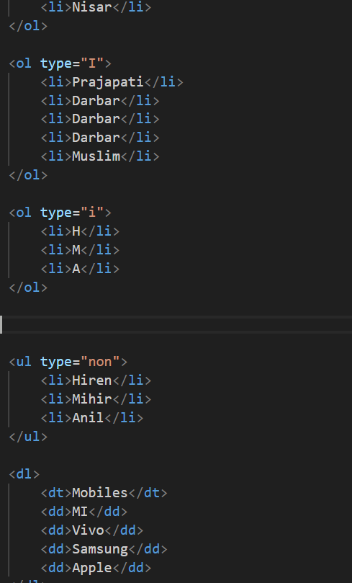

***Q.6) What is the ‘class’ attribute in HTML? With Example.***

Ans:-

* the class attribute is used to assign one or more class names to an HTML element. Classes are used to apply styles to one or more elements on a web page, and they also play a crucial role in JavaScript and CSS for selecting and manipulating specific groups of elements.

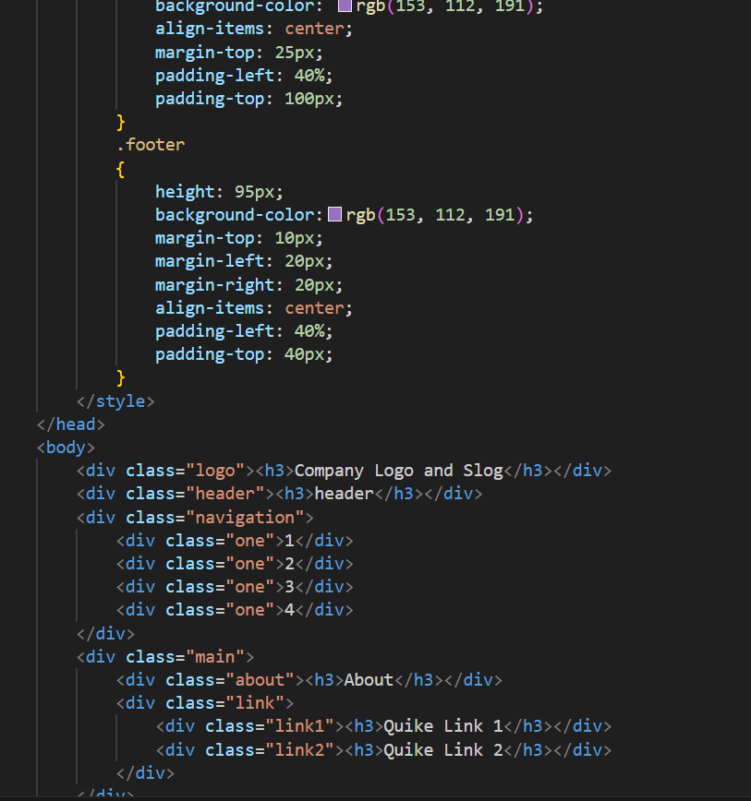

***Q.7) What is the difference between the ‘id’ attribute and the ‘class’ attribute of HTML elements? With Example***

***Ans:-***

* **ID Attribute:**
* The id attribute is used to uniquely identify a single HTML element on a page.
* Each id attribute within a document should be unique; no two elements should have the same id.
* It is often used when you want to apply styles or scripting to a specific, unique element.
* In CSS, you select an element by its id using the # symbol followed by the id value.

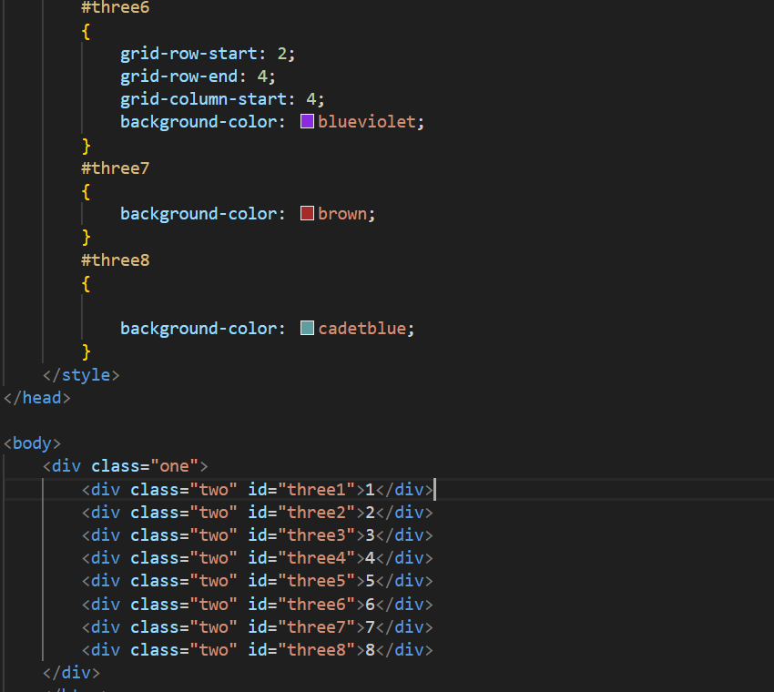

* **Class Attribute**
* The class attribute is used to group multiple HTML elements together and apply styles or scripting to all of them collectively.
* Multiple elements can share the same class attribute.
* It is useful when you want to apply the same style to multiple elements or when you want to select elements with JavaScript.

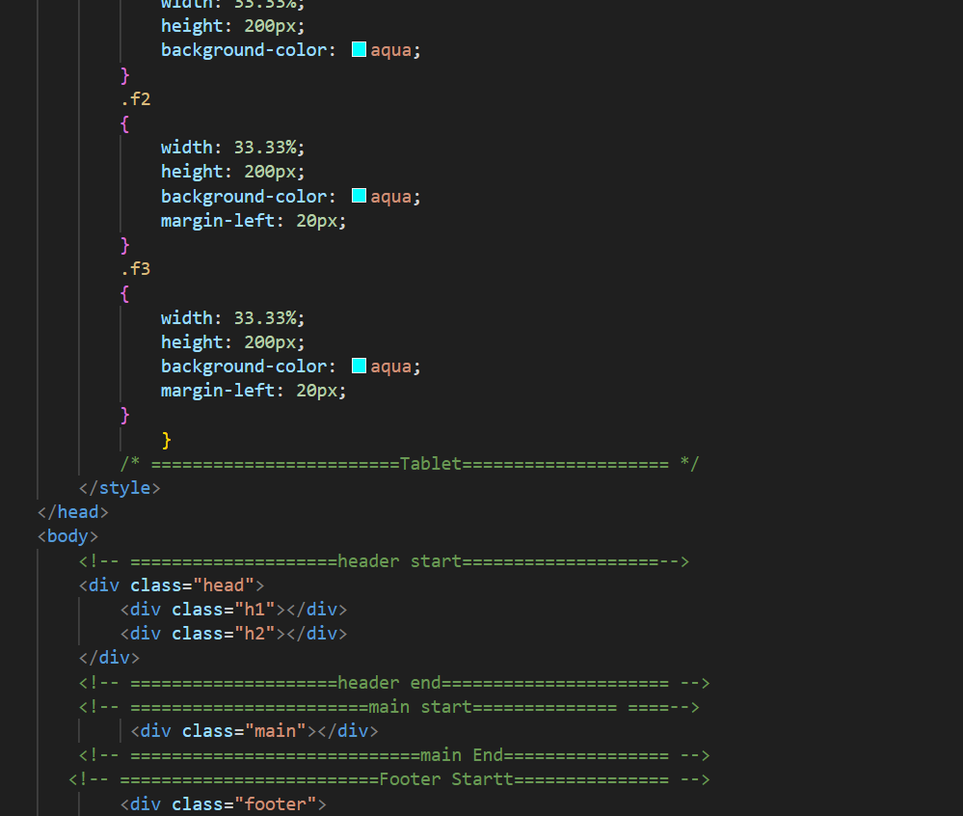

**Q.8) What are the various formatting tags in HTML?**

**Ans:-**

1. Bold Tag
2. Italic Tag
3. Strong Tag
4. Underline Tag
5. Mark Tag
6. Superscript and Subscript Tag
7. Del Tag
8. Emphasized Tag
9. Marquee Tag,etc

Example:-

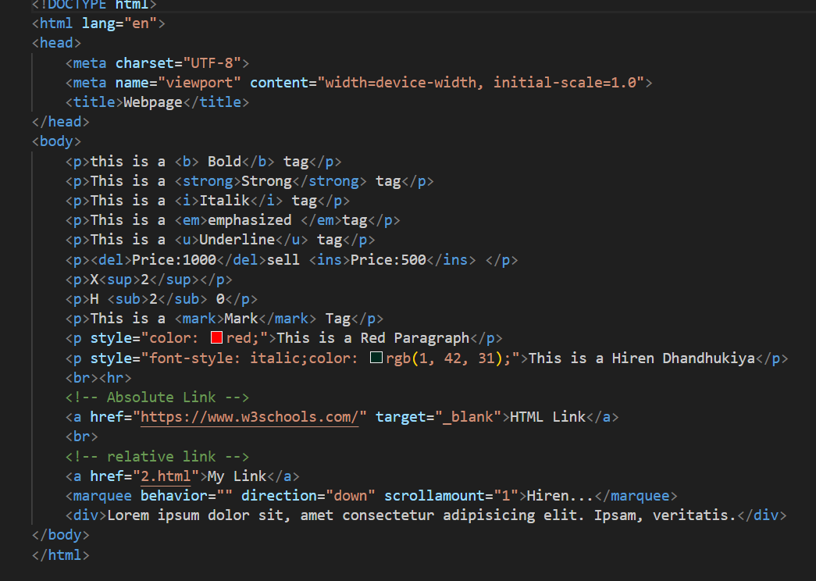

***Q.9) How is Cell Padding different from Cell Spacing? With Example.***

***Ans:-***

* ***Cell Padding:***
* Cell padding is the space between the content of a table cell and its border.
* It is controlled using the cellpadding attribute in the <table> tag.
* The value of cellpadding determines the amount of space inside the cell, creating a buffer between the cell content and the cell border.
* ***Example:-***

<table cellpadding="10">

<tr>

<td>This is cell 1</td>

<td>This is cell 2</td>

</tr>

</table>

* ***Cell Spacing:***
* Cell spacing is the space between adjacent cells in a table.
* It is controlled using the cellspacing attribute in the <table> tag.
* The value of cellspacing determines the amount of space between cells, creating a gap or border between them.
* ***Example:-***

<table cellspacing="5">

<tr>

<td>This is cell 1</td>

<td>This is cell 2</td>

</tr>

</table>

**Q.10) How can we club two or more rows or columns into a single row or column in an HTML table? With Example.**

**Ans:-**

* HTML tables, the rowspan and colspan attributes to merge two or more rows or columns into a single row or column, respectively. These attributes specify how many rows or columns a cell should span.
* **Rows**

<table border="1">

<tr>

<td rowspan="2">Row 1, Cell 1</td>

<td>Row 1, Cell 2</td>

<td>Row 1, Cell 3</td>

</tr>

<tr>

<td>Row 2, Cell 2</td>

<td>Row 2, Cell 3</td>

</tr>

<tr>

<td>Row 3, Cell 1</td>

<td>Row 3, Cell 2</td>

<td>Row 3, Cell 3</td>

</tr>

</table>

* **Columns:-**

<table border="1">

<tr>

<td colspan="2">Row 1, Cell 1</td>

<td>Row 1, Cell 2</td>

<td>Row 1, Cell 3</td>

</tr>

<tr>

<td>Row 2, Cell 1</td>

<td>Row 2, Cell 2</td>

<td>Row 2, Cell 3</td>

</tr>

<tr>

<td>Row 3, Cell 1</td>

<td>Row 3, Cell 2</td>

<td>Row 3, Cell 3</td>

</tr>

</table>

**Q.11) What is the difference between a block-level element and an inline element?**

***Ans:-***

* ***Block-level Elements:***

**1)Display:**

* Takes up the full width available, creating a "block" on the page.
* Starts on a new line and forces subsequent elements to appear on a new line after it.
* Extends the full width of its container, and you can set its width and height.

**2)Examples:**

<div>

<p>

<h1> to <h6>

<ul>, <ol>, <li>

<table>, <tr>, <td>

<form>

<hr>

**3)Usage:**

* Typically used to structure the layout and create divisions in the content.
* ***Inline Elements:***

**1)Display:**

* Does not start on a new line; it only takes up as much width as necessary.
* Does not force subsequent elements to appear on a new line.

**2)Examples:**

<span>

<a> (anchor)

<strong>, <em> (text formatting)

<img>

<br> (line break)

<input>, <button>

**3)Usage:**

* Often used within block-level elements to style or format specific parts of the content.

***Example:***

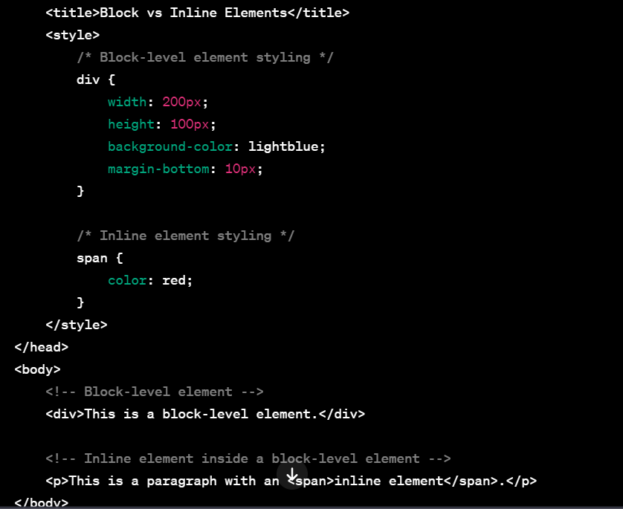

***Q.12) How to create a Hyperlink in HTML? With Example.***

***Ans:-***

* Create a hyperlink using the <a> (anchor) element.

***Example:-***

<a href="https://www.amazon.com" target="_blank">Visit amazon.com</a>

**Q.13) What is the use of an iframe tag? With Example.**

**Ans:-**

* The <iframe> (inline frame) HTML tag is used to embed another document within the current HTML document. It allows you to include content from one source into another, such as embedding a webpage, a video, or other types of media. This is commonly used to embed third-party content into a website.
* **Example:-**

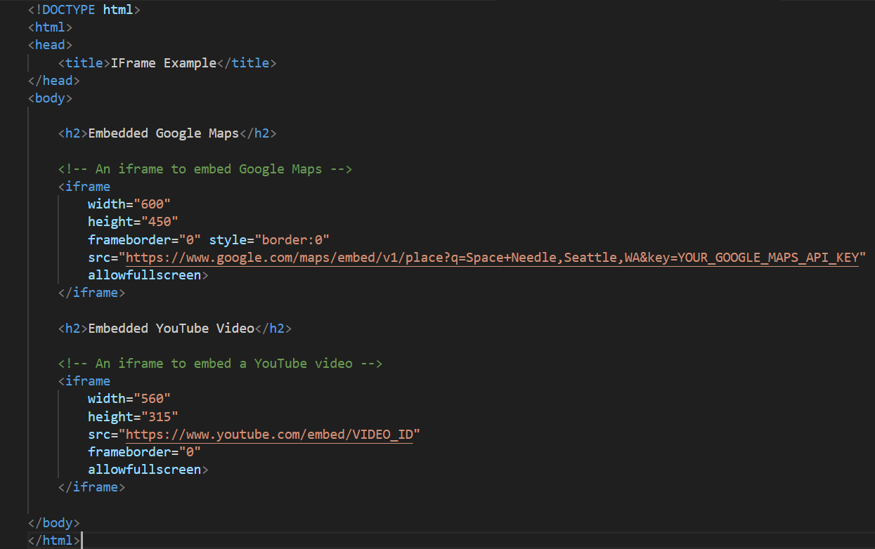

**Q.14) What is the use of a span tag? Explain with example?**

**Ans:-**

* The <span> HTML tag is an inline container used to group and apply styles to inline elements or a specific portion of text within a larger block of content. It doesn't add any specific visual styling itself but can be styled using CSS or used for JavaScript interactions.
* ***Example:-***

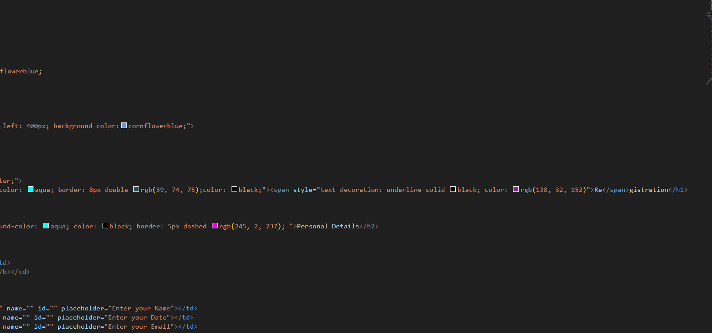

***Q.15) How to insert a picture into a background image of a web page? With Example.***

***Ans:-***

* If you want to insert a picture into the background of a web page, you can use the CSS background property.
* ***Example:-***

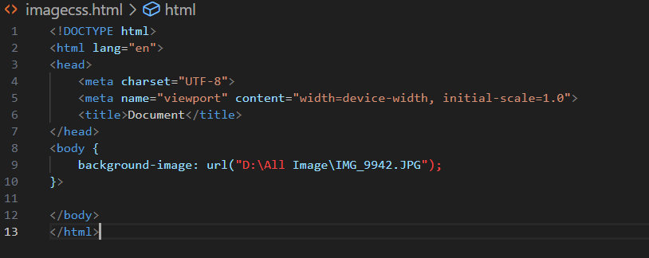

***Q.16) How are active links different from normal links?***

***Ans:-***

* Active Links vs. Inactive Links:
* These links are live and lead to a specific destination.
* Inactive links are those that, for some reason, do not lead to a valid destination, perhaps because the webpage has been removed or the URL is incorrect.
* Active Links vs. Static Links:
* Active Links: These links could trigger actions or events when clicked, such as opening a pop-up, submitting a form, or initiating a specific function on the webpage.
* Normal Links or Static Links: They are the conventional links that simply navigate to a different URL.

**Q.17)What are the different tags to separate sections of text?**

**Ans:-**

* Paragraph Tag (<p>):

Example:

<p>This is a paragraph of text.</p>

* Heading Tags (<h1> to <h6>):

Example:

<h1>This is a Level 1 Heading</h1>

<h2>This is a Level 2 Heading</h2>

<!-- ...and so on up to h6 -->

* Div Tag (<div>):

Example:

<div>

<p>This is a paragraph inside a div.</p>

<p>Another paragraph inside the same div.</p>

</div>

* Section Tag (<section>):

Example:

<section>

<h2>Section Title</h2>

<p>This is the content of the section.</p>

</section>

**Q.19) What is difference between HTML and XHTML?**

**Ans:-**

* HTML (Hypertext Markup Language) and XHTML (Extensible Hypertext Markup Language) are both markup languages used to structure and present content on the web. The main difference between them lies in their syntax and rules.

Q.20)

Ans:-

* **LogicalTags:**
* Description: Semantic tags are HTML elements that carry meaning about the structure and content of the document. They convey information about the role of the enclosed content.
* Examples:

1. <header>: Represents a header section, often containing headings, logos, or navigation.
2. <nav>: Defines a navigation menu.
3. <main>: Represents the main content of the document.
4. <section>: Represents a generic section of a document.

* ***Physical Tags:***
* Description: Presentational tags are elements that were historically used for formatting and layout purposes. These tags describe how the content should be presented visually but do not provide information about the content's meaning or structure.
* Examples (historical, discouraged):

1. <b>: bold text.
2. <i>: italic text.
3. <font>: Used for font-related styling.
4. <center>: Used for centering content.
5. <strike>: strikethrough text.