HIRFATY
Technical Architecture Overview
Prepared for: CEO · Prepared by: Achraf (CTO)
August 2026

1. Goals & Constraints
Hirfaty is an e-commerce platform connecting Moroccan artisans with buyers. The CEO's strategic direction is to focus first on B2B hospitality clients — riads, hotels, guesthouses, and restaurants — who order handcrafted products in bulk at professional pricing, with the full B2B/B2C marketplace (including individual retail buyers) as the longer-term vision.
Today, sellers and their products are registered directly by the Admin; a self-service seller registration flow with Admin approval is planned but not yet built. Payments are processed through CMI, the Moroccan interbank gateway. The platform is built on Laravel with a React/TypeScript frontend, hosted on Hetzner, with product images stored on the server's local filesystem for now.
These choices are deliberate for this stage: they let us ship the B2B hospitality use case quickly without over-building infrastructure (multi-region storage, multiple payment providers, etc.) the business doesn't need yet.

2. System Context — Who Uses Hirfaty
This is the highest-level view: Hirfaty as a single system, and the people and external service it interacts with.
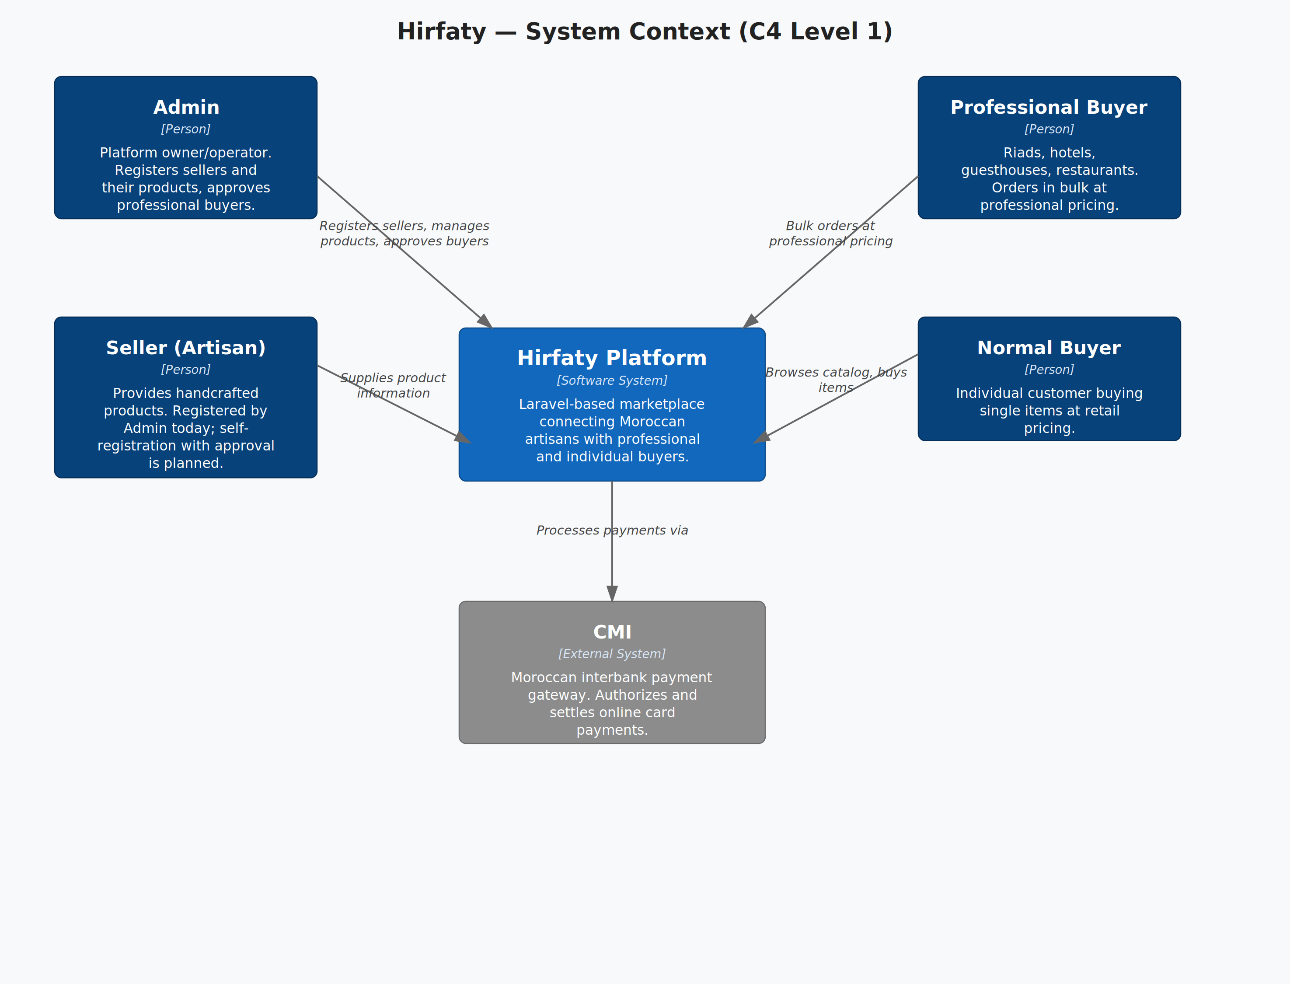
C4 Level 1 — System Context
Four kinds of people touch the platform — the Admin who runs it, Sellers (artisans) who supply products, Professional Buyers (hospitality businesses) who order in bulk, and Normal Buyers who order individually. The only external system today is CMI, which handles payment authorization and settlement.

3. Containers — How Hirfaty Is Built
Zooming in one level, this shows the major moving parts inside Hirfaty and how they talk to each other.
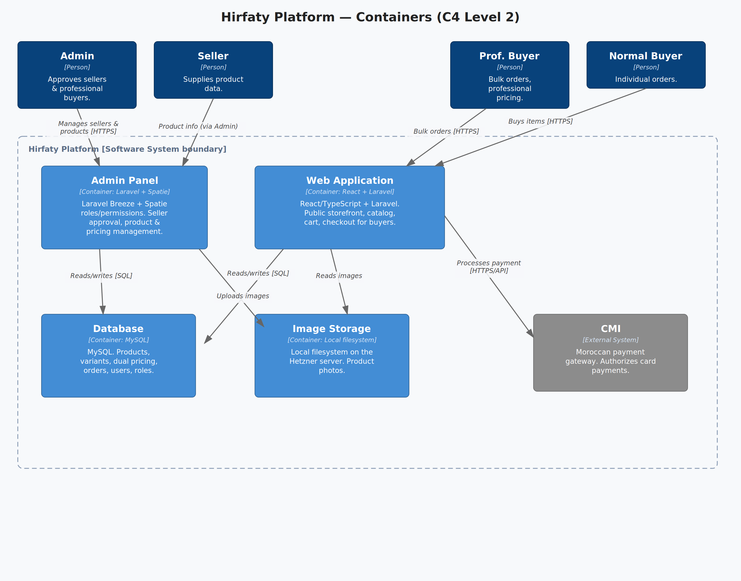
C4 Level 2 — Containers
The Web Application is the public storefront buyers use to browse and order. The Admin Panel is a separate, purpose-built interface (Laravel Breeze + Spatie roles) where the Admin approves sellers and manages the product catalog and pricing. Both share the same MySQL database and the same local image storage. Only the Web Application talks to CMI to process payments.

4. Key Business Flows

Seller Onboarding (current process)
- Admin receives product and pricing details from an artisan.
- Admin registers the seller and enters their products directly into the platform.
- Products become visible to buyers immediately once entered — no separate approval step yet, since Admin is the sole gatekeeper.
Planned next step: sellers register themselves, and products stay hidden until Admin approves them — separating "who can sell" from "what goes live" as more sellers join.

Professional Buyer Order (hospitality focus)
- A riad, hotel, or restaurant browses the catalog and sees professional (bulk) pricing.
- They place an order meeting the minimum order quantity for professional buyers.
- Order is confirmed and payment is captured through CMI.
- Admin fulfils the order with the relevant seller(s).

5. Risks & Roadmap
- Local image storage doesn't scale past a single server — fine for launch, but will need object storage (e.g. S3-compatible) once catalog size or traffic grows.
- Single payment gateway (CMI) — no fallback if it has an outage; acceptable for a Morocco-only launch.
- Seller self-registration & approval flow is designed but not built — Admin is currently a manual bottleneck for onboarding new artisans.
- Professional buyer flow: still deciding between a simple lead-capture form and a full RFQ/quoting system — this shapes how much of the order flow needs to be built next.
- Cross-language product search (French/Arabic/English) is planned using vector embeddings, not yet built.

