From the raytrace manual

My comments

From Dipole.dat

1 (A4) DIPOLE (not used in SNAKE)

2 (6F10.5)

LF1 - Entrance fringing field integration step size (cm)

LU1 - Uniform field integration step size (cm)

LF2 - Exit fringing field integration step size (cm)

DG - Differential step size used in determining off mid-plane components of B using numerical differential methods. Recommended for all four step, sizes: 0.3D (D=Gap) although LU1 can be made larger to save computer time. For MTYP=6, DG serves another function. See Sec. V. A.

MTYP - Magnetic dipole option

MTYP=0,1 - Uniform field dipole. Fringing field determined by calculation of the distance to the effective field boundary in the z-direction.

MTYP=2 - Uniform field dipole. Fringing field determined as described in Sec. V.A.

MTYP=3 - Non-uniform field dipole with n-value and second-, third-, and fourth-order corrections. Fringing field determined as for MTYP=2, but including n-value, etc.

MTYP=4 - Non-uniform field dipole – cylindrical geometry. Similar to MTYP=3 but better suited for purely conical pole pieces. This option is used to describe magnets with wedge-shaped gaps (“CLAMSHELL”) by making R large, PHI small, and by setting BET1=GAMA=DELT=0 but n≠0, and normally large because R is artificially large.

MTYP=5 - Uniform field dipole, circular pole option.

MTYP=6 - Pretzel magnet option.

IMAP - Array number for generating and identifying fringing field array maps. If IMAP=0, maps are not generated and the field components are calculated directly for each point, i.e., four times for each integration step. Two dipoles with identical values of IMAP will share a common array. IMAP≤5.

2., 4., 2., 8., 4. (1st 4 not used in SNAKE, last one is correct for Raytrace dipole as implemented in SNAKE)

3 (5F10.5)

A - Distance (cm) from origin of system A (initial) to system B (situated at entrance edge EFB of

magnetic element)

B - Distance (cm) from origin of system C (situated at exit edge EFB of magnetic element) to origin of output system D

D - Gap width (cm)

R - Radius of curvature (cm) used in geometrical construction of layout

BF - Nominal value of the field on the central radius R (Tesla)

0., 0., 15.,1289.31,0.2587 (A & B not relevant in SNAKE, 15 cm gap, 1289.31 cm radius of curvature for central ray, Central field 0.2587 T)

4 (3F10.5)

PHI - Angular extent between the EFB of system B and that of system C (degrees). Nominally equivalent to the bend angle

ALPHA - Angle between the central trajectory and the normal to the effective field boundary (EFB) at entrance (degrees)

BETA - Angle between the central trajectory and the normal to the exit boundary (degrees). Both ALPHA and BETA are positive when the normals are outside the orbit for positive transverse plane focussing.

7.3,7.3,7.3 (φ, α, β as is the figure below- Rectangular magnet with 7.3° bend. **N.b**. the C coordinate system in the figure below is the coordinate system for the dipole free box in SNAKE, substitute ysnake for z)

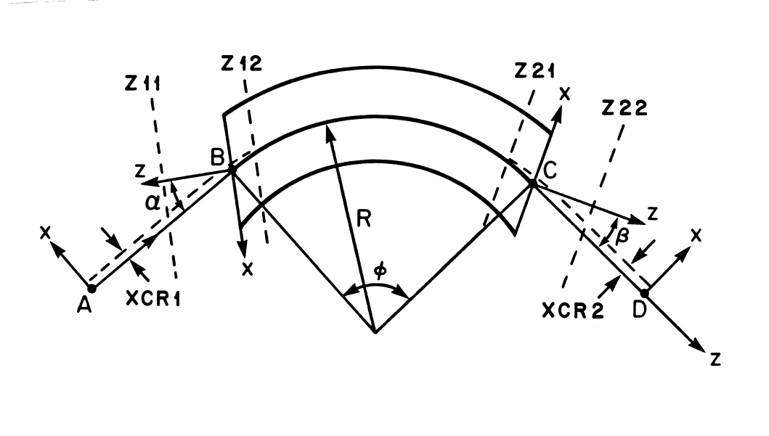

5 (4F10.5)

NDX - ‘n-value’, of field index for non-uniform field magnets (first-order term).

BET1 - ‘β-value’, of field index for non-uniform field magnets (second-order term).

GAMA - ‘γ-value’, of field index for non-uniform field magnets (third-order term).

DELT - ‘δ-value’, of field index for non-uniform field magnets (fourth-order term).

0.0 (all zeroes for your magnet)

6 (4F10.5)

Z11 - Integration limit (cm) defining the start of the entrance fringing field zone in coordinate system B. Normally positive.

Z12 - Integration limit (cm) defining the termination of the entrance fringing field zone in coordinate system B. Normally negative.

Z21 - Integration limit (cm) defining the start of the exit fringing field zone in coordinate system C. Normally negative.

Z22 - Integration limit (cm) defining the termination of the exit fringing field zone in coordinate system C. Normally positive.

130.,-100.,-100.,130. (if you want to turn off the fringe fields you can do it here by setting all to zero)

7 (6F10.5)

C00, C01, C02, C03, C04, C05 - Coefficients used in the expansion of the fringing field fall-off at the entrance of the magnetic element.

0.04725,2.2395,-.9768,.7288,-.1299,.0222 (These are sacred numbers passed on to me by Ingvar Blomqvist (ask Paul or Jim about Ingvar) just leave them alone!)

8 (6F10.5)

C10,C11, C12, C13, C14, C15 - Coefficients used in the expansion of the fringing field fall-off at the exit of the magnetic element.

0.04725,2.2395,-.9768,.7288,-.1299,.0222 (Ditto)

9 (6F10.5)

BR1 - Correction for presence of constant field in region of entrance fringe field (Tesla).

BR2 - Correction for presence of constant field in region of exit fringe field (Tesla). In the Split-Pole Spectrometer, BR1 and BR2 describe the asymptotic field in the split.

XCR1 - Equivalent to a coordinate system shift (cm) at the entrance (element SHRT) with Δx=XCR1. Used to correct for displacement of central ray caused by extended fringing field (see Fig. 2). Use XCR1=XCR2=0 unless the actual hardware element will be offset.

XCR2 - Equivalent to a coordinate system shift (cm) at the exit with Δx=XCR2. Used to correct for displacement of central ray caused by extended fringing field.

DELS1 - A correction to the location of the effective field boundary. The effective field boundary at entrance is moved towards the magnet (for positive Δz) by an amount Δz =DELS1∗D.

DELS2 - A correction to the location of the effective field boundary. The effective field boundary at exit is moved towards the magnet (for positive Δz) by an amount Δz =DELS2∗D.

1. (all zeroes, don’t worry about them)

10 (2F10.5)

RAP1 - Inverse radius of curvature of entrance boundary (cm−1). Convex surfaces are positive.

RAP2 - Inverse radius of curvature of exit boundary (cm−1). Convex surfaces are positive. In the program, except for MTYP=5, circles described by RAP1 and RAP2 are approximated with an eighthorder power series.

WDE - Mechanical width of the entrance pole boundary. Used only when IMAP is non-zero.

WDX - Mechanical width of the exit pole boundary. Used only when IMAP is non-zero.

1. (all zeroes, entrance and exit boundaries are straight and IMAP=0 don’t worry about them)

11 (7F10.5)

S02, S03, S04, S05, S06, S07, S08 - Coefficients used in description of entrance boundary curvature. Contributions of RAP1 are added to those of S02, S04, S06, and S08.

0., 0., 0., 0. (your entrance boundary is straight)

12 (7F10.5)

S12, S13, S14, S15, S16, S17, S18- Coefficients used in description of exit boundary curvature. Contributions of RAP2 are added to those of S12, S14, S16, and S18.

0., 0., 0., 0. (your exit boundary is straight)