Categorical Outcome Training

Hiroki Matsui

Thursday, January 15, 2015

#install.packages("car")  
#install.packages("lme4")

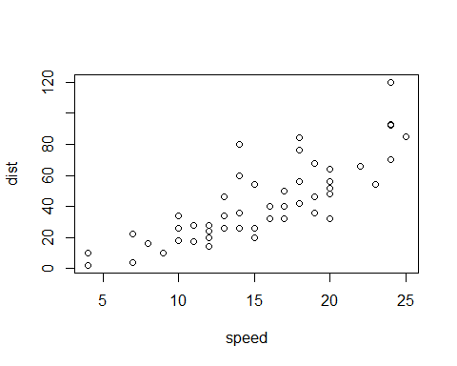

Note that the echo = FALSE parameter was added to the code chunk to prevent printing of the R code that generated the plot.