Guth Model
Table xx: Optimized A and B parameters for each data set and the corresponding mean absolute percentage error (MAPE) for each material. “Averaged” refers to the mean performance of individually optimized parameters for each material, while “All materials combined” indicates the results obtained by optimizing parameters using a data set that includes all three materials collectively.
Optimizer | A | B | FM | Cerr 117 | Cerr 158 | Average
FM | 2.7845 | 0.6413 | 7.6 | 10.85 | 15.75 | 11.4
Cerr 117 | 2.9741 | 0.2879 | 11.77 | 5.77 | 10.29 | 9.28
Cerr 158 | 3.1184 | 0.0727 | 14.65 | 7.68 | 8.85 | 10.39
Averaged | 2.959 | 0.3339 | 11.09 | 5.86 | 10.98 | 9.31
All materials combined | 3.0462 | 0.1803 | 13.21 | 6.72 | 9.1 | 9.68
Buckner et al | 0.67 | 1.62 | 16.42 | 18 | 18.6 | 17.67
Guth | 2.5 | 14.1 | 378.19 | 409.48 | 440.17 | 409.28

Final selected values A =3 and B = 0.3
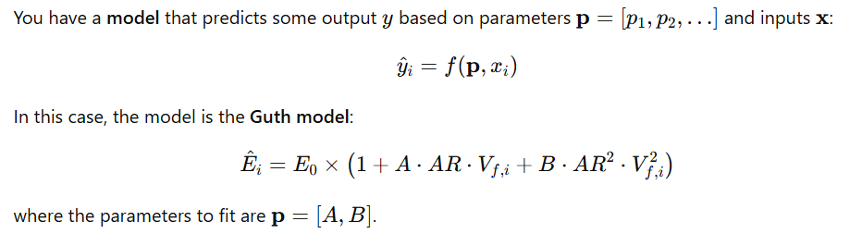
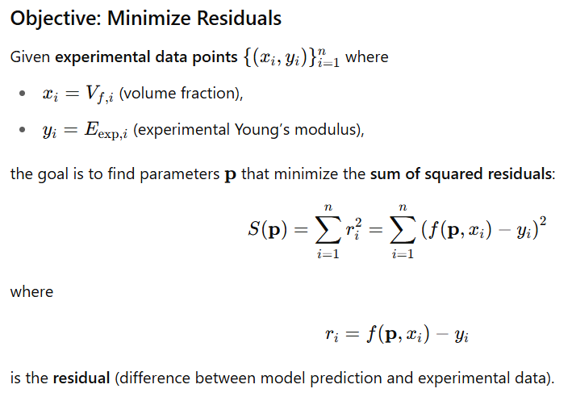
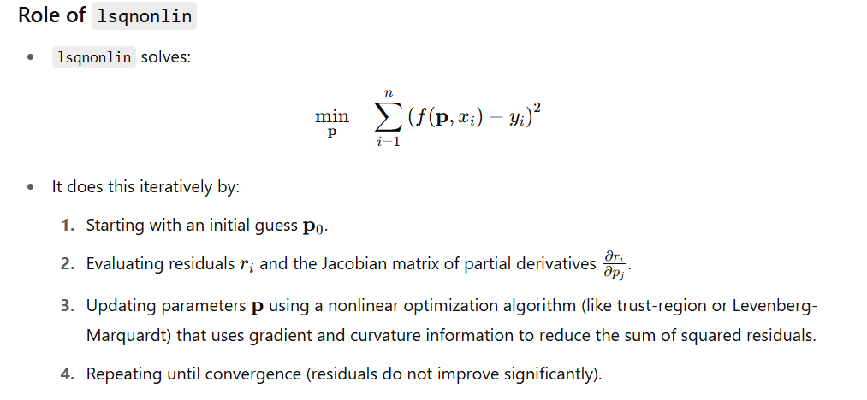

Trust-Region-Reflective Algorithm

Model | Filler Type | Equation Form | Best For | Limitations | Citation / Origin
Guth–Gold | Spherical | Ec=Em(1+2.5ϕ+14.1ϕ2)E_c = E_m (1 + 2.5\phi + 14.1\phi^2) | Rubber with spherical fillers (e.g., silica, carbon black) | Limited to low filler fractions, assumes perfect dispersion | Guth & Gold, Phys. Rev. 1945
Kerner Model | Spherical | Analytical (complex) | Thermoplastics and rubbers with spherical particles | Assumes isotropy and perfect bonding | Kerner, J. Mech. Phys. Solids, 1956
Halpin–Tsai | Fibers / Platelets | Ec=Em(1+ξηϕ1−ηϕ)E_c = E_m \left( \frac{1 + \xi \eta \phi}{1 - \eta \phi} \right) | Short fibers, nanotubes, clay, graphene | Semi-empirical; accuracy depends on aspect ratio ξ\xi | Halpin & Kardos, Polym. Eng. Sci., 1976
Nielsen–Lewis | Platelets | Ec=Em(1+Aϕ1−Bϕ)E_c = E_m \left( \frac{1 + A\phi}{1 - B\phi} \right) | Platelets (nanoclay, mica), barrier materials | Requires calibrated constants A and B | Nielsen, J. Macromol. Sci., 1967
Tandon–Weng | Short Fibers | Analytical (complex) | Randomly or partially aligned short fibers | Assumes uniform orientation distribution | Tandon & Weng, Composites Sci. Technol., 1984
Mori–Tanaka | Ellipsoidal (fibers, rods) | Numerical/matrix-based | General high-aspect fillers with interaction effects | Complex; assumes perfect interface and uniformity | Mori & Tanaka, Acta Metall., 1973
Voigt (Rule of Mixtures – Upper Bound) | Any | Ec=ϕEf+(1−ϕ)EmE_c = \phi E_f + (1 - \phi) E_m | Aligned long fibers | Overestimates for non-aligned systems | Voigt, 1889
Reuss (Lower Bound) | Any | 1Ec=ϕEf+1−ϕEm\frac{1}{E_c} = \frac{\phi}{E_f} + \frac{1 - \phi}{E_m} | Load perpendicular to fiber direction | Underestimates actual behavior | Reuss, 1929
Hashin–Shtrikman Bounds | Any shape | Bound equations | Theoretical limits for isotropic composites | Not predictive, just bounding | Hashin & Shtrikman, J. Mech. Phys. Solids, 1963

Halpin-Tsai Model

Optimizer | Sigma | FM | Cerr 117 | Cerr 158 | Average
FM | 20.2403 | 9.58 | 14.94 | 18.01 | 14.18
Cerr 117 | 17.4941 | 10.02 | 11.42 | 14.11 | 11.85
Cerr 158 | 16.8656 | 10.61 | 12.25 | 13.22 | 12.03
Averaged | 18.2 | 9.9 | 11.96 | 15.11 | 12.32
All materials combined | 17.49 | 10 | 11.4 | 14.11 | 11.9
Buckner et al* | 8.51 | 34.7 | 33.72 | 29.48 | 32.63
*with true averaged aspect ratio
Assumption: Young’s modulus of the material assumed to be similar to the modulus of the FM 9.25GPa.
Final selection 17.5 as sigma

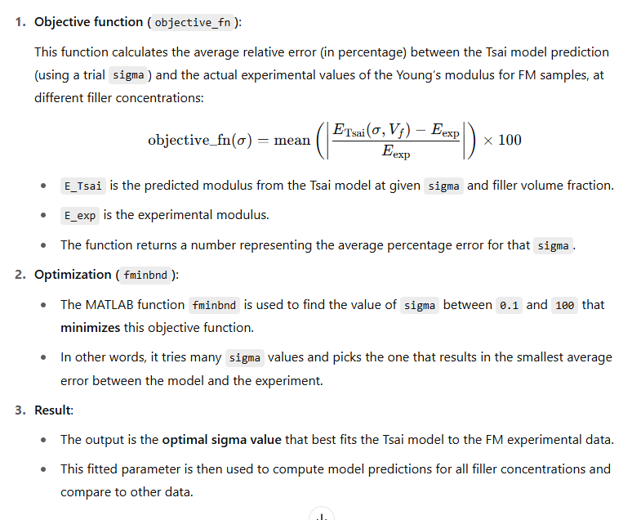

Final selection
Guth A=3 B=0.3
Tsai Sigma = 17.5

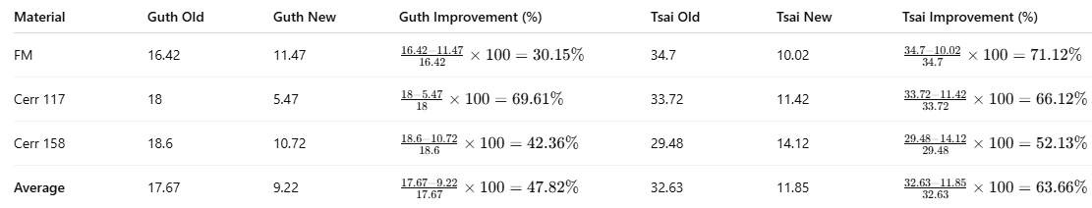

Model | Average % Improvement

Guth | 47.82%

Tsai | 63.66%
Assu


Considering the analysis; Guth model has been selected considering the less error.

Kruskal-wallis test has been used to identify the
Concentration 10%:
p-value = 0.3679
➤ No significant difference between materials

Optimization for A and B
Optimizer | A | B | FM | Cerr 117 | Cerr 158 | Average
FM | 0.99 | 0.01 | 9.75 | 13.39 | 16.5 | 13.21
Cerr 117 | 0.89 | 0.11 | 10.02 | 11.42 | 14.1 | 11.85
Cerr 158 | 0.86 | 0.14 | 10.6 | 12.25 | 13.22 | 12.02
Buckner et al | 0.375 | 0.625 | 34.7 | 33.72 | 29.48 | 32.63

