Word layout reference
Mixed formatting: italic, Japanese 日本語, emoji ✓, and a long line that exercises wrapping.
Feature | Value | Status
Typography | 18 pt / bold | Ready
Table | Merged-independent | Ready
External link | https://example.invalid/ | Blocked
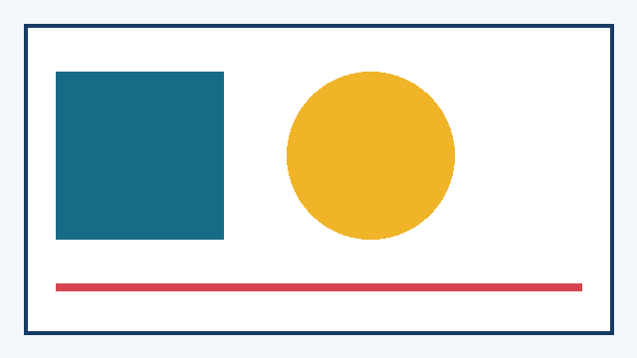
Figure 1: deterministic geometry reference

Second page
The second page verifies page breaks, headers, margins, and navigation.

