**CPMS242 Machine Learning**

**Homework 1 Report**

Group Members: Yunzhe Li (#1571061), Yong Deng (#1571065)

Date: Apr.10, 2018

# **10_Fold Cross Validation**

* Random shuffle the 100 data in the trainset, then divide it into 10 partitions equally.
* Discrete lambda from 0 to 5 with 0.1 interval.
* For each lambda, proceed the 10 fold cross validation. Then I get one test error and one train error for each lambda.
* Find the lambda with minimum test error.
* Use that lambda along with the 100 data in trainset to compute the coefficients w. That’s my optimal 9-th order polynomial model.
* Use the optimal polynomial model to predict the data in testset, and compute the sum of the square error.

Our result shows that,

* The optimal w:

[ 1.17748975e+00 -3.02485606e-01 -1.11894191e-01 2.40628377e-01

-9.48726052e-03 -3.59021142e-02 1.26988438e-03 1.85847109e-03

-3.58009594e-05 -3.17265738e-05]

* The optimal lambda is 2.8
* The minimum train RMSE is 0.9166735913611381
* The minimum test RMSE is 0.9974757376472851
* The loss in test set of my model is 5941.966776085015

Our plots are following:

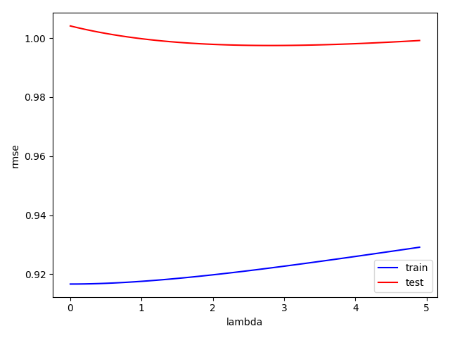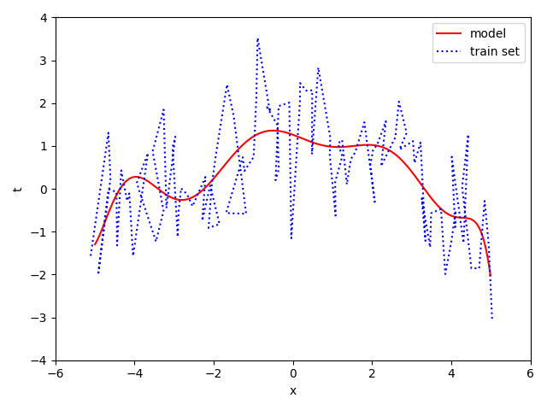

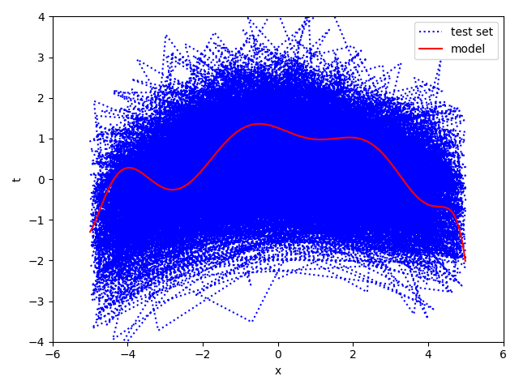

## **LOOCV**

* Random shuffle the 100 data in the trainset.
* Discrete lambda from 0 to 5 with 0.1 interval.
* For each lambda, proceed the leave one out cross validation. Then I get one test error and one train error for each lambda.
* Find the lambda with minimum test error.
* Use that lambda along with the 100 data in trainset to compute the coefficients w. That’s my optimal 9-th order polynomial model.
* Use the optimal polynomial model to predict the data in testset, and compute the sum of the square error.

Our result shows that,

* The optimal w:

[ 1.21518339e+00 -3.18628809e-01 -1.33349631e-01 2.47243865e-01

-6.27459951e-03 -3.67221444e-02 1.09492465e-03 1.89780423e-03

-3.26640365e-05 -3.23687829e-05]

* The optimal lambda is 2.2
* The minimum train RMSE is 0.9211138558950875
* The minimum test RMSE is 0.8291492656762018
* The loss in test set of my model is 5962.329077615319

The corresponding plots are following:

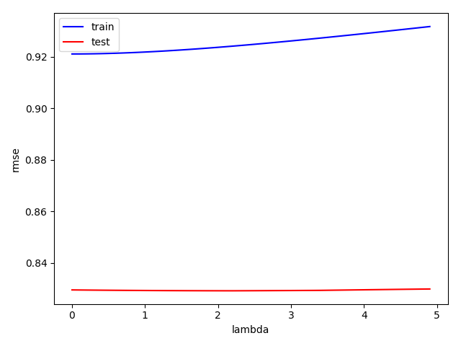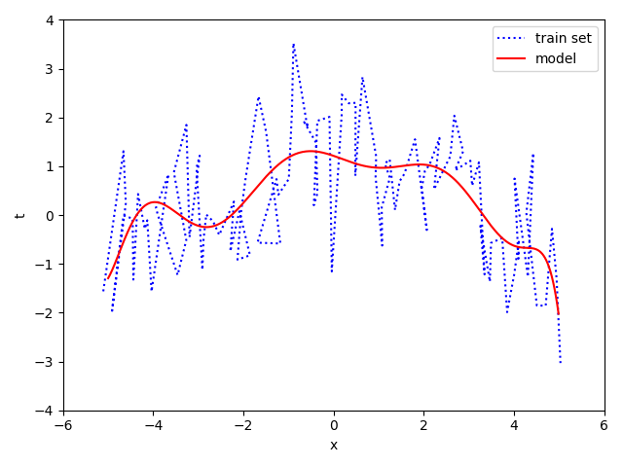

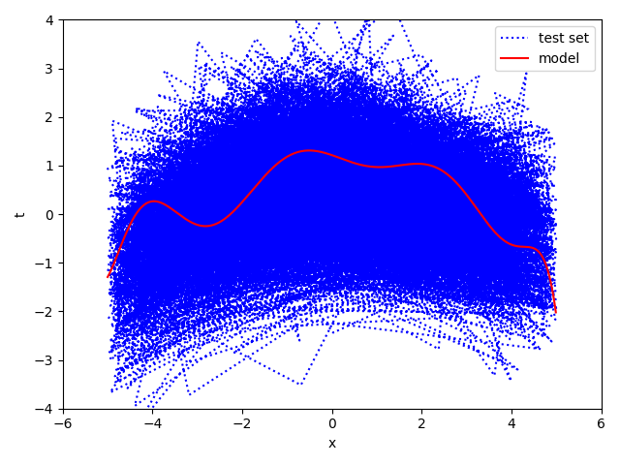

## **Appendix**

The code of the 10 fold CV:

* **Train.py**

import numpy as np  
import matplotlib.pyplot as plt  
  
out_fn = 'w.npz'  
  
x, t = [], []  
  
with open("train.txt", "r") as train:  
 for line in train:  
 row = line.split(',')  
 x.append(float(row[0]))  
 t.append(float(row[1]))  
  
x = np.asarray(x)  
t = np.asarray(t)  
  
X = np.zeros((10, 100))  
  
train = np.zeros((10, 90))  
test = np.zeros((10, 10))  
  
  
train_t = np.zeros(90)  
test_t = np.zeros(10)  
  
index = np.arange(100)  
np.random.shuffle(index)  
index = index.reshape((10, 10))  
  
  
for i in range(0, 10):  
 X[i, :] = np.power(x, i)  
  
test_err = []  
test_err = np.asarray(test_err)  
train_err = []  
train_err = np.asarray(train_err)  
  
Eye = np.eye(10)  
  
  
def rmse(predictions, targets):  
 return np.sqrt(((predictions - targets) ** 2).mean())  
  
lamda = []  
lamda = np.asarray(lamda)  
lamda_i = 0  
log_lamda = []  
log_lamda = np.asarray(log_lamda)  
  
for step in range(0, 50):  
 lamda = np.append(lamda, 0.1*step)  
  
 test_err_temp = []  
 test_err_temp = np.asarray(test_err_temp)  
 train_err_temp = []  
 train_err_temp = np.asarray(train_err_temp)  
  
 for k in range(0, 10):  
 test_index = index[k]  
 train_index = np.delete(index, k, 0).reshape(90)  
  
 ct = 0  
 for n in test_index:  
 test[:, ct] = X[:, n]  
 test_t[ct] = t[n]  
 ct = ct + 1  
  
 ct = 0  
 for m in train_index:  
 train[:, ct] = X[:, m]  
 train_t[ct] = t[m]  
 ct = ct + 1  
 w = np.dot(np.dot(np.linalg.inv((np.dot(train, train.T) + lamda[lamda_i]*Eye)), train), train_t)  
  
 train_err_temp = np.append(train_err_temp, rmse(np.dot(train.T, w), train_t))  
  
 test_err_temp = np.append(test_err_temp, rmse(np.dot(test.T, w), test_t))  
  
 lamda_i = lamda_i + 1  
 test_err = np.append(test_err, test_err_temp.mean())  
 train_err = np.append(train_err, train_err_temp.mean())  
  
# print(test_err)  
print(np.argmin(test_err))  
print(np.amin(test_err))  
# print(train_err)  
print(np.argmin(train_err))  
print(np.amin(train_err))  
  
lamda_min = 0.1*np.argmin(test_err)  
print(lamda_min)  
  
w_opt = np.dot(np.dot(np.linalg.inv((np.dot(X, X.T) + lamda_min*Eye)), X), t)  
print(w_opt)  
  
plt.plot(lamda, train_err, 'b', label='train')  
plt.plot(lamda, test_err, 'r', label='test')  
  
plt.ylabel('rmse')  
plt.xlabel('lambda')  
plt.legend()  
plt.show()  
  
np.savez(out_fn, w_opt=w_opt, lamda_min=lamda_min, test_err_min=np.amin(test_err), train_err_min=np.amin(train_err))  
  
  
exit()

* **Test.py**

import numpy as np  
import matplotlib.pyplot as plt  
  
  
def serr(predictions, targets):  
 return np.sum((predictions - targets) ** 2)  
  
  
x, t = [], []  
  
with open("test.txt", "r") as test:  
 for line in test:  
 row = line.split(',')  
 x.append(float(row[0]))  
 t.append(float(row[1]))  
  
x = np.asarray(x)  
t = np.asarray(t)  
  
parameters = np.load('w.npz')  
w = parameters['w_opt']  
lamda = parameters['lamda_min']  
test_err_min = parameters['test_err_min']  
train_err_min = parameters['train_err_min']  
  
print(w)  
print(lamda)  
print(test_err_min)  
print(train_err_min)  
  
X = np.zeros((10, len(x)))  
  
for i in range(0, 10):  
 X[i, :] = np.power(x, i)  
  
loss = serr(np.dot(X.T, w), t)  
  
x_plt = []  
x_plt = np.asarray(x_plt)  
  
for i in range(0, 1000):  
 x_plt = np.append(x_plt, -5+i*0.01)  
  
X_plt = np.zeros((10, len(x_plt)))  
  
for i in range(0, 10):  
 X_plt[i, :] = np.power(x_plt, i)  
  
plt.plot(x, t, 'b', label='test set', linestyle=':')  
plt.plot(x_plt, np.dot(X_plt.T, w), 'r', label='model')  
plt.xlabel('x')  
plt.ylabel('t')  
plt.ylim((-4, 4))  
plt.xlim((-6, 6))  
plt.legend()  
plt.show()  
  
print(loss)  
  
exit()