default account is: techcenter
Password is: bondjamesbond

to open terminal: ctrl + alt + T

How to wipe a drive.
Step one: Either double click on drivewiper5001.sh or
Step Two: hit ctrl + alt + t
Step Three: cd ~/Desktop
Step Four: ./drivewiper5001.sh (hit tab part way through typing to autocomplete
Step Five: hit "Y" to see list of drives
Step Five.5: See Image One
Step Six: if you're having problems determining which device you want to wipe, look at the size of the drives and that should help you decide which. (usually the flashdrive with be sdb, don't wipe the flash drive. Most drives you want to wipe will be 256GB or larger.)
Step Seven: Say you're wanting to wipe drive "sda" (that's most likely going to be the one to wipe) type sda then hit enter.
Step Eight. Wait until the drive is finished wiping. It will say when you're done.
Step Eight.5: See Image Two
How to find the MAC address of your machine.

Step One: double click on MACFinder.sh (Alternately you could do it the same way as you did in in "How to wipe a drive")
Step TWo: There is no step two.

Don't forget to remove this flash drive from the computer in question.

Image One: the drive you want to wipe should look like this before wiping.
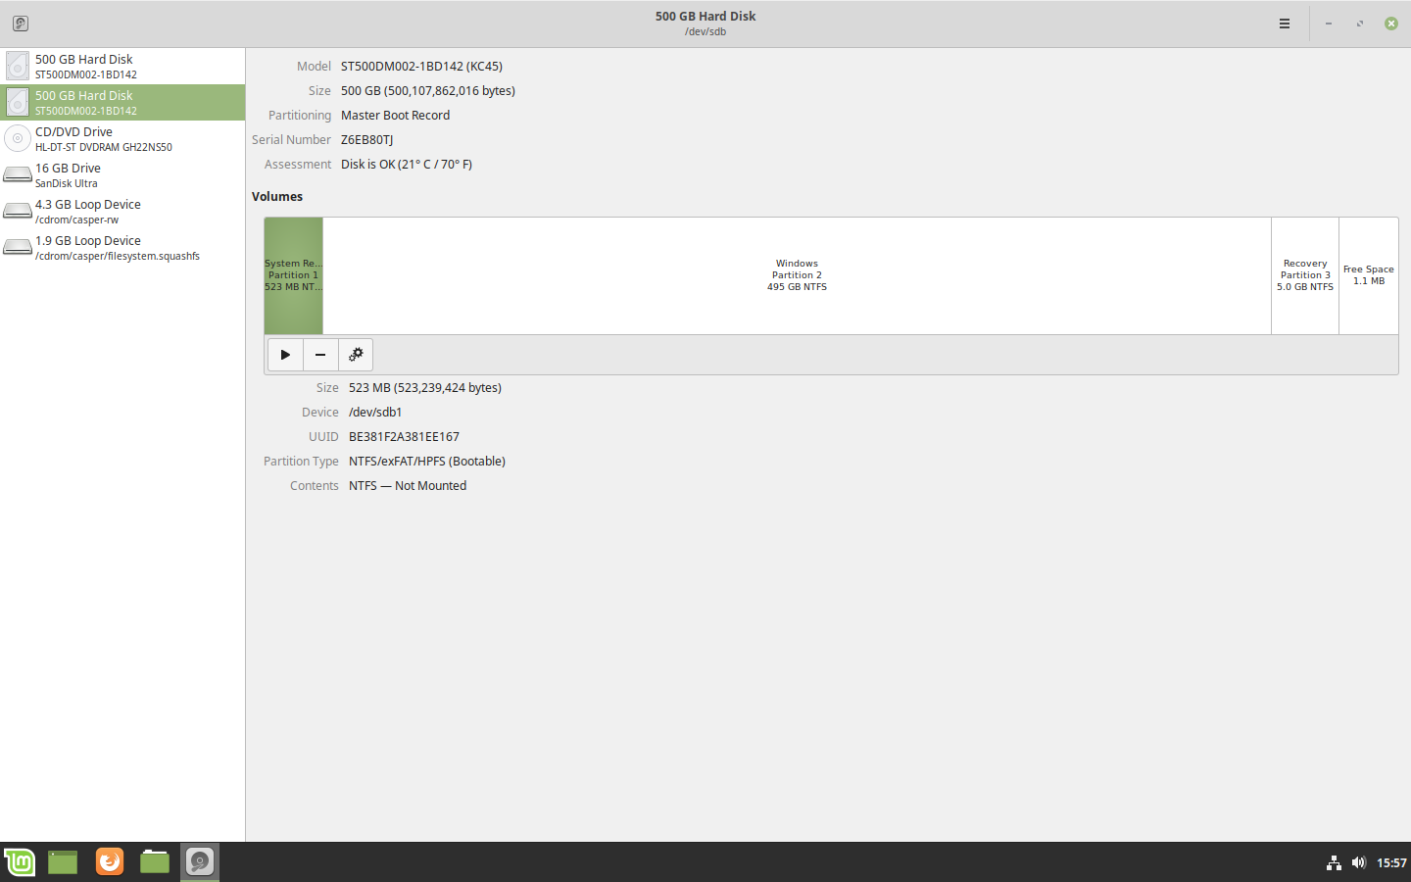
Image two: This is what a drive should look like after wiping it!
