Predicting Default with Machine Learning models
PART 2: Business Report

Marjorie Hirschi

Faculty of Computing & Data Sciences, Boston University
DX799 O2: Data Science Capstone
Joshua Von Korff, Ph.D.
April 19th, 2026

Executive Summary
This project aims to improve the financial stability of lending institutions by identifying borrowers who are at high risk of failing to repay their loans. Using approximately 400,000 historical loan records from the Lending Club platform (George, 2018), I developed a predictive system that correctly identifies 92% of high-risk borrowers before a loan is issued.
In this dataset, nearly 1 in 8.4 loans (11.88%) results in default. This means that even modest improvements in identifying risky borrowers can translate into significant financial savings and reduced losses for lenders. In addition to developing a reliable predictive model to spot risky borrowers, this project also uncovered key borrower characteristics linked to repayment behavior. Factors such as income level, loan size, loan term, and home ownership status emerged as some of the most important indicators of risk. For example, borrowers who rent their homes tend to default more often than those with mortgages. However, this does not necessarily mean that renting causes default; rather, it likely reflects broader financial circumstances such as income stability and access to credit. Grouping borrowers based on these factors revealed distinct segments with differing risk levels. Some groups showed consistently low default rates and strong financial profiles, while others presented higher risk despite appearing average on the surface. This suggests that treating all borrowers the same may overlook important differences in risk. This project provides a practical system for improving credit decisions. By integrating this system into loan approval processes, financial institutions can more quickly approve low-risk applicants while reducing exposure to high-risk loans.
To further strengthen decision-making and fairness, I recommend incorporating additional data sources, such as rent payment history, which may provide a more complete picture of a borrower’s financial behavior.
Overall, this system allows lenders to focus their attention where it matters most: preventing the small portion of loans that drive a large share of losses.

Introduction & Problem Definition

In the lending industry, profitability is dependent upon the accurate assessment of risk. Misclassifying a high-risk borrower as "safe" leads to direct financial loss, while being too conservative prevents the institution from growing its loan portfolio. Peer-to-peer lending platforms such as Lending Club generate real-world, high-dimensional credit datasets that offer an opportunity to apply machine learning methods to default prediction. This project addresses two critical questions:
- How can a financial institution accurately predict if a borrower will pay back their loan in full?
- What specific borrower traits are the most reliable indicators of default risk?

Success Criteria
At the outset of this project, the goal was to develop a system that can reliably identify at least 90% of high-risk borrowers before loans are approved. Achieving this level of accuracy would help financial institutions reduce losses and provisions, better manage risk, and protect their capital.
This project is considered successful if it enables institutions to consistently:
- Identify at least 90% of high-risk borrowers before a loan is issued as in the case of the Lending Club dataset, I have estimated that the cost of False Negative is roughly 3.5x more expansive than a False Positive (wrong rejection).
- Group borrowers into clear risk categories, making it easier to understand and manage different types of applicants
- Streamline the loan approval process, reducing both decision time and operational costs

Data Overview
As explained above, my analysis is based on historical loan data from the Lending Club platform, covering approximately 400,000 loans with 152 variables. The dataset includes information on borrower profiles, financial history, loan characteristics, and repayment outcomes.
The average borrower in the dataset earns approximately $77,000 per year, takes out loans of around $15,000, repays over a period of roughly 3.5 years and pays an average interest rate of 13%. This dataset reflects real-world lending conditions, where most borrowers repay their loans, with a meaningful minority (circa 11.88%) which defaults (see Figure 1 below).
Figure 1 - Default Class Distribution
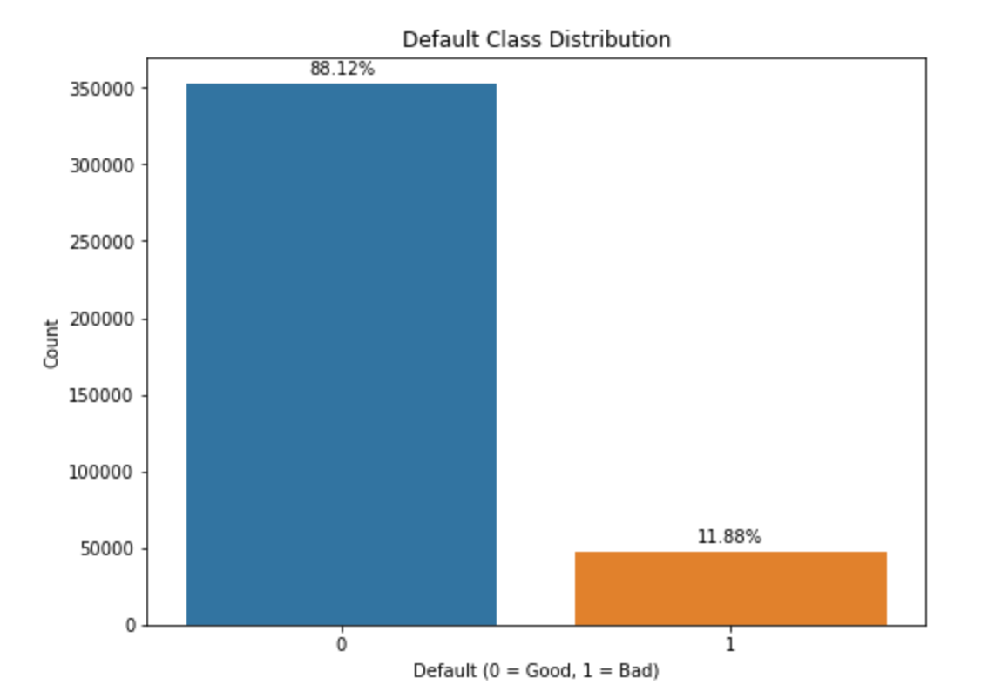

Data Preparation and Quality Checks
Before building the model, I took several steps to ensure the data was accurate and reliable. First, I removed incomplete variables with significant missing data. Second, I handled remaining missing values by using the median of each variable to avoid bias as many variable exhibited skewed distributions making the median a more appropriate measure of central tendency than the mean. Third, I excluded information not available at the time of loan approval to prevent misleading results. Fourth, I simplified the outcome into two categories: loans that were repaid and loans that defaulted.
Finally, I needed to make some adjustments to re-balance the dataset because defaults are underrepresented in the dataset (approximately 12% of loans), to ensure that the analysis would produce accurate results. These steps ensured that the model reflected realistic decision-making conditions and could be trusted in practice.

Borrower Segmentation (Clustering Analysis)
To better understand different types of borrowers, the dataset was grouped into four distinct borrower segments based on shared financial characteristics (see Table 1 below). This grouping was achieved using a Machine Learning Algorithm called K-Means. It groups similar data points together based on how far they are from their group centers, the center of each group is calculated using a measure of centrality such as the mean (Géron, 2019).
Table 1 - K-Means: Four-cluster analysis
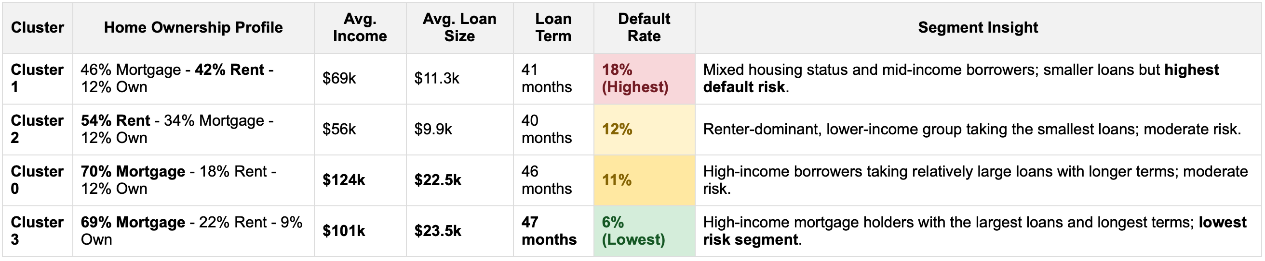
From the above, we can see that clusters/groups with high rates of mortgage ownership (0 and 3) tend to have higher incomes, larger loans, longer terms, and lower default rates. Conversely, rent-heavy clusters (2 and partly 1) generally have lower incomes, smaller loans, shorter terms, and higher default rates, especially cluster 1. In summary, mortgage ownership correlates with financial stability, renting relates to smaller loans and slightly increased risk, while longer loan terms are associated with more stable clusters. However, these relationships should be interpreted carefully. Home ownership itself is unlikely to be the direct cause of default; instead, it likely reflects broader financial stability, such as income level and access to credit. This segmentation uncovers an important point: not all borrowers should be assessed in the same way. By recognizing distinct borrower profiles, financial institutions can better tailor risk assessments, identify hidden high-risk segments and make more accurate lending decisions.

Limitations & Ethics
Although sensitive attributes are excluded, financial variables may still reflect broader socioeconomic disparities. Incorporating alternative data (e.g., rent payment history) can help improve fairness and granularity in borrower assessment. This would ensure a more precise assessment of reliable borrowers located in the ‘rent-heavy” clusters, who may currently lack a strong credit profile but could appear in their own cluster of “low default” renting borrowers.
Modeling Approach
To identify high-risk borrowers, several predictive models were tested and compared. The goal was to find a model that could reliably detect borrowers likely to default, while remaining practical and interpretable for real-world use. Two models emerged as the most effective; 1. a regularized Logistic Regression model (a simple and highly interpretable approach), 2. a Gradient Boosting model (a more complex but powerful machine learning method, more like a black-box, difficult to interpret). Since the primary business objective was to identify as many high-risk borrowers as possible, the models were specifically optimized to maximize the detection of potential defaults, rather than overall accuracy alone.
Model Performance & Results
Both models performed strongly and delivered very similar results: the logistic regression model correctly identified approximately 91–92% of high-risk borrowers while the gradient boosting model achieved a comparable detection rate of around 92%. Thus, the simpler, more transparent model, Logistic regression, performed just as well as a more complex alternative (i.e gradient boosting). Logistic regression is an alternative model to Linear Regression which is used to predict the probability of an event occurring when there are only two possible outcomes, such as “default” versus “no default” (Géron, 2019).

Despite testing more advanced techniques and additional variable transformations, no meaningful improvement in performance was achieved. This suggests that the key drivers of default risk are already well captured by the available data and that relationships in the data are relatively stable. This result has important practical and business implications:
- Transparency: a simpler model such as Logistic regression is easier to understand and explain to stakeholders and regulators. This should make it easier to pass the various audits a financial institution is subjected to.
- Implementation: simpler models are faster, easier to deploy and consume less computing power.
Thus, the simpler model, Logistic Regression is the model I recommend using in a credit approval workflow and the model I will focus on in the rest of this paper.

Model Economic Results - Impact of using the Simpler Model vs. Baseline
Using average loan characteristics from the Lending Club dataset ($15k principal, 13% interest rate, 3-year term), the simpler model delivers a substantial economic uplift compared to a no-model baseline. Without the model, expected net profit is approximately $1.31B, driven by $1.03B in default losses offset by $2.34B in interest income (see Table 2 below - refer to Appendix I for detailed calculations). When applying the model, improved risk detection (recall: 91.5%) reduces defaults significantly, lowering losses to approximately $87M from $1.03B (without model) or a preservation of capital equivalent to $0.94B. But this comes at the cost of $0.29B in foregone interest from rejected good borrowers (i.e False Positives). Overall, the model generates approximately $1.67B in net profit, representing an uplift of about $0.35B (+27%) versus baseline.

Table 2 – Final Comparison: Economic Value Analysis (see also Appendix I for further figures and analysis)
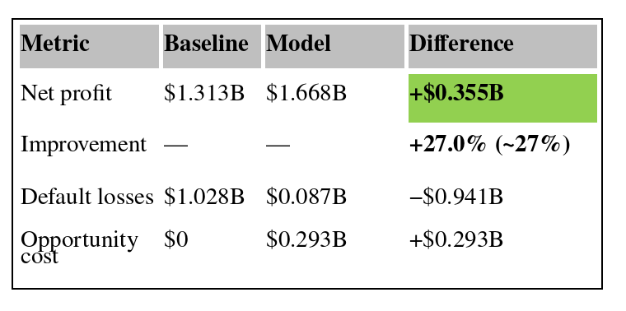
Figure 2 - Portfolio Economic Comparison: Baseline vs Model
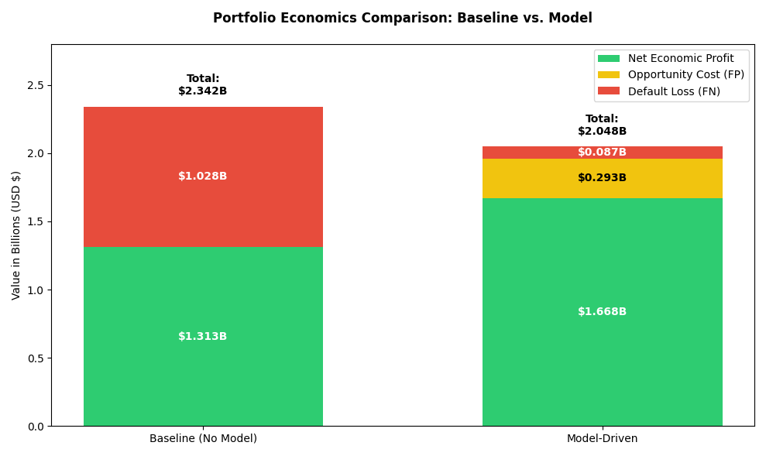
From a unit economics perspective, each missed defaulter costs approximately $22k, while each incorrectly rejected good borrower (False Positives) costs approximately $7k in lost interest. Since a false negative is roughly 3.3x more expensive than a false positive, the model’s high-recall operating point is economically optimal despite lower precision.

Conclusion and Recommendations

This project demonstrates that it is possible to reliably identify high-risk borrowers before loans are issued, with the preferred, simpler model correctly detecting approximately 92% of potential defaults. This level of performance can significantly reduce financial losses and improve overall lending decisions. Beyond prediction, the current analysis also provides important insights into borrower behavior. In particular, factors such as income, loan structure, and home ownership are closely associated with default risk, with borrowers falling into distinct groups with different risk profiles, suggesting that a one-size-fits-all approach to lending may overlook important differences between applicants. However, these patterns should be interpreted carefully. For example, higher default rates among renters are likely linked to broader financial circumstances rather than home ownership itself. This highlights an opportunity to improve both accuracy and fairness in credit decisions. Importantly, the model also delivers strong economic value relative to baseline (i.e using no models), as its higher recall substantially reduces the expected cost of defaulted loans despite a manageable increase in rejected good borrowers. Consequently, the following recommendations are proposed to enhance risk assessment and decision-making processes within loan approval workflows: first, integrate the predictive model into the credit approval workflows in order to improve the identification of high-risk applications prior to approval; second, investigate further the borrower segmentations uncovered in this analysis in order to further support tailored risk evaluations; third, incorporate alternative data sources, such as rent payment history, to strengthen assessments for individuals with limited traditional credit profiles; fourth, continuously monitor and update the model to maintain strong performance and adapt to evolving economic conditions. Finally, strategically leverage model insights to help refine pricing strategies, optimize portfolio composition, and enhance overall risk management.
References

George, N. (2018). All Lending Club loan data: 2007 through current Lending Club accepted and rejected loan dataset. Kaggle. https://www.kaggle.com/datasets/wordsforthewise/lending-club
Géron, A. (2019). Hands-On Machine Learning with Scikit-Learn, Keras, and TensorFlow (2nd ed.). O’Reilly Media. Chapter 9: Unsupervised Learning Techniques – K-Means (silhouette score and diagram).
Huntington-Klein, N. (2021). The Effect: An Introduction to Research Design and Causality (1st ed.). Chapman and Hall/CRC. https://doi.org/10.1201/9781003226055

Appendix I
1. Economics units using the Average Loan Characteristics

Simplified Assumptions used to Compare Economics of Model vs No Model

- All loans have the same following three characteristics as the average loan:
- Average loan principal: $15,000
- Average interest rate: 13%
- Average loan term before repayment: 3 years

- Loan Principal is fully drawn on day 1
- No recoveries from Defaulted loans

Component | Formula | Value
Principal | — | $15,000
Interest growth factor | (1.13)³ | 1.442897
Total repayment | $15,000 × 1.442897 | $21,643
Interest income | $21,643 − $15,000 | $6,643

2. Portfolio setup (400,000 loans)

Metric | Value
Total # of loans | 400,000
Default rate | 11.88%
# Defaulters | 47,520
# Good loans | 352,480

Model performance

Metric | Value
Recall | 0.9154
Precision | 0.5409

Derived confusion matrix
Category | Count
True Positives (caught defaulters) | 43,479
False Negatives (missed defaulters) | 4,041
False Positives (rejected good loans) | 44,134
True Negatives | 308,346

Baseline (no model used)

Losses from defaults
47,520 × $21,643= ($1.028B)

Income from good loans
352,480 × $6,643 = $2.342B
Component | Value
Total revenue | $2.342B
Total losses | ($1.028B)
Net profit | $1.313B

6. With Model

Loss from missed defaulters (FN)
4,041× $21,643 = ($0.087B)

Opportunity cost from rejected good borrowers (FP)
44,134 × $6,643 = $0.293B

Income from correctly accepted good loans (TN)
308,346 × $6,643 = $2.048B

Net profit (model)
Component | Value
Income – interest revenues TN | $2.048B
Loss from missed defaulters – FN cost | ($0.087B)
Opportunity cost (rejecting GB) − FP cost | ($0.293B)
Net profit | $1.668B
- Final Comparison

6.1 Economic Value Analysis
Metric | Baseline | Model | Difference
Net profit | $1.313B | $1.668B | +$0.355B
Improvement | — | — | +27.0% (~27%)
Default losses | $1.028B | $0.087B - FN | −$0.941B
Opportunity cost | $0 | $0.293B - FP | +$0.293B

6.2 Cash Loss Analysis

Metric | Baseline | Model | Difference
Total # Defaulters | 47,520 | 47,520 | - 43,479 loans
Cash Loss (Principal) | ($0.713B) | ($0.061B) | +$0.652B Saved

7. Unit economics

Type | Cost per loan on average
False Negative | $21,643 (loss of principal + interest)
False Positive | $6,643 (loss of interest only)
Ratio | 3.26 × more expensive (FN vs FP)

Appendix – Utilization of Generative AI tools
While writing this paper, I used Grammarly to help with grammar, spelling, and clarity, as English is not my first language. I used ChatGPT to generate a few tables and assist with organizing information. All ideas, analysis, and conclusions presented in this paper are my own.

