Predicting Default with Machine Learning models
PART 1: Technical Report

Marjorie Hirschi

Faculty of Computing & Data Sciences, Boston University
DX799 O2: Data Science Capstone
Joshua Von Korff, Ph.D.
April 19th, 2026

Executive Summary
The aim of this project is to 1. predict loan default risk and 2. identify the key factors and predictors of borrowers likely to default using Machine Learning modelling. This is critical, as the pillar of a profitable financial institution is its success at predicting default risk effectively, often referred to as Probability of Default. To achieve this, the project utilizes a large subset of data from the peer-to-peer lending platform Lending Club, which is available on Kaggle (George, 2018). Using approximately 400,000 loan records and 150 loan-related features, I developed several predictive models and refined the best-performing ones. The strongest-performing models, Elastic Net Logistic Regression and Gradient Boosting, correctly classified approximately 91–92% of borrowers who ultimately defaulted. Because defaults are relatively rare events, my modeling strategy prioritized Recall over Accuracy to ensure that high-risk borrowers were detected effectively.
In addition to supervised prediction, I tested several clustering algorithms to uncover possible hidden structural borrower segments in the data. K-Means was shown to produce the best results. K-Means uncovered four major risk clusters defined by home ownership status, income level, loan size, and loan term. Borrowers with mortgages tend to have higher incomes and lower default rates, while renters generally are generally less ‘credit worthy’.
In summary, I developed two satisfactory supervised models for predicting default (test recall: 92%, meaning that 92% of defaulting borrowers are correctly identified as defaulting), as well as an unsupervised model that identified structural aspects of borrower profiles that are directly transferable to other credit-related datasets. These models, taken together, produce a holistic framework for credit risk prediction that can be adapted or extended to other credit datasets.

Introduction and Problem Definition
Predicting borrower default is the cornerstone of credit risk modeling. Financial institutions derive their profit margins through an accurate evaluation of risk, which allows them to avoid financial losses, allocate capital efficiently, and comply with regulatory standards. Misclassifying high-risk borrowers as safe can result in substantial credit losses, while lending practices that are too conservative might erode profitability and limit access to credit. Gaining a better understanding of what causes and how to anticipate defaults would benefit the entire banking system and the broader economy. Peer-to-peer lending platforms such as Lending Club generate real-world, high-dimensional credit datasets that offer an opportunity to apply machine learning methods to default prediction.

Problem Definition
The core focus of this project is to build predictive models that help financial institutions speed up the loan approval process by accurately forecasting whether a loan will be Charged Off or Fully Paid at any stage of the loan’s lifetime. Accordingly, this project pursues two related goals:
- Identify the most influential factors associated with borrower default.
- Develop a model that is adaptable and scalable to other credit datasets.

Research Questions
Thus, my research questions are directly derived from the problem definition:
- Which borrower and loan characteristics most strongly predict default?
- How much noise is embedded in loan datasets (i.e., which features are irrelevant and should be disregarded to help streamline the loan approval process)?
- Do unsupervised clustering methods reveal meaningful borrower segments associated with varying levels of default risk?
- Which models best predict default given the tabular nature of credit datasets? Will regularized linear models perform better, or will nonlinear ensemble methods outperform them in predicting default?
Success Criteria
Defaults represent the minority/positive class. The main focus of this project is to accurately predict defaulters, as missing them can be costly and may jeopardize the profitability and, thus stability of a financial institution. Consequently, I focused on maximizing the Recall and ROC-AUC metrics to evaluate model performance. The Recall rate quantifies the proportion of actual positive cases (defaulters) correctly identified by the model, while the ROC-AUC score evaluates the model’s capability to discriminate between positive and negative classes (Singh, 2024). After refining the ML models I developed to analyse this dataset, I achieved a Recall of 0.90 or more for detecting defaulters, and maintained elevated discrimination with a ROC-AUC rate of 0.90 or more.

Scope and Constraints
Given the large size and depth of features of the Lending Club dataset, I focused exclusively on a subset sample (circa 400,000 rows, 152 features) and stopped looking at the other credit datasets that were allocated to me in the previous semesters. I also purposely narrowed my focus to information available at loan origination and disregarded post-origination features, such as total_principal_received or total_late_fee_received in order to avoid data leakage.

Data Overview

The dataset consists of historical loan records from Lending Club, a peer-to-peer lending platform. The data includes borrower demographics, credit history variables, loan characteristics, and loan outcomes. As explained above, the dataset contains a pre-filtered subset of approximately 400,000 loans with 152 features. The data reflects real-world lending outcomes.

Table 1

Data Description
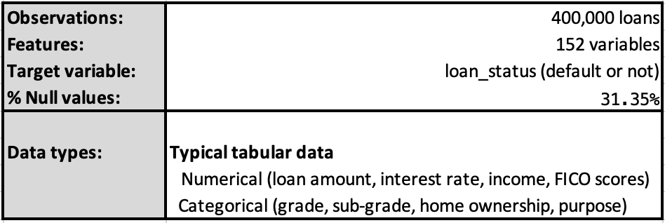
Table 2
Data Dictionary Extract – Selected Variables/Features
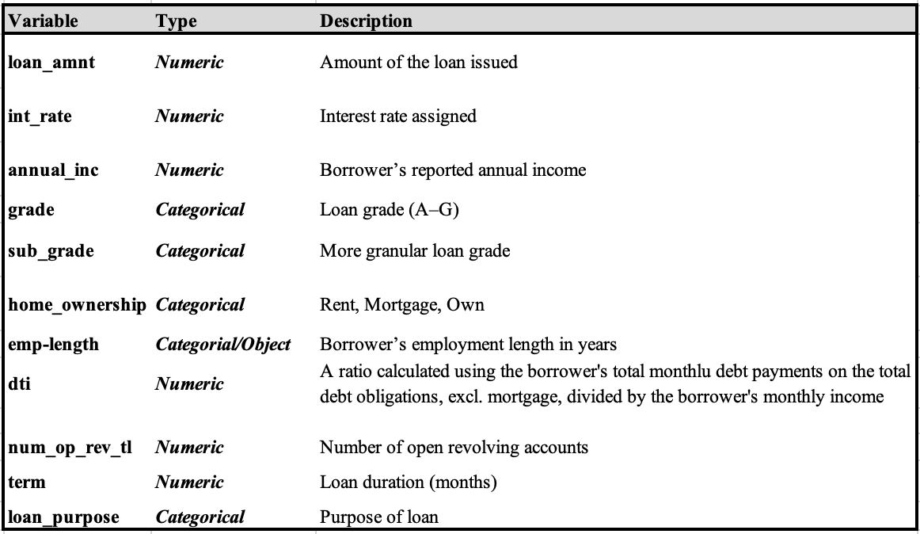

From the summary statistics table below (Table 3), we can infer that the average borrower earns an annual income of $77k and takes out a loan of approximately $15k for a 42-month term at an average interest rate of 13.1%.
Table 3
Summary Statistics

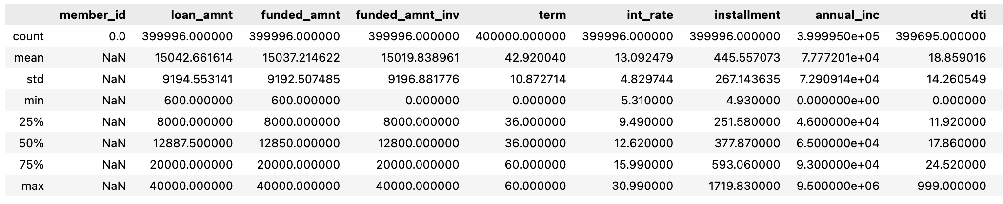

Exploratory Data Analysis

I performed a detailed EDA to investigate feature distributions, identify class imbalances, analyse relationships between predictor variables and the target, as well as detect outliers. During the EDA, I discovered the presence of potential data leakage: several features contained post-loan outcome information, which could unfairly influence model predictions. I dropped these features in the Data Cleaning phase to ensure that only data available at the time of loan origination was used. As the main objective of this project is to predict default, I converted the loan_status target feature, which contained multiple categories, into a binary variable: I encoded loans labeled as ‘Fully Paid’ and other non-default statuses as 0 (No Default), and those marked as ‘Charged Off’ as 1 (Default). Following this, it became clear that there was an important class imbalance in the target variable: the vast majority of loans were good/not charged off, in line with real-world conditions in which defaults are relatively rare (see Figure 1 below).

Figure 1
Default Class Distribution
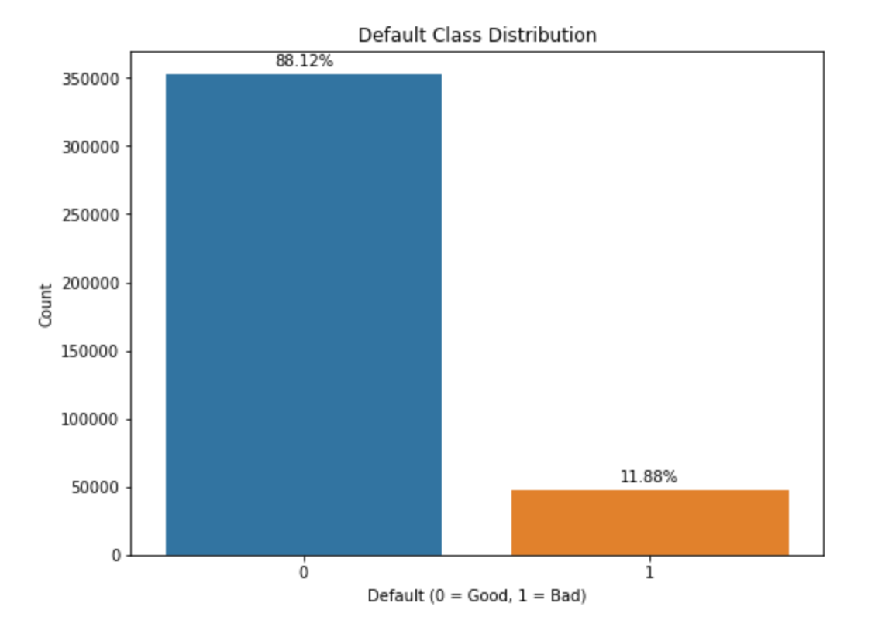
After investigating missing values, I discovered that the dataset contained numerous features with more than 65% missing values, as illustrated in Figure 2. This bar chart clearly shows that the percentage of missing values per feature drops sharply around the 65% threshold and even more noticeably after the 40% threshold. Thus, I removed features with 65% or more missing values. I then imputed the remaining missing values using the median, as many features exhibited skewed distributions making the median a more appropriate measure of central tendency than the mean.
Figure 2 - Missing Values per Variable
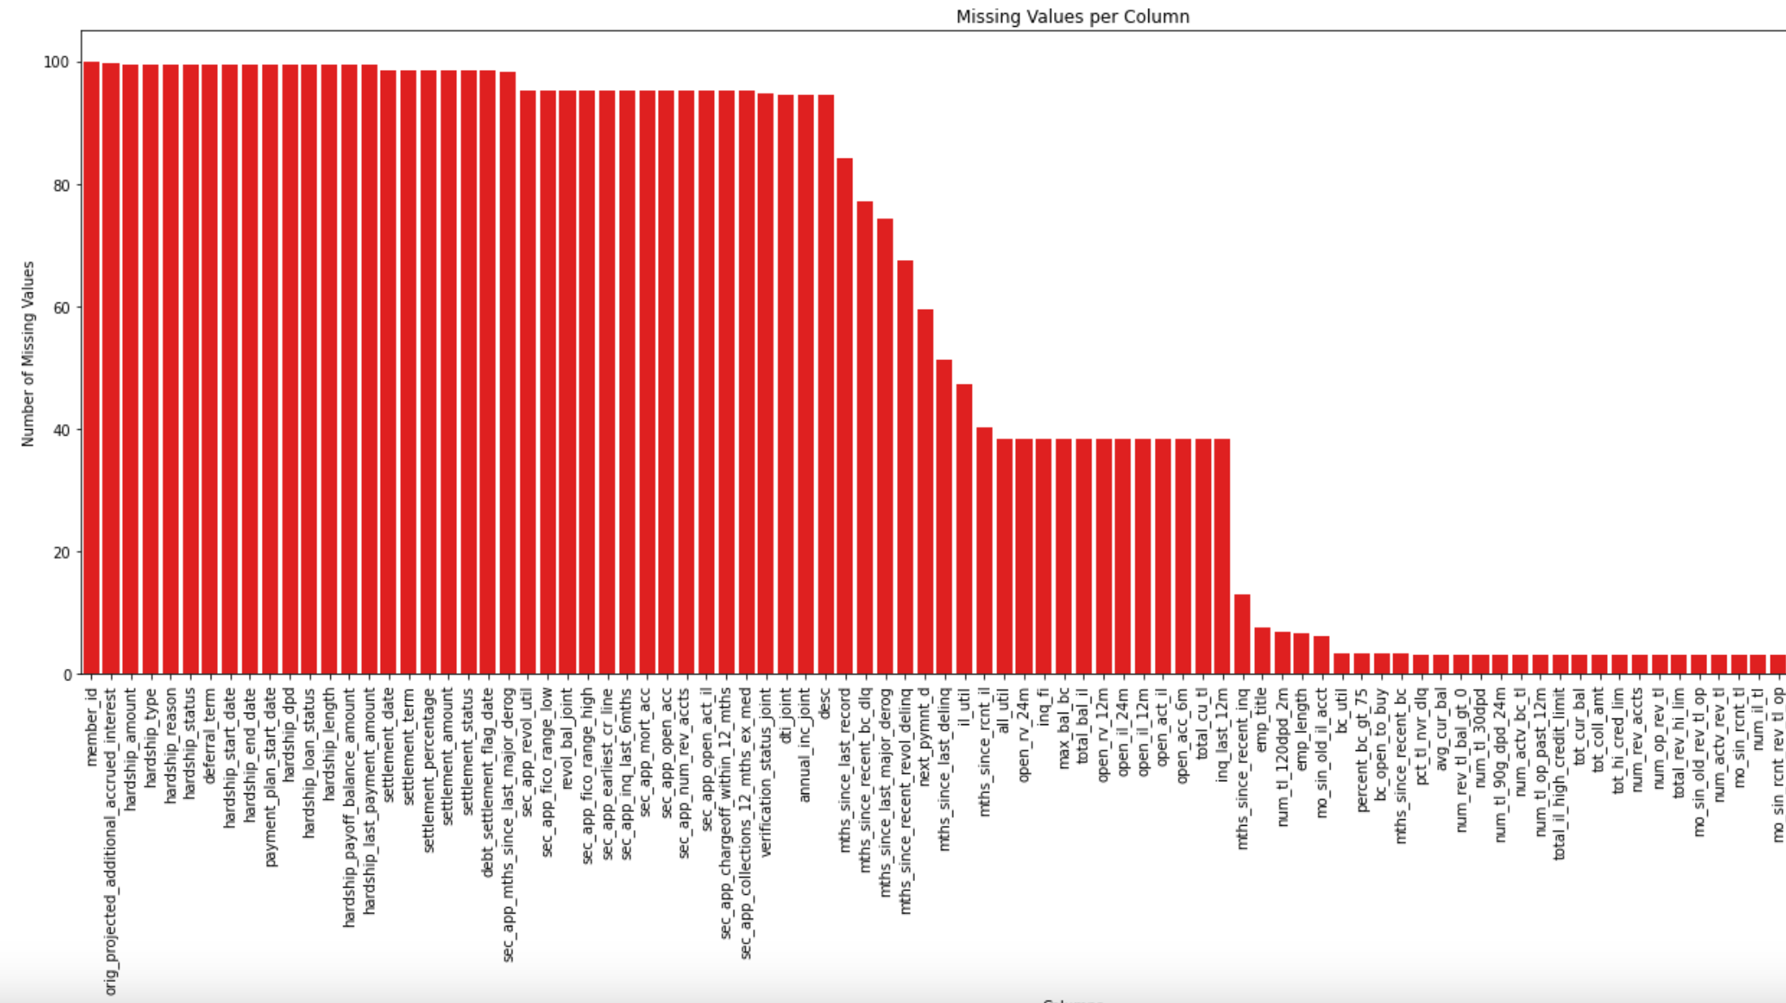

I addressed outliers by focusing primarily on extreme income values, which I considered strong indicators of potential data inconsistencies. I also removed highly multicollinear features, as they are inherently redundant. For example, variables such as funded_amnt, installment, and the sub-versions of the main FICO rating feature, more granular variants of the primary credit score, were excluded from the analysis. While higher loan amounts showed a modest positive correlation with default, loan grades (and sub-grades), as well as interest rates displayed a much stronger relationship and emerged as important predictors of default. Loan Grade and Sub-grade were particularly informative, with default rates increasing consistently with lower-grade loans (e.g., F and G). This pattern can be seen in the Figure 3 below titled Default Rate by Loan Grade.
Figure 3 - Default Rate by Loan Grade
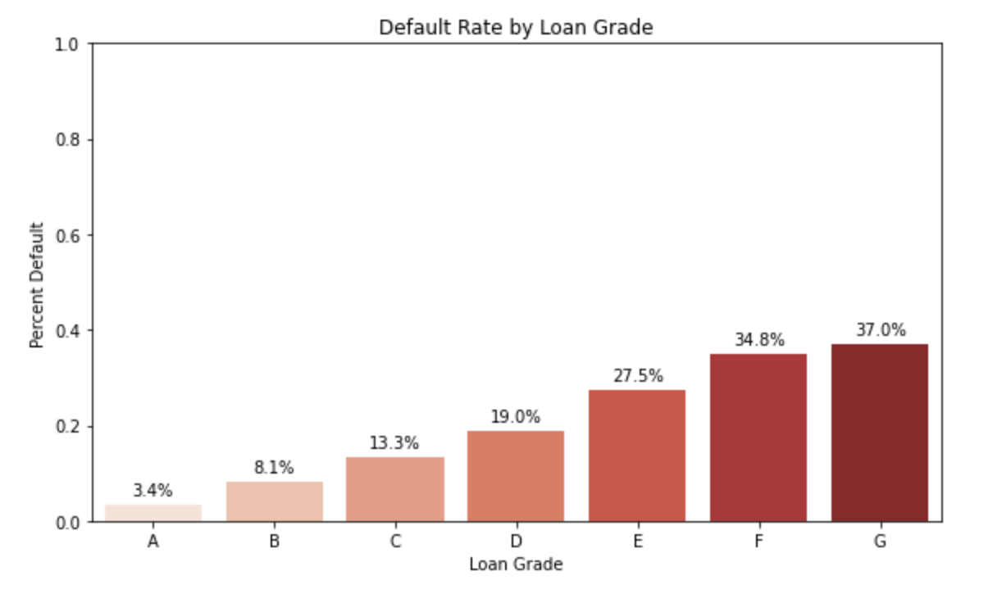

Finally, I split the dataset into training and test sets, standardized the features to prevent variables with larger magnitudes from disproportionately influencing the models, and started building several machine learning models.

EDA using Unsupervised Learning
I used various clustering models as a data exploration tool (such as DBSCAN, HAC) to identify underlying patterns in the dataset. Of all these models, K-Means was the only model that generated relevant clusters. Since K-Means is a distance-based algorithm (using Euclidean distance), it is sensitive to the scale of the features, particularly in high-dimensional spaces. To address this, I first scaled the features using StandardScaler and then reduced the dataset’s dimensionality to two principal components using PCA. Because the number of clusters (k) is a hyperparameter of K-Means, I selected the optimal value using:
- the Inertia metrics, that is, the mean squared distance between each instance and its closest centroid (with the Elbow Method) (Géron, 2019), and
- the Silhouette scores, which measures separation and cohesion of clusters (Géron, 2019).
I computed both metrics for k = 2 to 10. The elbow curve showed a gradual decrease but no sharp “angle,” so no obvious cluster count seemed apparent. Silhouette scores peaked around k = 4 to k = 6. I used k=6 and k=4 to produce two silhouette graphs/diagrams. Based on the shapes of the clusters represented in the silhouette diagrams and the vertical dashed line indicating the silhouette score, I decided to focus on four clusters (Géron, 2019): the silhouette score was higher for them - see silhouette diagram below for four clusters.

Figure 4 - K-Means Silhouette Plot and 2D Visualization using PCA
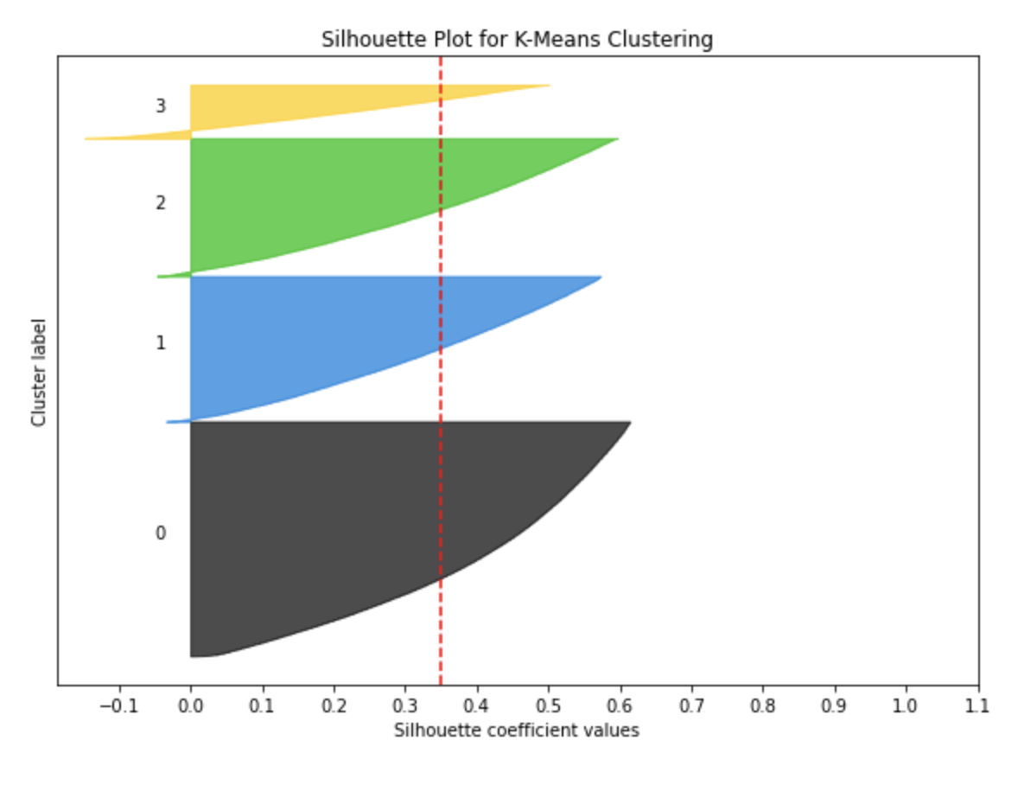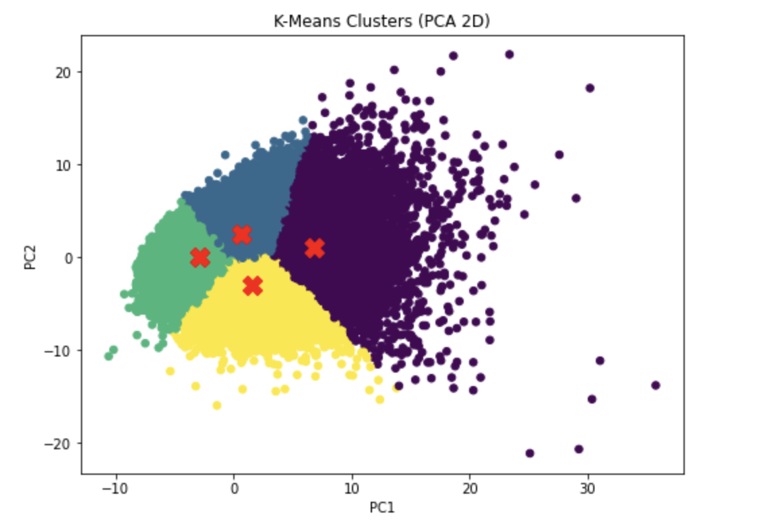
The most paramount conclusion I derived from the four-cluster analysis (see Table 4 below) was that the likelihood of ‘default’ primarily depends on whether a borrower rents, has a mortgage, or owns a home.
Table 4 - K-Means: Four-cluster analysis
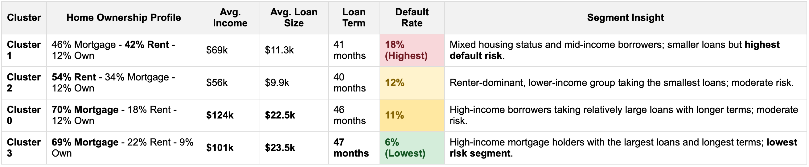
From the above, I concluded that clusters with high rates of mortgage ownership (0 and 3) tend to have higher incomes, larger loans, longer terms, and lower default rates. Conversely, rent-heavy clusters (2 and partly 1) generally have lower incomes, smaller loans, shorter terms, and higher default rates, especially cluster 1. In summary, mortgage ownership correlates with financial stability, renting relates to smaller loans and slightly increased risk, while longer loan terms are associated with more stable clusters. The below graphs (Figure 5 & 6) confirm that clusters differ materially in their risk profiles, confirming that my final K-Means model with four clusters, uncovered meaningful, structural subgroups among borrowers.
Figure 5 Figure 6
Loan Amount Distribution Across Clusters Credit History Distribution Across Clusters
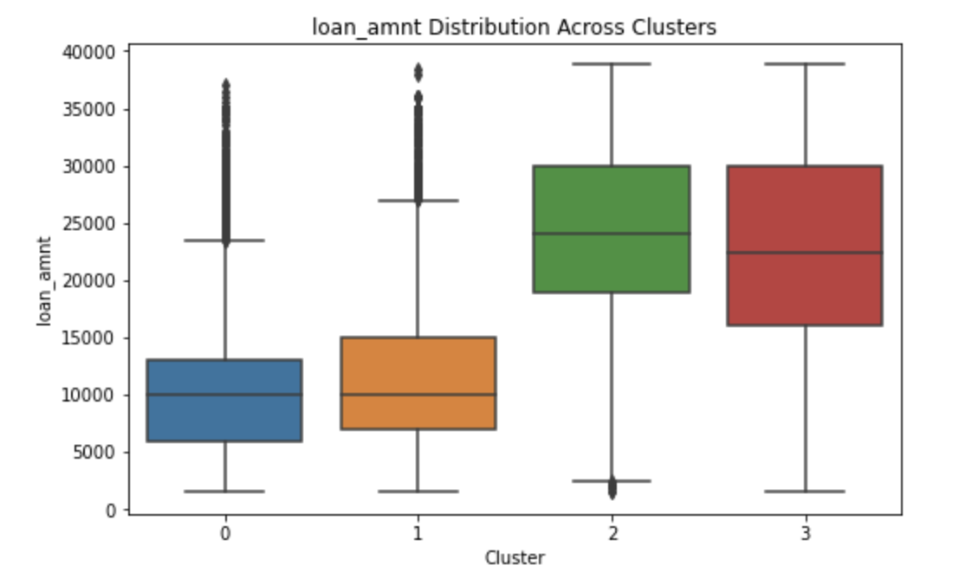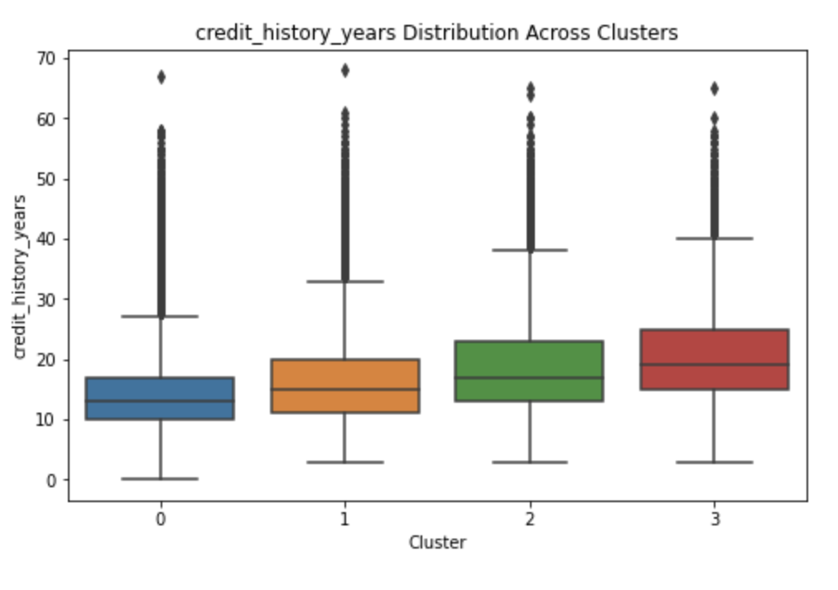
From Correlation to Causal Inference: Propensity Score Matching
While the K-Means clustering analysis revealed that rent-heavy clusters exhibit higher default rates, these results remain correlational. Borrowers who rent differ from those with mortgages across several variables, including income, loan size, and credit history. To further investigate whether home ownership status itself is associated with default risk,independent of these confounding variables, I propose extending the analysis using Propensity Score Matching (PSM) going forward. PSM is a technique used to reduce selection bias in observational datasets by constructing a control group that is statistically similar to the treatment group (Huntington-Klein, 2021, Chapter 14.5). In this context:
- Treatment group: Borrowers who rent
- Control group: Borrowers with mortgages
In the context of this analysis, the propensity score would be the probability of being a renter conditional on observed characteristics (Huntington-Klein, 2021, Chapter 14.5). I would estimate this probability using a logistic regression model, where the dependent variable is home ownership status (i.e renter vs. mortgage holder), and the independent variables include key borrower and loan attributes such as Annual income, Loan amount, Loan term, Debt-to-income ratio and Credit history indicators (e.g., FICO score). Using these estimated propensity scores, renters would be matched to mortgage holders with similar profiles (e.g., via nearest-neighbor matching). This would create a balanced sample in which the two groups are comparable across covariates. Once matched, I would compare default rates between the two groups to estimate the Average Treatment Effect on the Treated (ATT) (Huntington-Klein, 2021). This would allow to answer this refined research question: Among borrowers with similar financial profiles, does renting remain associated with a higher probability of default? If the difference in default rates remains statistically significant after matching, this would suggest that renting is independently associated with higher credit risk. Conversely, if the difference decreases or disappears, it would indicate that the higher default rates observed in the clustering analysis are mainly driven by other underlying financial characteristics rather than home ownership status itself.
Ethical Considerations
As noted above, the K-means clustering analysis shows that rent-heavy clusters tend to pose a higher default risk. However, I must warn against drawing conclusions too quickly given the following two weak points:
- As explained in the Correlational to Causal Inference section above, at this time of my analysis, I can only conclude that the observed relationship highlighted by the K-Means analysis is purely correlational, as a causal link has not yet been established.
- The underlying data structure likely contains structural historical biases causing the correlations and clustering resulting from K-Means. While the Lending Club dataset does not contain personally identifiable information (variables such as race or gender are prohibited by law in credit datasets), potential biases may still be reflected due to the historical data such datasets contain. For example, features such as FICO scores or debt-to-income ratios can serve as indicators of wealth accumulation and depth of credit history. These indicators tend to correlate with socioeconomic status, which in turn correlates with ethnicity, race, or gender. In other words, certain groups of borrowers, in particular, minorities and women, often have “thinner” credit histories. This occurs because some sub-groups rely primarily on cash transactions or a limited number of credit cards (one or two), which inadvertently hinders the development of a solid credit profile. In addition, structural inequalities in access to wealth-building opportunities can compromise wealth accumulation even for high-income individuals. This limited data can lead credit models to wrongfully label such borrowers as “bad credit”, despite their potential as reliable, high-quality borrowers.
Thus, to remediate these biases, I am proposing adding high-quality alternative data to this dataset, such as rent payment history by, for example, requesting recommendation letters from landlords or other alternative sources that would show good standing on rent payment and help create more granular clusters in the K-means analysis performed above. Additionally, applying Propensity Score Matching as I proposed above, could potentially help mitigate bias by distinguishing between true risk factors and proxies for socioeconomic status. If renting is no longer associated with higher default risk after matching, this would suggest that models relying heavily on home ownership may inadvertently penalize borrowers due to structural inequalities rather than actual creditworthiness.
Finally, features that introduce data leakage, such as inadvertently including post-default or post-approval information, can also create bias which is another reason why I made the decision to remove them.
Modeling and Analysis
While I experimented with many models, including Ordinary Least Squares, K-Nearest Neighbors, SVM, and Random Forest, in this section, I focused only on the experiments and results that led to my two best-performing models: Elastic Net Logistic Regression and Gradient Boosting Classifier.
Regularized Logistic Regression with Lasso, Ridge, and Elastic Net Penalties

I started by exploring some of the simplest and most interpretable models available in the supervised Machine Learning toolbox: Linear Models. Thus, I started my modeling journey by implementing Logistic Regression with Lasso, Ridge, and ElasticNet regularization. I evaluated these models using the typical classification metrics (i.e Recall, F1, Accuracy ROC AUC), and put a specific emphasis on maximizing Recall and ROC AUC (as explained above). I also used the hyperparameter, ‘class_weight:balanced’, to handle the imbalanced target feature described above (GeeksforGeeks, 2024).

Model Optimization and Evaluation
I performed GridSearchCV to identify the optimal hyperparameters for each model, using Logistic Regression as the base estimator. I evaluated all three regularization types (L1, L2, and Elastic Net) and tuned the regularization strength parameter C. For Elastic Net, I additionally tuned the l1_ratio parameter. Model selection was based on the highest recall score across cross-validation folds. As already explained, I prioritized Recall because detecting true defaulters was more important than minimizing false positives. Results are shown in the Table 5 below:
Table 5
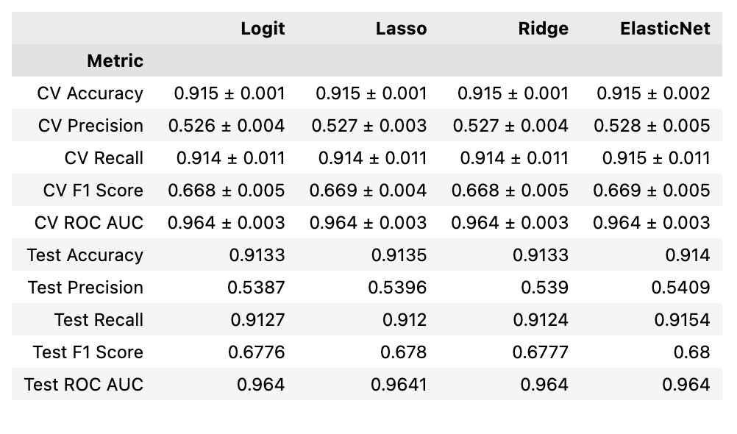
Elastic Net was the top performer of all the models evaluated during GridSearchCV, with Test Recall at 91.5%, Test F1 Score at 68.0%, Test ROC AUC at 0.964 and Test Accuracy at 91.4%.

Feature Engineering with Polynomial & Interaction Terms
Once I had reached the best ‘optimized’ Logistic Regression model, I investigated adding both a polynomial (‘int_rate_squared’) and an interaction term (‘loan_amount’ * ‘annual inc’). I then retrained this ‘best’ model (i.e, with Elastic Net penalty, C=10, l1_ratio=0.5) and found out that output results stayed in line with what I had before, but at slightly lower levels: test Recall stood at 91.2%, test F1 at 67.7%, ROC AUC at 0.964 with precision at 53.8%. Unfortunately, these newly engineered features did not add any predictive value, indicating that the regularized logistic model already captured effectively most of the predictive information within the data.

Feature Selection
I implemented Forward Feature Selection using repeated 5-fold cross-validation. Given the large size of the dataset, it was computationally expensive and took a long time to complete. Consequently, I did not conduct Backward Feature Selection. However, after running the Forward Feature Selection algorithm, the best features (65 in total) were output. I re-ran my best Logistic Regression model with the selected features only and found very similar results to those shown above. In other words, Forward Feature Selection did not add predictive value, as the ElasticNet regularization term had already “inherently” performed feature selection. Finally, I applied PCA to reduce the dimensionality of the feature space, retaining 99 principal components that explained 95% of the variance. Logistic regression was then trained on the transformed data. Surprisingly, while the model achieved high overall accuracy (94%) and strong performance on the majority class, the recall for the minority class (defaulters) dropped to 63%, compared to a 91% recall on the test set for the Elastic Net Logistic Regression model described above. Thus, PCA combined with Logistic Regression did not appear to add predictive value, as Logistic Regression with the Elastic Net penalty already performed effective feature selection by shrinking unimportant weights/coefficients. When combined with PCA, it seemed that the model underfitted the data, resulting in poorer performance.

Gradient Boosting Classifier
As for Logistic Regression, I tuned Gradient Boost using 5-fold stratified CV, thus reducing overfitting risk by averaging performance across folds. Again, I optimized for Recall since capturing defaults is the primary business goal. I also performed a randomized parameter search (30 iterations) exploring learning rate, depth, leaf constraints, and minimum leaf sizes. However, I did not initially re-balance the dataset, as it appeared that Gradient Boosting (as per Sklearn) did not include a dedicated class-weighting parameter (unlike models such as logistic regression or random forests). Consequently, the classification report showed high overall accuracy but poor recall for the minority class (circa 0.70). After investigating how to adjust class weights manually (GeeksforGeeks, 2025), I chose to apply the standard balanced weighting formula provided in the Sklearn documentation (Scikit-learn, 2025):
W_i = n_samples / (n_classes x n_i),
where n_samples is the total number of samples, n_i is the number of samples in class i,and n_classes is the number of classes.
According to Sklearn, the correct way to handle class imbalance for Gradient Boosting is to pass the sample weights calculated with the above formula directly into the fit() method. After doing so, I finally improved the model's recall to 0.92, matching the performance of the logistic regression (with Elastic Net regularization). ROC-AUC also improved to approx. 0.94 (see Classification Report below).
Figure 7 to Figure 9
Classification Report (Test Set), Confusion Matrix & ROC Curve for Gradient Boosting
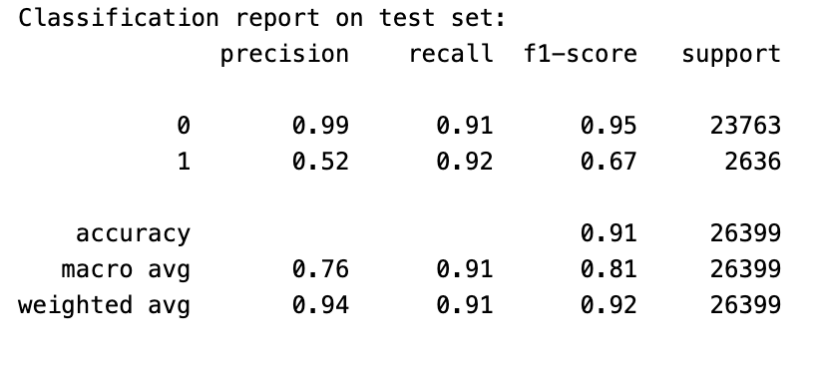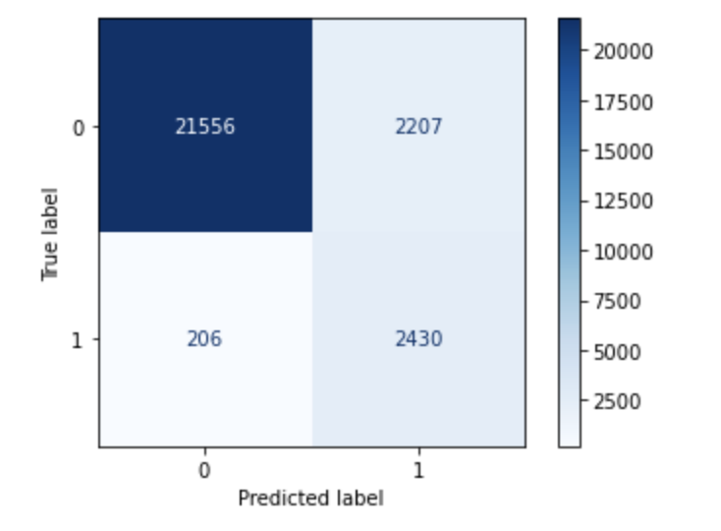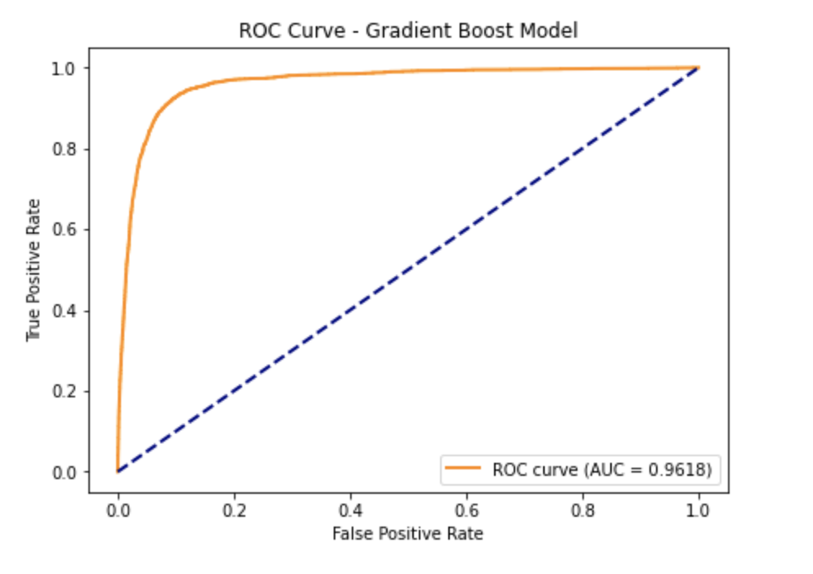
What surprised me was that Gradient Boosting did not outperform the Logistic Regression model. Instead, it achieved comparable performance. This was somewhat unexpected, as Gradient Boosting is generally better at capturing complex nonlinear relationships, although at the cost of reduced interpretability. One possible explanation is that the data’s underlying structure is largely linear, which implies that a simpler model was sufficient to capture the signal.

Results Summary
Model | Recall | ROC-AUC | Accuracy
Elastic Net Logistic | 91.5% | 0.964 | 91.4%
Gradient Boosting (weighted) | 92% | ~0.94 | 91%

Conclusion/Recommendations
Both Gradient Boosting and Elastic Net Logistic Regression were my top-performing models, with a test recall of approx. 91.5% - 92%, and a ROC AUC score of 0.964 and 0.94, respectively. Despite the slightly higher ROC AUC of Gradient Boosting, my preference goes to the Elastic Net Logistic Regression model as it balances prediction and interpretability. The Elastic Net regularization (a combination of L1 and L2 penalties) improved the model by shrinking uninformative features, enabling ‘inherent’ feature selection, thus preventing overfitting. In its current form, the model delivers strong predictive performance and effectively addresses the primary business objective: identifying potential defaulters. With over 91% recall and comparable accuracy, it demonstrates reliable classification capability.
In parallel, my K-Means Clustering analysis revealed tangible borrower segments, particularly highlighting the role of home ownership and income in risk differentiation. Thus, K-Means helped address the second objective of this project: identifying the most influential factors associated with borrower default. To further refine these clusters and promote lending fairness, I recommend incorporating non-traditional credit data, such as verified rent payment history into future versions of the dataset. This would ensure a more granular assessment of reliable borrowers located in the ‘rent-heavy” segments, who may currently lack a strong credit profile but could appear in their own cluster of “low default” renting borrowers. Additionally, I propose conducting Propensity Score Matching going forward, as it could potentially help mitigate bias by distinguishing between true risk factors from proxies for socioeconomic status. For example, if renting is no longer associated with higher default risk after matching, this would suggest that current models are capturing structural inequalities rather than true creditworthiness.
Beyond refining model parameters, I recommend revisiting EDA and exploring clustering-informed modeling approaches, where separate models are trained on borrower clusters/segments and their predictions are combined (e.g., via Ensembling). This approach could improve recall and precision by capturing segment-specific patterns that a single global model may overlook. As a further extension, a neural network could be explored to capture complex non-linear relationships and higher-order feature interactions.
In summary, I believe that the modeling framework proposed in this project is comprehensive, interpretable, adaptable, and well-aligned with the original research objectives, offering a robust foundation for scalable credit risk prediction.

References

George, N. (2018). All Lending Club loan data: 2007 through current Lending Club accepted and rejected loan dataset. Kaggle. https://www.kaggle.com/datasets/wordsforthewise/lending-club
Singh, A. (2024, October 3). ROC Curve In Machine Learning? https://www.appliedaicourse.com/blog/roc-curve-in-machine-learning
Géron, A. (2019). Hands-On Machine Learning with Scikit-Learn, Keras, and TensorFlow (2nd ed.). O’Reilly Media. Chapter 9: Unsupervised Learning Techniques – K-Means (silhouette score and diagram).
GeeksforGeeks. (2024, March 11). Weighted logistic regression for imbalanced dataset. https://www.geeksforgeeks.org/machine-learning/weighted-logistic-regression-for-imbalanced-dataset/
Brownlee, J. (2020, October 30). Cost-sensitive logistic regression for imbalanced classification. MachineLearningMastery.com. https://machinelearningmastery.com/cost-sensitive-logistic-regression/
GeeksforGeeks. (2025a, July 23). Bagging and Random Forest for imbalanced classification. https://www.geeksforgeeks.org/bagging-and-random-forest-for-imbalanced-classification/
Huntington-Klein, N. (2021). The Effect: An Introduction to Research Design and Causality (1st ed.). Chapman and Hall/CRC. https://doi.org/10.1201/9781003226055

Predicting Default with Machine Learning models
PART 2: Business Report

Marjorie Hirschi

Faculty of Computing & Data Sciences, Boston University
DX799 O2: Data Science Capstone
Joshua Von Korff, Ph.D.
April 19th, 2026

Executive Summary
This project aims to improve the financial stability of lending institutions by identifying borrowers who are at high risk of failing to repay their loans. Using approximately 400,000 historical loan records from the Lending Club platform (George, 2018), I developed a predictive system that correctly identifies 92% of high-risk borrowers before a loan is issued.
In this dataset, nearly 1 in 8.4 loans (11.88%) results in default. This means that even modest improvements in identifying risky borrowers can translate into significant financial savings and reduced losses for lenders. In addition to developing a reliable predictive model to spot risky borrowers, this project also uncovered key borrower characteristics linked to repayment behavior. Factors such as income level, loan size, loan term, and home ownership status emerged as some of the most important indicators of risk. For example, borrowers who rent their homes tend to default more often than those with mortgages. However, this does not necessarily mean that renting causes default; rather, it likely reflects broader financial circumstances such as income stability and access to credit. Grouping borrowers based on these factors revealed distinct segments with differing risk levels. Some groups showed consistently low default rates and strong financial profiles, while others presented higher risk despite appearing average on the surface. This suggests that treating all borrowers the same may overlook important differences in risk. This project provides a practical system for improving credit decisions. By integrating this system into loan approval processes, financial institutions can more quickly approve low-risk applicants while reducing exposure to high-risk loans.
To further strengthen decision-making and fairness, I recommend incorporating additional data sources, such as rent payment history, which may provide a more complete picture of a borrower’s financial behavior.
Overall, this system allows lenders to focus their attention where it matters most: preventing the small portion of loans that drive a large share of losses.

Introduction & Problem Definition

In the lending industry, profitability is dependent upon the accurate assessment of risk. Misclassifying a high-risk borrower as "safe" leads to direct financial loss, while being too conservative prevents the institution from growing its loan portfolio. Peer-to-peer lending platforms such as Lending Club generate real-world, high-dimensional credit datasets that offer an opportunity to apply machine learning methods to default prediction. This project addresses two critical questions:
- How can a financial institution accurately predict if a borrower will pay back their loan in full?
- What specific borrower traits are the most reliable indicators of default risk?

Success Criteria
At the outset of this project, the goal was to develop a system that can reliably identify at least 90% of high-risk borrowers before loans are approved. Achieving this level of accuracy would help financial institutions reduce losses and provisions, better manage risk, and protect their capital.
This project is considered successful if it enables institutions to consistently:
- Identify at least 90% of high-risk borrowers before a loan is issued as in the case of the Lending Club dataset, I have estimated that the cost of False Negative is roughly 3.5x more expansive than a False Positive (wrong rejection).
- Group borrowers into clear risk categories, making it easier to understand and manage different types of applicants
- Streamline the loan approval process, reducing both decision time and operational costs

Data Overview
As explained above, my analysis is based on historical loan data from the Lending Club platform, covering approximately 400,000 loans with 152 variables. The dataset includes information on borrower profiles, financial history, loan characteristics, and repayment outcomes.
The average borrower in the dataset earns approximately $77,000 per year, takes out loans of around $15,000, repays over a period of roughly 3.5 years and pays an average interest rate of 13%. This dataset reflects real-world lending conditions, where most borrowers repay their loans, with a meaningful minority (circa 11.88%) which defaults (see Figure 1 below).
Figure 1 - Default Class Distribution

Data Preparation and Quality Checks
Before building the model, I took several steps to ensure the data was accurate and reliable. First, I removed incomplete variables with significant missing data. Second, I handled remaining missing values by using the median of each variable to avoid bias as many variable exhibited skewed distributions making the median a more appropriate measure of central tendency than the mean. Third, I excluded information not available at the time of loan approval to prevent misleading results. Fourth, I simplified the outcome into two categories: loans that were repaid and loans that defaulted.
Finally, I needed to make some adjustments to re-balance the dataset because defaults are underrepresented in the dataset (approximately 12% of loans), to ensure that the analysis would produce accurate results. These steps ensured that the model reflected realistic decision-making conditions and could be trusted in practice.

Borrower Segmentation (Clustering Analysis)
To better understand different types of borrowers, the dataset was grouped into four distinct borrower segments based on shared financial characteristics (see Table 1 below). This grouping was achieved using a Machine Learning Algorithm called K-Means. It groups similar data points together based on how far they are from their group centers, the center of each group is calculated using a measure of centrality such as the mean (Géron, 2019).
Table 1 - K-Means: Four-cluster analysis
From the above, we can see that clusters/groups with high rates of mortgage ownership (0 and 3) tend to have higher incomes, larger loans, longer terms, and lower default rates. Conversely, rent-heavy clusters (2 and partly 1) generally have lower incomes, smaller loans, shorter terms, and higher default rates, especially cluster 1. In summary, mortgage ownership correlates with financial stability, renting relates to smaller loans and slightly increased risk, while longer loan terms are associated with more stable clusters. However, these relationships should be interpreted carefully. Home ownership itself is unlikely to be the direct cause of default; instead, it likely reflects broader financial stability, such as income level and access to credit. This segmentation uncovers an important point: not all borrowers should be assessed in the same way. By recognizing distinct borrower profiles, financial institutions can better tailor risk assessments, identify hidden high-risk segments and make more accurate lending decisions.

Limitations & Ethics
Although sensitive attributes are excluded, financial variables may still reflect broader socioeconomic disparities. Incorporating alternative data (e.g., rent payment history) can help improve fairness and granularity in borrower assessment. This would ensure a more precise assessment of reliable borrowers located in the ‘rent-heavy” clusters, who may currently lack a strong credit profile but could appear in their own cluster of “low default” renting borrowers.
Modeling Approach
To identify high-risk borrowers, several predictive models were tested and compared. The goal was to find a model that could reliably detect borrowers likely to default, while remaining practical and interpretable for real-world use. Two models emerged as the most effective; 1. a regularized Logistic Regression model (a simple and highly interpretable approach), 2. a Gradient Boosting model (a more complex but powerful machine learning method, more like a black-box, difficult to interpret). Since the primary business objective was to identify as many high-risk borrowers as possible, the models were specifically optimized to maximize the detection of potential defaults, rather than overall accuracy alone.
Model Performance & Results
Both models performed strongly and delivered very similar results: the logistic regression model correctly identified approximately 91–92% of high-risk borrowers while the gradient boosting model achieved a comparable detection rate of around 92%. Thus, the simpler, more transparent model, Logistic regression, performed just as well as a more complex alternative (i.e gradient boosting). Logistic regression is an alternative model to Linear Regression which is used to predict the probability of an event occurring when there are only two possible outcomes, such as “default” versus “no default” (Géron, 2019).

Despite testing more advanced techniques and additional variable transformations, no meaningful improvement in performance was achieved. This suggests that the key drivers of default risk are already well captured by the available data and that relationships in the data are relatively stable. This result has important practical and business implications:
- Transparency: a simpler model such as Logistic regression is easier to understand and explain to stakeholders and regulators. This should make it easier to pass the various audits a financial institution is subjected to.
- Implementation: simpler models are faster, easier to deploy and consume less computing power.
Thus, the simpler model, Logistic Regression is the model I recommend using in a credit approval workflow and the model I will focus on in the rest of this paper.

Model Economic Results - Impact of using the Simpler Model vs. Baseline
Using average loan characteristics from the Lending Club dataset ($77k principal, 13% interest rate, 3-year term), the simpler model delivers a substantial economic uplift compared to a no-model baseline. Without the model, expected net profit is approximately $6.75B, driven by $5.28B in default losses offset by $12.03B in interest income (see Table 2 below - refer to Appendix I for detailed calculations). When applying the model, improved risk detection (recall: 91.5%) reduces defaults significantly, lowering losses to approximately $449M from $5.28B (without model) or a preservation of capital equivalent to $4.83B. But this comes at the cost of $1.51B in foregone interest from rejected good borrowers (i.e False Positives). Overall, the model generates approximately $8.57B in net profit, representing an uplift of about $1.82B (+27%) versus baseline.

Table 2 – Final Comparison: Economic Value Analysis (see also Appendix I for further figures and analysis)
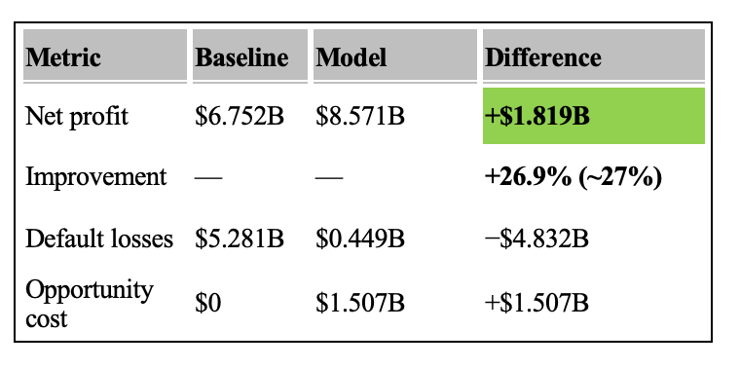
Figure 2 - Portfolio Economic Comparison: Baseline vs Model
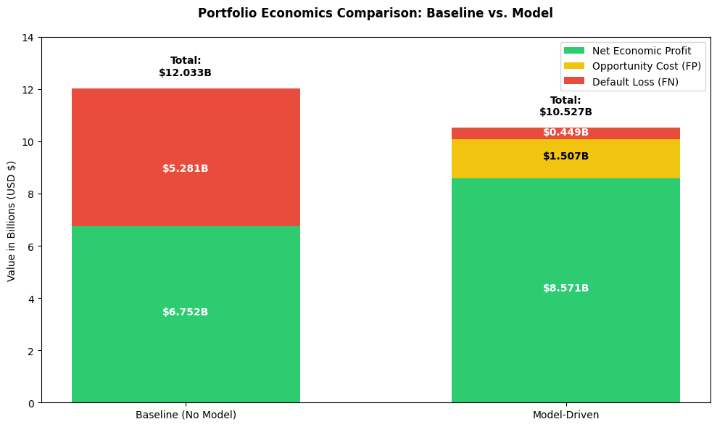
From a unit economics perspective, each missed defaulter costs approximately $111k, while each incorrectly rejected good borrower (False Positives) costs approximately $34k in lost interest. Since a false negative is roughly 3.3x more expensive than a false positive, the model’s high-recall operating point is economically optimal despite lower precision.

Conclusion and Recommendations

This project demonstrates that it is possible to reliably identify high-risk borrowers before loans are issued, with the preferred, simpler model correctly detecting approximately 92% of potential defaults. This level of performance can significantly reduce financial losses and improve overall lending decisions. Beyond prediction, the current analysis also provides important insights into borrower behavior. In particular, factors such as income, loan structure, and home ownership are closely associated with default risk, with borrowers falling into distinct groups with different risk profiles, suggesting that a one-size-fits-all approach to lending may overlook important differences between applicants. However, these patterns should be interpreted carefully. For example, higher default rates among renters are likely linked to broader financial circumstances rather than home ownership itself. This highlights an opportunity to improve both accuracy and fairness in credit decisions. Importantly, the model also delivers strong economic value relative to baseline (i.e using no models), as its higher recall substantially reduces the expected cost of defaulted loans despite a manageable increase in rejected good borrowers. Consequently, the following recommendations are proposed to enhance risk assessment and decision-making processes within loan approval workflows: first, integrate the predictive model into the credit approval workflows in order to improve the identification of high-risk applications prior to approval; second, investigate further the borrower segmentations uncovered in this analysis in order to further support tailored risk evaluations; third, incorporate alternative data sources, such as rent payment history, to strengthen assessments for individuals with limited traditional credit profiles; fourth, continuously monitor and update the model to maintain strong performance and adapt to evolving economic conditions. Finally, strategically leverage model insights to help refine pricing strategies, optimize portfolio composition, and enhance overall risk management.
References

George, N. (2018). All Lending Club loan data: 2007 through current Lending Club accepted and rejected loan dataset. Kaggle. https://www.kaggle.com/datasets/wordsforthewise/lending-club
Géron, A. (2019). Hands-On Machine Learning with Scikit-Learn, Keras, and TensorFlow (2nd ed.). O’Reilly Media. Chapter 9: Unsupervised Learning Techniques – K-Means (silhouette score and diagram).
Huntington-Klein, N. (2021). The Effect: An Introduction to Research Design and Causality (1st ed.). Chapman and Hall/CRC. https://doi.org/10.1201/9781003226055

Appendix I
1. Economics units using the Average Loan Characteristics

Simplified Assumptions used to Compare Economics of Model vs No Model

- All loans have the same following three characteristics as the average loan:
- Average loan principal: $77,000
- Average interest rate: 13%
- Average loan term before repayment: 3 years

- Loan Principal is fully drawn on day 1
- No recoveries from Defaulted loans

Component | Formula | Value
Principal | — | $77,000
Interest growth factor | (1.13)³ | 1.442897
Total repayment | $77,000 × 1.4428 | $111,144
Interest income | $111,144 − $77,000 | $34,144

2. Portfolio setup (400,000 loans)

Metric | Value
Total # of loans | 400,000
Default rate | 11.88%
# Defaulters | 47,520
# Good loans | 352,480

Model performance

Metric | Value
Recall | 0.9154
Precision | 0.5409

Derived confusion matrix
Category | Count
True Positives (caught defaulters) | 43,479
False Negatives (missed defaulters) | 4,041
False Positives (rejected good loans) | 44,134
True Negatives | 308,346

Baseline (no model used)

Losses from defaults
47,520 × $111,144 = ($5.281B)

Income from good loans
352,480 × $34,144 = $12.033B
Component | Value
Total revenue | $12.033B
Total losses | ($5.281B)
Net profit | $6.752B

6. With Model

Loss from missed defaulters (FN)
4,041× $111,144 = ($0.449B)

Opportunity cost from rejected good borrowers (FP)
44,134 × $34,144 = $1.507B

Income from correctly accepted good loans (TN)
308,346 × $34,144 = $10.527B

Net profit (model)
Component | Value
Income – interest revenues TN | $10.527B
Loss from missed defaulters – FN cost | ($0.449B)
Opportunity cost (rejecting GB) − FP cost | ($1.507B)
Net profit | $8.571B
- Final Comparison

6.1 Economic Value Analysis
Metric | Baseline | Model | Difference
Net profit | $6.752B | $8.571B | +$1.819B
Improvement | — | — | +26.9% (~27%)
Default losses | $5.281B | $0.449B - FN | −$4.832B
Opportunity cost | $0 | $1.507B - FP | +$1.507B

6.2 Cash Loss Analysis

Metric | Baseline | Model | Difference
Total # Defaulters | 47,520 | 47,520 | - 43,479 loans
Cash Loss (Principal) | ($3.659B) | ($0.311B) | +$3.348B Saved

7. Unit economics

Type | Cost per loan on average
False Negative | $111,144 (loss of principal + interest)
False Positive | $34,144 (loss of interest only)
Ratio | 3.26 × more expensive (FN vs FP)

Appendix – Utilization of Generative AI tools
While writing this paper, I used Grammarly to help with grammar, spelling, and clarity, as English is not my first language. I used ChatGPT to generate a few tables and assist with organizing information. All ideas, analysis, and conclusions presented in this paper are my own.

