FaCTS: Fact-Conditioned Generation and Sentence-Level Verification for Clinical Note Generation from Doctor–Patient Conversations
Keerthana Saravanan | Ruchitha Reddy | Hirthick Srinivaasan
CSE AI and Robotics | CSE AI and Robotics | CSE AI and Robotics
VIT Chennai | VIT Chennai | VIT Chennai
Chennai, India | Chennai, India | Chennai, India

Abstract—Large language models (LLMs) can transform doctor–patient conversations into clinical notes, but fluent generation does not guarantee factual accuracy. Unsupported symptoms, incorrect medication dosages, altered numerical values, and reversed negation can compromise the reliability of generated documentation. This paper presents FaCTS, a fact-conditioned clinical note generation pipeline that combines rule-based clinical fact extraction, structured fact-table conditioning, large language model generation, evidence retrieval, and sentence-level verification. The system uses Llama-3.1-8B-Instruct as its generator, with a 4-bit QLoRA-adapted variant evaluated as a baseline. Extracted facts encode clinical entities and attributes, including polarity, certainty, temporality, experiencer, and numerical information. A BM25+-based retriever identifies relevant dialogue evidence, while a DeBERTa-v3 natural-language-inference model estimates sentence-level support and filters sentences classified as unsupported. Evaluation uses ACI-Bench for full clinical notes and MTS-Dialog for individual note sections. On ACI-Bench test 1, the zero-shot model obtains a ROUGE-1 score of 0.519. Fact-table conditioning reduces the reported entity-level hallucination rate to 10.6%, while verification reduces it further to 8.7%, with lower content coverage. These findings highlight the trade-off between factual precision and completeness and motivate further clinical validation.
Keywords—Clinical note generation, large language models, factual consistency, hallucination detection, doctor–patient dialogue summarization, QLoRA, BM25+ retrieval, natural language inference, clinical documentation.

Introduction

Background and Motivation
Clinical documentation is an essential component of healthcare delivery, recording patient symptoms, medical history, diagnoses, investigations, medications, and follow-up recommendations. However, preparing clinical notes from consultations can consume substantial clinician time. Ambient clinical documentation systems aim to reduce this burden by converting doctor–patient conversations into structured clinical records. Recent advances in large language models (LLMs) have made this task increasingly feasible, while publicly available datasets have enabled systematic evaluation of automated note generation [1]–[5].
Two datasets relevant to this task are ACI-Bench and MTS-Dialog. ACI-Bench contains doctor–patient encounter transcripts paired with complete clinical visit notes, whereas MTS-Dialog contains conversational data paired with individual clinical note sections [3], [4]. The MEDIQA-Chat 2023 shared task further established these datasets as benchmarks for comparing systems that generate clinical documentation from conversational input [5].

Despite these advances, clinical note generation presents a more demanding requirement than producing a readable summary. The generated note must preserve clinically significant information while remaining faithful to the source conversation. A statement may be grammatically correct and medically plausible yet still be incorrect if the patient never reported the symptom, the medication dosage was not stated, or the dialogue expressed uncertainty rather than confirmation.

Problem Statement
The central problem addressed in this work is the generation of clinically relevant notes while minimising unsupported factual statements. Given a doctor–patient dialogue D, the system generates a clinical note $\hat{Y}$ appropriate to the required output format. For ACI-Bench, the target is a complete visit note; for MTS-Dialog, it is the requested note section.

The generated note must satisfy two complementary objectives: Factual consistency and Information coverage. Under Factual consistency, clinical statements should be supported by information in the source dialogue. The system should preserve negation, medication dosages, numerical values, uncertainty, and the context in which a statement was made. Under Information coverage, the generated note should retain the clinically relevant information required for the target note, avoiding excessive omission of symptoms, history, assessments, and follow-up instructions.

These objectives can conflict. A system that generates detailed notes may introduce unsupported information, while a system that removes every uncertain statement may omit relevant clinical content. Consequently, factuality and coverage must be evaluated separately.

For example, if a patient states that they do not experience chest pain, generating “The patient reports chest pain” reverses the original meaning. Similarly, generating a medication dosage that does not appear in the dialogue introduces a specific factual error even if the medication itself was mentioned. Such errors demonstrate why lexical similarity alone is insufficient for evaluating clinical documentation [2], [6], [7].

Limitations of Existing Approaches
Existing approaches to clinical note generation include fine-tuned encoder–decoder models, prompting-based generation with large proprietary models, and parameter-efficient adaptation of open-source LLMs [1], [5], [10]–[14].
Fine-tuned models can learn the structure and style of clinical documentation from paired dialogue–note examples. Prompting-based methods can generate detailed notes without modifying model weights, while parameter-efficient techniques such as Low-Rank Adaptation (LoRA) and Quantized Low-Rank Adaptation (QLoRA) reduce the computational requirements of adapting large models [12]–[14].

However, improving note fluency or lexical overlap does not necessarily improve factual consistency. Clinical reference notes may contain information that is not explicitly stated in the associated dialogue. A model trained to reproduce such notes may therefore learn to generate plausible details without sufficient evidence in the input. Research on hallucination and fine-tuning provides additional motivation for evaluating factuality independently of conventional text-similarity metrics [8], [9], [17].

A second limitation concerns verification after generation. Sentence-level natural-language-inference (NLI) methods can help identify inconsistencies between generated statements and source evidence [15], [16]. Nevertheless, a long conversation may contain many unrelated turns, and the evidence needed to verify a particular clinical statement may be distributed across multiple turns. Verification must therefore consider both the generated sentence and the relevant dialogue context.

Proposed Approach
This paper presents FaCTS, a pipeline combining structured clinical fact extraction, fact-conditioned generation, evidence retrieval, and sentence-level verification.

The system first applies a rule-based clinical fact extractor to identify relevant entities and attributes in the dialogue. These facts are organised into a structured table that records information such as clinical category, canonical entity, polarity, certainty, temporality, experiencer, and applicable numerical or dosage attributes.

The fact table is then supplied to Llama-3.1-8B-Instruct alongside the original dialogue and generation instructions. Retaining the dialogue is important because a lexicon-based extractor may fail to identify some relevant information. A QLoRA-adapted version of the generator is also evaluated to examine how parameter-efficient fine-tuning affects generation quality and factual consistency.

Following generation, the system separates the note into sentences and retrieves potentially relevant dialogue evidence using BM25+. A DeBERTa-v3 natural-language-inference model estimates whether the retrieved evidence supports each sentence. The evaluated flag-and-drop configuration removes sentences whose support scores fall below the specified threshold. The pipeline also records sentence-level verdicts and supporting dialogue-turn identifiers, providing a basis for inspecting the evidence associated with retained statements.
The proposed approach therefore introduces two complementary constraints: fact-table conditioning before generation and evidence-based sentence filtering after generation. Their effects are evaluated separately to determine how they influence factual consistency and information coverage.

Contributions
The principal contributions of this work are as follows:
- A fact-conditioned clinical note generation pipeline that uses a structured, negation-aware fact table to guide an open-source LLM while retaining the original dialogue as additional context.
- A sentence-level evidence verification mechanism that combines retrieval and NLI to check generated statements against relevant dialogue evidence and remove statements classified as insufficiently supported.
- A comparative evaluation of zero-shot generation and QLoRA fine-tuning on ACI-Bench and MTS-Dialog, examining both text-generation metrics and entity-level factuality.
- An ablation-based assessment of the effects of fact-table conditioning and sentence filtering on hallucination rates, information coverage, negation consistency, and numerical consistency.
- Documentation of the training configuration, decoding settings, software environment, validation procedures, and known limitations of the automatic factuality measurements.

Organisation of the Paper
Section II presents related research on clinical note generation, hallucination evaluation, parameter-efficient model adaptation, and NLI-based consistency checking. Section III describes the FaCTS architecture, clinical fact extraction, fact-table construction, language-model configuration, retrieval strategy, verification procedure, and generation algorithm. Section IV presents the experimental setup and results, including datasets, implementation details, evaluation metrics, comparisons with published systems, and analyses of factuality and coverage. The paper concludes with a discussion of the findings, limitations, and directions for future work.

Literature Review and Related Research

Clinical Note Generation from Doctor–Patient Conversations
Clinical note generation aims to convert doctor–patient conversations into clear, structured medical records while preserving the important details of the consultation. Traditionally, doctors spend considerable time documenting patient symptoms, medical history, diagnoses, and treatment plans. Automating this process can reduce their workload and allow more time for patient care. However, generating a useful note requires more than simply summarizing a conversation; the system must also identify relevant information and organize it correctly.

Ben Abacha et al. introduced MTS-Dialog, a dataset containing approximately 1,700 doctor–patient dialogues paired with clinical notes, to study automatic clinical summarization [1]. Similarly, Yim et al. introduced ACI-Bench, which supports the generation of complete clinical notes from conversations [2]. These datasets provide useful benchmarks for comparing different approaches. Despite progress in language generation, producing notes that are both readable and factually accurate remains a major challenge.

Hallucination and Factual Consistency in Clinical Text
Although large language models (LLMs) can generate fluent clinical notes, they may introduce information that is not supported by the original conversation. Such errors, commonly called hallucinations, include invented symptoms, incorrect medication dosages, altered numerical values, and changes in negation. In healthcare, even a small factual error can affect how a patient's condition is understood.

Ben Abacha et al. highlighted the importance of evaluating clinical summaries using both automatic metrics and expert judgement [1]. General text-overlap measures, such as ROUGE, can indicate similarity to a reference note but may not identify every clinically important error [3]. Factual consistency therefore requires additional checks that compare generated statements against the available evidence. Natural language inference (NLI) provides one possible solution by estimating whether a statement is supported by a given text [4]. However, clinical terminology, uncertainty, and subtle differences in meaning can make reliable verification difficult.

Taken together, these studies establish that factual consistency is a distinct evaluation objective. They also motivate separate measurements of unsupported statements, omissions, negation errors, and numerical inconsistencies rather than relying exclusively on text-similarity metrics.

Parameter-Efficient Adaptation of Large Language Models
Large language models can be adapted to specialized tasks through fine-tuning, but updating all model parameters can require substantial computing resources. Parameter-efficient fine-tuning offers a more practical alternative by training only a small portion of the model while retaining most of its original weights. Hu et al. introduced Low-Rank Adaptation (LoRA), which adds trainable low-rank matrices to selected model layers [5]. Dettmers et al. extended this idea through QLoRA, combining low-rank adaptation with quantization to reduce memory requirements during fine-tuning [6].

These approaches make it easier to adapt large models using limited hardware. In clinical note generation, adaptation may help a model follow medical documentation formats and produce more task-specific responses. However, learning from training examples does not automatically prevent hallucinations. A model may still generate unsupported details even when its output resembles the expected clinical writing style. Therefore, parameter-efficient adaptation can improve task performance, but it should be complemented by methods that explicitly check factual support.

Retrieval-Based and Sentence-Level Verification

Retrieval-based verification can help address the limitations of generation and fine-tuning by checking whether each statement is supported by relevant evidence. Instead of relying only on the language model's generated output, a system first retrieves useful parts of the original conversation and then compares them with individual sentences in the clinical note. BM25 is a widely used text-retrieval method that ranks passages according to their relevance to a query [7]. The retrieved passages can then be evaluated using an NLI model to estimate whether they support a generated statement [4]. Applying verification at the sentence level allows a system to identify potentially unsupported claims without discarding the entire note.

However, this approach also has limitations: relevant evidence may not be retrieved, and subtle clinical distinctions may be missed by the verifier. Strict filtering can also remove useful information, reducing note completeness. These limitations motivate a combined approach that uses structured clinical facts, evidence retrieval, and sentence-level verification to balance factual accuracy with information coverage.

Comparison of related research
Table I summarizes selected studies relevant to the proposed approach. The comparison focuses on each study's methodological contribution and its relevance to factual clinical note generation.

TABLE I
COMPARISON OF RELATED RESEARCH
Ref. | Study / Focus | Method or Contribution | Limitation
[1] | MTS-Dialog and clinical dialogue summarisation | Provides doctor–patient dialogues paired with clinical note sections for training and evaluation. | Generated notes may still contain unsupported clinical details.
[2] | ACI-Bench for clinical note generation | Provides a benchmark for generating full clinical notes from doctor–patient conversations. | Similarity to reference notes alone does not establish factual correctness.
[3] | ROUGE-based evaluation | Measures overlap between generated and reference summaries using n-grams and sequence matching. | May not detect incorrect dosages, negation changes, or unsupported facts.
[4] | Natural Language Inference (NLI) | Classifies relationships between text pairs, including entailment, contradiction, and neutral relationships. | Performance may be affected by clinical terminology and complex dialogue context.
[5] | LoRA for parameter-efficient fine-tuning | Uses trainable low-rank updates to adapt large language models with fewer trainable parameters. | Reduces training costs but does not directly prevent hallucinations.
[6] | QLoRA for memory-efficient fine-tuning | Combines 4-bit quantisation with low-rank adapters to reduce memory requirements. | Efficient adaptation does not guarantee that generated content is supported by the source.
[7] | BM25 for information retrieval | Ranks text passages according to their relevance to a query, helping identify useful evidence. | May retrieve passages with similar wording that do not fully support a clinical statement.

Research Gap
The reviewed research suggests three gaps relevant to the design and evaluation of FaCTS.
First, benchmark performance and factual consistency are different objectives. Existing clinical dialogue generation studies provide important reference-overlap baselines, but a high ROUGE or semantic-similarity score does not establish that each generated statement is supported by the conversation. FaCTS therefore evaluates generation metrics alongside entity-level factuality measurements on ACI-Bench and MTS-Dialog.

Second, the factual effects of parameter-efficient adaptation require direct examination. QLoRA makes large language models more practical to adapt, but the resulting model may reproduce reference-note patterns without consistently grounding each statement in the source dialogue. FaCTS compares zero-shot generation with QLoRA adaptation and examines whether adding a structured fact table changes the resulting factuality and coverage.
Third, post-generation verification must account for the structure of conversational evidence. General sentence-level NLI approaches provide a basis for detecting inconsistencies, but long dialogues, short answers, negation, and numerical attributes complicate verification. FaCTS combines BM25+ evidence retrieval with NLI-based sentence scoring and evaluates the effect of filtering unsupported statements.

The resulting contribution is an integrated evaluation of fact-table conditioning and sentence-level verification, with the two interventions assessed separately. The objective is not to establish that any automatic verifier can guarantee clinical correctness, but to measure how the proposed components affect factual consistency and content coverage under the evaluated experimental conditions.

Proposed Methodology

System Architecture and Technology
FaCTS is a clinical note generation pipeline that combines rule-based fact extraction, fact-conditioned language generation, evidence retrieval, and sentence-level verification. As shown in Fig. 1, the system takes a doctor–patient dialogue as input and produces a verified clinical note as output. The architecture consists of four main stages: clinical fact extraction, fact-conditioned generation, evidence retrieval using BM25+, and sentence-level verification using natural language inference (NLI).
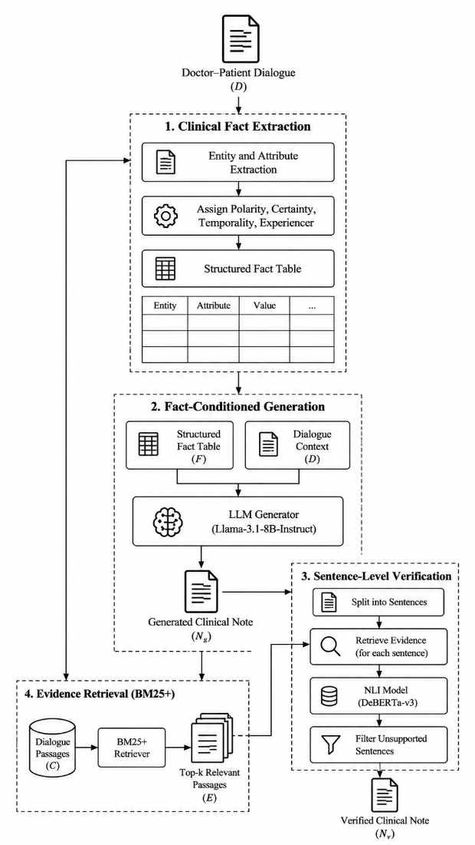
Fig. 1. System architecture of the proposed FaCTS pipeline.
The system is implemented in Python using PyTorch and the Hugging Face Transformers library. Llama-3.1-8B-Instruct is used as the main language model, while a 4-bit QLoRA-adapted version is evaluated as a baseline. Clinical facts are extracted using rule-based methods, and BM25+ retrieves relevant dialogue passages for verification. A DeBERTa-v3 NLI model evaluates whether generated sentences are supported by the retrieved evidence. The implementation uses the PEFT and bitsandbytes libraries for parameter-efficient adaptation and quantization, along with rank-bm25 for retrieval.

The pipeline applies constraints both before and after generation. Before generation, the extracted facts guide the language model and help preserve important clinical attributes. After generation, each sentence is checked against the dialogue evidence, and sentences classified as insufficiently supported are removed. This design allows the effects of fact conditioning and verification to be evaluated separately.

Stage 1: Clinical Fact Extraction
The first stage extracts clinically relevant information from the doctor–patient dialogue using a rule-based fact extraction method. The objective is to identify important clinical entities and preserve their meaning before the language model generates a note. The extractor covers eight categories: symptoms, medical history, diagnosis, medication, dosage, investigation, treatment or follow-up, and numerical information.

Each extracted fact is represented using attributes that describe its category, text, canonical form, polarity, certainty, temporality, experiencer, numerical value, and unit, where applicable. Polarity distinguishes affirmed information from negated information, while certainty identifies whether a statement is confirmed or uncertain. Temporality indicates whether the information relates to the past or present, and experiencer identifies whether it concerns the patient or another person, such as a family member.

Negation is handled using trigger-based rules inspired by NegEx. The extractor also uses dialogue context to interpret short responses. For example, a patient's response of “no” may negate the symptom mentioned in the preceding doctor's question. This helps reduce errors in which a denied symptom is incorrectly recorded as present.

The extracted facts are subsequently organised into a structured fact table. The original dialogue is retained because rule-based extraction may miss relevant information. In a manual evaluation of 40 extracted facts, 35 were initially fully correct, corresponding to 87.5%. After rule adjustments, 38 of the 40 facts were correct at the entity-and-polarity level. These results provide an initial assessment of the extractor, although the small sample does not establish its general performance across different clinical conversations.

Stage 2: Fact Table Construction and Prompt Design
After extracting clinical facts, FaCTS combines mentions referring to the same canonical entity to construct a structured fact table. When an entity appears multiple times, the system selects its status using a predefined priority order. Certain mentions are preferred over uncertain mentions, patient statements over doctor statements, and later mentions over earlier mentions. This rule provides a consistent way to resolve repeated information, although it may not capture every complex conversational situation.
The fact table organises entities by clinical category and uses tags to preserve important distinctions. These include (DENIED) for negated information, (POSSIBLE) for uncertain information, (FAMILY) for information concerning family members, and (PAST) for historical information. Medication dosages are recorded alongside their corresponding drugs to reduce the risk of separating a medicine from its stated dosage.
The generation prompt contains three components: instructions for producing the required clinical note, the structured fact table, and the original dialogue. The instructions ask the language model to use the extracted facts, preserve negation, and avoid introducing unsupported details.
The original dialogue remains in the prompt because the extractor may miss relevant information. The fact table typically occupies approximately 15–20% of the transcript length, providing a compact representation of clinical facts while retaining the full dialogue as context. This approach aims to improve factual consistency without relying entirely on the completeness of the extractor.

Stage 3: Language Model Architecture and Generation
FaCTS uses Llama-3.1-8B-Instruct as its primary language generator. The model is a decoder-only Transformer with 32 layers and a hidden dimension of 4096. It uses grouped-query attention with 32 query heads and eight key-value heads, together with rotary positional embeddings, RMSNorm, and SwiGLU feed-forward layers [18], [19]. These components support contextual processing and text generation.
The model receives the generation instructions, structured fact table, and original dialogue. It then generates a clinical note using greedy decoding, a repetition penalty of 1.1, and a maximum of 1024 new tokens. Greedy decoding selects the highest-probability next token at each step, providing a consistent generation configuration for evaluation.
A 4-bit QLoRA-adapted version is also evaluated to examine the effect of parameter-efficient fine-tuning. The configuration uses NormalFloat 4-bit quantisation, double quantisation, FP16 computation, LoRA rank 16, alpha 32, and dropout 0.05. Adapters are applied to the attention and feed-forward projection modules. Approximately 41.9 million parameters are trainable, representing about 0.52% of the model's 8.07 billion parameters.
Training uses a maximum sequence length of 4096 tokens, a microbatch size of one, gradient accumulation over 16 steps, and a learning rate of 2 × 10⁻⁴. With random seed 42, training stops after 332 optimiser steps, or approximately 1.24 epochs, because of a wall-clock limit. The best validation loss is 0.9555 at step 200, so the baseline results must be interpreted in light of the incomplete planned training schedule.

Stage 4: Evidence Retrieval Using BM25+
After generating the initial clinical note, FaCTS retrieves relevant passages from the original dialogue to support sentence-level verification. It uses BM25+, a lexical retrieval method that ranks text passages according to their relevance to a query. The retrieval parameters are k₁ = 1.5, b = 0.75, and δ = 1.
The dialogue is organised into windows containing the current turn and the preceding turn. This helps preserve local conversational context, which can be important when a patient's response depends on a doctor's earlier question. The generated note is divided into sentences, and each sentence is used to retrieve potentially relevant evidence. The system selects the top three passages for each sentence.
These passages provide focused evidence for the verifier rather than requiring every sentence to be evaluated against the entire dialogue alone. The verification process also considers the complete transcript when it fits within the model's input limit, allowing different evidence configurations to be compared.
Retrieval is not treated as proof of factual correctness. BM25+ relies on lexical relevance, so it may miss evidence expressed using different wording or retrieve passages that share terms without supporting the claim. Keeping the original dialogue available helps address some of these limitations. By linking generated sentences with potentially relevant dialogue passages, the retrieval stage provides a basis for checking factual support and inspecting the evidence behind the final note.

Stage 5: Sentence-Level Verification
FaCTS uses a DeBERTa-v3 natural language inference (NLI) model to estimate whether each generated sentence is supported by available dialogue evidence. The verifier compares a generated sentence with evidence drawn from the original conversation and assigns an entailment probability. This score estimates textual support rather than guaranteeing clinical correctness.
Three evidence configurations are evaluated: the complete transcript when it fits within the model's input limit, the top three retrieved dialogue windows, and the concatenation of the retrieved windows. For each generated sentence, the maximum entailment probability across the available configurations is used as its support score.
The system assigns one of three verdicts. Scores of at least 0.60 are classified as green, indicating stronger support. Scores from 0.30 to below 0.60 are classified as yellow, indicating uncertain support. Scores below 0.30 are classified as red, indicating insufficient support.
In the flag-and-drop configuration, red sentences are removed, while green and yellow sentences are retained. Headers and fragments shorter than three words are retained without verification. The system also records sentence-level verdicts and supporting dialogue-turn identifiers.
The thresholds and evidence-selection strategy are chosen using validation data rather than test data. However, the verifier may struggle with negation, numerical changes, and clinically equivalent expressions. Strict filtering may also remove useful information when evidence is not retrieved or recognised correctly, creating a trade-off between factual precision and information coverage.

End-to-End Generation and Verification Algorithm
The complete FaCTS pipeline combines fact extraction, structured conditioning, language generation, retrieval, and verification. First, the system receives a doctor–patient dialogue and extracts clinical entities and their attributes. Related mentions are merged into a structured fact table, which is combined with the original dialogue and generation instructions to construct the prompt.
Next, Llama-3.1-8B-Instruct generates the initial clinical note using the specified decoding configuration. The generated note is divided into sentences, and BM25+ retrieves the three most relevant dialogue windows for each sentence. The DeBERTa-v3 verifier then estimates support using the available evidence configurations and assigns a verdict to each sentence.
Sentences with support scores below 0.30 are removed in the evaluated flag-and-drop configuration. Sentences with higher scores are retained, along with short headers and fragments that bypass verification. The remaining content forms the verified clinical note.
This procedure makes the effects of fact conditioning and verification easier to evaluate separately. However, the resulting note still depends on the quality of extraction, retrieval, and verification.

Implementation Environment and Reproducibility
FaCTS is implemented using Python, PyTorch, Hugging Face Transformers, PEFT, and bitsandbytes. The rank-bm25 library supports evidence retrieval, while DeBERTa-v3 performs natural language inference. The evaluation pipeline uses ROUGE, BERTScore, and custom fact-level metrics to assess text similarity and factual consistency.
Model training and generation are conducted on Kaggle using two NVIDIA Tesla T4 GPUs, each with 16 GB of memory. Fact extraction, retrieval, verification, and evaluation are performed on a laptop equipped with an NVIDIA RTX 2050 GPU with 4 GB of memory. The reported environment includes Python 3.12, Transformers 4.57, PEFT 0.19, and bitsandbytes 0.50, alongside the other libraries used in the pipeline.
The training configuration uses random seed 42, a maximum sequence length of 4096 tokens, gradient accumulation over 16 steps, and a cosine learning-rate schedule with 3% warm-up. Training stops after 332 optimiser steps because of a wall-clock limit, with the best validation loss recorded at step 200. Generation and verification settings are documented to support repeatable evaluation.
Some dependency versions are reported as ranges in the source material rather than as a single locked environment. A dependency lockfile and repeated experiments across multiple random seeds would improve reproducibility. In addition, the fact extractor's manual evaluation uses only 40 facts, and broader validation with independent annotators would provide stronger evidence of reliability.
Overall, the methodology combines structured clinical facts with evidence-based verification to reduce unsupported statements in generated notes. The next section evaluates the pipeline on ACI-Bench and MTS-Dialog, examining generation quality, factual consistency, hallucination rates, and information coverage.

Implementation and Results

Experimental Setup
FaCTS is evaluated on ACI-Bench and MTS-Dialog to examine its performance on full clinical note generation and individual note sections. ACI-Bench is used to evaluate complete notes generated from doctor–patient conversations, while MTS-Dialog provides dialogue-summary pairs for evaluating clinical note sections.
The evaluation uses three official ACI-Bench test sets containing 40 items each, giving 120 test items in total. For MTS-Dialog, two official test sets contain 200 items each, giving 400 test items. The evaluation includes the MEDIQA-Chat Task B test set for ACI-Bench and the MEDIQA-Chat Task A and MEDIQA-Sum 2023 test sets for MTS-Dialog.
The training data comprises 67 ACI-Bench examples, 1,198 MTS-Dialog examples, and 3,000 synthetic DialogueSOAP pairs, giving 4,265 training examples. The validation set contains 220 examples: 20 from ACI-Bench, 100 from MTS-Dialog, and 100 synthetic examples. Test items are excluded from training and threshold selection.
The experiments compare zero-shot Llama-3.1-8B-Instruct, fact-table-conditioned generation, sentence-level verification, and a QLoRA-adapted baseline. Published systems are included where comparable benchmark results are available. This setup allows the study to examine both text-generation quality and factual consistency rather than relying on language similarity alone.

Evaluation Metrics
The evaluation combines text-generation metrics with measures of factual consistency and information coverage. ROUGE-1, ROUGE-2, and ROUGE-L measure overlap between generated notes and reference notes. The official MEDIQA-Chat configuration is used for ROUGE evaluation. BERTScore is also calculated using roberta-large with rescaling, but comparisons are restricted to the systems evaluated under this configuration because the shared task used a different backbone.
The hallucination rate is defined as the proportion of predicted clinical facts that are absent from the transcript. Let P denote the predicted fact set and S the facts supported by the transcript. Hallucination rate is calculated as |P \ S| / |P|. Fact precision is defined as one minus this rate.
Coverage measures the proportion of reference facts recovered in the prediction. If R is the reference fact set, coverage is calculated as |R ∩ P| / |R|. Fact recall is equivalent to coverage, and fact F1 is the harmonic mean of fact precision and recall.
Negation-flip rate measures the proportion of shared reference and prediction entities whose polarity differs. Numerical consistency is calculated as one minus the proportion of predicted numbers that are unsupported. Together, these metrics help identify errors that text-overlap scores may overlook, including incorrect numbers, altered negation, unsupported claims, and omitted clinical details.

Comparison with Published Methods
On ACI-Bench test 1, zero-shot Llama-3.1-8B-Instruct achieves a ROUGE-1 score of 0.519, which is close to GPT-4 zero-shot at 0.518. However, GPT-4 with in-context examples achieves 0.614, while fine-tuned BART reaches 0.530. Adding the fact table changes the Llama model's ROUGE-1 score from 0.519 to 0.516. Applying sentence-level verification reduces it further to 0.462, partly because unsupported sentences are removed. In Fig 2. six methods are compared on ACI-Bench test 1.
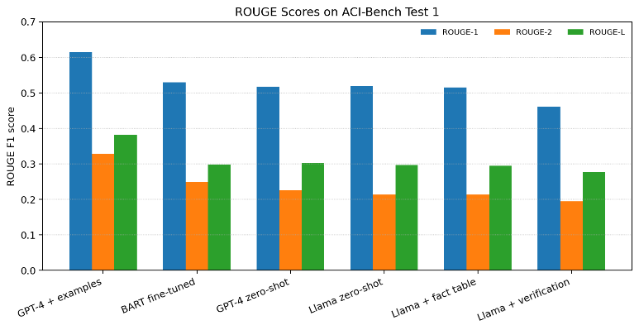
Fig 2. ROUGE scores of different methods on ACI-Bench test 1.

TABLE II
ACI-BENCH TEST 1: ROUGE F1 SCORES
Method | ROUGE-1 | ROUGE-2 | ROUGE-L
GPT-4 with in-context examples | 0.614 | 0.329 | 0.382
BART fine-tuned | 0.530 | 0.250 | 0.298
GPT-4 zero-shot | 0.518 | 0.226 | 0.303
Llama-3.1-8B-Instruct, zero-shot | 0.519 | 0.214 | 0.297
Llama-3.1-8B-Instruct with fact table | 0.516 | 0.214 | 0.295
Llama-3.1-8B-Instruct with verification | 0.462 | 0.195 | 0.277

On MTS-Dialog test 1, the QLoRA-adapted model achieves a ROUGE-1 score of 0.400, comparable to published fine-tuned systems scoring approximately 0.395–0.401. Across all 400 MTS-Dialog test items, it achieves 0.392, exceeding the reported scores of GatorTronGPT-20B with prompt tuning (0.363) and T5-Large (0.343) [12]. These comparisons show that the model can generate notes with competitive textual similarity, but ROUGE scores alone cannot establish factual reliability.

Factuality Results
The factuality evaluation examines whether generated clinical entities are supported by the dialogue and whether important information is preserved. The zero-shot model has a hallucination rate of 14.4% on ACI-Bench and 20.4% on MTS-Dialog. After QLoRA fine-tuning, these rates increase to 51.7% and 35.6%, respectively. This result indicates that improving a model's ability to follow the target note format does not necessarily improve its grounding in the source conversation.
Fact-table conditioning reduces hallucination to 10.6% on ACI-Bench and 15.8% on MTS-Dialog without reducing coverage. It also improves fact F1 from 80.9 to 82.8 on ACI-Bench and from 73.3 to 77.4 on MTS-Dialog. These findings suggest that explicitly supplying extracted clinical facts helps the generator preserve relevant information while reducing unsupported claims.
Sentence-level verification reduces hallucination further, to 8.7% on ACI-Bench and 14.2% on MTS-Dialog. However, coverage decreases by 11.6 and 10.6 percentage points, respectively, compared with fact-table conditioning alone. This trade-off occurs because the verifier can remove clinically relevant sentences when supporting evidence is not retrieved or recognised. Therefore, fact-table conditioning provides the better balance between factual consistency and coverage, while verification offers a stricter, higher-precision mode. Fig 3. shows the coverage trade-off when fact conditioning and verification are applied.

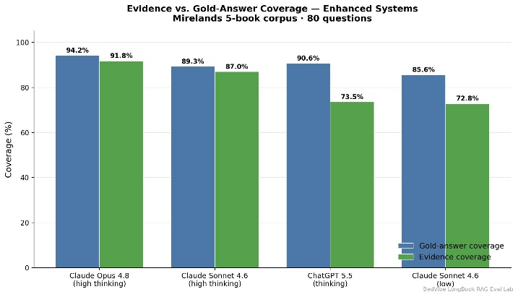
Fig 3. Content coverage across system configurations on ACI-Bench and MTS-Dialog.

Fact Extractor Validation
The rule-based fact extractor was assessed using unit tests and a small manual evaluation. The implementation includes 14 unit tests covering selected extraction behaviours. In the manual sample, 35 of 40 extracted facts were initially fully correct, corresponding to 87.5%. After rule adjustments, 38 of the 40 facts were correct at the entity-and-polarity level.
Full correctness requires the extracted fact to match the entity, canonical form, polarity, certainty, temporality, experiencer, and applicable numerical value and unit. Entity-and-polarity correctness is a narrower measure because it does not necessarily confirm every attribute. The difference between the two results highlights the importance of evaluating clinical attributes rather than checking entity names alone.
These findings provide an initial indication that the extractor can identify clinical information and handle some negation cases. However, the sample of 40 facts is too small to establish reliable general performance. The available experimental record does not document whether the facts were randomly sampled, whether different clinical categories were adequately represented, or whether two annotators independently checked the results. No adjudication procedure is documented either.
Consequently, the reported accuracy should be treated as a preliminary spot check rather than a comprehensive validation. A stronger evaluation would use a larger, stratified sample covering negation, uncertainty, medication, dosage, and numerical information, with independent annotation and documented disagreement resolution.

Verifier Validation
The verifier's evidence-selection strategy was selected using validation data. Three configurations were compared: the complete dialogue transcript, retrieved dialogue windows, and their combination. The selected maximum-support strategy uses the highest entailment probability across the available evidence configurations.
During validation, the verifier accepted 72.8% of 966 reference sentences and detected 60.6% of 302 deliberately corrupted sentences. It detected 75.4% of numerical changes but only 35.1% of negation flips. Its balanced accuracy was 0.667, compared with 0.648 when using one retrieved premise and 0.639 when using five retrieved windows. Fig 4. shows overall corrupted-sentence detection and performance on numerical changes and negation flips.
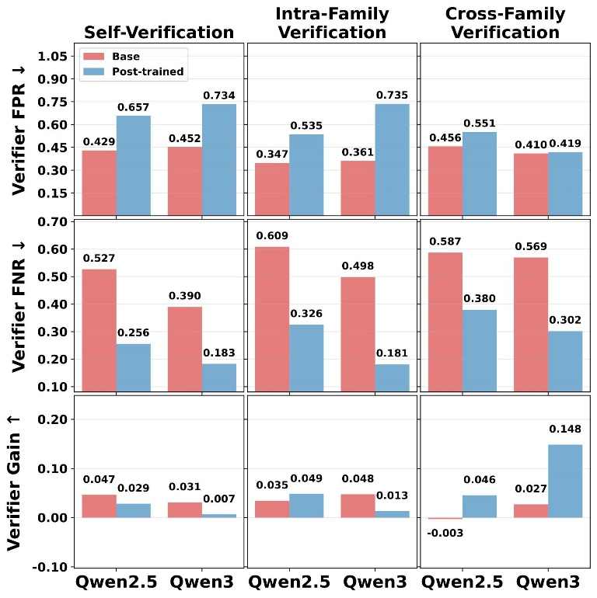
Fig 4. Detection rates of the sentence-level verifier for corrupted sentences, numerical changes, and negation flips.
These results indicate that combining evidence sources can improve verification performance, but the general-domain NLI model remains less reliable at identifying changes in clinical polarity. Negation is particularly important because reversing a statement such as a patient denying a symptom can substantially change the meaning of a clinical note.
The results also show why an entailment score should not be interpreted as definitive proof of clinical correctness. A generated sentence may be supported by evidence that the retriever fails to find, while a sentence that appears linguistically similar may contain a clinically important alteration. Further evaluation with clinical-domain verification data is therefore needed.

Discussion and Limitations
The experimental findings show that fact-table conditioning and sentence-level verification address different aspects of clinical note generation. Fact conditioning improves fact F1 and reduces hallucination while maintaining coverage. Verification reduces hallucination further, but it can remove supported information when the retrieval or NLI model fails to recognise the evidence. The two stages should therefore be viewed as complementary methods with different precision–coverage trade-offs rather than as guaranteed improvements in every metric.
The results also show that QLoRA fine-tuning can improve textual similarity without improving factual grounding. In this experiment, the fine-tuned model produces substantially more unsupported clinical entities than its zero-shot counterpart. The result should be interpreted in the context of the training setup: fine-tuning stopped after 332 optimiser steps because of a wall-clock limit, and the planned schedule was not completed.
Several limitations affect the strength of the conclusions. The fact extractor relies on rules and lexicons, its manual evaluation covers only 40 facts, and the sampling and annotation procedures are insufficiently documented. The automatic factuality metrics also have limitations: reference notes themselves produce hallucination rates of 15% on ACI-Bench and 28% on MTS-Dialog under the same measure. These figures show that the metric is a proxy for factual consistency, not clinical ground truth.
Finally, the experiments use one greedy decoding run, no clinician assessment, and no documented multi-seed evaluation. The findings are promising, but broader validation is needed before the pipeline can be considered reliable for clinical use.

Summary of Experimental Findings
The experiments support three main observations. First, zero-shot Llama-3.1-8B-Instruct achieves competitive ROUGE-1 performance on ACI-Bench test 1, with a score of 0.519. Second, fact-table conditioning reduces entity-level hallucination on both ACI-Bench and MTS-Dialog while preserving coverage, and improves fact F1 on both datasets. Third, sentence-level verification further reduces hallucination but lowers coverage because some useful statements are filtered out.
The QLoRA baseline highlights an additional concern: fine-tuning can improve the style or structure of generated notes without ensuring that their contents are supported by the dialogue. This reinforces the need to evaluate factuality alongside conventional text-generation metrics.
The verifier's validation results also reveal weaknesses in handling negation, despite better detection of numerical changes. Together, these results suggest that structured fact conditioning currently provides the most balanced configuration, while verification is useful when reducing unsupported claims is prioritised over complete information retention.
These findings should be interpreted cautiously because of the limited extractor validation, incomplete fine-tuning schedule, limitations of the automatic metrics, and absence of clinician evaluation. FaCTS should therefore be treated as a research approach for assisting clinical documentation, not as a replacement for clinician review.

Conclusion and Future Work
This paper presented FaCTS, a clinical note generation pipeline that combines rule-based fact extraction, fact-table conditioning, BM25+-based evidence retrieval, and sentence-level natural language inference (NLI) verification. The system was evaluated on ACI-Bench and MTS-Dialog to study both text-generation quality and factual consistency.
The results show that zero-shot Llama-3.1-8B-Instruct achieved a ROUGE-1 score of 0.519 on ACI-Bench test 1, comparable to GPT-4 zero-shot at 0.518. However, QLoRA fine-tuning increased the entity-level hallucination rate from 14.4% to 51.7% on ACI-Bench and from 20.4% to 35.6% on MTS-Dialog. Fact-table conditioning reduced these rates to 10.6% and 15.8%, respectively, while maintaining coverage. Sentence-level verification reduced hallucination further to 8.7% and 14.2%, but also reduced coverage by 11.6 and 10.6 percentage points compared with fact-table conditioning alone.
These findings highlight the importance of evaluating factual consistency alongside conventional text-generation metrics. They also show that stricter verification can improve factual precision while removing useful information. The current results should be interpreted cautiously because the fact extractor was evaluated on a small manual sample, QLoRA training stopped early, and the system was not assessed by clinicians.
Future work will explore a bounded repair mechanism instead of directly removing unsupported sentences, improve the verifier's handling of clinical negation and numerical information, and select model checkpoints using factuality as well as validation loss. Further work should also include a larger fact-extractor evaluation with independent annotators, multiple decoding runs, and clinician assessment. These improvements are necessary before considering the system for use beyond research and draft clinical documentation support.

References
[1] D. Van Veen et al., “Adapted large language models can outperform medical experts in clinical text summarization,” Nature Medicine, vol. 30, pp. 1134–1142, 2024, doi: 10.1038/s41591-024-02855-5.
[2] E. Asgari et al., “A framework to assess clinical safety and hallucination rates of LLMs for medical text summarisation,” npj Digital Medicine, vol. 8, 2025, doi: 10.1038/s41746-025-01670-7.
[3] W. Yim et al., “Aci-bench: A novel ambient clinical intelligence dataset for benchmarking automatic visit note generation,” Scientific Data, vol. 10, 2023, doi: 10.1038/s41597-023-02487-3.
[4] A. Ben Abacha, W. Yim, Y. Fan, and T. Lin, “An empirical study of clinical note generation from doctor-patient encounters,” in Proc. 17th Conf. European Chapter of the Association for Computational Linguistics (EACL), 2023, pp. 2291–2302, doi: 10.18653/v1/2023.eacl-main.168.
[5] A. Ben Abacha, W. Yim, G. Adams, N. Snider, and M. Yetisgen, “Overview of the MEDIQA-Chat 2023 shared tasks on the summarization & generation of doctor-patient conversations,” in Proc. 5th Clinical Natural Language Processing Workshop, 2023, pp. 503–513, doi: 10.18653/v1/2023.clinicalnlp-1.52.
[6] S. BN et al., “Fact-controlled diagnosis of hallucinations in medical text summarization,” in Proc. Interspeech, 2025, doi: 10.21437/Interspeech.2025-537.
[7] A. B. Das, S. Ahmed, and S. K. Sakib, “Hallucinations and key information extraction in medical texts: A comprehensive assessment of open-source large language models,” in Proc. IEEE Biomedical and Health Informatics (BHI), 2025, doi: 10.1109/BHI67747.2025.11269492.
[8] Z. Gekhman et al., “Does fine-tuning LLMs on new knowledge encourage hallucinations?” in Proc. Conf. Empirical Methods in Natural Language Processing (EMNLP), 2024, pp. 7765–7784, doi: 10.18653/v1/2024.emnlp-main.444.
[9] G. Kaplan, Z. Gekhman, Z. Zhu et al., “Why fine-tuning encourages hallucinations and how to fix it,” arXiv preprint, 2026.
[10] A. Sharma, D. Feldman, and A. Jain, “Team Cadence at MEDIQA-Chat 2023: Generating, augmenting and summarizing clinical dialogue with large language models,” in Proc. 5th Clinical Natural Language Processing Workshop, 2023, doi: 10.18653/v1/2023.clinicalnlp-1.28.
[11] J. Giorgi, A. Toma, R. Xie et al., “WangLab at MEDIQA-Chat 2023: Clinical note generation from doctor-patient conversations using large language models,” in Proc. 5th Clinical Natural Language Processing Workshop, 2023, doi: 10.18653/v1/2023.clinicalnlp-1.36.
[12] M. Lyu, C. Peng, X. Li et al., “Automatic summarization of doctor-patient encounter dialogues using large language model through prompt tuning,” arXiv preprint arXiv:2403.13089, 2024. Also published in the AMIA Joint Summits on Translational Science Proceedings.
[13] T. Dettmers, A. Pagnoni, A. Holtzman, and L. Zettlemoyer, “QLoRA: Efficient finetuning of quantized LLMs,” in Advances in Neural Information Processing Systems, vol. 36, 2023, doi: 10.48550/arXiv.2305.14314.
[14] E. J. Hu et al., “LoRA: Low-rank adaptation of large language models,” in Proc. International Conference on Learning Representations (ICLR), 2022, doi: 10.48550/arXiv.2106.09685.
[15] P. Laban, T. Schnabel, P. N. Bennett, and M. A. Hearst, “SummaC: Re-visiting NLI-based models for inconsistency detection in summarization,” Transactions of the Association for Computational Linguistics, vol. 10, pp. 163–177, 2022, doi: 10.1162/tacl_a_00453.
[16] K.-H. Huang, S. Singh, X. Ma et al., “SWING: Balancing coverage and faithfulness for dialogue summarization,” in Findings of the Association for Computational Linguistics: EACL, 2023, doi: 10.18653/v1/2023.findings-eacl.37.
[17] S. K. Seethakantha, D. N. Thai, V. P. Gudi et al., “Hallucination detection-guided preference optimization for clinical summarization,” arXiv preprint, 2026.
[18] A. Dubey et al. (Llama Team, Meta), “The Llama 3 herd of models,” arXiv preprint arXiv:2407.21783, 2024.
[19] A. Vaswani et al., “Attention is all you need,” in Advances in Neural Information Processing Systems, vol. 30, 2017.
[20] W. W. Chapman, W. Bridewell, P. Hanbury, G. F. Cooper, and B. G. Buchanan, “A simple algorithm for identifying negated findings and diseases in discharge summaries,” Journal of Biomedical Informatics, vol. 34, no. 5, pp. 301–310, 2001, doi: 10.1006/jbin.2001.1029.
[21] Y. Lv and C. Zhai, “Lower-bounding term frequency normalization,” in Proc. ACM International Conference on Information and Knowledge Management (CIKM), 2011, pp. 7–16.
[22] P. He, J. Gao, and W. Chen, “DeBERTaV3: Improving DeBERTa using ELECTRA-style pre-training with gradient-disentangled embedding sharing,” in Proc. International Conference on Learning Representations (ICLR), 2023.
[23] Omi Health, “medical-dialogue-to-soap-summary,” Hugging Face dataset, 2024.
[24] C.-Y. Lin, “ROUGE: A package for automatic evaluation of summaries,” in Text Summarization Branches Out: Proceedings of the ACL Workshop, 2004, pp. 74–81.
[25] T. Zhang, V. Kishore, F. Wu, K. Q. Weinberger, and Y. Artzi, “BERTScore: Evaluating text generation with BERT,” in Proc. International Conference on Learning Representations (ICLR), 2020.
[26] J. Hong, N. Lee, and J. Thorne, “ORPO: Monolithic preference optimization without reference model,” in Proc. Conf. Empirical Methods in Natural Language Processing (EMNLP), 2024, doi: 10.48550/arXiv.2403.07691.

