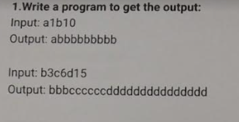

CODE :

import java.util.Scanner;

public class HelloWorld{

public static void main(String []args){

int count = 0;

String result = "";

Scanner scan = new Scanner(System.in);

System.out.println("Input : ");

String s1 = scan.nextLine();

char ch1 = s1.charAt(0);

for (int i = 0; i < s1.length(); i++) {

if (Character.isDigit(s1.charAt(i))) {

count = count * 10 + Character.digit(s1.charAt(i), 10);

} else {

for (int j = 0; j < count; j++) {

result += ch1;

}

ch1 = s1.charAt(i);

count = 0;

}

}

for (int j = 0; j < count; j++) {

result += ch1;

}

System.out.println(result);

}

}

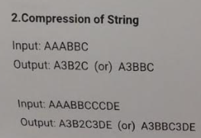

CODE :

import java.util.Scanner;

public class HelloWorld{

public static void main(String []args){

Scanner scan = new Scanner(System.in);

System.out.println("Enter the string: ");

String s = scan.nextLine();

StringBuilder result = new StringBuilder();

char currentChar = s.charAt(0);

int count = 1;

for (int i = 1; i < s.length(); i++) {

char nextChar = s.charAt(i);

if (currentChar == nextChar) {

count++;

} else {

result.append(currentChar);

result.append(count);

count = 1;

currentChar = nextChar;

}

}

result.append(currentChar);

result.append(count);

System.out.println(result.toString());

}

}

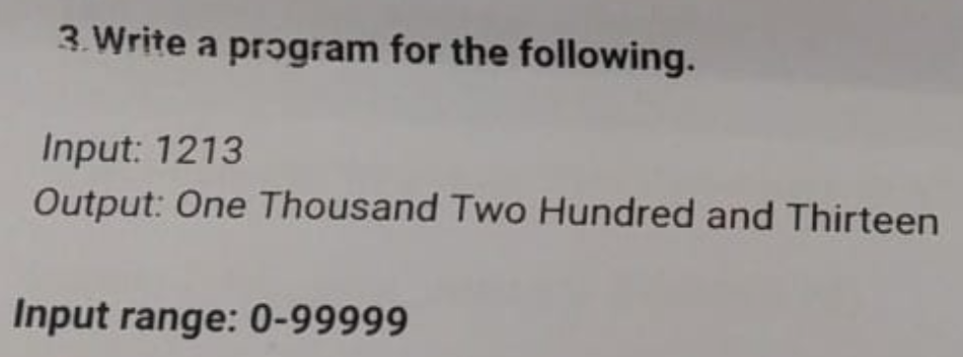

CODE :

import java.util.Scanner;

public class HelloWorld{

private static final String[] units = {"", "one", "two", "three", "four", "five", "six", "seven", "eight", "nine"};

private static final String[] teens = {"ten", "eleven", "twelve", "thirteen", "fourteen", "fifteen", "sixteen", "seventeen", "eighteen", "nineteen"};

private static final String[] tens = {"", "", "twenty", "thirty", "forty", "fifty", "sixty", "seventy", "eighty", "ninety"};

public static void main(String []args){

Scanner scanner = new Scanner(System.in);

System.out.print("Enter a number: ");

int number = scanner.nextInt();

System.out.println(convertToWords(number));

}

public static String convertToWords(int number) {

if (number == 0) {

return "zero";

}

return convertToWordsHelper(number).trim();

}

private static String convertToWordsHelper(int number) {

String words = "";

if (number < 10) {

words += units[number];

} else if (number < 20) {

words += teens[number - 10];

} else if (number < 100) {

words += tens[number / 10] + " " + units[number % 10];

} else if (number < 1000) {

words += units[number / 100] + " hundred " + convertToWordsHelper(number % 100);

} else if (number < 10000) {

words += units[number / 1000] + " thousand " + convertToWordsHelper(number % 1000);

} else {

words += "Number is too large to convert.";

}

return words;

}

}

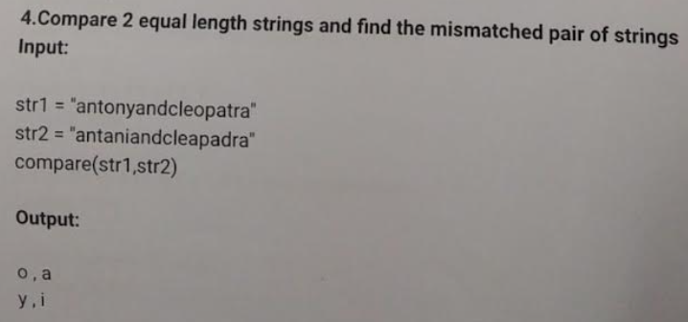

CODE :

import java.util.Scanner;

public class HelloWorld{

public static void main(String []args){

String s1="antonyandcleopatra";

String s2="antaniandcleapadra";

if(s1.length()!=s2.length()){

System.out.println("the length of strings are not equal");

}

else{

for(int i=0;i<s1.length();i++){

if(s1.charAt(i)!=s2.charAt(i)){

System.out.println(s1.charAt(i)+","+s2.charAt(i));

}

}

}

}

}

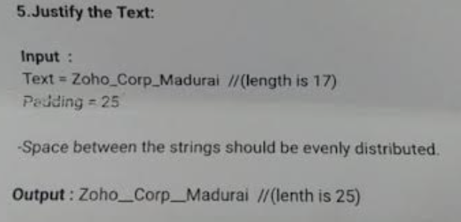

CODE :

public class HelloWorld {

public static void main(String[] args) {

String input = "zoho_corp_madurai";

int desiredLength = 25;

char paddingChar = '_';

String paddedString = padString(input, desiredLength, paddingChar);

System.out.println("Input: " + input + " // Length: " + input.length());

System.out.println("Output: " + paddedString + " // Length: " + paddedString.length());

}

public static String padString(String input, int desiredLength, char paddingChar) {

// Split the input string into segments

String[] segments = input.split("_");

int numSegments = segments.length;

// Calculate total number of padding spaces needed

int totalPaddingSpaces = desiredLength - input.length();

// Calculate number of padding spaces between each segment

int paddingSpacesPerSegment = numSegments > 1 ? totalPaddingSpaces / (numSegments - 1) : 0;

// Calculate remaining padding spaces

int remainingPaddingSpaces = numSegments > 1 ? totalPaddingSpaces % (numSegments - 1) : totalPaddingSpaces;

// Construct padded string with evenly distributed padding spaces

StringBuilder paddedString = new StringBuilder();

for (int i = 0; i < numSegments; i++) {

paddedString.append(segments[i]);

// Add padding spaces between segments (except after the last segment)

if (i < numSegments - 1) {

for (int j = 0; j < paddingSpacesPerSegment; j++) {

paddedString.append(paddingChar);

}

// Add remaining padding spaces evenly until exhausted

if (remainingPaddingSpaces > 0) {

paddedString.append(paddingChar);

remainingPaddingSpaces--;

}

}

}

return paddedString.toString();

}

}

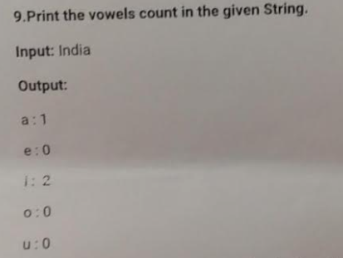

CODE :

import java.util.Scanner;

public class HelloWorld{

public static void main(String []args){

String input = "india";

int[] vowelCount = new int[5]; // 'a', 'e', 'i', 'o', 'u'

input = input.toLowerCase(); // Convert to lowercase to handle both upper and lower case vowels

for (char ch : input.toCharArray()) {

switch (ch) {

case 'a':

vowelCount[0]++;

break;

case 'e':

vowelCount[1]++;

break;

case 'i':

vowelCount[2]++;

break;

case 'o':

vowelCount[3]++;

break;

case 'u':

vowelCount[4]++;

break;

}

}

System.out.println("a-" + vowelCount[0] + "\ne-" + vowelCount[1] + "\ni-" + vowelCount[2] + "\no-" + vowelCount[3] + "\nu-" + vowelCount[4]);

}

}

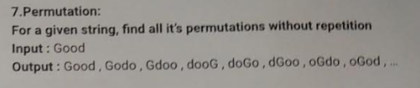

CODE :

import java.util.ArrayList;

import java.util.List;

public class HelloWorld {

public static void main(String[] args) {

String input = "good";

List<String> permutations = findPermutations(input);

for (String permutation : permutations) {

System.out.println(permutation);

}

}

public static List<String> findPermutations(String input) {

List<String> permutations = new ArrayList<>();

backtrack("", input, permutations);

return permutations;

}

private static void backtrack(String currentPermutation, String remainingChars, List<String> permutations) {

if (remainingChars.length() == 0) {

permutations.add(currentPermutation);

return;

}

for (int i = 0; i < remainingChars.length(); i++) {

char currentChar = remainingChars.charAt(i);

String newPermutation = currentPermutation + currentChar;

String newRemainingChars = remainingChars.substring(0, i) + remainingChars.substring(i + 1);

backtrack(newPermutation, newRemainingChars, permutations);

}

}

}

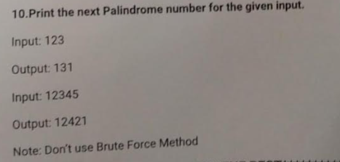

CODE :

public class HelloWorld {

public static void main(String[] args) {

int input = 12321;

int nextPalindrome = findNextPalindrome(input);

System.out.println("Next palindrome number after " + input + " is: " + nextPalindrome);

}

public static int findNextPalindrome(int input) {

char[] digits = String.valueOf(input).toCharArray();

int n = digits.length;

// Find the middle index for odd-length numbers, or the left half for even-length numbers

int left = n / 2 - 1;

int right = (n % 2 == 0) ? n / 2 : n / 2 + 1;

// Increment the middle and adjust digits if necessary to ensure a palindrome

while (left >= 0 && right < n && digits[left] == digits[right]) {

left--;

right++;

}

// If the number is already a palindrome, increase the central digit(s)

if (left < 0 || digits[left] < digits[right]) {

while (left >= 0) {

digits[right] = digits[left];

left--;

right++;

}

} else {

// Mirror the left half to the right half to construct the next palindrome

while (left >= 0) {

digits[right] = digits[left];

left--;

right++;

}

}

// Convert the modified digits back to an integer

return Integer.parseInt(new String(digits));

}

}

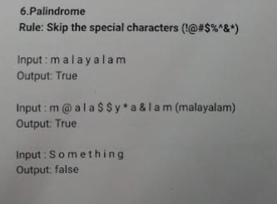

CODE :

/* Online Java Compiler and Editor */

public class HelloWorld{

public static void main(String []args){

String s = "m@ala$$y*a&lam";

String reverse = "";

int len = s.length();

for(int i=(len-1);i>=0;--i){

if(s.charAt(i)=='@'||s.charAt(i)=='$'||s.charAt(i)=='*'||s.charAt(i)=='&'){

continue;

}

reverse = reverse + s.charAt(i);

}

String string_without_special=s.replaceAll("['@$*&']","");

String reverse_without_special=reverse.replaceAll("['@$*&']","");

System.out.println(reverse);

if(string_without_special.equals(reverse_without_special)){

System.out.println("true");

}

else{

System.out.println("false");

}

}

}