Phase 1,2: Foundations Research Document
Foundations of RAG, Embeddings and Vector databases
This research explores the foundational concepts required to build a Retrieval-Augmented Generation (RAG) system. RAG improves the accuracy and trustworthiness of Large Language Models (LLMs) by combining external knowledge retrieval with generative reasoning.
What is RAG? Retrieval-Augmented Generation is a hybrid AI architecture that combines:
Component | Function | Example
Retriever | Searches vector database for relevant content | Will fetch text chunks and related diagrams from manuals
Generator | Produces final answer using retrieved context | OpenAI GPT or Google Gemini API
Vector Store | Stores document embeddings for similarity search

Used to: Reduces LLM "hallucinations" by grounding responses in retrieved documents
Allows dynamic knowledge updates without retraining the LLM
Enhances transparency with traceable source references
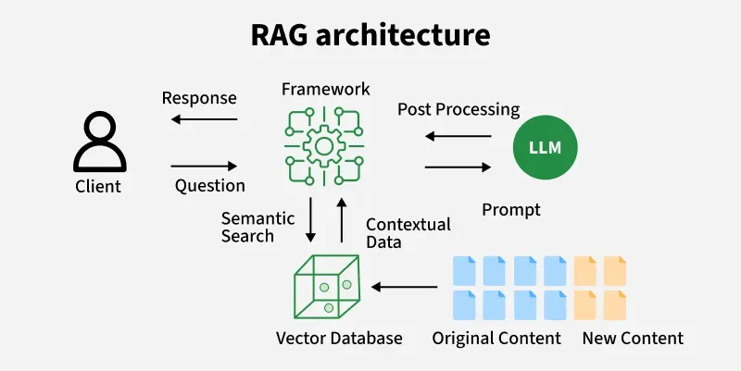

RAG System Workflow
- Document Ingestion
  - PDFs, text files, manuals, diagrams are collected.
  - Preprocessing: cleaning, splitting, optical character recognition (OCR) for images/PDFs.
- Chunking & Embedding
  - Documents are broken into chunks (200–500 tokens).
Each chunk is sent to an embedding model to obtain a vector representation.
Chunking Strategy - Chunking determines how documents are divided before embedding.
Common methods:
Method | Description | When to Use
Fixed-size chunks | 200–500 tokens | General-purpose RAG
Semantic chunking | Split based on headings/meaning | Manuals, structured documents
Overlapping chunks | 20–30% repeated | Prevents context loss

- Indexing in Vector Database
  - Vectors + metadata (source, page number, content type)
  - Stored for fast similarity search (e.g., HNSW, IVF index).
- Query Processing
  - User submits a query → Query is converted into an embedding vector.
- Retrieval Stage
  - Vector DB returns top-K most similar text/image chunks.
- Augmentation
  - The retrieved passages are injected into the LLM prompt.
- Generation Stage
  - The LLM produces a grounded answer, citing sources when needed.
Embedding models and Vector
Embeddings are numerical representations (vectors) that capture semantic meaning:
- Similar items have similar vector representations
- Enables mathematical operations on concepts (e.g., "king - man + woman ≈ queen")
Model Type | Purpose | Examples
Text Embeddings | Convert text to vectors | Sentence-BERT, text-embedding-ada-002
Image Embeddings | Convert images to vectors | CLIP, SigLIP, ResNet
Multimodal Embeddings | Align text and images in same space | CLIP, BLIP

How Embeddings Capture Meaning
Modern embedding models are trained using contrastive or self-supervised objectives that encourage semantically similar text/image pairs to cluster together in vector space.
Key properties:
- Semantic proximity - "Broken pipe" and "leakage issue" produce close vectors.
- High dimensionality - Typical vector sizes: 512, 768, 1024, 1536.
- Distance metrics - Cosine similarity is the most common.
Model | Dimension | Strengths | Use Case
Sentence-BERT | 768 | Good semantic similarity | Text manuals
CLIP | 512 | Multimodal | Diagrams & images
OpenAI text-embedding-3-large | 3072 | Very high accuracy | Production RAG

CLIP (Contrastive Language-Image Pre-training)
- Trained on 400M image-text pairs
- Projects both modalities into shared 512-dimensional space
- Enables image search by text and text search by images
How CLIP Works:
- Image encoder (ViT or ResNet) creates image embeddings
- Text encoder (Transformer) creates text embeddings
- Contrastive loss aligns matching image-text pairs
Vector Database Fundamentals
Why Not Traditional Databases? Traditional SQL/NoSQL databases excel at exact matches but struggle with:
- Semantic similarity searches
- High-dimensional data (512-1536 dimensions)
- Approximate nearest neighbor (ANN) operations

Vector Storage and Retrieval Workflow
- A document chunk is embedded → vector
- Vector stored with metadata:
- content type: text/image
- source file
- page number
- timestamp
- Vector DB builds an index (HNSW/IVF)
- Query embedding → nearest neighbor search
- Top-K vectors returned
Vector database architecture

Indexing - is the process of organizing vectors (embeddings) in a special data structure so that they can be searched quickly and efficiently for similarity.
Feature | Description | Usage
ANN indexing  Approximate Nearest Neighbor search | App. Nearest neighbor algorithms for fast search | Enables millisecond responses on millions of vectors
Metadata filtering | Combine vector similarity with metadata filters
Scalability | Distributed architecture for horizontal scaling | Handle growing manual collections
Multi tenancy | Isolated collections for different use cases | Separate text and image embeddings

Indexing Strategies for Performance
- HNSW (Hierarchical Navigable Small World): Fast, high-recall, higher memory
- IVF (Inverted File Index): Balanced speed and accuracy
- PQ (Product Quantization): Memory-efficient, good for very large datasets

Popular vector databases
Database | Strengths | Best For
Milvus | High performance, rich indexing options, cloud-native | Production systems with large datasets
ChromaDB | Simple API, Python-native, easy setup | Prototyping and development
Pinecone | Fully managed, auto-scaling | Teams without DevOps resources
Weaviate | GraphQL interface, hybrid search | Applications needing combined vector+keyword search

Evaluation Metrics for RAG Retrieval to measure the retrieval quality:
Metric | Meaning
Recall@K | How many relevant chunks appear in top-K results
Precision@K | How many retrieved chunks are relevant
MRR | Ranking quality of correct answers
Embedding Cosine Score | Similarity confidence

Challenges and Limitations
- Incorrect chunking leads to poor retrieval.
- Embedding drift if model versions change.
- Large vector indexes require memory and optimization.
- Retrieval errors → LLM hallucinations.
- Multimodal embeddings may mismatch textual cues.

