Sri Lanka Institute of Information Technology


Final Report

Search Algorithms in Pac-Man

Faculty of Computing
SE3062 - Intelligent Systems
Year 3 - 2026
Group - AI49

Name | IT number
De Silva T H H D | IT242101010
Kavindi P P | IT24101611
Fernando M S T | IT24101063
Bodini G V E J | IT24101177

Table of Contents
List of Figures iii
Chapter 1: Project Overview 1
1.1 Objective 1
1.2 Graph Search Skeleton 1
1.3 Project Files 2
1.4 Environment Setup 2
Chapter 2: Team Organisation and Workflow 3
2.1 Version Control Workflow 3
2.2 Review and Shared Understanding 3
Chapter 3: Search Algorithms (Q1-Q4) 4
3.1 Q1 - Depth First Search 4
3.2 Q2 - Breadth First Search 5
3.3 Q3 - Uniform Cost Search 7
3.4 Q4 - A* Search 8
Chapter 4: Corners Problem (Q5-Q6) 9
4.1 Q5 - Finding All the Corners (Problem Representation) 9
4.2 Q6 - Corners Problem: Heuristic 11
Chapter 5: Food Search Heuristic (Q7) 12
5.1 Q7 - Eating All The Dots: Food Heuristic 12
Chapter 6: Results Summary 15
Chapter 7: Git Repository and Contribution Evidence 16
7.1 Public Git Repository 16
7.2 Commit History 16
7.3 Contribution Graphs 16
7.4 Pull Requests 16
Chapter 8: Individual Contribution Table 17
Chapter 9: AI Usage Declaration 17
Chapter 10: References 17

List of Figures
Figure 3.1: Autograder output for Q1 5
Figure 3.2: Autograder output for Q2 6
Figure 3.3: Autograder output for Q3 7
Figure 3.4: Autograder output for Q4 9
Figure 4.1: Autograder output for Q5 10
Figure 4.2: Autograder output for Q6 11
Figure 5.1: Autograder output for Q7 13
Figure 6.1: Full autograder output for Q1-Q7 15
Figure 7.1: Commit history of the group repository 16
Figure 7.2: Contribution graph showing activity from each member 16
Figure 7.3: Merged pull requests and reviews 16

Project Overview

Objective
This report documents our group's implementation of classic search algorithms for the Pac-Man environment from the UC Berkeley CS188 projects [1]. The objective is to implement Depth First Search (DFS), Breadth First Search (BFS), Uniform Cost Search (UCS) and A* as graph-search algorithms, and to design admissible and consistent heuristics for two structured problems: visiting all four corners of a maze, and eating all the food dots.
All algorithms and problem definitions are implemented in two files, search.py (Q1-Q4) and searchAgents.py (Q5-Q7). Every question passes the provided autograder: the corners heuristic expands 741 nodes on mediumCorners and the food heuristic expands 4,137 nodes on trickySearch, both well within the full-marks thresholds.

Graph Search Skeleton
Every algorithm in this project follows the same graph-search skeleton. Only the fringe changes.
1. Put the start state on the fringe.
2. Pop a node from the fringe. If its state is a goal, return the path of actions that reached it.
3. If the state has already been expanded, skip it. Otherwise mark it as expanded and push each successor onto the fringe with the extended path and, where relevant, the accumulated cost.
4. Repeat until a goal is found or the fringe is empty, in which case an empty list is returned.
Algorithm | Fringe (util.py) | Ordering | Optimal?
DFS | util.Stack | Last in, first out (deepest node first) | No
BFS | util.Queue | First in, first out (shallowest node first) | Yes, for equal step costs
UCS | util.PriorityQueue | Priority = path cost g(n) | Yes, for non-negative costs
A* | util.PriorityQueue | Priority = g(n) + h(n) | Yes, with a consistent heuristic

Project Files
File | Role | Description
search.py | Edited | Search algorithms: DFS, BFS, UCS and A* (Q1-Q4).
searchAgents.py | Edited | Search problems and heuristics: CornersProblem, cornersHeuristic and foodHeuristic (Q5-Q7).
util.py | Read only | Provides Stack, Queue and PriorityQueue, which are used instead of Python built-ins.
pacman.py | Reference | Runs the game and defines the GameState type.
game.py | Reference | Game logic: AgentState, Agent, Directions and Grid.
autograder.py | Run | Automated grading script, with test cases in test_cases/.

Environment Setup
The project was run using Python 3.11 in an isolated virtual environment, with numpy and matplotlib installed through pip. The setup was verified by launching a playable game with python pacman.py. File, function and class names were left unchanged so that the autograder can import them.

Team Organisation and Workflow

Version Control Workflow
The group collaborated through a single public Git repository. The workflow was organised as follows.
• Each member worked on a dedicated feature branch: feature/q1-q2-dfs-bfs, feature/q3-q4-ucs-astar, feature/q5-q6-corners and feature/q7-food-heuristic.
• Completed work was merged into the main branch through pull requests once it passed the autograder.
• Commits were small and frequent, with descriptive messages. The heuristic questions were committed in stages, so the history shows each improvement and its node count.

Review and Shared Understanding
Because every member is assessed on the whole solution, each pull request was reviewed by a different member of the group. Before submission, the group held a walkthrough in which each member explained every question aloud, including the proof that the Q6 and Q7 heuristics are admissible and consistent.

Search Algorithms (Q1-Q4)
This chapter covers the four search algorithms implemented in search.py. All four are graph-search versions, so an explored (expanded) set ensures that no state is expanded twice.

Q1 - Depth First Search
Function / class | depthFirstSearch(problem)
File | search.py
Key data structure | util.Stack
Marks | 4
Autograder result | python autograder.py -q q1 → 3/3 (all tests pass)

Code Edited
def depthFirstSearch(problem: SearchProblem):

# Initialize the frontier with the start state and an empty list of actions.
frontier = util.Stack()
frontier.push((problem.getStartState(), []))
# Initialize the explored set to keep track of visited states.
explored = set()

# Loop until the frontier is empty.
while not frontier.isEmpty():

state, actions = frontier.pop()

# Return this route's moves when the goal is reached.
if problem.isGoalState(state):
return actions

# Skip states whose successors were already explored.
if state in explored:
continue

explored.add(state)

# Add the successors of the current state to the frontier.
for next_state, action, step_cost in problem.getSuccessors(state):
if next_state not in explored:
# Create a separate move list for this new route.
new_actions = actions + [action]
frontier.push((next_state, new_actions))

return []

Autograder Output

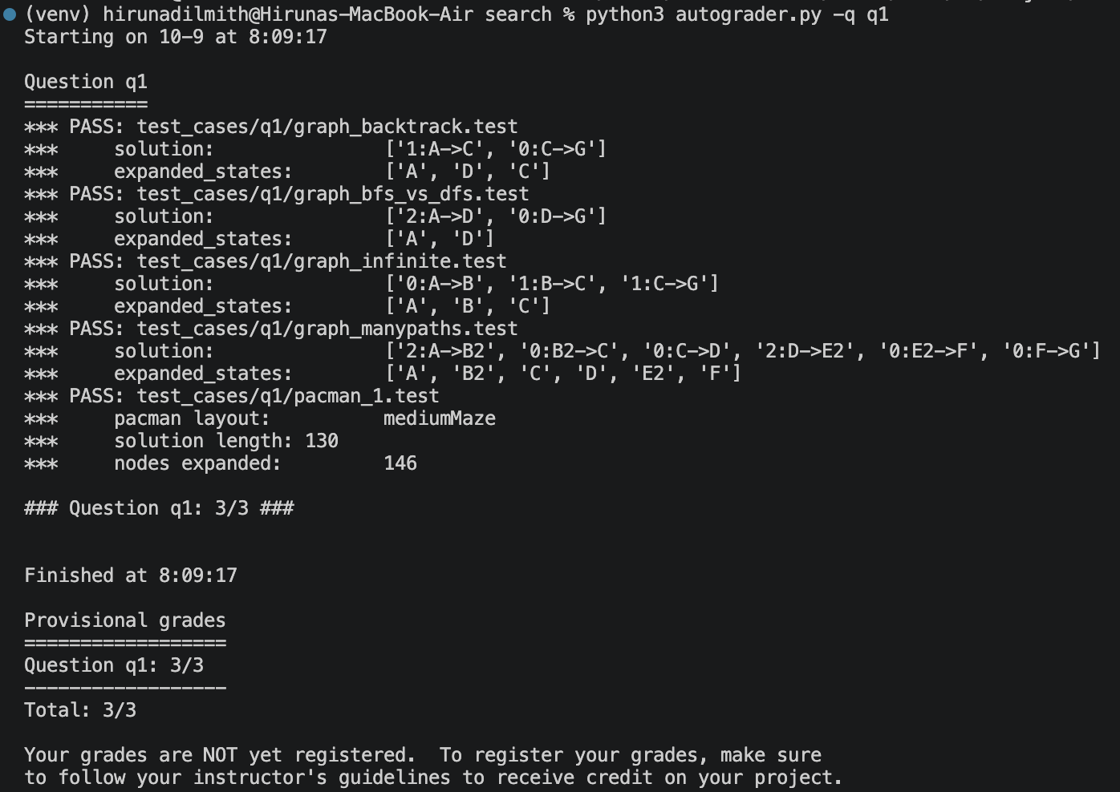Figure 3.1: Autograder output for Q1

Explanation
depthFirstSearch is a graph search that uses util.Stack as the frontier. Each frontier entry holds a state and the list of actions that reached it. The start state is pushed with an empty action list. In each iteration the most recently pushed entry is popped. If its state is a goal, the action list is returned. If the state is already in the explored set it is skipped; otherwise it is added, and every successor that has not been explored is pushed with its action appended to a new copy of the path.
Because the Stack is last-in, first-out, the search always follows the deepest branch first. The explored set prevents any state from being expanded twice, which avoids infinite loops in mazes with cycles. DFS returns the first solution it reaches, not the shortest: on mediumMaze it finds a path of cost 130 after expanding 146 nodes, while the optimal path costs 68. DFS is therefore not optimal, but it uses little memory.

Q2 - Breadth First Search
Function / class | breadthFirstSearch(problem)
File | search.py
Key data structure | util.Queue
Marks | 4
Autograder result | python autograder.py -q q2 → 3/3 (all tests pass)

Code Edited
def breadthFirstSearch(problem: SearchProblem):
frontier = util.Queue()

frontier.push((problem.getStartState(), []))
explored = set()

while not frontier.isEmpty():

state, actions = frontier.pop()

if problem.isGoalState(state):
return actions

# Skip states whose successors were already explored.
if state in explored:
continue

explored.add(state)

# Add each legal next state to the back of the queue.
for next_state, action, step_cost in problem.getSuccessors(state):
if next_state not in explored:
# Give the new route its own move list.
new_actions = actions + [action]
frontier.push((next_state, new_actions))

# No route to the goal was found.
return []

Autograder Output

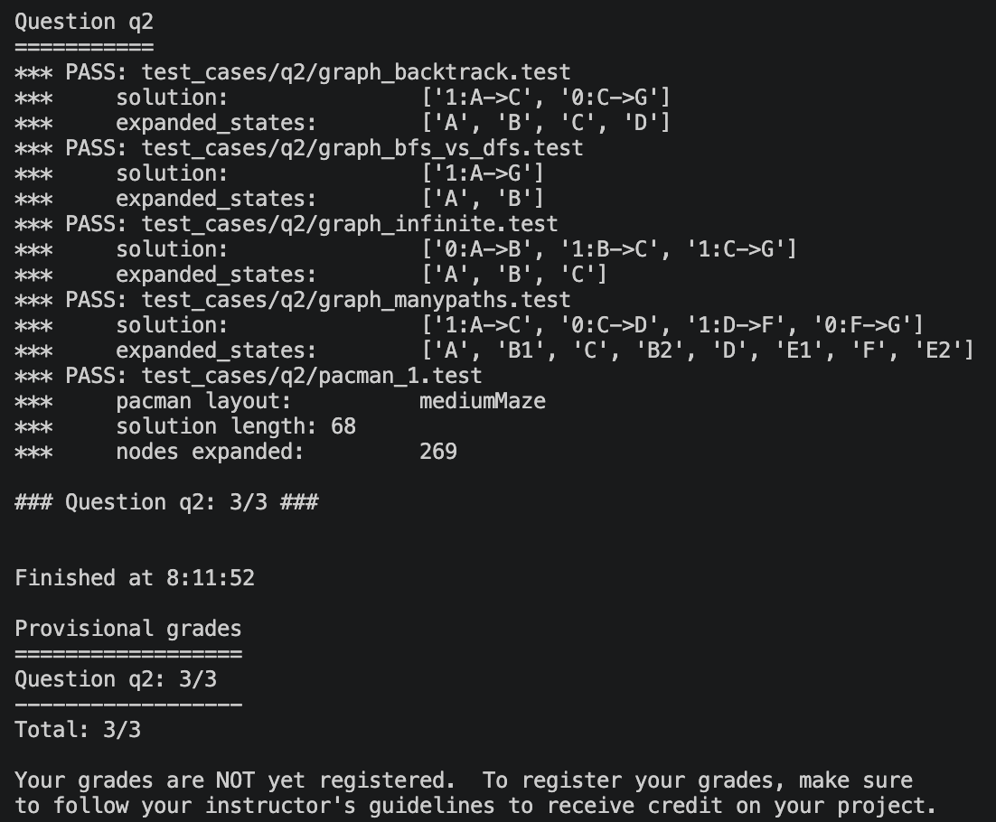

Figure 3.2: Autograder output for Q2

Explanation
breadthFirstSearch uses the same graph-search structure as DFS, with util.Queue as the frontier. Entries are removed in first-in, first-out order, so every node at depth d is expanded before any node at depth d+1. The goal test is applied when a node is popped, and the explored set prevents a state from being expanded twice. The same function is also used by the provided mazeDistance helper, which the Q7 heuristic relies on.
Because the Queue always expands the shallowest node first, BFS returns a solution with the fewest actions. It is therefore optimal when every step costs the same, as in the standard Pac-Man maze. On mediumMaze it finds the optimal path of cost 68, but expands 269 nodes, more than DFS. Its main disadvantage is memory, because the frontier can hold an entire level of the search tree.

Q3 - Uniform Cost Search
Function / class | uniformCostSearch(problem)
File | search.py
Key data structure | util.PriorityQueue (priority = g)
Marks | 4
Autograder result | python autograder.py -q q3 → 3/3 (all tests pass)

Code Edited
def uniformCostSearch(problem: SearchProblem):
fringe = util.PriorityQueue()
expanded =set()
start = problem.getStartState()

# Fringe entry: (state, actions so far, total cost so far); priority = total cost g
fringe.push((start, [], 0), 0)

while not fringe.isEmpty():

state, actions, cost = fringe.pop()

# Goal test happens when the node is POPPED, not when it is generated.
if problem.isGoalState(state):
return actions

# Skip states that were already expanded (graph search).
if state in expanded:
continue
expanded.add(state)

for successor , action, stepCost in problem.getSuccessors(state):

if successor not in expanded:
newCost = cost+ stepCost
fringe.push((successor, actions + [action], newCost), newCost)

return []

Autograder Output

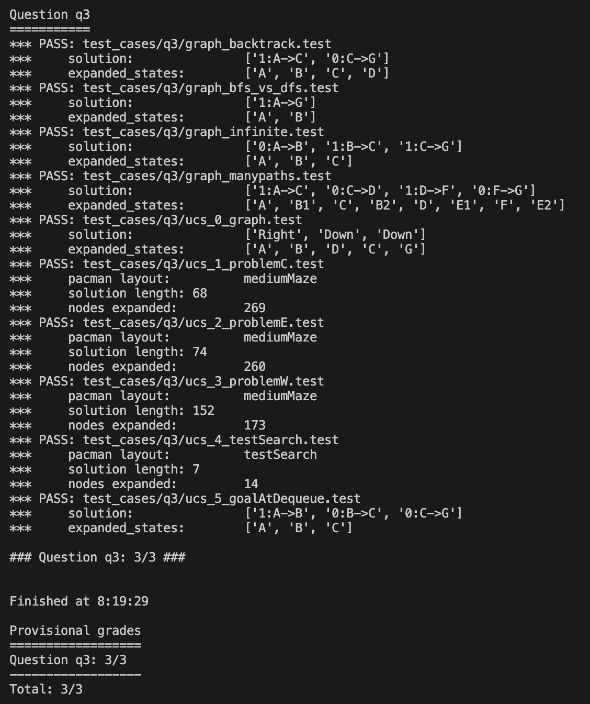

Figure 3.3: Autograder output for Q3

Explanation
uniformCostSearch uses util.PriorityQueue, where the priority of each entry is the total path cost g(n) from the start state. Each entry stores the state, the action list and the accumulated cost. The cheapest entry is popped first, and a successor's cost is the parent's cost plus the step cost returned by problem.getSuccessors. Because the real step costs are used, UCS handles the custom cost functions of StayEastSearchAgent and StayWestSearchAgent, which give paths of cost 1 on mediumDottedMaze and about 6.9 × 10^10 on mediumScaryMaze.
The goal test is applied when a node is popped rather than when it is generated, because only then is the cheapest path to it guaranteed. Expanded states are skipped, and successors that were already expanded are not pushed again. With non-negative step costs UCS is complete and optimal, and with unit costs it behaves like BFS.

Q4 - A* Search
Function / class | aStarSearch(problem, heuristic)
File | search.py
Key data structure | util.PriorityQueue (priority = g + h)
Marks | 4
Autograder result | python autograder.py -q q4 → 3/3 (all tests pass)

Code Edited
def aStarSearch(problem: SearchProblem, heuristic=nullHeuristic):

fringe = util.PriorityQueue()
expanded =set()
start = problem.getStartState()

# Fringe entry stores g (cost so far); priority is f = g + h
fringe.push((start, [], 0) , heuristic(start, problem))

while not fringe.isEmpty():

state, actions, cost = fringe.pop()

if problem.isGoalState(state):
return actions

if state in expanded:
continue
expanded.add(state)

for successor, action, stepCost in problem.getSuccessors(state):

newCost =cost + stepCost
priority = newCost + heuristic(successor, problem)
fringe.push((successor, actions + [action], newCost), priority)

return []

Autograder Output

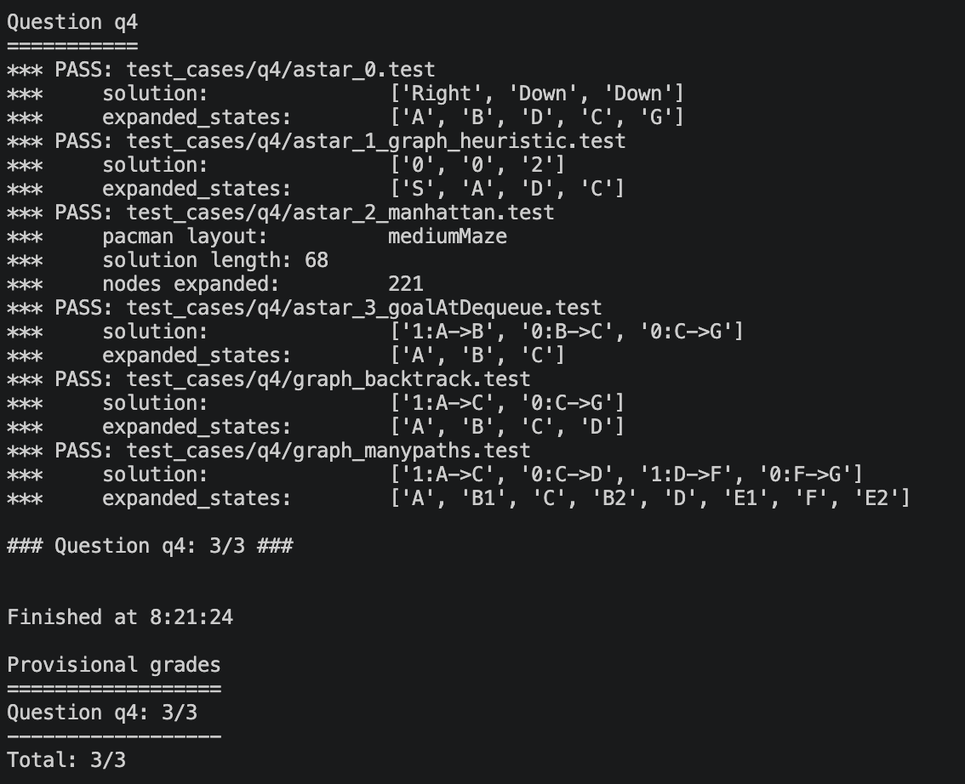

Figure 3.4: Autograder output for Q4

Explanation
aStarSearch uses the same structure as UCS, but the priority is f(n) = g(n) + h(n). The heuristic is called as heuristic(state, problem) and defaults to nullHeuristic, which returns 0 and makes A* behave like UCS. Each entry stores g(n) separately from the priority, because g cannot be recovered from f, so successor costs are accumulated correctly.
The goal test happens when a node is popped. A state may be pushed more than once with different priorities, but the expanded-set check on pop ensures it is only expanded once, the first time it comes off the queue with its lowest f value. With graph search, A* is optimal when the heuristic is consistent, meaning h(n) ≤ c(n, n') + h(n') for every step. On bigMaze with the Manhattan heuristic, A* finds the same optimal cost-210 path as UCS but expands 549 nodes instead of 620.

Corners Problem (Q5-Q6)
The corners problem requires Pac-Man to find the shortest path that touches all four corners of the maze. Q5 defines the search problem and Q6 provides a heuristic for it.

Q5 - Finding All the Corners (Problem Representation)
Function / class | CornersProblem
File | searchAgents.py
Key data structure | State = (position, tuple of unvisited corners)
Marks | 8
Autograder result | python autograder.py -q q5 → 3/3 (all tests pass)

Code Edited
def getStartState(self):
# State = (position, tuple of corners NOT yet visited).
# If Pacman starts on a corner, that corner is already visited.
unvisited = tuple(c for c in self.corners if c != self.startingPosition)
return (self.startingPosition, unvisited)

def isGoalState(self, state: Any):
# Goal: no corners left to visit.
_, unvisited = state
return len(unvisited) == 0

def getSuccessors(self, state: Any):

successors = []
(x, y), unvisited = state
for action in [Directions.NORTH, Directions.SOUTH, Directions.EAST, Directions.WEST]:
dx, dy = Actions.directionToVector(action)
nextx, nexty = int(x + dx), int(y + dy)
if not self.walls[nextx][nexty]:
nextPos = (nextx, nexty)
# Reaching a corner removes it from the unvisited tuple.
nextUnvisited = tuple(c for c in unvisited if c != nextPos)
successors.append(((nextPos, nextUnvisited), action, 1))

self._expanded += 1 # DO NOT CHANGE
return successors

Autograder Output

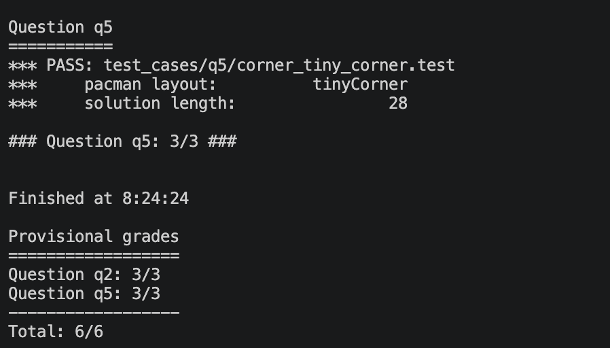

Figure 4.1: Autograder output for Q5

Explanation
Each state is a pair (position, unvisited), where position is Pac-Man's (x, y) coordinate and unvisited is a tuple of the corners that still need to be reached. Both parts are immutable tuples, so the state is hashable and works with the expanded set. The wall grid and the GameState are stored on the problem object, not in the state, so states stay small: there are at most 16 corner combinations for each position.
getStartState builds the tuple of all four corners, removing the start position if Pac-Man begins on a corner. isGoalState returns True when the unvisited tuple is empty. getSuccessors tries the four directions, ignores moves into walls, and builds a new unvisited tuple without the new position, so stepping onto a corner marks it as visited. Every move costs 1.
We chose a tuple of unvisited corners rather than four booleans or a bitmask because it is easy to read, and it gives the Q6 heuristic the remaining corners directly.

Q6 - Corners Problem: Heuristic
Function / class | cornersHeuristic(state, problem)
File | searchAgents.py
Key data structure | Recursive search over orders of the unvisited corners
Marks | 8
Autograder result | python autograder.py -q q6 → 3/3, 741 nodes expanded on mediumCorners

Code Edited
def cornersHeuristic(state: Any, problem: CornersProblem):

corners = problem.corners # These are the corner coordinates
walls = problem.walls # These are the walls of the maze, as a Grid (game.py)

# Shortest Manhattan tour from Pacman through every unvisited corner.
position, unvisited = state

def shortestTour(current, remaining):

# Try each remaining corner as the next stop, keep the cheapest total .
if not remaining:
return 0
best = float('inf')

for corner in remaining:
rest =tuple(c for c in remaining if c != corner)
cost = util.manhattanDistance(current, corner) + shortestTour(corner, rest)
best = min(best, cost)

return best

return shortestTour(position, unvisited)

Autograder Output

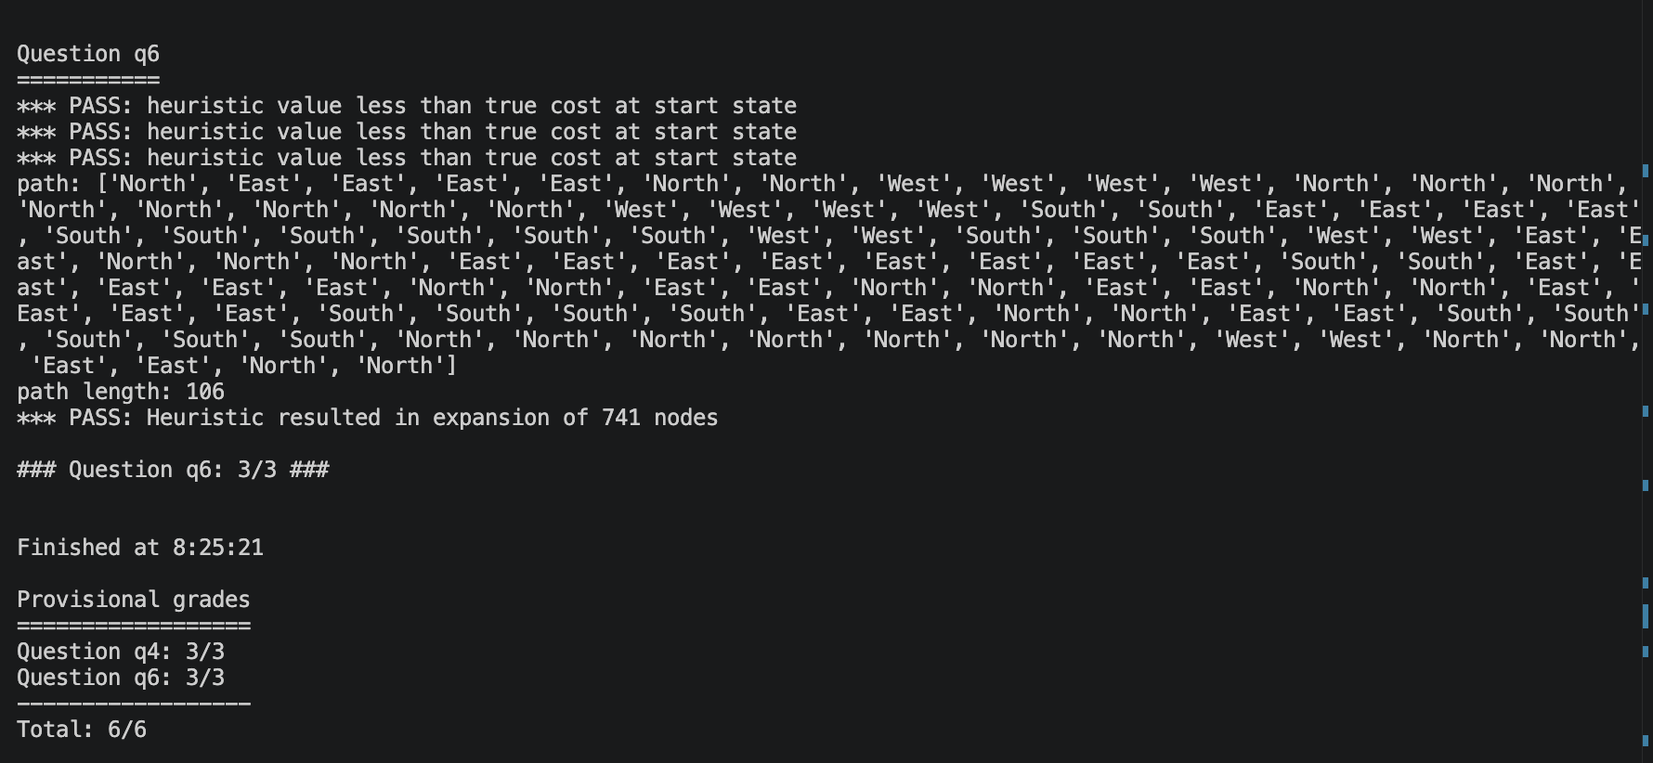Figure 4.2: Autograder output for Q6

Explanation
The heuristic returns the length of the shortest Manhattan-distance tour that starts at Pac-Man and visits every unvisited corner. The helper shortestTour tries each remaining corner as the next stop, adds the Manhattan distance to it, recurses on the corners left, and keeps the minimum. With at most four corners there are at most 24 orders, so the calculation is fast.
Admissible: any real path visits the remaining corners in some order, and each leg of that path is at least as long as its Manhattan distance, because walls can only make a route longer. The true cost is therefore at least the shortest Manhattan tour. Consistent: one move changes the distance to the first corner by at most 1, and if the move reaches a corner, that corner is removed from the tour, so h(n) ≤ 1 + h(n'). The heuristic returns 0 when no corners remain and is never negative. We also checked consistency over every reachable state of tinyCorners, mediumCorners and bigCorners and found no violations.

Node Count Results (mediumCorners)
Version | Heuristic idea | Nodes expanded | Marks
Version 1 | Manhattan distance to the farthest unvisited corner | 1,136 | 8 / 8
Final | Shortest Manhattan tour through all unvisited corners | 741 | 8 / 8

Both versions are admissible and under the full-marks threshold. The final version is tighter because it also counts the travel between corners, which reduces nodes expanded by about 35%.
Marking thresholds for reference: at most 1200 nodes earns 8/8, at most 1600 earns 6/8, at most 2000 earns 4/8, and more than 2000 earns 0/8.

Food Search Heuristic (Q7)
The food search problem requires Pac-Man to eat all the food dots in the fewest steps. FoodSearchProblem is provided, and the task is to design foodHeuristic so that A* expands as few nodes as possible while staying admissible and consistent.

Q7 - Eating All The Dots: Food Heuristic
Function / class | foodHeuristic(state, problem)
File | searchAgents.py
Key data structure | problem.heuristicInfo cache of maze distances
Marks | 8
Autograder result | python autograder.py -q q7 → 5/4, 4,137 nodes expanded on trickySearch

Code Edited
def foodHeuristic(state: Tuple[Tuple, List[List]], problem: FoodSearchProblem):
position, foodGrid = state

# Real MAZE distance (BFS through corridors) to the farthest
# remaining food dot. Distances are cached in problem.heuristicInfo so
# each pair of points is only solved with BFS once per search.
foods = foodGrid.asList()

if not foods:
return 0

cache = problem.heuristicInfo.setdefault('mazeDistances', {})
farthest = 0

for food in foods:
key= (position, food)
if key not in cache:
cache[key] = mazeDistance(position, food, problem.startingGameState)
farthest = max(farthest, cache[key])

return farthest

Autograder Output

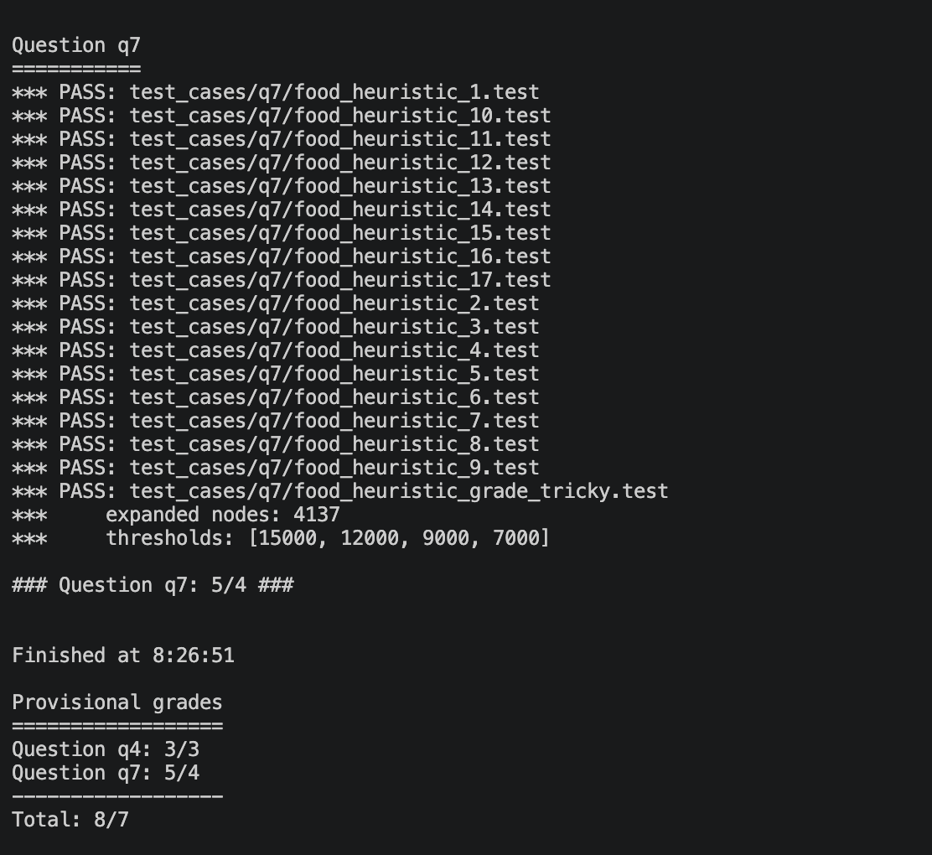

Figure 5.1: Autograder output for Q7

Explanation
The state is (position, foodGrid). The heuristic lists the remaining food with foodGrid.asList(), returns 0 if none is left, and otherwise returns the maze distance from Pac-Man to the farthest food dot. Maze distance is the length of the shortest legal path, computed by the provided mazeDistance helper, which runs our BFS.
Admissible: Pac-Man must reach every dot, including the farthest one, and no route to that dot is shorter than its maze distance, so the estimate never exceeds the true remaining cost. Consistent: one move changes the shortest maze distance to any dot by at most 1, and a dot eaten by that move was one step away, so h(n) ≤ 1 + h(n'). The value is never negative.
A* calls the heuristic thousands of times, and each mazeDistance call runs a full BFS. Distances are therefore cached in problem.heuristicInfo, keyed by (position, food). The cache does not change the node count, but it reduces the Q7 autograder runtime from about 10 seconds to under 1 second.

Heuristic Versions and Node Counts (trickySearch)
Version | Heuristic idea | Nodes expanded | Marks
Version 1 | Manhattan distance to the farthest remaining food dot | 9,551 | 6 / 8
Version 2 | Maze distance to the farthest food dot (about 10 s runtime) | 4,137 | 8 / 8
Final | Version 2 with a cache in problem.heuristicInfo (under 1 s) | 4,137 | 8 / 8

Version 1 is admissible and consistent, but it ignores walls, so it badly underestimates the cost wherever Pac-Man must detour. That leaves it just above the 9,000-node threshold. Using the real maze distance roughly halves the nodes expanded, and all versions find the optimal 60-move path.
Marking thresholds for reference: at most 9000 nodes earns 8/8, at most 12000 earns 6/8, at most 15000 earns 4/8, and more than 15000 earns 2/8. The autograder's 5/4 means all of its thresholds were met, including the 7,000-node bonus.

Results Summary
The table below summarises the final result for each question, taken from the merged main branch. The autograder scores each question on its own scale; the marks column uses the assignment's marking scheme.
Question | Function / class | Autograder | Marks | Notes
Q1 - DFS | depthFirstSearch | 3 / 3 | 4 / 4
Q2 - BFS | breadthFirstSearch | 3 / 3 | 4 / 4
Q3 - UCS | uniformCostSearch | 3 / 3 | 4 / 4
Q4 - A* | aStarSearch | 3 / 3 | 4 / 4
Q5 - Corners problem | CornersProblem | 3 / 3 | 8 / 8
Q6 - Corners heuristic | cornersHeuristic | 3 / 3 | 8 / 8 | 741 nodes
Q7 - Food heuristic | foodHeuristic | 5 / 4 | 8 / 8 | 4,137 nodes
Total |  | 23 / 22 | 40 / 40

The full autograder run also lists a q8 (ClosestDotSearchAgent and AnyFoodSearchProblem), which is outside the Q1-Q7 scope of this assignment and was not attempted, so it shows 0/3. The full run therefore reports 23/25.
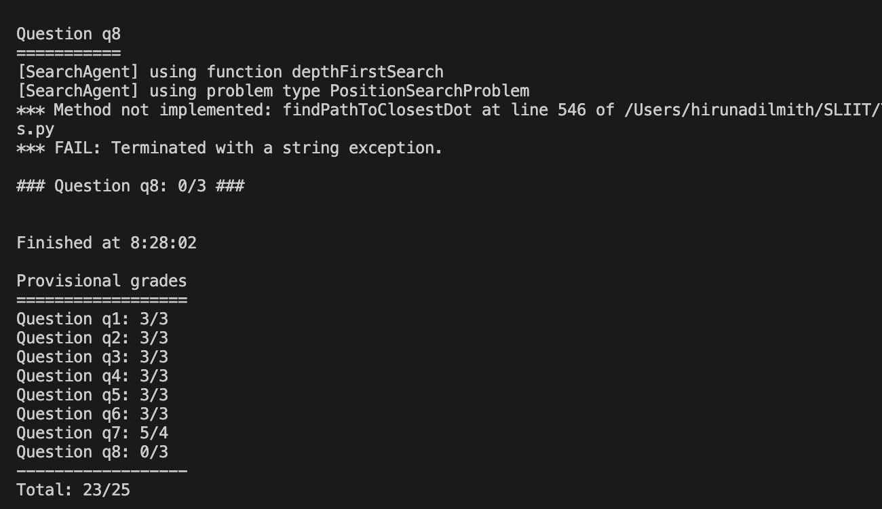
Figure 6.1: Full autograder output for Q1-Q7

Git Repository and Contribution Evidence

Public Git Repository
Repository URL: https://github.com/Hiruna01/pacman-search-algorithms

Commit History
The screenshots below show the commit history, including the frequency and descriptive messages of commits from every member across the assignment period.
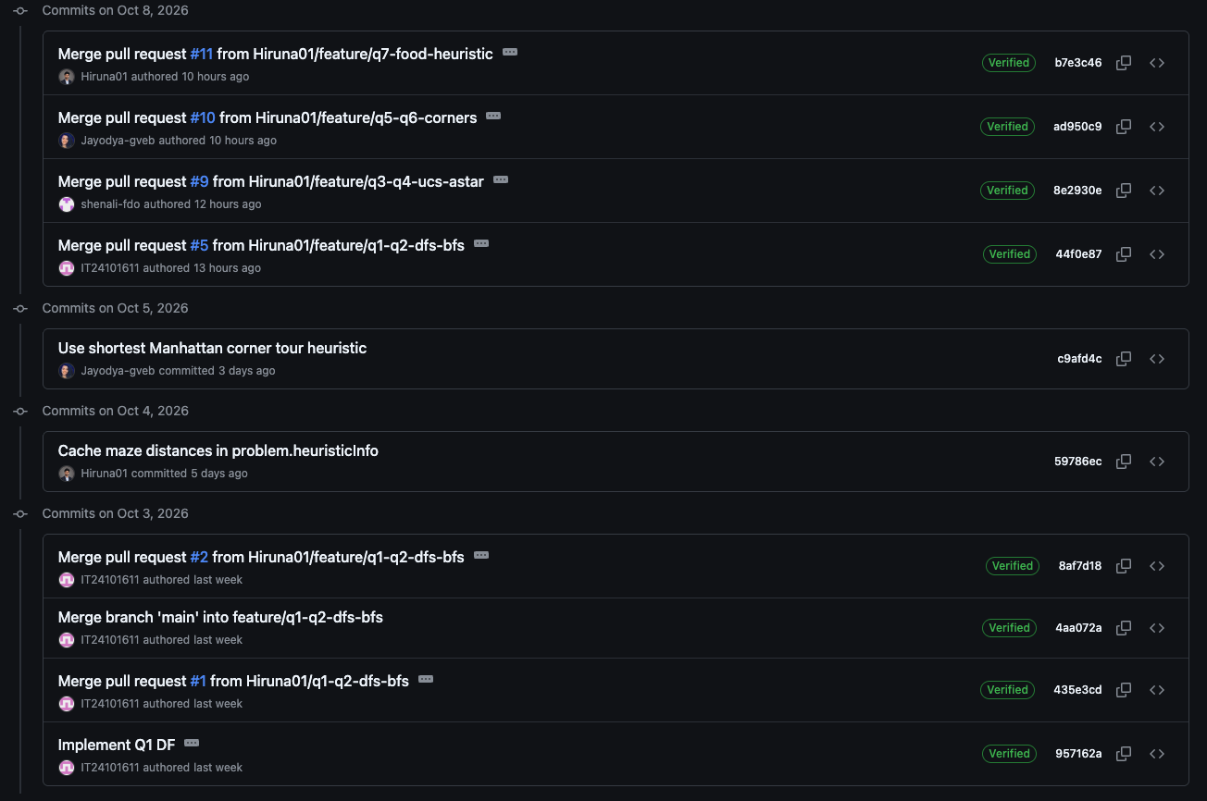
Figure 7.1: Commit history of the group repository

Contribution Graphs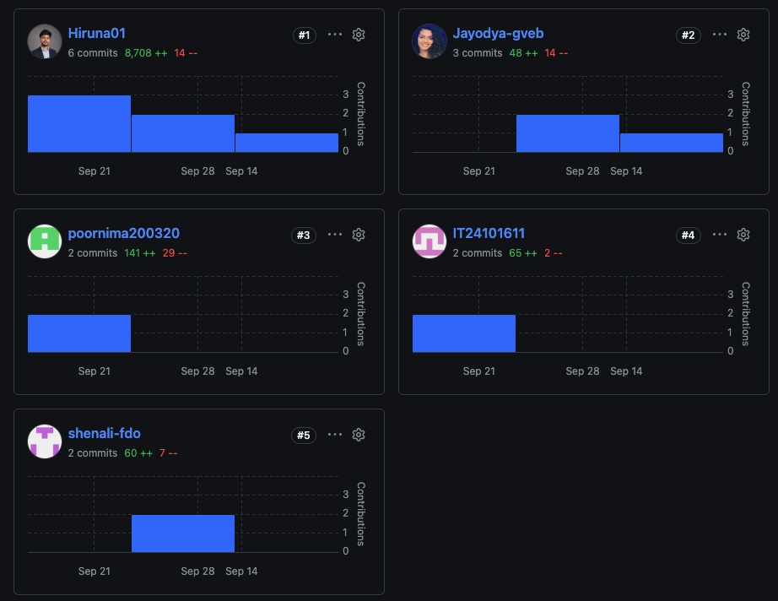

Figure 7.2: Contribution graph showing activity from each member

Pull RequestsFigure 7.3: Merged pull requests and reviews

Individual Contribution Table
The table below lists each member and the specific questions and tasks they contributed to.
Name | Student ID | Questions | Specific tasks
Kavindi P.P | IT24101611 | Q1, Q2 | DFS and BFS, repository setup, report assembly
Fernando M.S.T | IT24101063 | Q3, Q4 | UCS and A*, Git evidence, contribution table
Bodini G.V.E.J | IT24101177 | Q5, Q6 | CornersProblem, cornersHeuristic, node-count testing
De Silva T.H.H.D | IT24101010 | Q7 | foodHeuristic, AI usage declaration, final autograder run

AI Usage Declaration
We used AI tools to help us understand the assignment requirements, plan our work, and explore how to develop the solution. These tools supported our understanding of search algorithms, problem representations, and heuristic design. We critically reviewed the explanations and suggestions, and the group remained responsible for implementing, testing, and understanding the final solution. The tools and the exact prompts used are listed below.
Tool | Purpose | Exact prompt | Member
Claude AI | Understand the assignment requirements | Read the attached assignment document carefully and explain exactly what our group needs to do, including the requirements, tasks, deliverables, and final submission checklist. | De Silva T.H.H.D
Chatgpt | Understand the assignment | Explain the main objective and requirements of this assignment in plain terms | Bodini G.V.E.J
Claude AI | Plan the work division and Github workflow | Give me an idea to divide these works across 4 members | De Silva T.H.H.D
Claude AI | Understand how the system run | How these files are connected and how the system works. Explain clearly | De Silva T.H.H.D
Gemini AI | Understand how to setup and run the testing part | How to run the pacman game and test our parts | Fernando M.S.T
Chatgpt | Make a draft README.md file | Create a clean README.md template for our IA assignment with placeholder sections to fill in later. | Kavindi P.P
Claude AI | Plan dependencies between questions | We have a group assignment for our Intelligent Agents module. I’ve attached the assignment document and divided the work into the following parts. Can we develop these parts in parallel, or do some parts depend on others | De Silva T.H.H.D
Chatgpt | Understand state design | What does ‘state space’ mean in search? For a problem where Pacman must visit all four corners, what information must the state hold, and why can’t it be just the position? | Bodini G.V.E.J
Chatgpt | To evaluate heuristic ideas. | For the corners problem, is sum of Manhattan distances to all unvisited corners admissible? Explain why not with a counterexample. | Bodini G.V.E.J
Chatgpt | Learn the Pac-Man search interface | I attached the search.py, what do getStartState, isGoalState and getSuccessors return? Explain what a successor triple contains, | Kavindi P.P
Chatgpt | To get feedback on own code without being handed a fix. | Here is my DFS implementation. Point out any bugs or edge cases I’ve missed, and ask me questions that lead me to fix them myself | Kavindi P.P
Gemini AI | Understand A* and heuristics | Explain f(n) = g(n) + h(n) in A* with a example. What happens when h is 0, when it is admissible, and when it overestimates? | Fernando M.S.T
Gemini AI | Understand admissible and a consistent heuristic | What is the difference between an admissible and a consistent heuristic | Fernando M.S.T
Claude AI | Understand the problem state. | In the FoodSearchProblem, the state is (position, foodGrid). Explain what Astar needs from a heuristic here, and why the heuristic must return 0 | De Silva T.H.H.D
Claude AI | Compare distance measures | Explain the difference between Manhattan distance and maze distance | De Silva T.H.H.D
Claude AI | To find out why the Manhattan version expands too many nodes. | My Q7 heuristic uses the Manhattan distance to the farthest food and expands 9,551 nodes on trickySearch. explain what makes it weak and what kind of distance would be tighter but still admissible. | De Silva T.H.H.D
Claude AI | To check that the improved idea stays admissible. | if i replace manhattan distance with the real maze distance to the farthest food, is it still admissible and consistent? explain why | De Silva T.H.H.D

References
[1] UC Berkeley CS188, "The Pac-Man Projects," UC Berkeley. [Online]. Available: http://ai.berkeley.edu/project_overview.html. (Accessed: [date]).
[2] S. Russell and P. Norvig, Artificial Intelligence: A Modern Approach, 4th ed. Pearson, 2020.

