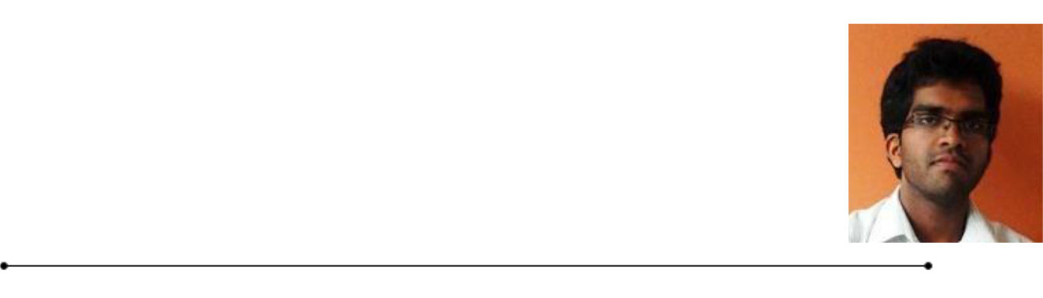**HETTIGE DON RAVINDU RASHMIKA HETTIGE**

41/3F/4A ,Blackpearl Estate,Watereka,Meegoda.

* (+94)713905184 / (+94)112757354 • rashmikaravindu@gmail.com

**CURRICULAM VITAE**



**Career Objective**

To be a dynamic IT professional, working in a challenging environment that would enable me to enhance and utilize my skills and abilities by serving the organization successfully, leading to organizational development, self-development and career progression.

**Education**



|  |  |  |  |  |  |
| --- | --- | --- | --- | --- | --- |
| **B.Sc. Special (Hons) – Information Technology** | | | **Expected Graduation Date – Feb 2017** | | |
| **Specialization – Information Technology** | | |  |  |  |
| Sri Lanka Institute of Information Technology | | |  |  |  |
|  | **Diploma in Information Technology (Esoft)** | |  | **Dec 2013** | |
|  | **Diploma in Information Technology (Ewis)** | |  | **Apr 2009** | |
| **GCE Advance Level (Sinhala Medium-Ananda College,Colombo 10)** | | | | **Aug 2012** | |
|  | Biology | C |  |  |  |
|  |  |  |  |  |  |
|  | Physics | C |  |  |  |
|  |  |  |  |  |  |
|  |  |  |  |  |  |
|  | Chemistry | C |  |  |  |
|  |  |  |  |  |  |
|  | General English | A |  |  |  |
|  |  |  | |  |  |
|  |  |  | | |  |
| **GCE Ordinary Level (English Medium-Ananda College,Colombo 10) Dec 2008** | | | | | |
|  | Buddhism | A |  |  |  |
|  |  |  |  |  |  |
|  | Sinhala | A |  |  |  |
|  |  |  |  |  |  |
|  |  |  |  |  |  |
|  | English | A |  |  |  |
|  |  |  |  |  |  |
|  | Mathematics | A |  |  |  |
|  |  |  |  |  |  |
|  |  |  |  |  |  |
|  | Science & Technology | A |  |  |  |
|  |  |  |  |  |  |
|  | History | A |  |  |  |
|  |  |  |  |  |  |
|  |  |  |  |  |  |
|  |  |  |  |  |  |
|  | Commerce | A |  |  |  |
|  |  |  |  |  |  |
|  | Communication & Mass media | A |  |  |  |
|  |  |  |  |  |  |
|  |  |  |  |  |  |
| H.D.R.R Hettige | rashmikaravindu@gmail.com | | | Curriculum Vitae |  |  |

**Projects and Research**



|  |  |
| --- | --- |
| **iAS - iOT Application Server – Project** | **Oct 2013** |

iAS is an 100% opensource and free software. Anyone can login by using their Google account and start building applications right away. All the apps that are build will be displayed to all the users of the platform so that, anyone can use them, modify them as well as build more innovative solutions. Specially, anyone can use our platform to learn about IoT. Ideamart API is used to send SMS alerts.

Project initiated at codelanka organization as an open source project with Apache2 license. Currently ongoing project.

Technologies used- Python, Flask, Mongodb IdeaMart APIs, raspberry pi, Jinja2, HTML, CSS, JavaScript, Bootstrap

Contribution- Lead the project, Concept development & adaptation, Implement core functionalities of the project

|  |  |
| --- | --- |
| **LMP - Laptop Management Platform – Project** | **Mar 2014** |

Device Management is the administration of Mobile devices such as mobile phones, tablets, laptops, desktop computers etc. This involves controlling and managing several tasks of those devices. Such as getting statistics of the device, enforce security levels etc. The main idea is to control and manage laptops/ desktop computers which are connected to the organization network. Most common use case is managing computers in a computer lab or organization. Ideamart API is used to send SMS alerts. Project is selected for best 15 ideas in AngelHack 2016, Sri Lanka. Currently ongoing project.

Technologies used- Python, Flask, Mongodb, IdeaMart APIs, Jinja2, HTML, CSS, JavaScript, Bootstrap

Contribution- Lead the project, Concept development & adaptation, Implement core functionalities of the project, Implement Mac OS x device Enrollment

**Key Skills and Competencies**



Computer skills – C++, C#, Java, PHP

Database – MySQL, MS SQL

Demonstrated experience in leadership

Proficient in written and oral communication skills

Ability to meet deadlines

H.D.R.R Hettige | rashmikaravindu@gmail.com Curriculum Vitae

**Personal Details**



|  |  |  |  |  |
| --- | --- | --- | --- | --- |
| **Full Name** | Hettige Don Ravindu Rashmika Hettige | | |  |
|  |  |  |  |  |
|  |  |  |  |  |
| **Contact Nos.** |  | 0713905184 , 0112757354 |  |  |
|  |  |  |  |  |
|  |  |  |  |  |
| **Email** |  | rashmikaravindu@gmail.coom | |  |
|  |  |  | |  |
|  |  |  |  |  |
| **NIC No** |  | 930010928V |  |  |
|  |  |  |  |  |
|  |  |  | |  |
| **Nationality** |  | Sri Lankan | |  |
|  |  |  | |  |
|  |  |  |  |  |
| **Gender** |  | Male |  |  |
|  |  |  |  |  |
|  |  |  |  |  |
| **Date of Birth** | 01.01.1993 | |  |  |
|  |  |  | |  |
| **Marital Status** |  | Single |  |  |
|  |  |  |
|  |  |  |  |  |
|  |  |  | |  |
| **Spoken Languages** | Sinhala , English | | |  |

**Referees**



|  |  |  |  |  |  |  |  |  |  |  |  |
| --- | --- | --- | --- | --- | --- | --- | --- | --- | --- | --- | --- |
|  |  |  |  |  |  |  |  |  |  |  |  |
|  |  |  |  |  |  |  | Ms. N.D.M Priyadarshanie, | |  |  |  |
|  | Ms.Anuradha Karunasena, | | | |  |  |  |  |  |
| Lecturer, | | | | | |  | Protocol Officer, | | |  |  |
| Sri Lanka Institute of Information Technology, | | | | | |  | Ministry of External Affairs, | | |  |  |
| New Kandy Road, | | | | | |  | Colombo 1. | | |  |  |
| Malabe. | |  |  |  |  |  |  |  |  |  |  |
|  |  |  |  |  |  |  | General : (+94) 776326560 Work | | |  |  |
| General : (+94) 338367514 | | | | | |  | : (+94) 112858384 | |  |  |  |
| Work | | : (+94) 117544137 | |  |  |  |  |  |  |  |  |
|  |  |  |  |  |  |  |  |
|  |  |  | email : | mangala0830@yahoo.com | |  |  |
|  |  |  |  |  |  |  |  |  |
| email | | : |  |  |  |  |  |  |  |  |  |
| anuradha.k@sliit.lk |  |  |  |  |  |  |  |  |
|  |  |  |  |  |  |  |  |
|  |  |  |  |  |  |  |  |  |  |  |  |

+94771128255

<https://www.facebook.com/hirusha.kumarasinha>

<https://twitter.com/HirushaTheLefty>

<https://stackoverflow.com/users/10375530/hirusha-kumarasinghe>

<https://www.linkedin.com/in/hirusha-kumarasinghe-386152167>

<https://www.youtube.com/channel/UCKSVUHI9rbbkXhvAXK-2uxA>

<https://id.pinterest.com/madushanh127/>

https://github.com/lorey

[facebook.com/hirusha.kumarasinha](https://www.facebook.com/hirusha.kumarasinha)

[linkedin.com/in/hirusha-kumarasinghe-386152167](https://www.linkedin.com/in/hirusha-kumarasinghe-386152167)

[youtube.com/channel/UCKSVUHI9rbbkXhvAXK-2uxA](https://www.youtube.com/channel/UCKSVUHI9rbbkXhvAXK-2uxA)

H.D.R.R Hettige | rashmikaravindu@gmail.com Curriculum Vitae