COVID-19 Mortality Excess and Cost-Effective Analysis of Different Treatments

**Introduction**

COVID-19 pandemic has created a public health crisis with serious consequences in most countries worldwide, and Mexico has been one of the most affected. On November 19, 2020, the Mexican government reported 1,019,543 accumulated cases of Covid-19 and 100,104 deaths 1. This makes it the eleventh country in the world in the number of confirmed cases and the fourth in reported deaths.2 The current situation has created the urgency to study mortality associated to Covid-19 Usually, studies focus in factors often associated with critical illness and fatal outcome such as age, sex or certain comorbidities 3,4 and calculate mortality estimates of a cohort of patients with COVID-19, however people who are part of the cohorts of these studies have an expected mortality rate for other causes associated with its particular characteristics (such as sex or age) and a certain number of fatal outcomes were expected. The remaining mortality in that same period of time could be called excess mortality due to Covid-19.

Excess mortality [explicación] from a disease can be a very useful measure for decision makers, since it allows to evaluate different strategies that attempt to modify and mitigate directly this specific risk in the population. Currently, there are neither studies that have estimated the excess mortality from Covid-19, nor that attempt to evaluate the effectiveness of various strategies to reduce mortality from Covid-19. The estimation of this excess mortality for the Mexican population provides an opportunity to evaluate possible strategies to reduce the mortality of Covid-19 even if they have not yet been applied in the country.

The aim of this analysis is twofold. First, to estimate the Covid-19 specific mortality for the population over 45 years of age in Mexico using relative survival methods. Second, to quantify the costs, effectiveness and cost-effectiveness using a microsimulation model of two different treatments that aim to reduce the Covid-19-specific mortality: Dexamethasone and Remdesivir. All calculations, models and graphs were done using R,5 and Rstudio software.6

**Methodo**

**Overview**

**Data**

**Tambien se estimaron las probabilidades**

**Relative Survival**

**Decision Model (tabla de parámetros de la microsimulacion).**

**Cost effectiveness- análisis**

**Icer, horizonte temporal, porque, tasas de descuentos, todo lo que venga en cheers checklist.**

**Results**

**Una tabla, con edad, sexo, con lo que este usando en el modelo. Por mes. Que porcentajes son hombres y mujeres, cuantas personas. Tiempo de muerte, mean survival.**

**Datos, las probabilidades, como ha cambiado en el tiempo.**

**Luego la grafica que ya había creado.**

**Y luego la tabla de costos, utilidades, ICERS.**

**(Las probabilidades especificas de muerte van en material suplementario)**

I used information from the National Epidemiological Surveillance System base for monitoring possible cases of Covid-19. This dataset includes people tested for SARS-CoV-2 in Mexico and contains only data obtained from studies done on suspicious persons when detected in the medical units of the health sector.7 It is daily updated, and this work’s particular database has information until November 21, 2020 and has 2,892,449 individuals and 40 variables.

For analysis purposes, the database is filtered to select only people with a positive test result to SARS-CoV-2 and older than 44 years. Individuals in the database are divided in four age groups: “45 - 54”, “55 - 64”, “65 - 69”, “70 +”. Total individuals with these characteristics are 481,353. To build variable “Death” I use the date of death from the original database. Individuals with fatal outcome have a real date of death while individuals hospitalized or recovered have NA´s instead. The new column death takes 1 on the if the individual has a real date. Otherwise, it is 0.

[division de personas con respirador y hospitalizadas].

Background mortality rates for Mexican population in 2020 come from the National Population Council demographic indicators.8 Data bases includes mortality projections until 2050 which were modified to produced time series of mortal cases by sex and age at the national, state and county level. Daily mortality rates by sex and age for 2020 at a national level were used for the models in this work.

**Methods**

*Relative survival and specific probabilities of death*

Relative survival and excess mortality analysis is a methodology that deals with registries of a cohort diagnosed with a disease and follow up its time and vital status, though causes of death are unknown or not clear.12 This methodology is usually used in cancer studies,12,13 but it has been used in other diseases in national analysis such as HIV14 or in cohort of people infected with Hepatitis.15

Relative survival, crude probability of death and net survival are often reported in relative survival analysis.12 The first one consists in the ratio between the survival of the cohort analyzed $S_{O}(t)$ and the expected survival of the population $S_{p}(t)$ normally obtained from population mortality information. Relative survival is defined as 12,16 This methodology allows to report overall hazard $λ_{O_{i}}(t)$ over time, which could be written as the sum of the disease-specific hazard $λ_{E_{i}}\left(t\right)$ and the hazard of the population 12. Disease specific hazard or “excess-hazard” is an estimate of great importance since from its calculation the disease specific and background cumulative probabilities of death can be obtained.12

Package *reslsurv*17 for R software contains the function *cmp.rel,* which allows computing cause-specific and background probabilities of death as long as is provided with data from a cohort and background mortality rates. I estimate Covid-19-specific and background probabilities of death for 60 days using the Mexican population positive for Covid-19 as a cohort and the expected mortality as the daily death rates projected for 2020.

Package *reslsurv*17 for R software contains the function *cmp.rel,* which allows computing cause-specific and background probabilities of death as long as is provided with data from a cohort and background mortality rates. I estimate Covid-19-specific and background probabilities of death for 60 days using the Mexican population positive for Covid-19 as a cohort and the expected mortality as the daily death rates projected for 2020.

Derivation of Covid-19 specific and background population hazards were obtained using the following equation:

18

where is the derivative of the cumulative probability of death, in this case $F(t)$.

$f\left(t\right)=\frac{d}{dx}F(t)$.

*Microsimulation and Cost-Effective Analysis*

**Results**

*Covid-19 specific mortality*

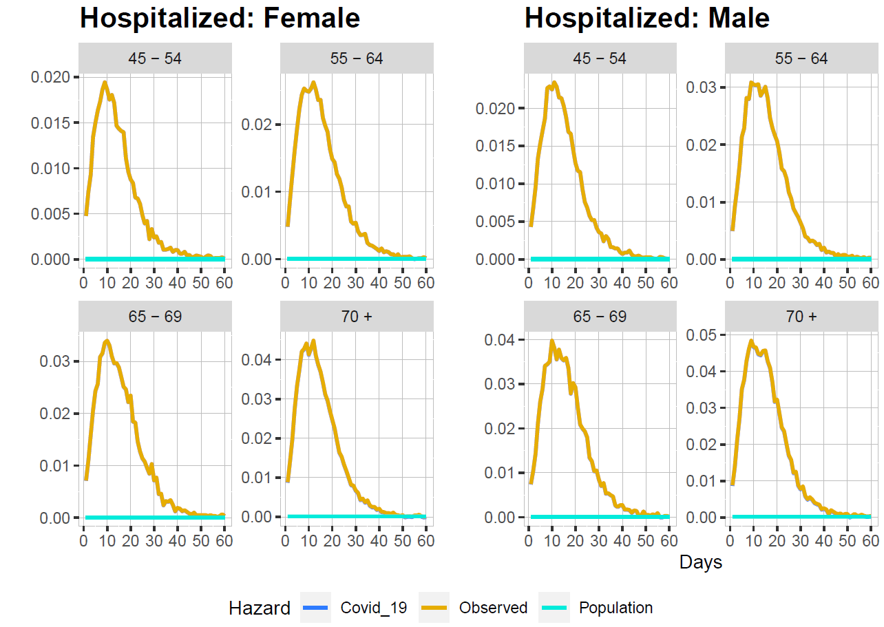

**Discussion**

**References**