CENTRO DE INVESTIGACIÓN Y DOCENCIA ECONÓMICAS, A.C.



COVID-19 EXCESS MORTALITY AND THE COST-EFFECTIVENESS TREATMENTS OPTIONS

TESINA

PARA OBTENER EL GRADO DE

MAESTRÍA EN MÉTODOS PARA EL ANÁLISIS DE POLÍTICAS PÚBLICAS

PRESENTA

HIRVIN AZAEL DIAZ ZEPEDA

DIRECTOR DE LA TESIS: DR. FERNANDO ALARID ESCUDERO

AGUASCALIENTES 2021

Table of Contents

Introduction 1

Methods 1

Relative Survival and Disease-specific Hazard 1

Decision Analytic Model 3

Cost-Effectiveness Analysis 5

Health Outcomes 5

Costs 6

Sensitivity Analyses 6

Results 9

Disease-specific Hazard 9

Cost-effectiveness Analysis 10

Sensitivity Analysis 12

Discussion 14

References 15

Appendix 18

COVID-19 specific hazard by month 18

Parameter distributions 19

EVPI and Expected Loss Curves 22

QALEs Table 23

# Introduction

Mexico has experienced one of the worst COVID-19 epidemics worldwide with high hospitalization and case fatality rates. On March 21, 2021, the Mexican government reported 2,238,887 accumulated cases of COVID-19 and 203,210 deaths1, making Mexico the fourteenth country in the world in confirmed cases and the third in reported deaths.2 The current situation has created the urgency to study mortality associated to COVID-19 and evaluate treatment options.

Excess mortality during the pandemic has been studied in several countries3–7. These estimates often use public data to estimate expected deaths during the pandemic period and calculate the difference from observed deaths. According to Mexico’s Ministry of Health, the excess mortality for all causes as of March 15, 2021 was 473,581, representing 47.9% more than expected8. These public data allow us to quantify the COVID-19-specific mortality.

The disease-specific mortality rate is a useful and important measure for decision makers, since it allows them to evaluate different strategies aimed at modifying and mitigating this outcome. To date, no studies have estimated Mexico’s excess mortality due to COVID-19 and used such estimates to evaluate the effectiveness of various COVID-19 strategies. An important advantage of this approach is that it provides an opportunity to analyze policies that have not yet implemented and hence supports decision-making and planning

The aims of this analysis are twofold: 1) to estimate the COVID 19-specific mortality for Mexico’s population aged 45 years and older using relative survival methods, and 2) to quantify the effectiveness, costs, and cost-effectiveness of different treatments that aim to reduce the COVID-19-specific mortality using a microsimulation model.

# Methods

## Relative Survival and Disease-specific Hazard

We employ the relative survival and excess mortality analysis methodology to estimate the COVID-19 specific mortality for Mexico’s population aged 45 years and older. We used data from the Mexican National Epidemiological Surveillance System. This dataset includes people tested for SARS-CoV-2 in Mexico and contains only data obtained from tests performed on those who were suspected of infection during stays in the medical units of the health sector9. We analyze data only for people with a positive test result, 45 years of age and older, who were hospitalized. We classify these patients by sex, age group, and whether they were intubated. The National Population Council demographic indicators provide background mortality rates for the Mexican population in 202010.

This methodology is appropriate when studying data on a cohort of people diagnosed with a specific disease, where follow-up time and information on vital status is available, but definitive cause of death information is not.11 Relative survival is expressed as a time-specific ratio between the survival of the cohort analyzed $S_{O}(t)$ and the expected survival of a cohort $S_{p}(t)$. The relative survival ratio is defined as .11,12 This ratio is similar to the marginal relative survival ratio or net survival 11. This measure is defined as the exponent of the disease-specific hazard $λ_{E}\left(t\right)$: $S_{E}\left(t\right)=exp\left\{- \int_{0}^{t}{λ_{E}\left(u\right)du}\right\}$.

The disease-specific hazard or “excess hazard” is derived from the formula of the overall hazard $λ_{O}\left(t\right)$, which is composed of two terms: the previously mentioned excess hazard and a population hazard $λ_{P}\left(t\right)$, $λ_{O}\left(t\right)= λ_{E}\left(t\right)+λ_{P}\left(t\right)$. This equation assumes that a cohort with a specific disease divides its overall hazard in two: the hazard of the disease itself and a background hazard normally obtained from population age and sex specific mortality information. Another important assumption is that $λ_{E}\left(t\right)$ is unchanged when other causes of death are removed13.

Disease-specific hazard or “excess-hazard” estimates allow for the computation of disease-specific mortality rates and, consequently, the extrapolation of intervention effects derived from RCTs (i.e., hazard rate ratios) in computing survival in the presence of interventions. By deriving the disease-specific mortality rate $λ_{Dis}$ and the background mortality rate by sex and age ($λ_{SA}$) from $λ_{E}\left(t\right)$ and $λ_{P}(t)$, and assuming the hazard is an additive function of each specific mortality rate, the overall mortality rate is then defined as14:

Thus, incorporating the effect of an intervention, such as a pharmacological treatment for a disease, involves modifying $λ_{Dis}$. Published Hazard Ratios from clinical trials $HR_{CT}$ often report modification in the overall mortality, making them overall hazard ratios $oHR_{CT}$. This estimate is then applied to the overall mortality rate $λ_{Ovall}$ which in turn alters the overall total mortality rate and therefore $λ_{Dis}$ and $λ_{SA}$:

$λ_{Ovall}= λ_{Ovall}*oHR_{CT}$

$λ_{Ovall}=$ $λ_{Dis}+$ $λ_{SA }$

*

* * *

We extracted the COVID 19-specific mortality from a modified version of function *relsurv* package of Pohar-Perme13 and background hazards for sex and age (${\overline{λ}}_{SA}$) over a 50-day follow-up period from time of diagnosis.

## Decision Analytic Model

These estimates allowed us to calculate daily disease-specific and background mortality probabilities by age group and sex assuming an exponential distribution of the hazard rate at a specific time. Then, we incorporated these outputs into a decision-analytic microsimulation model which follows individuals infected with COVID-19 in Mexico for 50 days.

$$P(Die)=1-\exp\left(- {\overline{λ}}_{Ovall}\right)$$

$$P\left(Die from Covid | Die\right)= P\left(Die\right)*\left(\frac{{\overline{λ}}_{Dis}}{{\overline{λ}}_{Ovall} }\right)$$

$$P\left(Die of other causes | Die\right)= P\left(Die\right)*(\frac{{\overline{λ}}_{SA}}{{\overline{λ}}_{Ovall} })$$

The model also evaluates alternative treatment strategies by incorporating the effects of treatments that have demonstrated mortality reductions for people with COVID-19: Dexamethasone15, Remdesivir16 and Remdesivir with Baricitinib17. The overall Hazard Ratio of the clinical trials $(oHR_{CT})$ of these treatments was applied to obtain the COVID-19 specific death probabilities under the effect of different drugs. Because the hazard ratio for Remdesivir and Baricitinib is reported in comparison to a group treated with Remdesivir, the effect of Baricitinib is applied to ${\overline{λ}}_{Dis with Remd}$.

$$P(Die)=1-\exp\left(- {\overline{λ}}_{Ovall}\right)$$

$$P(Die_{Remd})=1-\exp\left(- {\overline{λ}}_{Ovall}*oHR_{Remd}\right)$$

$$P(Die_{Remd \& Bari})=1-\exp\left(- {\overline{λ}}_{Ovall}*oHR_{Remd} *oHR_{Bari}\right)$$

$$P(Die_{Dexa})=1-\exp\left(- {\overline{λ}}_{Ovall}*oHR_{Dexa}\right)$$

We then calculate the conditional probabilities of death specific to the disease and from other causes by multiplying the probabilities of death under each treatment by the proportion of the COVID 19-specific mortality rate or the background mortality rate by age and sex.

$$P\left(Die from Covid | Die\right)= P\left(Die\right)*\left(\frac{{\overline{λ}}_{Dis}}{{\overline{λ}}_{Ovall} }\right)$$

$$P\left(Die of other causes | Die\right)= P\left(Die\right)*(\frac{{\overline{λ}}_{SA}}{{\overline{λ}}_{Ovall} })$$

The microsimulation model utilized in this analysis is an adaptation of the state-transition microsimulation algorithm proposed for modeling for health decision sciences18. The model includes two health states: *COVID-19 infection detected during hospitalization* and *Dead*. The model tracks whether those who die do so because of COVID-19 or from other causes. After obtaining these results, we projected the quality-adjusted life expectancy (QALE) and lifetime healthcare costs for the surviving population using a Markov model time-dependent of two states: Alive and Dead. The probabilities of transition by age and sex were derived from the background mortality rates and we use specific sex and age group utilities. The table of estimates of these projections can be found in the appendix section.

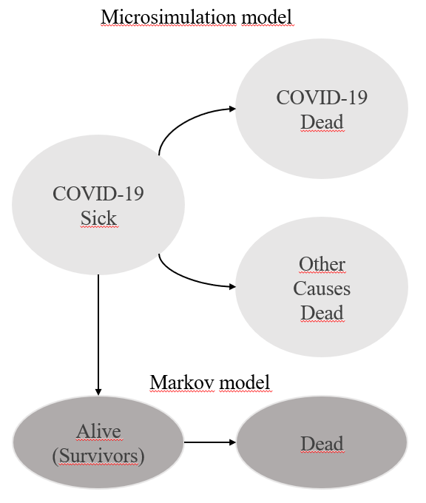

Figure 1: Model structure. States for the microsimulation and markov model.

## Cost-Effectiveness Analysis

Due to the fact that Dexamethasone is not recommended for non-intubated patients and Remdesivir is a drug that has shown more efficacy in less critical states, the simulated population was divided into two cohorts: patients who were hospitalized without intubation and patients who were hospitalized and intubated. We carry out a cost-effectiveness analysis for the following strategies: *Treat with Remdesivir*, *Treat with Remdesivir and Baricitinib* and *No treatment* for the cohort of hospitalized patients, not intubated. For intubated patients the strategies are: *Treat with Dexamethasone* and *No treatment*. The Incremental Cost-Effectiveness Ratio (ICER), is incorporated to determine the best strategy for each cohort*.* All costs are reported in 2021 Mexican pesos and health outcomes and costs are discounted at a 5% determined by the Mexican Health Supplies Evaluation Guide19.

## Health Outcomes

To get the quality-adjusted life expectancy we calculated the quality-adjusted life years (QALYs) for the simulated patients. We used age and sex specific health utilities reported in a study by Hanmer et al20 to incorporate the associated utility in the different health states of the time-dependent Markov model for each surviving individual survived after the simulated 50 days.

## Costs

Hospitalization costs were obtained from data published by the Mexican Social Security Institute (IMSS – Spanish acronym) 21. For treatment costs, we used the price of Remdesivir estimated by its ICER22 and an estimation of the most commonly accepted price at U.S. pharmacies for Baricitinib23. Dexamethasone costs were derived from public purchases by IMSS. Lifetime health expenditure comes from the World Health Organization Global Health Expenditure database24 that reports health expenditure per capita. To obtain the specific expenditure by age-group and sex, we employed specific weights derived from the Mexican budget for disease prevention25.

## Sensitivity Analyses

To incorporate uncertainty in the information on the effectiveness of treatments and hospital costs and time, we performed a probabilistic sensitivity analysis (PSA). Using the sensitivity ranges of published sources, we created 1,000 sets of parameters and calculated the health outcomes and costs for each of these sets. Finally, we calculated the average costs and mean QALYs for each strategy. The distribution of parameters is shown in the supplemental material.

A deterministic sensitivity analysis was carried out with a linear regression analysis metamodel using the PSA results, a method that obtains similar results to those of a traditional one-way or two-way sensitivity analysis26.

To obtain robust results to the uncertainty of the model on which strategy is the most cost effective, we estimated the cost-effectiveness acceptability curves and frontier (CEACs and CEAF), the expected value of perfect information (EVPI) and the expected loss curves (ELC). To calculate the CEAC and CEAF we assumed a willingness-to-pay (WTP) threshold of one Mexico’s per-capita GDP, consistent with that recommended by the Mexican General Health Council19.

All calculations, models and graphs were done using R27 and Rstudio software.28 The ICER estimation and all the sensitivity analysis and visualizations were carried out with *dampack*29package*.*

|  |  |  |  |
| --- | --- | --- | --- |
| **Model Values, Utilities and Costs** | | | |
| Cohorts characteristics | | | |
| Hospitalized, not intubated | | | |
| Sex | Age Group | N | Proportion |
| Male | 45 - 54 yo. | 32,154 | 16% |
| 55 -64 yo. | 35,973 | 18% |
| 65 - 69 yo. | 16,133 | 8% |
| 70 + yo. | 34,915 | 17% |
| Female | 45 - 54 yo. | 19,869 | 10% |
| 55 -64 yo. | 24,948 | 12% |
| 65 - 69 yo. | 11,512 | 6% |
| 70 + yo. | 25,189 | 13% |
| Total |  | 200,693 |  |
| Hospitalized, intubated | | | |
| Sex | Age Group | N | Proportion |
| Male | 45 - 54 yo. | 5,898 | 15% |
| 55 -64 yo. | 7,837 | 20% |
| 65 - 69 yo. | 3,838 | 10% |
| 70 + yo. | 7,295 | 19% |
| Female | 45 - 54 yo. | 2,719 | 7% |
| 55 -64 yo. | 4,451 | 11% |
| 65 - 69 yo. | 2,268 | 6% |
| 70 + yo. | 4,578 | 12% |
| Total |  | 38,884 |  |
| Model Assumptions | | | |
| Markov Model COVID-19 Sick - Dead | | | |
| Time horizon | 50 days | | |
| Number of states | 3 | | |
| Name of states | Cov-19 + | | |
| Cov-19 Dead | | |
| Dead Other causes | | |
| Markov Model COVID-19 Alive - Dead | | | |
| Time horizon | Lifetime | | |
| Number of states | 2 | | |
| Name of states | Alive | | |
| Dead | | |
| Discount rate | 0.05 | | |
| Utilities and Costs | | | |
| Cost (2021 Mexican Pesos) $ | | | |
| Treatment |  | Frequency | |
| Remdesivir Treatment | 6,188 | Daily | |
| Baricitinib Treatment | 3,672 | Daily | |
| Dexamethasone treatment | 4 | Daily | |
| Mean Hospitalization costs, not intubated | 9,272 | Daily | |
| Mean Hospitalization costs, intubated | 44,151 | Daily | |
| Healthcare expenditure by patient | 11,483 | Annually | |
| Quality of life | | | |
| Age - Group | | Utilities | |
| 45 - 49 | | 0.871 | |
| 50 - 59 | | 0.842 | |
| 60 - 69 | | 0.823 | |
| 70 - 79 | | 0.79 | |
| ≥ 80 | | 0.736 | |

|  |  |  |  |
| --- | --- | --- | --- |
| Cohorts characteristics | | | |
| Hospitalized, not intubated | | | |
| Sex | Age Group | N | Proportion |
| Male | 45 - 54 yo. | 32,154 | 16% |
| 55 -64 yo. | 35,973 | 18% |
| 65 - 69 yo. | 16,133 | 8% |
| 70 + yo. | 34,915 | 17% |
| Female | 45 - 54 yo. | 19,869 | 10% |
| 55 -64 yo. | 24,948 | 12% |
| 65 - 69 yo. | 11,512 | 6% |
| 70 + yo. | 25,189 | 13% |
| Total |  | 200,693 |  |
| Hospitalized, intubated | | | |
| Sex | Age Group | N | Proportion |
| Male | 45 - 54 yo. | 5,898 | 15% |
| 55 -64 yo. | 7,837 | 20% |
| 65 - 69 yo. | 3,838 | 10% |
| 70 + yo. | 7,295 | 19% |
| Female | 45 - 54 yo. | 2,719 | 7% |
| 55 -64 yo. | 4,451 | 11% |
| 65 - 69 yo. | 2,268 | 6% |
| 70 + yo. | 4,578 | 12% |
| Total |  | 38,884 |  |
| Model Assumptions | | | |
| Markov Model COVID-19 Sick - Dead | | | |
| Time horizon | 50 days | | |
| Number of states | 3 | | |
| Name of states | Cov-19 + | | |
| Cov-19 Dead | | |
| Dead Other causes | | |
| Markov Model COVID-19 Alive - Dead | | | |
| Time horizon | Lifetime | | |
| Number of states | 2 | | |
| Name of states | Alive | | |
| Dead | | |
| Discount rate | 0.05 | | |
| Utilities and Costs | | | |
| Cost (2021 Mexican Pesos) $ | | | |
| Treatment |  | Frequency | |
| Remdesivir Treatment | 6,188 | Daily | |
| Baricitinib Treatment | 3,672 | Daily | |
| Dexamethasone treatment | 4 | Daily | |
| Mean Hospitalization costs, not intubated | 9,272 | Daily | |
| Mean Hospitalization costs, intubated | 44,151 | Daily | |
| Anual Healthcare expenditure by patient | | | |
| Age - Group | Male | Female | |
| 20 - 59 | 10,912 | 13,519 | |
| 60 ≤ | 24,382 | 24382 | |
| Health outcomes | | | |
| Age - Group | Male | Female | |
| 45 - 49 | 0.887 | 0.863 | |
| 50 - 59 | 0.861 | 0.837 | |
| 60 - 69 | 0.84 | 0.811 | |
| 70 - 79 | 0.802 | 0.771 | |
| 80 ≤ | 0.782 | 0.724 | |



0

|  |  |  |  |
| --- | --- | --- | --- |
| **Decision Model Values, Utilities and Costs** | | | |
| Cohorts characteristics | | | |
| Hospitalized, not intubated | | | |
| Sex | Age Group | N | Proportion |
| Male | 45 - 54 yo. | 32,154 | 16% |
| 55 -64 yo. | 35,973 | 18% |
| 65 - 69 yo. | 16,133 | 8% |
| 70 + yo. | 34,915 | 17% |
| Female | 45 - 54 yo. | 19,869 | 10% |
| 55 -64 yo. | 24,948 | 12% |
| 65 - 69 yo. | 11,512 | 6% |
| 70 + yo. | 25,189 | 13% |
| Total |  | 200,693 |  |
| Hospitalized, intubated | | | |
| Sex | Age Group | N | Proportion |
| Male | 45 - 54 yo. | 5,898 | 15% |
| 55 -64 yo. | 7,837 | 20% |
| 65 - 69 yo. | 3,838 | 10% |
| 70 + yo. | 7,295 | 19% |
| Female | 45 - 54 yo. | 2,719 | 7% |
| 55 -64 yo. | 4,451 | 11% |
| 65 - 69 yo. | 2,268 | 6% |
| 70 + yo. | 4,578 | 12% |
| Total |  | 38,884 |  |
| Model Assumptions | | | |
| Markov Model COVID-19 Sick - Dead | | | |
| Time horizon | 50 days | | |
| Number of states | 3 | | |
| Name of states | Cov-19 + | | |
| Cov-19 Dead | | |
| Dead Other causes | | |
| Markov Model COVID-19 Alive - Dead | | | |
| Time horizon | Lifetime | | |
| Number of states | 2 | | |
| Name of states | Alive | | |
| Dead | | |
| Discount rate | 0.05 | | |
| Utilities and Costs | | | |
| Cost (2021 Mexican Pesos) $ | | | |
| Treatment |  | Frequency | |
| Remdesivir Treatment | 6,188 | Daily | |
| Baricitinib Treatment | 3,672 | Daily | |
| Dexamethasone treatment | 4 | Daily | |
| Mean Hospitalization costs, not intubated | 9,272 | Daily | |
| Mean Hospitalization costs, intubated | 44,151 | Daily | |
| Anual Healthcare expenditure by patient | | | |
| Age - Group | Male | Female | |
| 20 - 59 | 10,912 | 13,519 | |
| 60 ≤ | 24,382 | 24382 | |
| Health outcomes | | | |
| Age - Group | Male | Female | |
| 45 - 49 | 0.887 | 0.863 | |
| 50 - 59 | 0.861 | 0.837 | |
| 60 - 69 | 0.84 | 0.811 | |
| 70 - 79 | 0.802 | 0.771 | |
| 80 ≤ | 0.782 | 0.724 | |

# Results

## Disease-specific Hazard

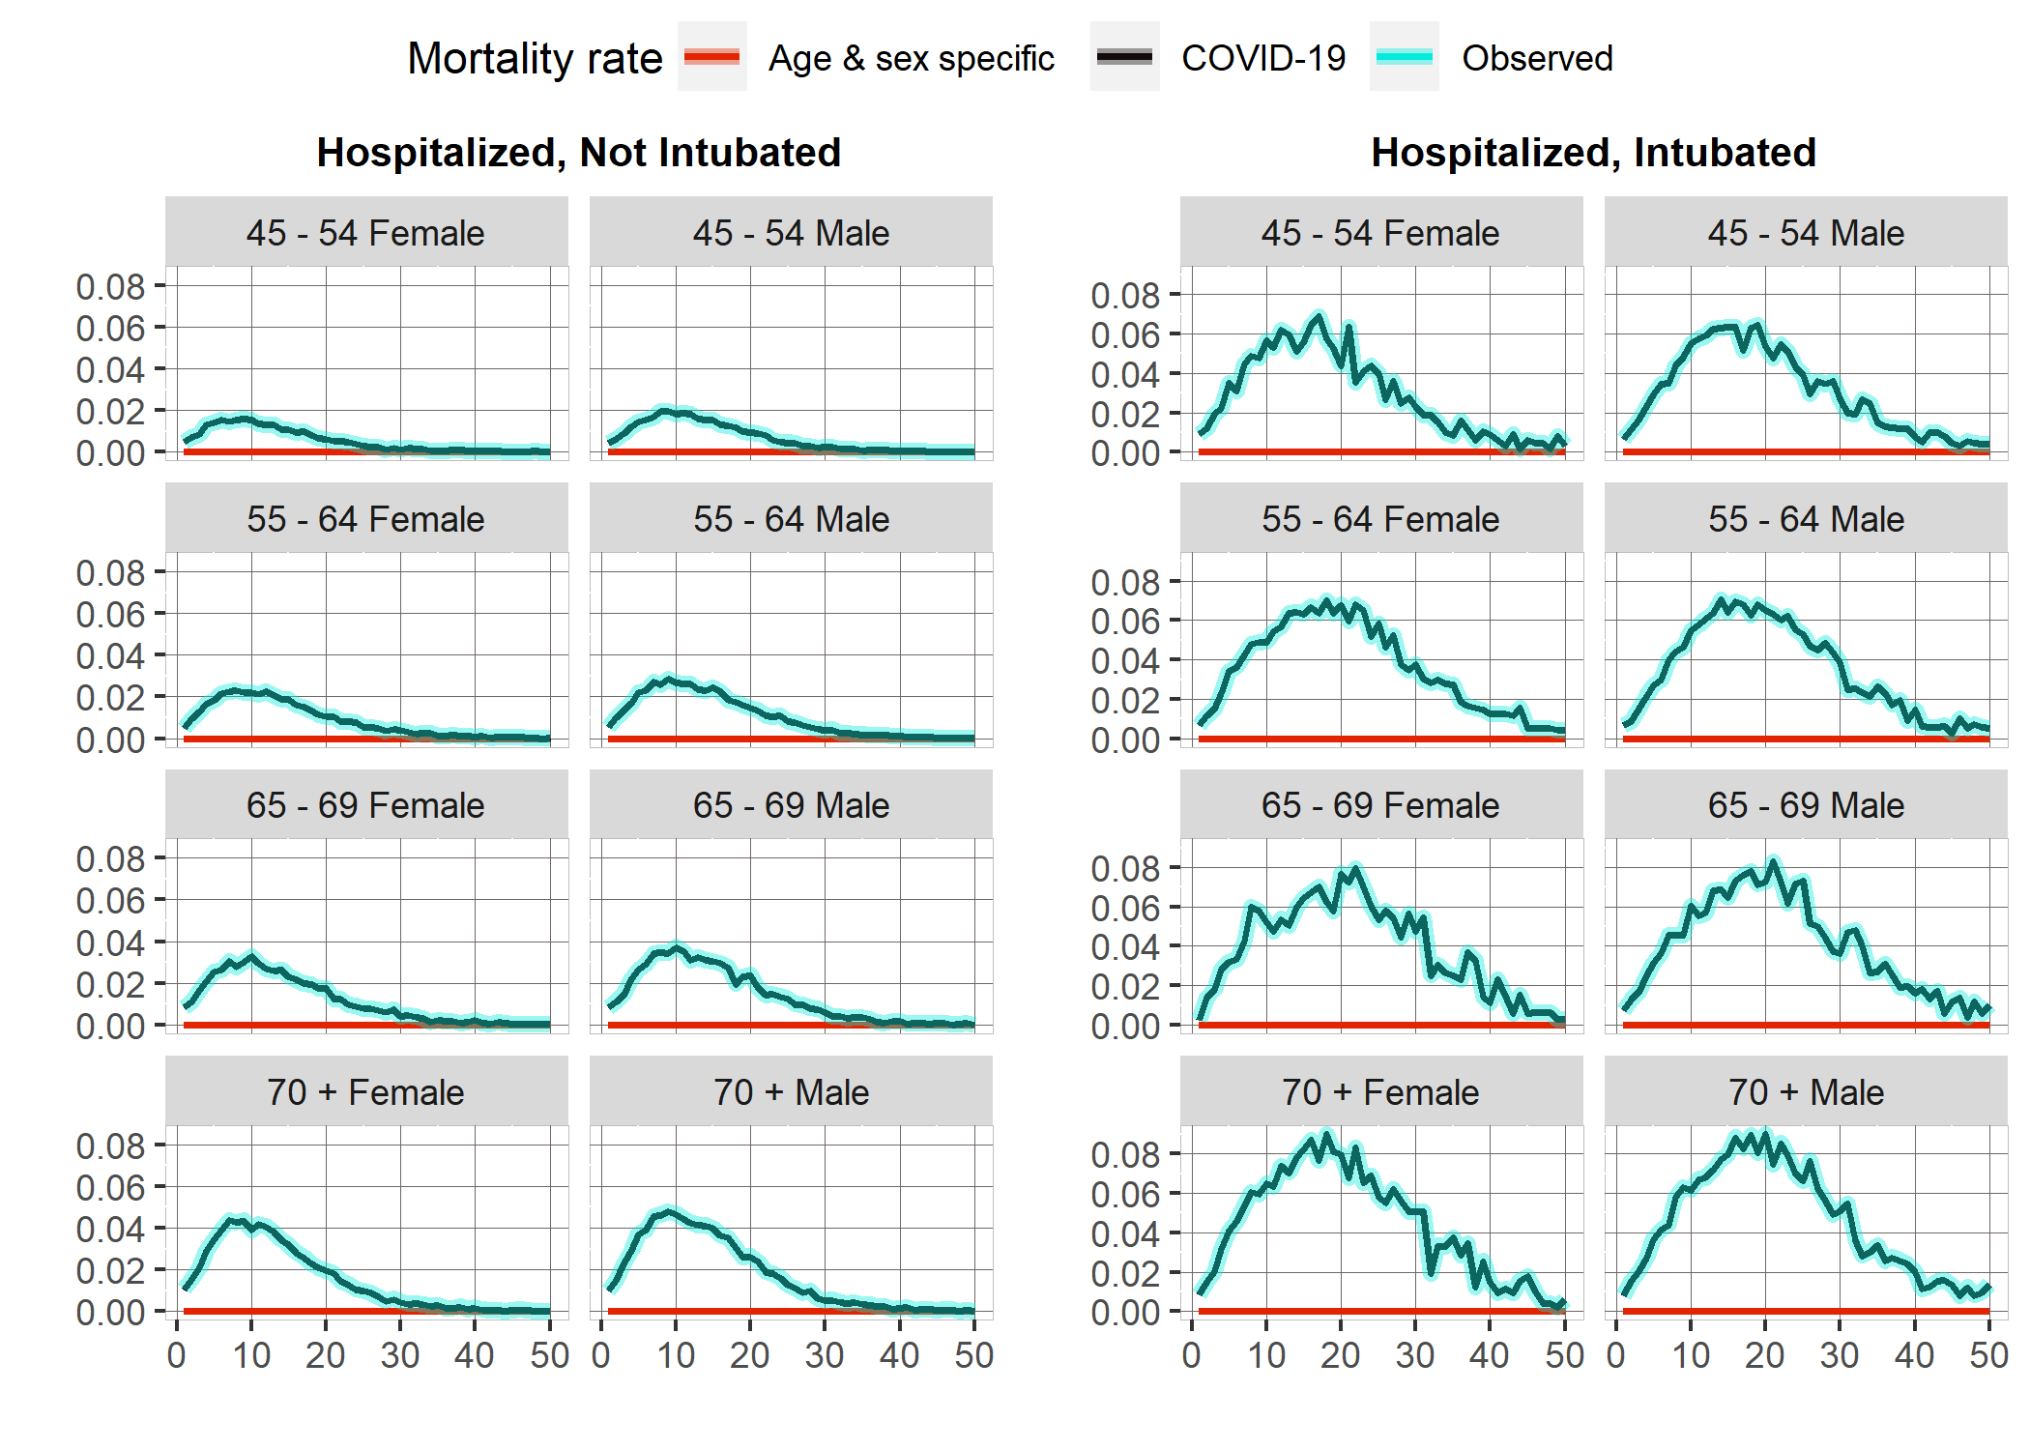

Figure 2: COVID-19 Daily hazards by cohort, age and sex group. Source: Created by author with information published by Mexico´s Ministry of Health.

The results show that the COVID 19-specific mortality rate practically represents the total mortality rate since the daily background population rates are near 0. The highest rates are around day 10 for the non-intubated cohort, extending beyond 20 days for the intubated. COVID-19-specific mortality rate increases with age: For the non-intubated cohort, patients 45 – 54 years old have a COVID 19-specific mortality rate of 507 per 100,000, while for patients 70 + years old, this rate increases to 1,347 per 100,000. For the intubated cohort, these rates are 2,503 and 3,770 per 100,000, respectively.

Men face higher mortality rates than women. The overall mean COVID-19 mortality rate for men is 2,101 per 100,000, while for women it is 1,967 per 100,000. For non-intubated patients, estimated mortality rates for men are 1,006 per 100,000 and 841 per 100,000 for women. Intubated cohort presents 3,196 and 3,093 respectively. We can see that age is a more important differentiating factor than sex in mortality rates.

## Cost-effectiveness Analysis

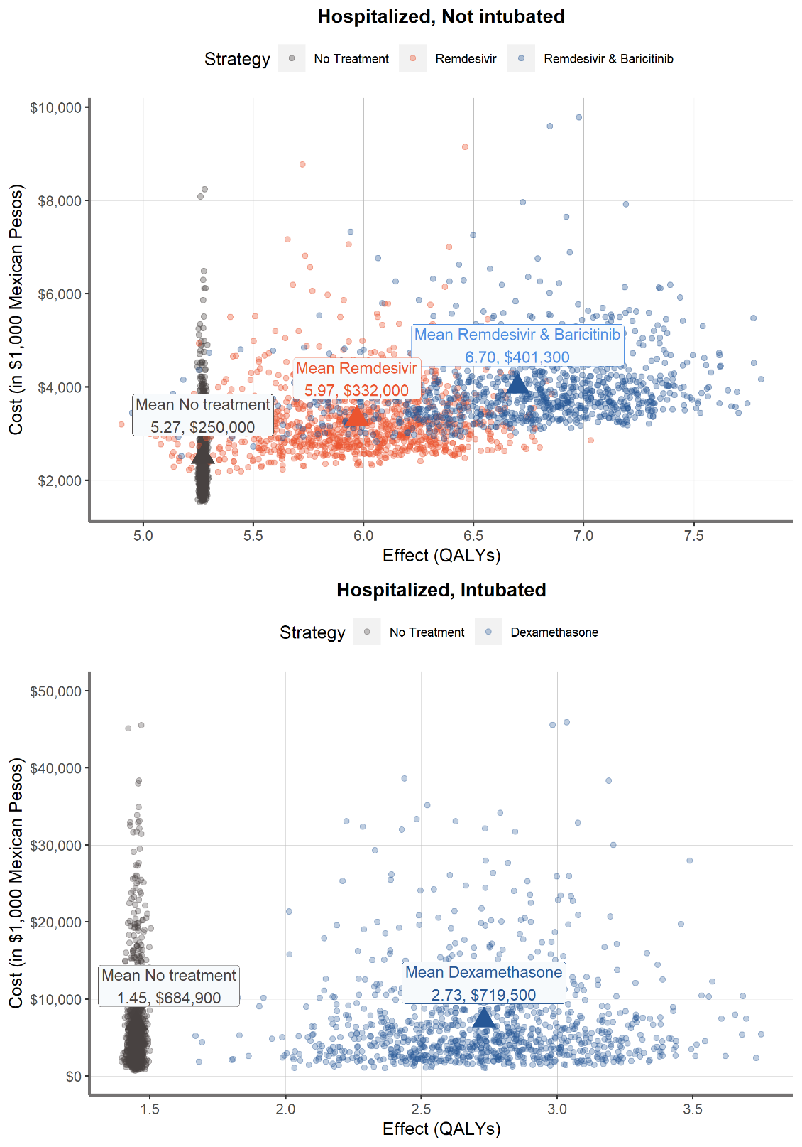

Table 2 shows the mean QALYs, average costs, incremental QALYs, costs and calculated ICERs for the five strategies evaluated through the PSA. The non-intubated cohort lives for 5.27 discounted QALYs and experiences average costs of $250,000 in a strategy without COVID-19 treatment. The strategy of Remdesivir alone reports 5.97 QALYs and $332,000. Estimated mean QALYs for Remdesivir and Baricitinib are 6.70 and expected costs $401,300. The ICER reported by this strategy, in comparison to no treatment, is 102,308.

|  |  |  |  |  |  |
| --- | --- | --- | --- | --- | --- |
| **Strategy** | **Costs ($)** | **Incremental Costs** | **QALYs** | **Incremental QALYs** | **ICERs ($/QALYs)** |
| Cohort: Hospitalized, Not Intubated | | | | | |
| No treatment | 255,000 | - | 5.27 | - | - |
| Remdesivir & Baricitinib | 401,300 | 146,300 | 6.70 | 1.43 | 102,308 |
| Remdesivir* | 332,000 | - | 5.97 | - | - |
| Cohort: Hospitalized, Intubated | | | | | |
| No treatment | 684,900 |  | 1.45 | - | - |
| Dexamethasone | 719,500 | 34,600 | 2.73 | 1.28 | 27,031 |
| * Weakly Dominated Strategy | | | | | |

For the hospitalized, intubated cohort, Dexamethasone strategy yields 2.73 discounted QALYs with lifetime costs of $719,500, while the no treatment strategy yields 1.45 QALYs and costs of $684,900. The cost of dexamethasone is minimal compared to other treatments, so most of the extra costs are generated by higher hospital costs among the surviving population.

## Sensitivity Analysis

The most influential parameter on the Net Monetary Benefit of the strategies of the non-intubated cohort was the effect of Remdesivir (expressed as hazard ratio). This is expected because it is the most expensive drug and the variation in its effect impacts two of the three strategies evaluated for these patients. It was also expected that the variation in the effect of dexamethasone would be the one that would modify the Net Monetary Benefit. However, since the hazard ratio parameter distribution always shows a positive effect in reducing mortality, dexamethasone is always the preferred strategy.

Figure shows the cost-effectiveness acceptability curves that displays the probability of a strategy of being cost-effective at a specific WTP threshold. The frontier indicates which strategy has the highest expected net monetary benefit at each point. Results show that Remdesivir and Baricitinib had the highest probability of being cost-effective from WTP thresholds greater than $102,976/QALY and is cost-effective—robustly so—with respect to parameter uncertainty for not intubated patients. Dexamethasone is highly likely to be cost-effective, since it has the highest probability of being cost-effective from WTP thresholds greater than $29,308//QALY.

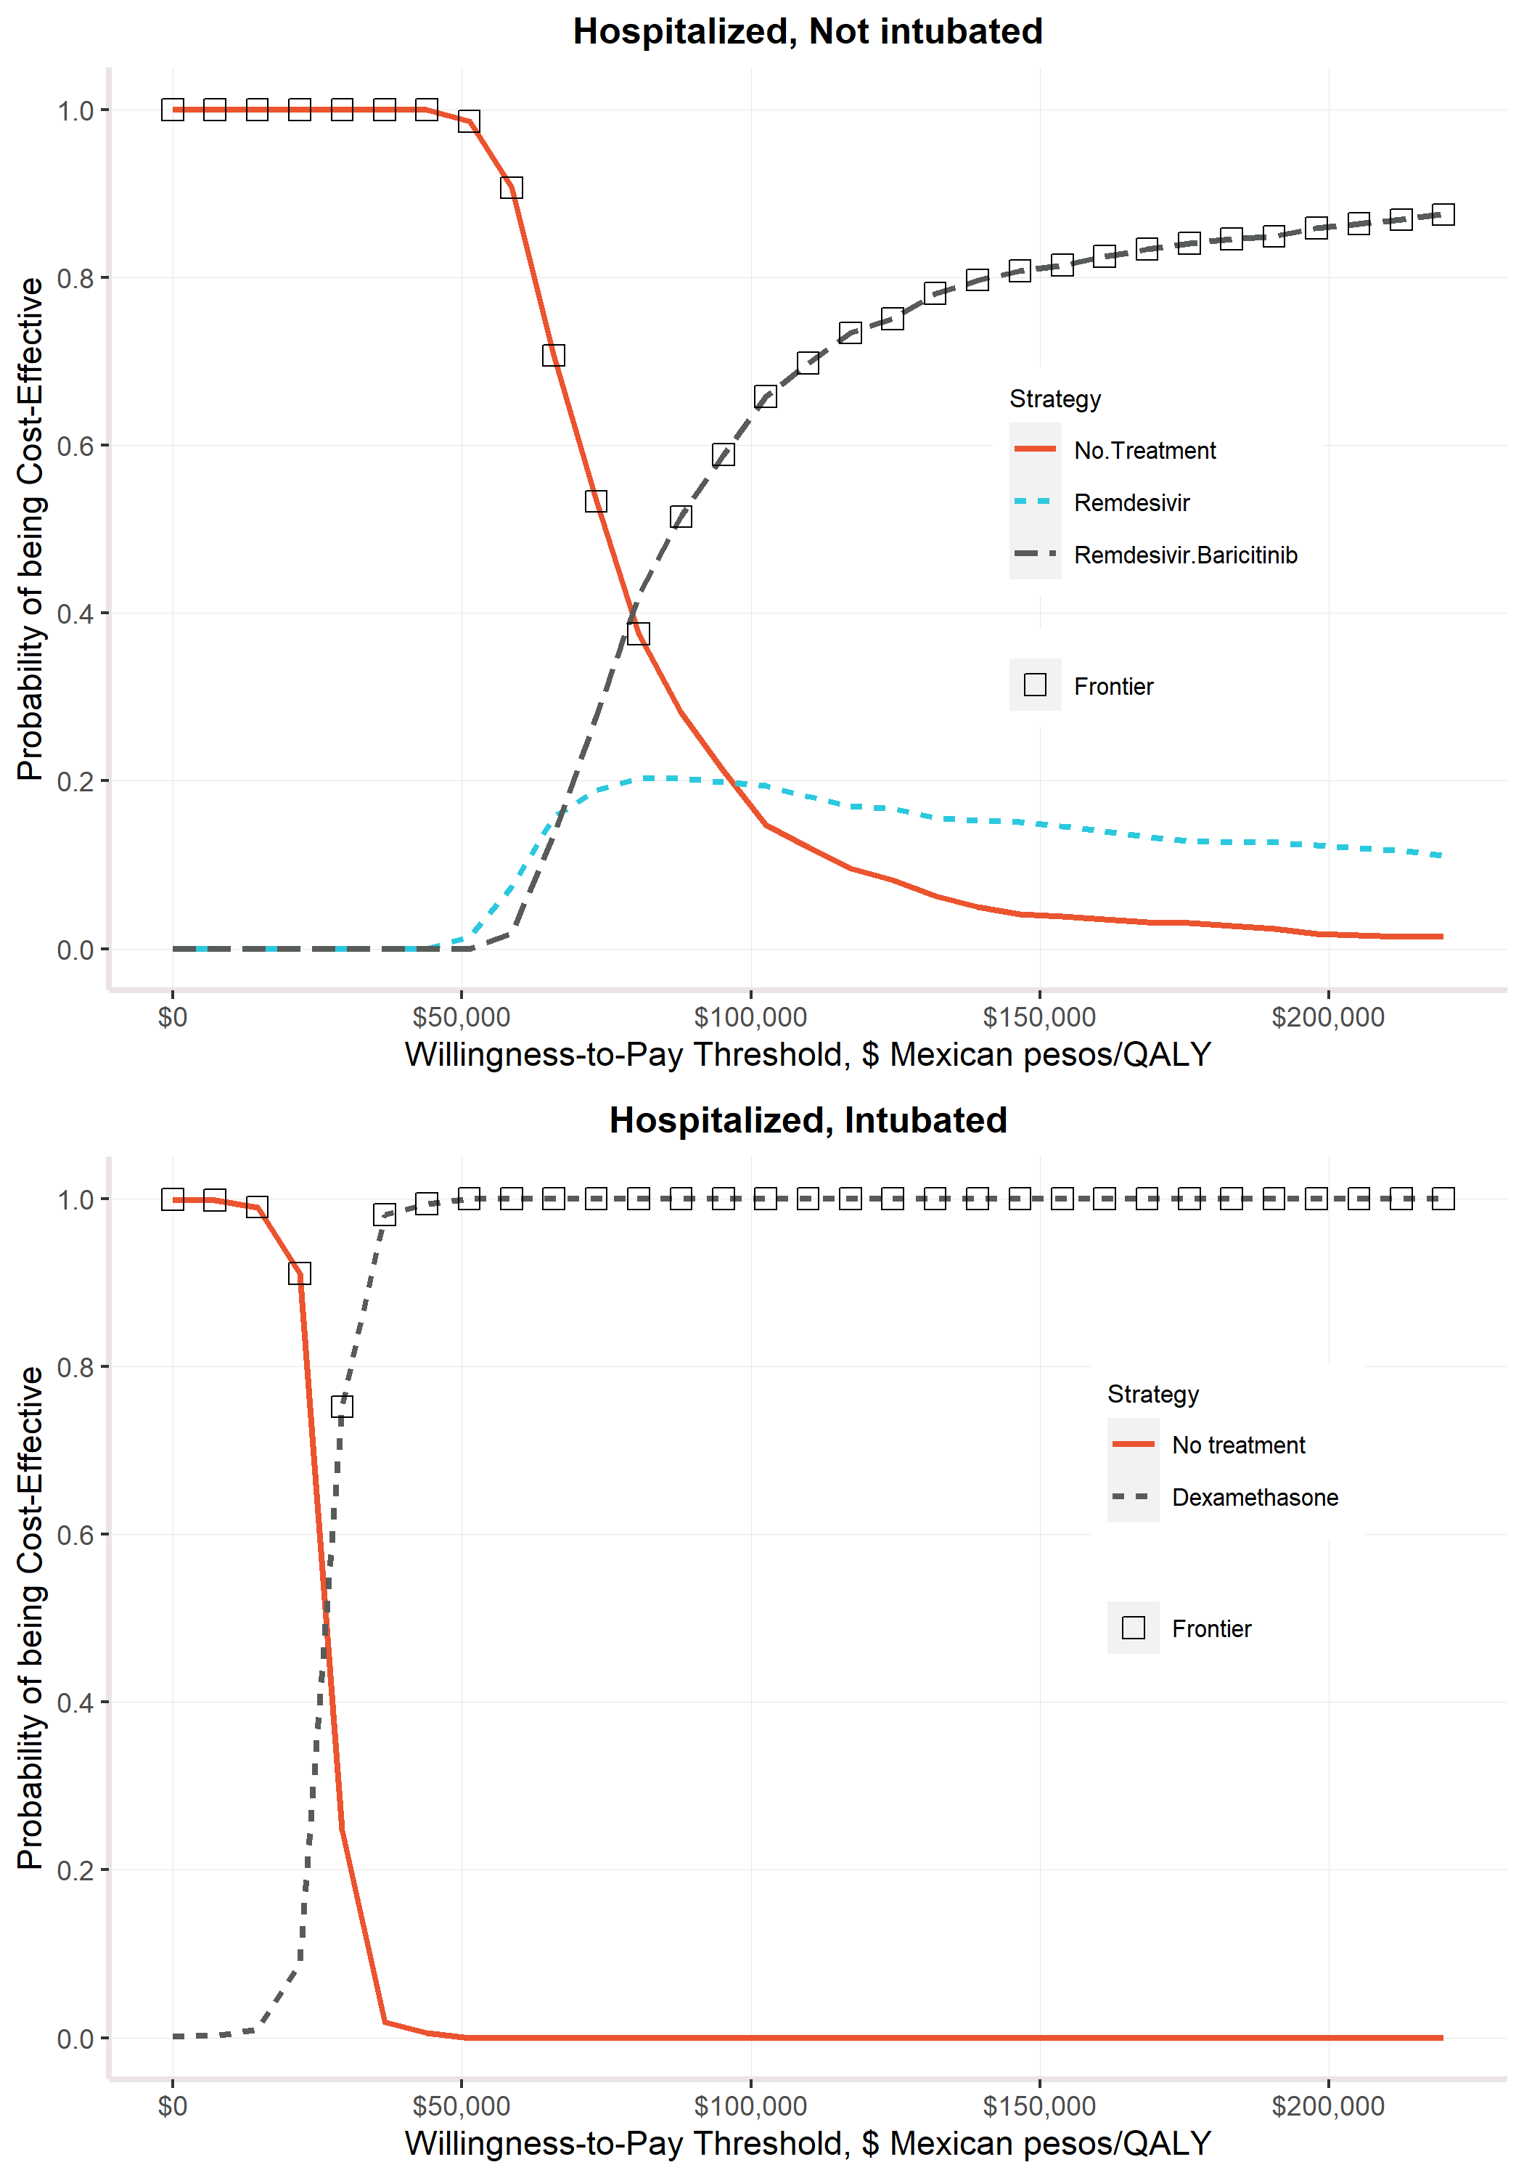

# Discussion

Treating COVID-19 hospitalized patients in Mexico is more cost-effective than choosing the no treatment strategy. For a cohort of non-intubated people, our estimations show that Remdesivir and Baricitinib is the most cost-effective strategy, while Remdesivir alone is a weakly dominated strategy. A similar analysis for the intubated cohort indicates that Dexamethasone is the best choice in terms of cost-effectiveness. Cost-effectiveness acceptability curves with a threshold of one GDP-Per Capita reaffirm that these results are robust to parameter uncertainty. Mortality rates increase with age and men face higher mortality rates than women. In both cohorts, COVID-19-specific mortality rates drastically decrease after day 30 for non-intubated patients, while for intubated patients, this decrease is not observed until day 50.

Segundo, comparar mis resultados con resultados de otros lados (research in context)

## Key Points for Decision Makers

The lack of specific cost-effectiveness studies for these treatment options means that decision-makers do not have evidence or information to choose courses of action during this pandemic. A simulation model that incorporates the uncertainty of various parameters can be a handy tool for public health authorities or managers responsible for managing the public health crisis in Mexico.

## Conclusions

The evidence utilized by this decision model is limited and sensitive to new information that may emerge on any of the parameters used so far. There is also no specific information for the Mexican case on the effects of treatments or public prices for the Mexican population. The prices used of Remdesivir and Baricitinib are set for high-income countries; however, it is foreseeable that there will be lower rates for middle-income countries, as in the case of Mexico. Although necessary due to the lack of specific information for the Mexican case, another possible factual discrepancy arises from the assumption that health benefits are similar in Mexico and the United States.

This analysis provides an evaluation of different action strategies to reduce the burden of this pandemic in Mexican hospitalized patients using publicly available information without having to rely on clinical trials or empirical evidence for Mexican patients. Although the evidence in favor of the evaluated treatments have been debated30 and is not conclusive, the sensitivity analysis of the decision model allowed us to consider these parameters and give robust results to this uncertainty.

More published information resources are needed to improve the accuracy of these analyzes. Counting on these types of inputs is a significant advantage when we have scenarios such as the current pandemic, where the amount of empirical evidence is limited, and we have to rely on simulations to project different scenarios and make evidence-based decisions.

# 

# List of Tables

Table 1: Decision model values, utilities, costs and healthcare expenditure. 8

Table 2: Health outcomes and costs mean estimates from probabilistc sensitivity analysis. 11

Table 3: Efficient Frontier. On the left side, for non-intubated patients it is observed that Remdesivir is a weakly dominated strategy since it is not contained by the Efficiency line. Author’s own elaboration with outcomes of the decision analytic model. 12

# List of Figures

Figure 1: Model Diagram 5

Figure 3: COVID-19 Daily hazards by cohort, age and sex group. Source: Author´s own creation with information published by Mexico´s Ministry of Health. 9

# References

1 Secretaria de Salud. Informe Técnico Diario COVID-19 MÉXICO. 2020. https://www.gob.mx/cms/uploads/attachment/file/593517/Comunicado_Tecnico_Diario_COVID-19_2020.11.19.pdf.

2 John Hopkins University. COVID-19 Dashboard by the Center for Systems Science and Engineering (CSSE) at Johns Hopkins University (JHU). 2020. https://coronavirus.jhu.edu/map.html (accessed Dec 9, 2020).

3 Stang A, Standl F, Kowall B, *et al.* Excess mortality due to COVID-19 in Germany. *J Infect* 2020; **81**: 797–801.

4 Nogueira PJ, Nobre MDEA, Nicola PJ, Furtado C. Excess Mortality Estimation During the COVID-19 Pandemic : Preliminary Data from Portugal Estimativa do Excesso de Mortalidade Durante a Pandemia COVID-19 : Dados Preliminares Portugueses. 2020; : 376–83.

5 Vandoros S. Has mortality due to other causes increased during the Covid-19 pandemic ? Early evidence from England and Wales. 2020; : 1–14.

6 Beaney T, Clarke JM, Jain V, *et al.* Excess mortality: the gold standard in measuring theimpact of COVID-19 worldwide? *R Soc Med* 2020; **113**: 329–34.

7 Karlinsky A, Kobak D, Planck M. The World Mortality Dataset : Tracking excess mortality across countries during the COVID-19 pandemic. 2021; : 1–10.

8 Secretaría de Salud (SISVER). Exceso de Mortalidad en México – Coronavirus. Datos- Exceso Mortal. 2021. https://coronavirus.gob.mx/exceso-de-mortalidad-en-mexico/ (accessed June 11, 2021).

9 Secretaría de Salud. Información referente a casos COVID-19 en México. Bases datos COVID 19 en México. 2020; published online Nov 19. https://datos.gob.mx/busca/dataset/informacion-referente-a-casos-covid-19-en-mexico/resource/3d7fb4a8-5763-4dba-a23f-a20edc7783f7 (accessed Dec 9, 2020).

10 Consejo Nacional de Población (CONAPO). Proyecciones de la Población de los Municipios de México, 2015-2030. 2019; published online Sept 22. https://www.gob.mx/conapo/documentos/proyecciones-de-la-poblacion-de-los-municipios-de-mexico-2015-2030 (accessed Dec 9, 2020).

11 Pohar Perme M, Klemen P. Pohar Perme, Pavlič - 2018 - Nonparametric relative survival analysis with the R package relsurv.pdf. *J Stat Softw* 2018; **87**. DOI:https://doi.org/10.18637/jss.v087.i08.

12 EDERER F, AXTELL L, CUTLER S. The relative survival rate: a statistical methodology. *Natl Cancer Inst Monogr* 1961; **6**: 101.

13 Pohar Perme M. Package ‘ relsurv ’. 2018. https://cran.r-project.org/web/packages/relsurv/relsurv.pdf.

14 Alarid-Escudero F, Kuntz KM. Potential Bias Associated with Modeling the Effectiveness of Healthcare Interventions in Reducing Mortality Using an Overall Hazard Ratio. *Pharmacoeconomics* 2020; **38**: 285–96.

15 The RECOVERY Collaborative Group. Dexamethasone in Hospitalized Patients with Covid-19 — Preliminary Report. *N Engl J Med* 2020; : 1–11.

16 Beigel JH, Tomashek KM, Dodd LE, *et al.* Remdesivir for the Treatment of Covid-19 — Final Report. *N Engl J Med* 2020; **383**: 1813–26.

17 Marconi VC, Palacios GMR, Hsieh L, *et al.* Baricitinib plus Remdesivir for Hospitalized Adults with Covid-19. 2020; : 1–13.

18 Krijkamp EM, Alarid-Escudero F, Enns EA, Jalal HJ, Hunink MGM, Pechlivanoglou P. Microsimulation Modeling for Health Decision Sciences Using R: A Tutorial. *Med Decis Mak* 2018; **38**: 400–22.

19 Consejo de Salubridad General. Guía de Evaluación de Insumos para la Salud. 2017; : 67.

20 Hanmer J, Lawrence WF, Anderson JP, Kaplan RM, Fryback DG. Report of nationally representative values for the noninstitutionalized US adult population for 7 health-related quality-of-life scores. *Med Decis Mak* 2006; **26**: 391–400.

21 H. Consejo Técnico. Acuerdo relativo a la Aprobación de los Costos Unitarios por Nivel de Atención Médica actualizadas al año 2021. México: Diario Oficial de la Federación, 2020.

22 Campbell JD, Whittington MD, Rind DM, Pearson SD. Alternative Pricing Models for Remdesivir and Other Potential Treatments for COVID-19. 2020; : 1–18.

23 Drugs.com. Olumiant Prices, Coupons & Patient Assistance Programs. Price Guid. 2021. https://www.drugs.com/price-guide/olumiant (accessed June 4, 2021).

24 The World Bank. Current health expenditures per capita (current $US). 2018. https://data.worldbank.org/indicator/SH.XPD.CHEX.PC.CD?locations=MX.

25 Méndez JS. Presupuesto para prevención y control de enfermedades. Cent. Investig. Económica y Presup. 2020. https://ciep.mx/OqSV (accessed June 7, 2021).

26 Jalal HJ, Dowd B, Sainfort F, Kuntz KM. Linear Regression Metamodeling as a Tool to Summarize and Present Simulation Model Results. *Med Decis Mak* 2013; **33**: 880–90.

27 R Core Team. R: A Language and Environment for Statistical Computing. 2013. http://www.r-project.org.

28 Rstudio Team. RStudio: Integrated Development for R. 2020. http://www.rstudio.com/.

29 Alarid-Escudero F, Krijkamp EM, Pechlivanoglou P, *et al.* A need for change! A coding framework for improving transparency in decision modeling. *Pharmacoeconomics* 2019; **37**: 1329–1339.

30 Zimmer C, Wu KJ, Corum J. Tratamientos y medicamentos para el coronavirus: monitoreo de efectividad. New York Times. 2020. https://www.nytimes.com/es/interactive/2020/science/coronavirus-tratamientos-curas.html (accessed Dec 9, 2020).

# Appendix

## COVID-19 specific hazard by month

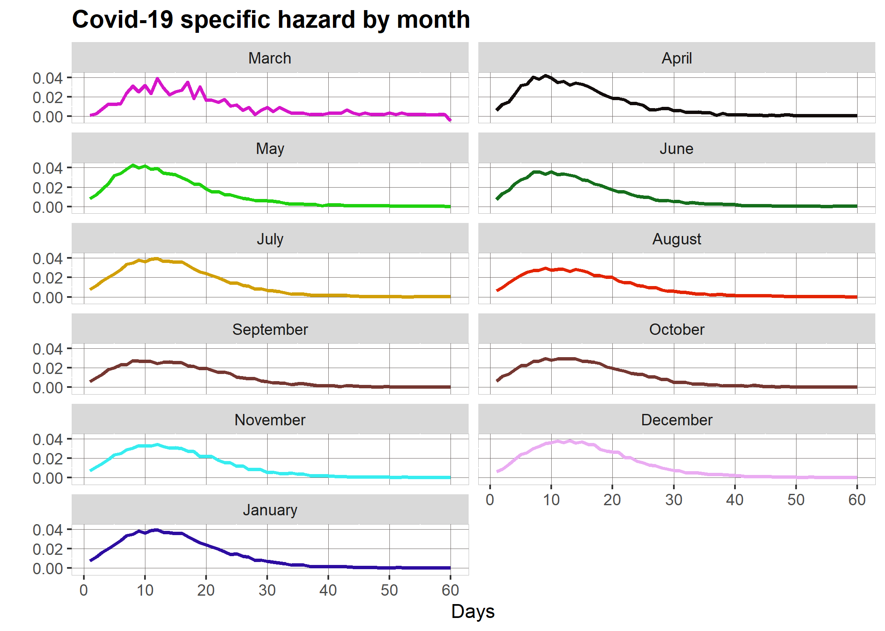

## Parameter distributions

|  |  |  |  |
| --- | --- | --- | --- |
| **Parameter Distributions for Probabilistic Sensitivity Analysis** | | | |
| Hospitalization costs, not intubated | Value | Distribution | Source |
| Hospitalization time: Not intubated Cohort | μ = 13.29; SD = 7.17 | Lognormal μ = 2.43, σ = 0.51 |  |
| Hospitalization time: Intubated Cohort | μ = 13.89; SD = 13.17 | Lognormal μ = 2.31, σ = 0.80 |  |
| Hospitalization costs $: Not intubated Cohort | μ = 9,272; SD = 3278 | Gamma  α = 8, β= 1159 |  |
| Hospitalization costs $: Intubated Cohort | μ = 44,151; SD = 15,610 | Gamma  α = 8, β= 5519 |  |
| Remdesivir Intervention effect | HR: 0.73, CI: 0.52 - 1.03 | Lognormal μ = 0.73, σ = 0.17 |  |
| Baricitinib Intervention effect | HR: 0.65, CI: 0.39 - 1.09 | Lognormal μ = 0.65, σ = 0.26 |  |
| Dexamethasone intervention effect | HR: 0.64, CI: 0.51 - 0.81 | Lognormal μ = 0.64, σ = 0.11 |  |



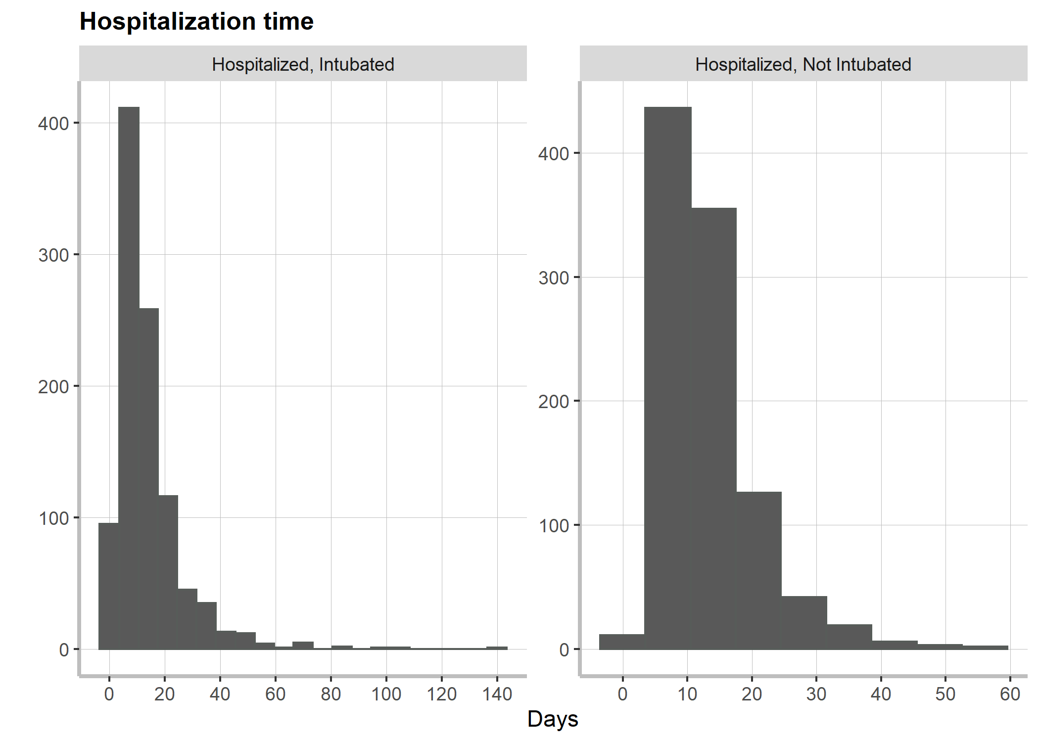

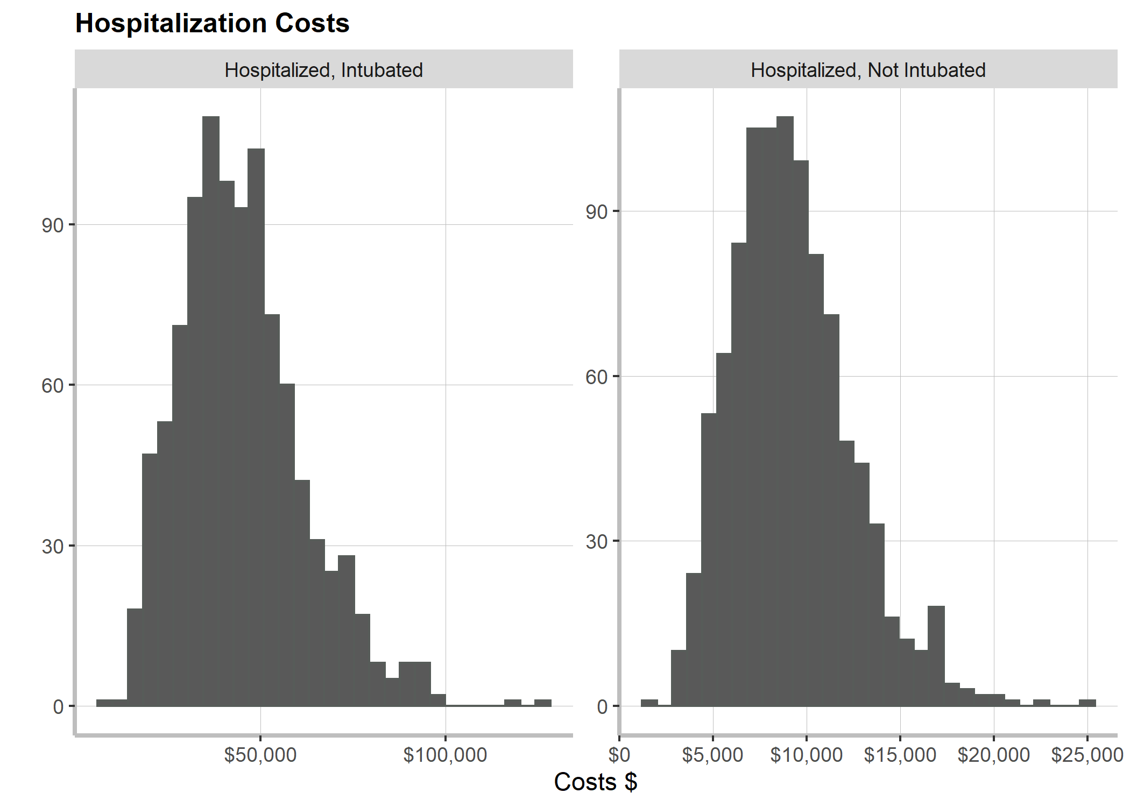

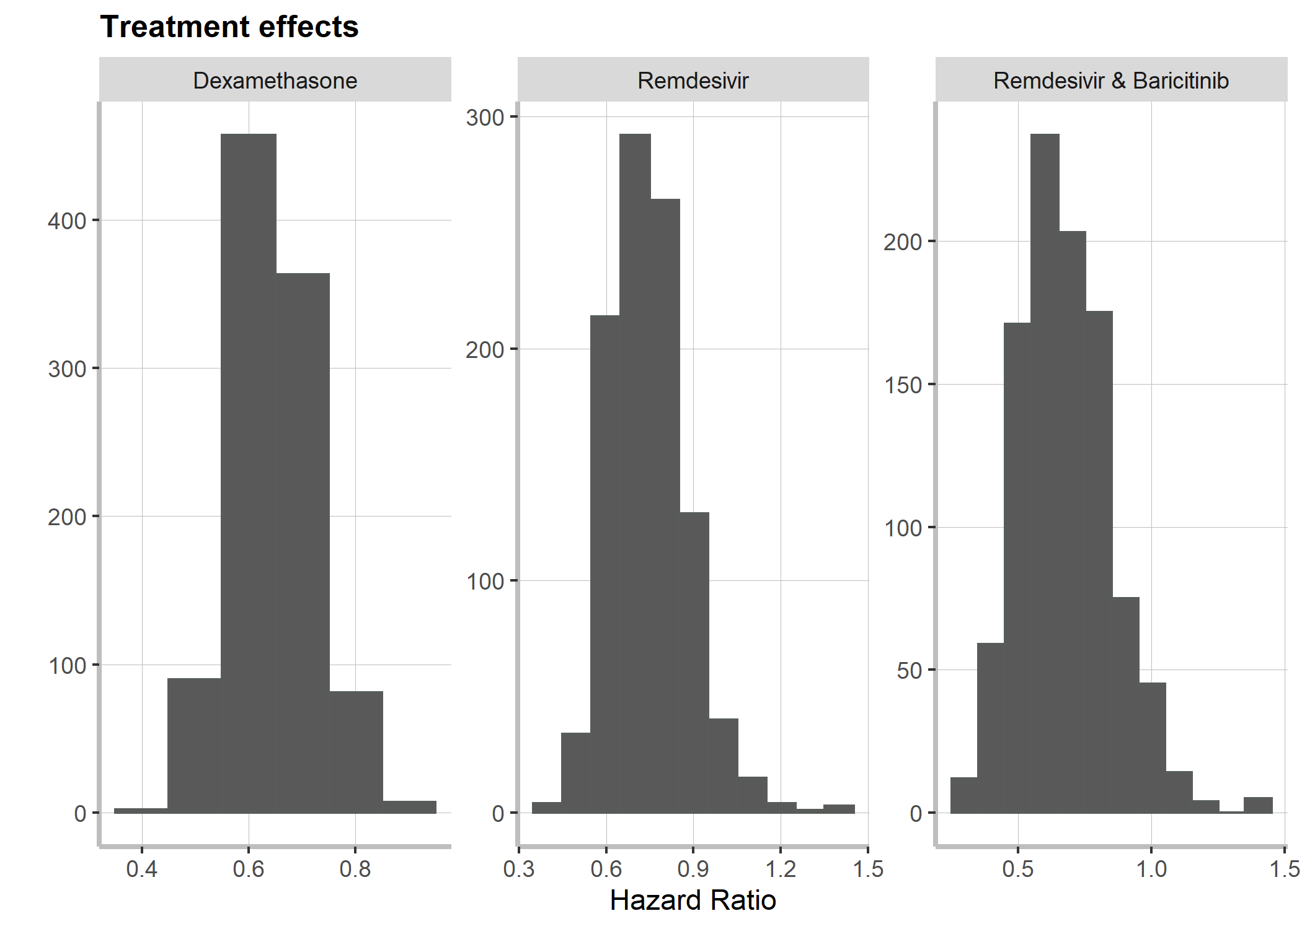

## EVPI and Expected Loss Curves

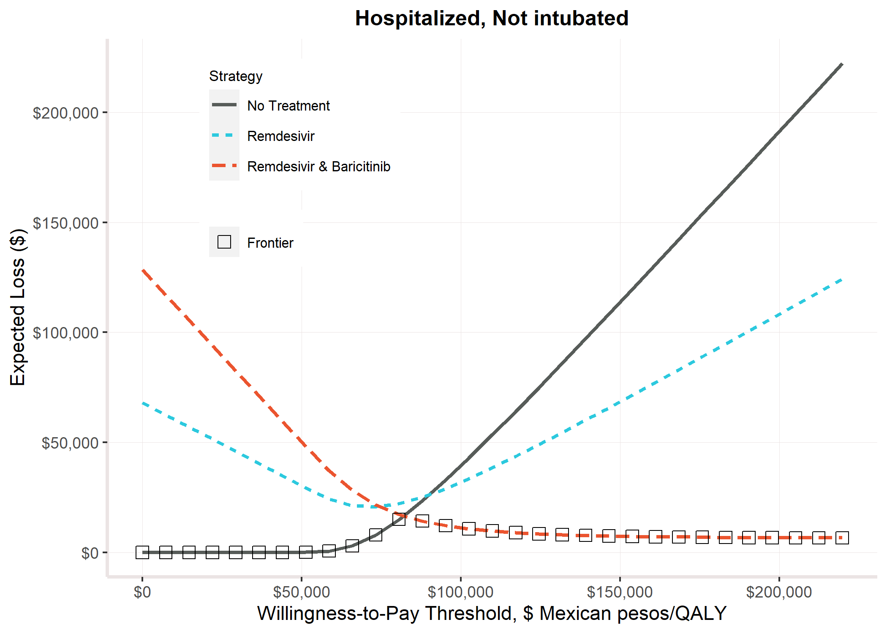

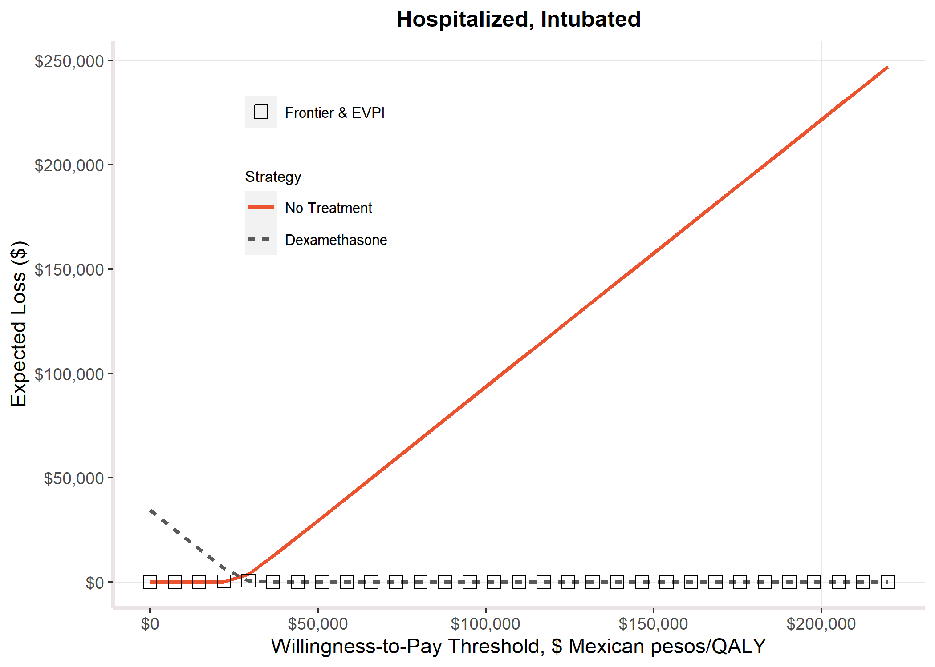

## QALEs Table

|  |  |  |  |  |  |
| --- | --- | --- | --- | --- | --- |
| **Age** | **Sex** | **Discounted Costs** | **Quality-Adjusted Life Years** | **Costs** | **Life Years Expected** |
| 45 | male | 224382 | 12.56 | 572265 | 32.31 |
| 46 | male | 225825 | 12.37 | 564111 | 31.46 |
| 47 | male | 227425 | 12.17 | 556105 | 30.62 |
| 48 | male | 229204 | 11.96 | 548264 | 29.78 |
| 49 | male | 231180 | 11.74 | 540606 | 28.95 |
| 50 | male | 233377 | 11.52 | 533146 | 28.13 |
| 51 | male | 235818 | 11.32 | 525897 | 27.32 |
| 52 | male | 238530 | 11.12 | 518880 | 26.51 |
| 53 | male | 241544 | 10.90 | 512110 | 25.72 |
| 54 | male | 244893 | 10.69 | 505607 | 24.93 |
| 55 | male | 248615 | 10.46 | 499394 | 24.15 |
| 56 | male | 252754 | 10.24 | 493494 | 23.39 |
| 57 | male | 257359 | 10.00 | 487936 | 22.63 |
| 58 | male | 262485 | 9.77 | 482749 | 21.88 |
| 59 | male | 268197 | 9.52 | 477967 | 21.15 |
| 60 | male | 274566 | 9.28 | 473626 | 20.42 |
| 61 | male | 268205 | 9.04 | 456296 | 19.71 |
| 62 | male | 261777 | 8.81 | 439276 | 19.02 |
| 63 | male | 255288 | 8.57 | 422574 | 18.33 |
| 64 | male | 248748 | 8.33 | 406196 | 17.66 |
| 65 | male | 242162 | 8.09 | 390148 | 17.00 |
| 66 | male | 235536 | 7.84 | 374434 | 16.36 |
| 67 | male | 228888 | 7.59 | 359071 | 15.73 |
| 68 | male | 222210 | 7.34 | 344042 | 15.11 |
| 69 | male | 215529 | 7.08 | 329378 | 14.51 |
| 70 | male | 208848 | 6.82 | 315075 | 13.92 |
| 71 | male | 202118 | 6.60 | 301052 | 13.35 |
| 72 | male | 195422 | 6.37 | 287423 | 12.79 |
| 73 | male | 188744 | 6.15 | 274153 | 12.24 |
| 74 | male | 182091 | 5.93 | 261242 | 11.71 |
| 75 | male | 175472 | 5.70 | 248692 | 11.20 |
| 76 | male | 168893 | 5.48 | 236497 | 10.70 |
| 77 | male | 162369 | 5.26 | 224669 | 10.21 |
| 78 | male | 155896 | 5.03 | 213189 | 9.74 |
| 79 | male | 149463 | 4.81 | 202033 | 9.29 |
| 80 | male | 143118 | 4.59 | 191251 | 8.84 |
| 81 | male | 136854 | 4.39 | 180819 | 8.42 |
| 82 | male | 130661 | 4.19 | 170716 | 8.00 |
| 83 | male | 124534 | 3.99 | 160920 | 7.60 |
| 84 | male | 118470 | 3.80 | 151419 | 7.21 |
| 85 | male | 112464 | 3.61 | 142195 | 6.83 |
| 86 | male | 106513 | 3.41 | 133235 | 6.46 |
| 87 | male | 100623 | 3.23 | 124539 | 6.11 |
| 88 | male | 94803 | 3.04 | 116107 | 5.76 |
| 89 | male | 89048 | 2.85 | 107921 | 5.43 |
| 90 | male | 83374 | 2.67 | 99994 | 5.10 |
| 91 | male | 77783 | 2.49 | 92314 | 4.79 |
| 92 | male | 72280 | 2.31 | 84875 | 4.48 |
| 93 | male | 66732 | 2.14 | 77514 | 4.18 |
| 94 | male | 61226 | 1.96 | 70323 | 3.88 |
| 95 | male | 55533 | 1.77 | 63037 | 3.59 |
| 96 | male | 49575 | 1.58 | 55571 | 3.28 |
| 97 | male | 43151 | 1.37 | 47714 | 2.96 |
| 98 | male | 35894 | 1.13 | 39093 | 2.60 |
| 99 | male | 27187 | 0.85 | 29109 | 2.19 |
| 100 | male | 15896 | 0.47 | 16690 | 1.68 |
| 45 | female | 270117 | 12.89 | 692372 | 35.88 |
| 46 | female | 270765 | 12.71 | 680469 | 34.96 |
| 47 | female | 271512 | 12.51 | 668690 | 34.05 |
| 48 | female | 272368 | 12.31 | 657047 | 33.14 |
| 49 | female | 273347 | 12.11 | 645550 | 32.24 |
| 50 | female | 274464 | 11.89 | 634209 | 31.35 |
| 51 | female | 275735 | 11.70 | 623038 | 30.46 |
| 52 | female | 277178 | 11.49 | 612048 | 29.58 |
| 53 | female | 278814 | 11.28 | 601253 | 28.70 |
| 54 | female | 280664 | 11.07 | 590668 | 27.84 |
| 55 | female | 282754 | 10.85 | 580308 | 26.98 |
| 56 | female | 285114 | 10.62 | 570192 | 26.14 |
| 57 | female | 287775 | 10.39 | 560339 | 25.30 |
| 58 | female | 290776 | 10.15 | 550772 | 24.47 |
| 59 | female | 294158 | 9.90 | 541514 | 23.65 |
| 60 | female | 297970 | 9.64 | 532594 | 22.84 |
| 61 | female | 291403 | 9.41 | 513177 | 22.05 |
| 62 | female | 284722 | 9.17 | 494046 | 21.26 |
| 63 | female | 277934 | 8.93 | 475215 | 20.49 |
| 64 | female | 271047 | 8.68 | 456692 | 19.73 |
| 65 | female | 264066 | 8.42 | 438487 | 18.98 |
| 66 | female | 257000 | 8.16 | 420610 | 18.25 |
| 67 | female | 249859 | 7.90 | 403072 | 17.53 |
| 68 | female | 242653 | 7.63 | 385887 | 16.83 |
| 69 | female | 235394 | 7.36 | 369062 | 16.14 |
| 70 | female | 228090 | 7.08 | 352608 | 15.46 |
| 71 | female | 220710 | 6.84 | 336467 | 14.80 |
| 72 | female | 213326 | 6.60 | 320742 | 14.15 |
| 73 | female | 205925 | 6.35 | 305404 | 13.53 |
| 74 | female | 198519 | 6.10 | 290456 | 12.91 |
| 75 | female | 191119 | 5.86 | 275908 | 12.32 |
| 76 | female | 183735 | 5.61 | 261758 | 11.74 |
| 77 | female | 176385 | 5.35 | 248021 | 11.17 |
| 78 | female | 169072 | 5.10 | 234686 | 10.62 |
| 79 | female | 161793 | 4.85 | 221739 | 10.09 |
| 80 | female | 154594 | 4.59 | 209226 | 9.58 |
| 81 | female | 147476 | 4.38 | 197134 | 9.08 |
| 82 | female | 140439 | 4.17 | 185446 | 8.61 |
| 83 | female | 133483 | 3.96 | 174148 | 8.14 |
| 84 | female | 126612 | 3.76 | 163233 | 7.69 |
| 85 | female | 119831 | 3.56 | 152689 | 7.26 |
| 86 | female | 113142 | 3.36 | 142506 | 6.84 |
| 87 | female | 106554 | 3.16 | 132683 | 6.44 |
| 88 | female | 100072 | 2.97 | 123212 | 6.05 |
| 89 | female | 93697 | 2.78 | 114078 | 5.68 |
| 90 | female | 87438 | 2.60 | 105279 | 5.32 |
| 91 | female | 81300 | 2.41 | 96803 | 4.97 |
| 92 | female | 75276 | 2.24 | 88630 | 4.63 |
| 93 | female | 69246 | 2.06 | 80606 | 4.31 |
| 94 | female | 63288 | 1.88 | 72811 | 3.99 |
| 95 | female | 57178 | 1.70 | 64982 | 3.67 |
| 96 | female | 50842 | 1.51 | 57038 | 3.34 |
| 97 | female | 44078 | 1.31 | 48764 | 3.00 |
| 98 | female | 36515 | 1.08 | 39781 | 2.63 |
| 99 | female | 27532 | 0.82 | 29482 | 2.21 |
| 100 | female | 16033 | 0.48 | 16834 | 1.69 |